Loading ENV1 data...

ENV1: Loaded 106 trials (Stay: 53, Leave: 53)

Saving ENV1 connectivity matrices...

C:\Users\sansk\miniconda3\Lib\site-packages\scipy\signal\_spectral_py.py:1668: RuntimeWarning: invalid value encountered in divide

Cxy = np.abs(Pxy)**2 / Pxx / Pyy

Saved connectivity matrices to connectivity_matrices_env1

Shapes: (106, 28, 28) (106, 28, 28) (106, 28, 28)

Running GNN with corr connectivity for ENV1...

==================================================

Training GNN for ENV1 with corr connectivity

==================================================

=== ENV1 Split 1/5 ===

After oversampling, class counts: Counter({0: 43, 1: 43})

C:\Users\sansk\miniconda3\Lib\site-packages\torch_geometric\deprecation.py:26: UserWarning: 'data.DataLoader' is deprecated, use 'loader.DataLoader' instead

warnings.warn(out)

Epoch 1/200 | Loss: 0.7501

Epoch 2/200 | Loss: 0.7806

Epoch 3/200 | Loss: 0.7415

Epoch 4/200 | Loss: 0.7207

Epoch 5/200 | Loss: 0.7448

Epoch 6/200 | Loss: 0.7097

Epoch 7/200 | Loss: 0.7754

Epoch 8/200 | Loss: 0.7385

Epoch 9/200 | Loss: 0.7183

Epoch 10/200 | Loss: 0.7951

Epoch 11/200 | Loss: 0.7449

Epoch 12/200 | Loss: 0.7114

Epoch 13/200 | Loss: 0.7753

Epoch 14/200 | Loss: 0.7177

Epoch 15/200 | Loss: 0.7800

Epoch 16/200 | Loss: 0.7607

Epoch 17/200 | Loss: 0.7391

Epoch 18/200 | Loss: 0.6973

Epoch 19/200 | Loss: 0.7113

Epoch 20/200 | Loss: 0.8158

Epoch 21/200 | Loss: 0.8455

Epoch 22/200 | Loss: 0.7200

Epoch 23/200 | Loss: 0.7571

Epoch 24/200 | Loss: 0.7337

Epoch 25/200 | Loss: 0.7769

Epoch 26/200 | Loss: 0.7742

Epoch 27/200 | Loss: 0.8014

Epoch 28/200 | Loss: 0.7134

Epoch 29/200 | Loss: 0.6749

Epoch 30/200 | Loss: 0.7605

Epoch 31/200 | Loss: 0.7265

Epoch 32/200 | Loss: 0.8094

Epoch 33/200 | Loss: 0.7551

Epoch 34/200 | Loss: 0.7941

Epoch 35/200 | Loss: 0.7490

Epoch 36/200 | Loss: 0.7588

Epoch 37/200 | Loss: 0.7269

Epoch 38/200 | Loss: 0.7575

Epoch 39/200 | Loss: 0.7597

Epoch 40/200 | Loss: 0.7217

Epoch 41/200 | Loss: 0.7427

Epoch 42/200 | Loss: 0.7723

Epoch 43/200 | Loss: 0.7016

Epoch 44/200 | Loss: 0.7280

Epoch 45/200 | Loss: 0.7404

Epoch 46/200 | Loss: 0.7485

Epoch 47/200 | Loss: 0.7620

Epoch 48/200 | Loss: 0.7492

Epoch 49/200 | Loss: 0.7800

Epoch 50/200 | Loss: 0.6932

Epoch 51/200 | Loss: 0.6845

Epoch 52/200 | Loss: 0.7159

Epoch 53/200 | Loss: 0.7545

Epoch 54/200 | Loss: 0.7300

Epoch 55/200 | Loss: 0.7437

Epoch 56/200 | Loss: 0.7150

Epoch 57/200 | Loss: 0.7409

Epoch 58/200 | Loss: 0.7262

Epoch 59/200 | Loss: 0.7186

Epoch 60/200 | Loss: 0.7147

Epoch 61/200 | Loss: 0.7106

Epoch 62/200 | Loss: 0.7159

Epoch 63/200 | Loss: 0.7299

Epoch 64/200 | Loss: 0.6981

Epoch 65/200 | Loss: 0.7649

Epoch 66/200 | Loss: 0.6884

Epoch 67/200 | Loss: 0.7317

Epoch 68/200 | Loss: 0.6791

Epoch 69/200 | Loss: 0.7403

Epoch 70/200 | Loss: 0.6986

Epoch 71/200 | Loss: 0.7054

Epoch 72/200 | Loss: 0.6759

Epoch 73/200 | Loss: 0.7174

Epoch 74/200 | Loss: 0.7131

Epoch 75/200 | Loss: 0.7226

Epoch 76/200 | Loss: 0.7100

Epoch 77/200 | Loss: 0.6579

Epoch 78/200 | Loss: 0.6646

Epoch 79/200 | Loss: 0.7355

Epoch 80/200 | Loss: 0.7002

Epoch 81/200 | Loss: 0.7431

Epoch 82/200 | Loss: 0.7090

Epoch 83/200 | Loss: 0.7094

Epoch 84/200 | Loss: 0.6776

Epoch 85/200 | Loss: 0.7483

Epoch 86/200 | Loss: 0.6989

Epoch 87/200 | Loss: 0.6494

Epoch 88/200 | Loss: 0.7506

Epoch 89/200 | Loss: 0.7211

Epoch 90/200 | Loss: 0.7231

Epoch 91/200 | Loss: 0.6748

Epoch 92/200 | Loss: 0.6616

Epoch 93/200 | Loss: 0.7095

Epoch 94/200 | Loss: 0.6949

Epoch 95/200 | Loss: 0.7131

Epoch 96/200 | Loss: 0.7376

Epoch 97/200 | Loss: 0.6815

Epoch 98/200 | Loss: 0.7707

Epoch 99/200 | Loss: 0.7201

Epoch 100/200 | Loss: 0.6834

Epoch 101/200 | Loss: 0.6250

Epoch 102/200 | Loss: 0.7348

Epoch 103/200 | Loss: 0.6679

Epoch 104/200 | Loss: 0.6968

Epoch 105/200 | Loss: 0.7138

Epoch 106/200 | Loss: 0.6742

Epoch 107/200 | Loss: 0.7099

Epoch 108/200 | Loss: 0.7034

Epoch 109/200 | Loss: 0.7557

Epoch 110/200 | Loss: 0.6735

Epoch 111/200 | Loss: 0.6809

Epoch 112/200 | Loss: 0.7032

Epoch 113/200 | Loss: 0.7048

Epoch 114/200 | Loss: 0.6797

Epoch 115/200 | Loss: 0.7121

Epoch 116/200 | Loss: 0.7940

Epoch 117/200 | Loss: 0.7296

Epoch 118/200 | Loss: 0.6488

Epoch 119/200 | Loss: 0.7234

Epoch 120/200 | Loss: 0.7129

Epoch 121/200 | Loss: 0.6936

Epoch 122/200 | Loss: 0.6942

Epoch 123/200 | Loss: 0.7090

Epoch 124/200 | Loss: 0.6679

Epoch 125/200 | Loss: 0.6759

Epoch 126/200 | Loss: 0.6826

Epoch 127/200 | Loss: 0.7134

Epoch 128/200 | Loss: 0.6684

Epoch 129/200 | Loss: 0.7229

Epoch 130/200 | Loss: 0.6754

Epoch 131/200 | Loss: 0.6911

Epoch 132/200 | Loss: 0.6459

Epoch 133/200 | Loss: 0.7189

Epoch 134/200 | Loss: 0.6889

Epoch 135/200 | Loss: 0.6962

Epoch 136/200 | Loss: 0.7090

Epoch 137/200 | Loss: 0.6837

Epoch 138/200 | Loss: 0.6766

Epoch 139/200 | Loss: 0.6803

Epoch 140/200 | Loss: 0.7148

Epoch 141/200 | Loss: 0.7137

Epoch 142/200 | Loss: 0.7517

Epoch 143/200 | Loss: 0.7250

Epoch 144/200 | Loss: 0.6487

Epoch 145/200 | Loss: 0.6360

Epoch 146/200 | Loss: 0.7077

Epoch 147/200 | Loss: 0.6831

Epoch 148/200 | Loss: 0.7261

Epoch 149/200 | Loss: 0.7130

Epoch 150/200 | Loss: 0.6672

Epoch 151/200 | Loss: 0.7206

Epoch 152/200 | Loss: 0.6676

Epoch 153/200 | Loss: 0.6391

Epoch 154/200 | Loss: 0.6709

Epoch 155/200 | Loss: 0.6527

Epoch 156/200 | Loss: 0.6989

Epoch 157/200 | Loss: 0.6931

Epoch 158/200 | Loss: 0.6770

Epoch 159/200 | Loss: 0.7521

Epoch 160/200 | Loss: 0.6412

Epoch 161/200 | Loss: 0.7712

Epoch 162/200 | Loss: 0.6050

Epoch 163/200 | Loss: 0.7148

Epoch 164/200 | Loss: 0.6619

Epoch 165/200 | Loss: 0.6409

Epoch 166/200 | Loss: 0.6695

Epoch 167/200 | Loss: 0.6581

Epoch 168/200 | Loss: 0.6415

Epoch 169/200 | Loss: 0.6541

Epoch 170/200 | Loss: 0.7094

Epoch 171/200 | Loss: 0.6396

Epoch 172/200 | Loss: 0.6768

Epoch 173/200 | Loss: 0.6656

Epoch 174/200 | Loss: 0.6960

Epoch 175/200 | Loss: 0.6643

Epoch 176/200 | Loss: 0.7069

Epoch 177/200 | Loss: 0.7300

Epoch 178/200 | Loss: 0.6648

Epoch 179/200 | Loss: 0.6884

Epoch 180/200 | Loss: 0.7288

Epoch 181/200 | Loss: 0.6371

Epoch 182/200 | Loss: 0.7050

Epoch 183/200 | Loss: 0.6905

Epoch 184/200 | Loss: 0.6932

Epoch 185/200 | Loss: 0.7003

Epoch 186/200 | Loss: 0.6789

Epoch 187/200 | Loss: 0.6436

Epoch 188/200 | Loss: 0.6624

Epoch 189/200 | Loss: 0.6413

Epoch 190/200 | Loss: 0.6814

Epoch 191/200 | Loss: 0.6863

Epoch 192/200 | Loss: 0.6894

Epoch 193/200 | Loss: 0.6907

Epoch 194/200 | Loss: 0.6029

Epoch 195/200 | Loss: 0.6883

Epoch 196/200 | Loss: 0.6954

Epoch 197/200 | Loss: 0.6469

Epoch 198/200 | Loss: 0.7098

Epoch 199/200 | Loss: 0.6576

Epoch 200/200 | Loss: 0.6338

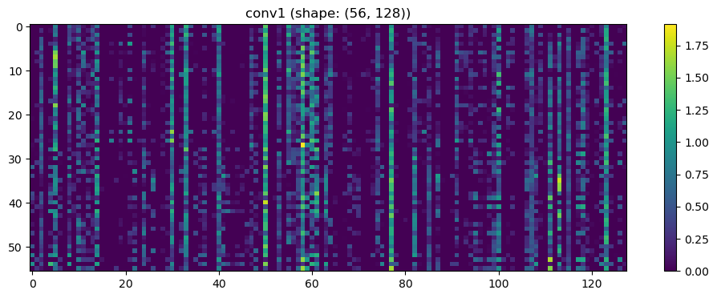

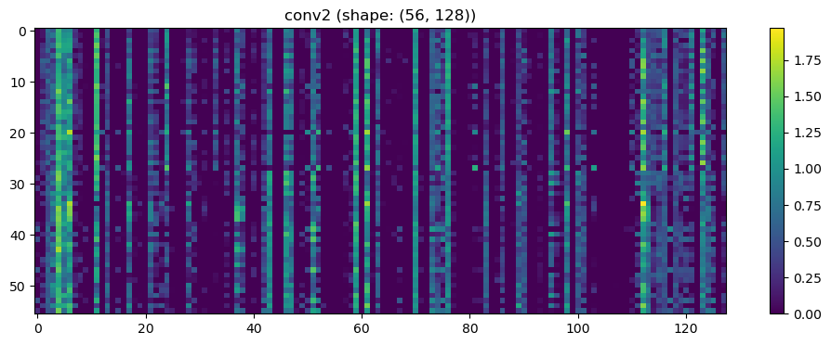

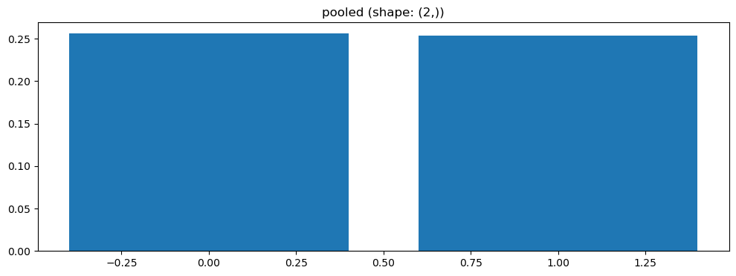

Epoch 1/100 | Loss: 0.7115

Epoch 2/100 | Loss: 0.7152

Epoch 3/100 | Loss: 0.7636

Epoch 4/100 | Loss: 0.7511

Epoch 5/100 | Loss: 0.6501

Epoch 6/100 | Loss: 0.6807

Epoch 7/100 | Loss: 0.7822

Epoch 8/100 | Loss: 0.7110

Epoch 9/100 | Loss: 0.6751

Epoch 10/100 | Loss: 0.6996

Epoch 11/100 | Loss: 0.6584

Epoch 12/100 | Loss: 0.7645

Epoch 13/100 | Loss: 0.7123

Epoch 14/100 | Loss: 0.6683

Epoch 15/100 | Loss: 0.7506

Epoch 16/100 | Loss: 0.6588

Epoch 17/100 | Loss: 0.7269

Epoch 18/100 | Loss: 0.6803

Epoch 19/100 | Loss: 0.6826

Epoch 20/100 | Loss: 0.6257

Epoch 21/100 | Loss: 0.7250

Epoch 22/100 | Loss: 0.6830

Epoch 23/100 | Loss: 0.6695

Epoch 24/100 | Loss: 0.6672

Epoch 25/100 | Loss: 0.6771

Epoch 26/100 | Loss: 0.6517

Epoch 27/100 | Loss: 0.6809

Epoch 28/100 | Loss: 0.6383

Epoch 29/100 | Loss: 0.6823

Epoch 30/100 | Loss: 0.6809

Epoch 31/100 | Loss: 0.6947

Epoch 32/100 | Loss: 0.6570

Epoch 33/100 | Loss: 0.6341

Epoch 34/100 | Loss: 0.6852

Epoch 35/100 | Loss: 0.6603

Epoch 36/100 | Loss: 0.7201

Epoch 37/100 | Loss: 0.7047

Epoch 38/100 | Loss: 0.7235

Epoch 39/100 | Loss: 0.7481

Epoch 40/100 | Loss: 0.6954

Epoch 41/100 | Loss: 0.6444

Epoch 42/100 | Loss: 0.6287

Epoch 43/100 | Loss: 0.7082

Epoch 44/100 | Loss: 0.6863

Epoch 45/100 | Loss: 0.6298

Epoch 46/100 | Loss: 0.6394

Epoch 47/100 | Loss: 0.6717

Epoch 48/100 | Loss: 0.6443

Epoch 49/100 | Loss: 0.6457

Epoch 50/100 | Loss: 0.6463

Epoch 51/100 | Loss: 0.5780

Epoch 52/100 | Loss: 0.6631

Epoch 53/100 | Loss: 0.6527

Epoch 54/100 | Loss: 0.6078

Epoch 55/100 | Loss: 0.6480

Epoch 56/100 | Loss: 0.6490

Epoch 57/100 | Loss: 0.6753

Epoch 58/100 | Loss: 0.6343

Epoch 59/100 | Loss: 0.6524

Epoch 60/100 | Loss: 0.5971

Epoch 61/100 | Loss: 0.6174

Epoch 62/100 | Loss: 0.7231

Epoch 63/100 | Loss: 0.6805

Epoch 64/100 | Loss: 0.6296

Epoch 65/100 | Loss: 0.6024

Epoch 66/100 | Loss: 0.6456

Epoch 67/100 | Loss: 0.6446

Epoch 68/100 | Loss: 0.6762

Epoch 69/100 | Loss: 0.6700

Epoch 70/100 | Loss: 0.7173

Epoch 71/100 | Loss: 0.6185

Epoch 72/100 | Loss: 0.7073

Epoch 73/100 | Loss: 0.5981

Epoch 74/100 | Loss: 0.6478

Epoch 75/100 | Loss: 0.7222

Epoch 76/100 | Loss: 0.6035

Epoch 77/100 | Loss: 0.6196

Epoch 78/100 | Loss: 0.6046

Epoch 79/100 | Loss: 0.6524

Epoch 80/100 | Loss: 0.5850

Epoch 81/100 | Loss: 0.6430

Epoch 82/100 | Loss: 0.5964

Epoch 83/100 | Loss: 0.6328

Epoch 84/100 | Loss: 0.6226

Epoch 85/100 | Loss: 0.6164

Epoch 86/100 | Loss: 0.6046

Epoch 87/100 | Loss: 0.6758

Epoch 88/100 | Loss: 0.6418

Epoch 89/100 | Loss: 0.5437

Epoch 90/100 | Loss: 0.5590

Epoch 91/100 | Loss: 0.5995

Epoch 92/100 | Loss: 0.6164

Epoch 93/100 | Loss: 0.6017

Epoch 94/100 | Loss: 0.5625

Epoch 95/100 | Loss: 0.6110

Epoch 96/100 | Loss: 0.5876

Epoch 97/100 | Loss: 0.6218

Epoch 98/100 | Loss: 0.6603

Epoch 99/100 | Loss: 0.5843

Epoch 100/100 | Loss: 0.6117

Split 1 Accuracy: 0.4091

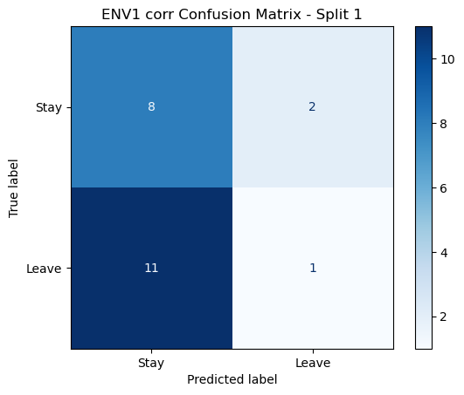

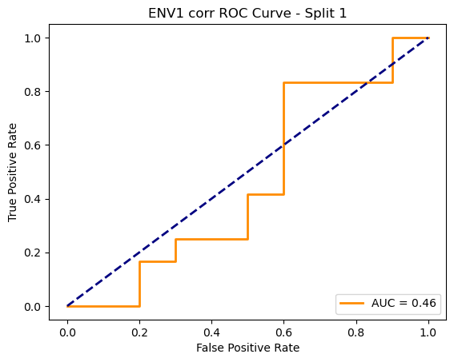

=== ENV1 Split 2/5 ===

After oversampling, class counts: Counter({1: 43, 0: 43})

C:\Users\sansk\miniconda3\Lib\site-packages\torch_geometric\deprecation.py:26: UserWarning: 'data.DataLoader' is deprecated, use 'loader.DataLoader' instead

warnings.warn(out)

Epoch 1/200 | Loss: 0.7452

Epoch 2/200 | Loss: 0.7864

Epoch 3/200 | Loss: 0.8339

Epoch 4/200 | Loss: 0.7805

Epoch 5/200 | Loss: 0.6960

Epoch 6/200 | Loss: 0.8129

Epoch 7/200 | Loss: 0.7795

Epoch 8/200 | Loss: 0.7887

Epoch 9/200 | Loss: 0.7795

Epoch 10/200 | Loss: 0.7013

Epoch 11/200 | Loss: 0.7375

Epoch 12/200 | Loss: 0.8315

Epoch 13/200 | Loss: 0.7174

Epoch 14/200 | Loss: 0.7479

Epoch 15/200 | Loss: 0.7803

Epoch 16/200 | Loss: 0.7280

Epoch 17/200 | Loss: 0.7834

Epoch 18/200 | Loss: 0.7289

Epoch 19/200 | Loss: 0.7140

Epoch 20/200 | Loss: 0.7656

Epoch 21/200 | Loss: 0.7029

Epoch 22/200 | Loss: 0.7864

Epoch 23/200 | Loss: 0.7012

Epoch 24/200 | Loss: 0.7763

Epoch 25/200 | Loss: 0.7252

Epoch 26/200 | Loss: 0.7431

Epoch 27/200 | Loss: 0.7194

Epoch 28/200 | Loss: 0.8161

Epoch 29/200 | Loss: 0.7585

Epoch 30/200 | Loss: 0.7951

Epoch 31/200 | Loss: 0.7150

Epoch 32/200 | Loss: 0.8050

Epoch 33/200 | Loss: 0.7353

Epoch 34/200 | Loss: 0.7754

Epoch 35/200 | Loss: 0.7375

Epoch 36/200 | Loss: 0.7410

Epoch 37/200 | Loss: 0.7350

Epoch 38/200 | Loss: 0.7197

Epoch 39/200 | Loss: 0.7210

Epoch 40/200 | Loss: 0.8237

Epoch 41/200 | Loss: 0.7733

Epoch 42/200 | Loss: 0.7662

Epoch 43/200 | Loss: 0.7779

Epoch 44/200 | Loss: 0.7412

Epoch 45/200 | Loss: 0.7751

Epoch 46/200 | Loss: 0.8056

Epoch 47/200 | Loss: 0.6945

Epoch 48/200 | Loss: 0.7158

Epoch 49/200 | Loss: 0.7560

Epoch 50/200 | Loss: 0.7781

Epoch 51/200 | Loss: 0.7218

Epoch 52/200 | Loss: 0.7374

Epoch 53/200 | Loss: 0.6752

Epoch 54/200 | Loss: 0.6857

Epoch 55/200 | Loss: 0.7201

Epoch 56/200 | Loss: 0.7091

Epoch 57/200 | Loss: 0.7204

Epoch 58/200 | Loss: 0.7078

Epoch 59/200 | Loss: 0.7630

Epoch 60/200 | Loss: 0.7764

Epoch 61/200 | Loss: 0.7590

Epoch 62/200 | Loss: 0.7179

Epoch 63/200 | Loss: 0.7412

Epoch 64/200 | Loss: 0.7567

Epoch 65/200 | Loss: 0.7519

Epoch 66/200 | Loss: 0.7555

Epoch 67/200 | Loss: 0.7096

Epoch 68/200 | Loss: 0.7628

Epoch 69/200 | Loss: 0.7272

Epoch 70/200 | Loss: 0.7203

Epoch 71/200 | Loss: 0.7441

Epoch 72/200 | Loss: 0.7891

Epoch 73/200 | Loss: 0.7097

Epoch 74/200 | Loss: 0.7089

Epoch 75/200 | Loss: 0.6939

Epoch 76/200 | Loss: 0.6833

Epoch 77/200 | Loss: 0.7097

Epoch 78/200 | Loss: 0.7226

Epoch 79/200 | Loss: 0.7374

Epoch 80/200 | Loss: 0.7334

Epoch 81/200 | Loss: 0.7058

Epoch 82/200 | Loss: 0.7054

Epoch 83/200 | Loss: 0.7282

Epoch 84/200 | Loss: 0.6713

Epoch 85/200 | Loss: 0.6936

Epoch 86/200 | Loss: 0.7175

Epoch 87/200 | Loss: 0.7251

Epoch 88/200 | Loss: 0.7712

Epoch 89/200 | Loss: 0.7580

Epoch 90/200 | Loss: 0.7572

Epoch 91/200 | Loss: 0.7435

Epoch 92/200 | Loss: 0.7318

Epoch 93/200 | Loss: 0.7379

Epoch 94/200 | Loss: 0.6968

Epoch 95/200 | Loss: 0.7393

Epoch 96/200 | Loss: 0.7179

Epoch 97/200 | Loss: 0.7086

Epoch 98/200 | Loss: 0.6771

Epoch 99/200 | Loss: 0.6905

Epoch 100/200 | Loss: 0.6861

Epoch 101/200 | Loss: 0.7013

Epoch 102/200 | Loss: 0.7226

Epoch 103/200 | Loss: 0.6740

Epoch 104/200 | Loss: 0.7059

Epoch 105/200 | Loss: 0.6900

Epoch 106/200 | Loss: 0.6877

Epoch 107/200 | Loss: 0.7011

Epoch 108/200 | Loss: 0.7640

Epoch 109/200 | Loss: 0.6887

Epoch 110/200 | Loss: 0.6839

Epoch 111/200 | Loss: 0.6497

Epoch 112/200 | Loss: 0.6428

Epoch 113/200 | Loss: 0.6853

Epoch 114/200 | Loss: 0.6371

Epoch 115/200 | Loss: 0.6784

Epoch 116/200 | Loss: 0.7139

Epoch 117/200 | Loss: 0.7268

Epoch 118/200 | Loss: 0.7848

Epoch 119/200 | Loss: 0.7527

Epoch 120/200 | Loss: 0.6666

Epoch 121/200 | Loss: 0.6635

Epoch 122/200 | Loss: 0.7697

Epoch 123/200 | Loss: 0.7087

Epoch 124/200 | Loss: 0.6761

Epoch 125/200 | Loss: 0.7008

Epoch 126/200 | Loss: 0.7301

Epoch 127/200 | Loss: 0.7339

Epoch 128/200 | Loss: 0.6856

Epoch 129/200 | Loss: 0.6835

Epoch 130/200 | Loss: 0.6867

Epoch 131/200 | Loss: 0.6911

Epoch 132/200 | Loss: 0.6758

Epoch 133/200 | Loss: 0.6315

Epoch 134/200 | Loss: 0.6717

Epoch 135/200 | Loss: 0.7074

Epoch 136/200 | Loss: 0.6668

Epoch 137/200 | Loss: 0.6701

Epoch 138/200 | Loss: 0.6819

Epoch 139/200 | Loss: 0.6981

Epoch 140/200 | Loss: 0.6535

Epoch 141/200 | Loss: 0.6395

Epoch 142/200 | Loss: 0.6735

Epoch 143/200 | Loss: 0.7313

Epoch 144/200 | Loss: 0.7108

Epoch 145/200 | Loss: 0.7112

Epoch 146/200 | Loss: 0.6511

Epoch 147/200 | Loss: 0.6645

Epoch 148/200 | Loss: 0.7043

Epoch 149/200 | Loss: 0.6732

Epoch 150/200 | Loss: 0.6912

Epoch 151/200 | Loss: 0.6748

Epoch 152/200 | Loss: 0.6676

Epoch 153/200 | Loss: 0.6416

Epoch 154/200 | Loss: 0.6723

Epoch 155/200 | Loss: 0.6613

Epoch 156/200 | Loss: 0.6684

Epoch 157/200 | Loss: 0.7165

Epoch 158/200 | Loss: 0.6670

Epoch 159/200 | Loss: 0.6964

Epoch 160/200 | Loss: 0.6153

Epoch 161/200 | Loss: 0.7019

Epoch 162/200 | Loss: 0.6704

Epoch 163/200 | Loss: 0.6772

Epoch 164/200 | Loss: 0.6655

Epoch 165/200 | Loss: 0.6301

Epoch 166/200 | Loss: 0.7101

Epoch 167/200 | Loss: 0.7364

Epoch 168/200 | Loss: 0.6465

Epoch 169/200 | Loss: 0.7331

Epoch 170/200 | Loss: 0.7448

Epoch 171/200 | Loss: 0.7216

Epoch 172/200 | Loss: 0.6773

Epoch 173/200 | Loss: 0.7079

Epoch 174/200 | Loss: 0.6626

Epoch 175/200 | Loss: 0.6975

Epoch 176/200 | Loss: 0.7061

Epoch 177/200 | Loss: 0.6417

Epoch 178/200 | Loss: 0.7117

Epoch 179/200 | Loss: 0.6948

Epoch 180/200 | Loss: 0.6330

Epoch 181/200 | Loss: 0.6537

Epoch 182/200 | Loss: 0.6175

Epoch 183/200 | Loss: 0.6725

Epoch 184/200 | Loss: 0.6670

Epoch 185/200 | Loss: 0.6585

Epoch 186/200 | Loss: 0.7220

Epoch 187/200 | Loss: 0.6714

Epoch 188/200 | Loss: 0.6997

Epoch 189/200 | Loss: 0.6792

Epoch 190/200 | Loss: 0.7179

Epoch 191/200 | Loss: 0.6619

Epoch 192/200 | Loss: 0.6713

Epoch 193/200 | Loss: 0.7068

Epoch 194/200 | Loss: 0.7432

Epoch 195/200 | Loss: 0.6395

Epoch 196/200 | Loss: 0.6346

Epoch 197/200 | Loss: 0.7218

Epoch 198/200 | Loss: 0.6974

Epoch 199/200 | Loss: 0.6733

Epoch 200/200 | Loss: 0.6748

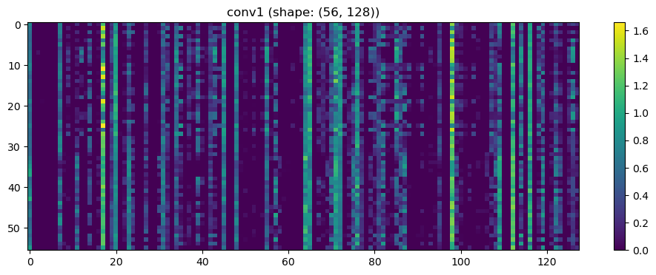

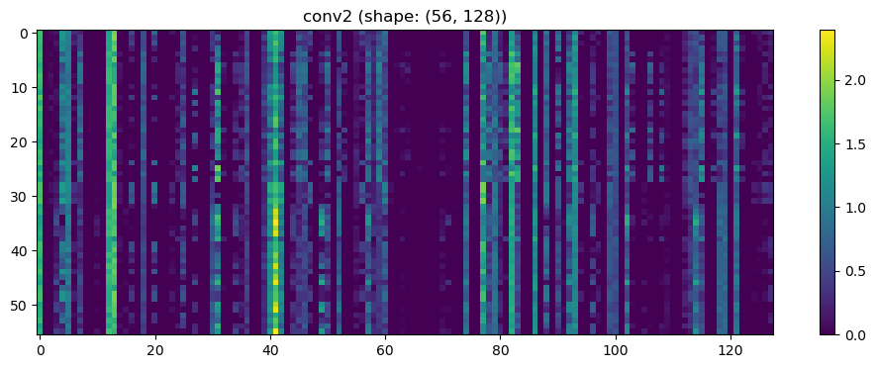

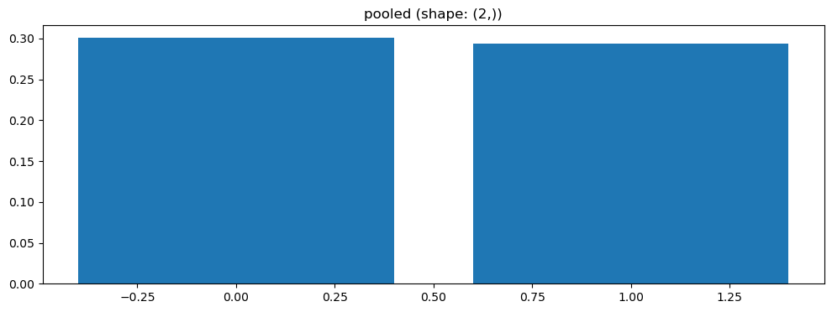

Split 2 Accuracy: 0.5714

Epoch 1/100 | Loss: 0.6675

Epoch 2/100 | Loss: 0.7131

Epoch 3/100 | Loss: 0.7249

Epoch 4/100 | Loss: 0.7145

Epoch 5/100 | Loss: 0.7635

Epoch 6/100 | Loss: 0.7065

Epoch 7/100 | Loss: 0.7529

Epoch 8/100 | Loss: 0.7309

Epoch 9/100 | Loss: 0.7241

Epoch 10/100 | Loss: 0.7023

Epoch 11/100 | Loss: 0.7066

Epoch 12/100 | Loss: 0.6532

Epoch 13/100 | Loss: 0.6970

Epoch 14/100 | Loss: 0.7161

Epoch 15/100 | Loss: 0.6820

Epoch 16/100 | Loss: 0.6958

Epoch 17/100 | Loss: 0.6972

Epoch 18/100 | Loss: 0.7052

Epoch 19/100 | Loss: 0.7141

Epoch 20/100 | Loss: 0.6657

Epoch 21/100 | Loss: 0.7007

Epoch 22/100 | Loss: 0.6978

Epoch 23/100 | Loss: 0.6437

Epoch 24/100 | Loss: 0.7511

Epoch 25/100 | Loss: 0.6570

Epoch 26/100 | Loss: 0.6711

Epoch 27/100 | Loss: 0.6350

Epoch 28/100 | Loss: 0.6145

Epoch 29/100 | Loss: 0.7178

Epoch 30/100 | Loss: 0.6383

Epoch 31/100 | Loss: 0.6940

Epoch 32/100 | Loss: 0.6772

Epoch 33/100 | Loss: 0.6872

Epoch 34/100 | Loss: 0.6182

Epoch 35/100 | Loss: 0.6233

Epoch 36/100 | Loss: 0.6237

Epoch 37/100 | Loss: 0.6885

Epoch 38/100 | Loss: 0.6320

Epoch 39/100 | Loss: 0.6516

Epoch 40/100 | Loss: 0.6879

Epoch 41/100 | Loss: 0.7072

Epoch 42/100 | Loss: 0.6201

Epoch 43/100 | Loss: 0.6162

Epoch 44/100 | Loss: 0.6294

Epoch 45/100 | Loss: 0.7150

Epoch 46/100 | Loss: 0.7187

Epoch 47/100 | Loss: 0.6406

Epoch 48/100 | Loss: 0.6245

Epoch 49/100 | Loss: 0.5952

Epoch 50/100 | Loss: 0.6688

Epoch 51/100 | Loss: 0.5713

Epoch 52/100 | Loss: 0.6211

Epoch 53/100 | Loss: 0.6128

Epoch 54/100 | Loss: 0.6349

Epoch 55/100 | Loss: 0.6588

Epoch 56/100 | Loss: 0.6726

Epoch 57/100 | Loss: 0.6857

Epoch 58/100 | Loss: 0.6458

Epoch 59/100 | Loss: 0.5833

Epoch 60/100 | Loss: 0.6472

Epoch 61/100 | Loss: 0.6370

Epoch 62/100 | Loss: 0.5855

Epoch 63/100 | Loss: 0.5967

Epoch 64/100 | Loss: 0.5786

Epoch 65/100 | Loss: 0.6308

Epoch 66/100 | Loss: 0.6977

Epoch 67/100 | Loss: 0.5256

Epoch 68/100 | Loss: 0.6959

Epoch 69/100 | Loss: 0.6432

Epoch 70/100 | Loss: 0.5791

Epoch 71/100 | Loss: 0.6054

Epoch 72/100 | Loss: 0.5757

Epoch 73/100 | Loss: 0.6412

Epoch 74/100 | Loss: 0.5904

Epoch 75/100 | Loss: 0.6028

Epoch 76/100 | Loss: 0.6444

Epoch 77/100 | Loss: 0.6422

Epoch 78/100 | Loss: 0.5936

Epoch 79/100 | Loss: 0.6578

Epoch 80/100 | Loss: 0.6090

Epoch 81/100 | Loss: 0.6394

Epoch 82/100 | Loss: 0.5914

Epoch 83/100 | Loss: 0.6040

Epoch 84/100 | Loss: 0.6036

Epoch 85/100 | Loss: 0.5385

Epoch 86/100 | Loss: 0.6142

Epoch 87/100 | Loss: 0.5716

Epoch 88/100 | Loss: 0.5510

Epoch 89/100 | Loss: 0.6581

Epoch 90/100 | Loss: 0.5875

Epoch 91/100 | Loss: 0.5609

Epoch 92/100 | Loss: 0.6737

Epoch 93/100 | Loss: 0.5823

Epoch 94/100 | Loss: 0.6234

Epoch 95/100 | Loss: 0.6095

Epoch 96/100 | Loss: 0.5665

Epoch 97/100 | Loss: 0.5356

Epoch 98/100 | Loss: 0.5794

Epoch 99/100 | Loss: 0.5588

Epoch 100/100 | Loss: 0.5190

Split 2 Accuracy: 0.4762

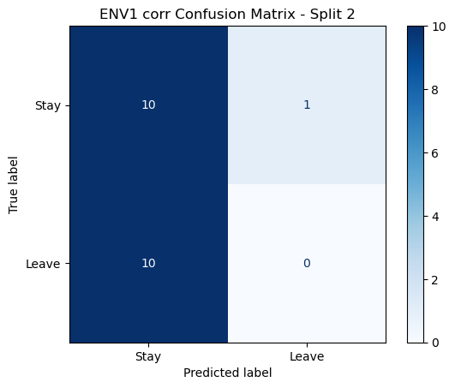

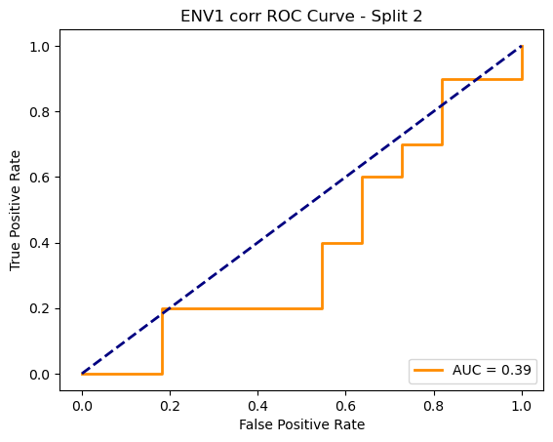

=== ENV1 Split 3/5 ===

After oversampling, class counts: Counter({1: 43, 0: 43})

C:\Users\sansk\miniconda3\Lib\site-packages\torch_geometric\deprecation.py:26: UserWarning: 'data.DataLoader' is deprecated, use 'loader.DataLoader' instead

warnings.warn(out)

Epoch 1/100 | Loss: 0.7639

Epoch 2/100 | Loss: 0.7410

Epoch 3/100 | Loss: 0.7708

Epoch 4/100 | Loss: 0.7365

Epoch 5/100 | Loss: 0.7472

Epoch 6/100 | Loss: 0.6792

Epoch 1/200 | Loss: 0.7643

Epoch 2/200 | Loss: 0.7233

Epoch 3/200 | Loss: 0.7528

Epoch 4/200 | Loss: 0.7663

Epoch 5/200 | Loss: 0.7995

Epoch 6/200 | Loss: 0.7639

Epoch 7/100200 | Loss: 0.7447Epoch 8/200 | Loss: 0.7785

Epoch 9/200 | Loss: 0.6869

Epoch 10/200 | Loss: 0.7833

Epoch 11/200 | Loss: 0.7161

Epoch 12/200 | Loss: 0.7642

Epoch 13/200 | Loss: 0.7169

Epoch 14/200 | Loss: 0.7803

Epoch 15/200 | Loss: 0.7610

Epoch 16/200 | Loss: 0.7224

Epoch 17/200 | Loss: 0.7265

Epoch 18/200 | Loss: 0.6971

Epoch 19/200 | Loss: 0.7044

Epoch 20/200 | Loss: 0.7321

Epoch 21/200 | Loss: 0.6622

Epoch 22/200 | Loss: 0.7505

Epoch 23/200 | Loss: 0.7031

Epoch 24/200 | Loss: 0.6512

Epoch 25/200 | Loss: 0.7156

Epoch 26/200 | Loss: 0.6950

Epoch 27/200 | Loss: 0.7104

Epoch 28/200 | Loss: 0.7045

Epoch 29/200 | Loss: 0.7132

Epoch 30/200 | Loss: 0.7992

Epoch 31/200 | Loss: 0.7375

Epoch 32/200 | Loss: 0.6856

Epoch 33/200 | Loss: 0.7555

Epoch 34/200 | Loss: 0.6878

Epoch 35/200 | Loss: 0.7698

Epoch 36/200 | Loss: 0.7025

Epoch 37/200 | Loss: 0.7031

Epoch 38/200 | Loss: 0.7251

Epoch 39/200 | Loss: 0.7099

Epoch 40/200 | Loss: 0.6895

Epoch 41/200 | Loss: 0.6713

Epoch 42/200 | Loss: 0.6782

Epoch 43/200 | Loss: 0.6867

Epoch 44/200 | Loss: 0.7011

Epoch 45/200 | Loss: 0.7803

Epoch 46/200 | Loss: 0.7389

Epoch 47/200 | Loss: 0.7646

Epoch 48/200 | Loss: 0.6963

Epoch 49/200 | Loss: 0.7442

Epoch 50/200 | Loss: 0.7325

Epoch 51/200 | Loss: 0.7390

Epoch 52/200 | Loss: 0.7033

Epoch 53/200 | Loss: 0.7074

Epoch 54/200 | Loss: 0.6121

Epoch 55/200 | Loss: 0.7030

Epoch 56/200 | Loss: 0.7325

Epoch 57/200 | Loss: 0.6458

Epoch 58/200 | Loss: 0.6756

Epoch 59/200 | Loss: 0.7185

Epoch 60/200 | Loss: 0.7404

Epoch 61/200 | Loss: 0.6816

Epoch 62/200 | Loss: 0.7398

Epoch 63/200 | Loss: 0.6879

Epoch 64/200 | Loss: 0.7366

Epoch 65/200 | Loss: 0.7100

Epoch 66/200 | Loss: 0.6962

Epoch 67/200 | Loss: 0.7774

Epoch 68/200 | Loss: 0.7442

Epoch 69/200 | Loss: 0.6852

Epoch 70/200 | Loss: 0.7001

Epoch 71/200 | Loss: 0.7203

Epoch 72/200 | Loss: 0.7194

Epoch 73/200 | Loss: 0.6290

Epoch 74/200 | Loss: 0.7410

Epoch 75/200 | Loss: 0.7253

Epoch 76/200 | Loss: 0.6874

Epoch 77/200 | Loss: 0.7336

Epoch 78/200 | Loss: 0.7512

Epoch 79/200 | Loss: 0.7412

Epoch 80/200 | Loss: 0.6817

Epoch 81/200 | Loss: 0.7252

Epoch 82/200 | Loss: 0.6741

Epoch 83/200 | Loss: 0.7690

Epoch 84/200 | Loss: 0.7019

Epoch 85/200 | Loss: 0.7135

Epoch 86/200 | Loss: 0.7231

Epoch 87/200 | Loss: 0.7084

Epoch 88/200 | Loss: 0.7169

Epoch 89/200 | Loss: 0.6447

Epoch 90/200 | Loss: 0.6825

Epoch 91/200 | Loss: 0.6523

Epoch 92/200 | Loss: 0.6292

Epoch 93/200 | Loss: 0.6958

Epoch 94/200 | Loss: 0.6499

Epoch 95/200 | Loss: 0.6942

Epoch 96/200 | Loss: 0.7418

Epoch 97/200 | Loss: 0.7035

Epoch 98/200 | Loss: 0.7093

Epoch 99/200 | Loss: 0.6652

Epoch 100/200 | Loss: 0.7685

Epoch 101/200 | Loss: 0.7383

Epoch 102/200 | Loss: 0.6571

Epoch 103/200 | Loss: 0.7582

Epoch 104/200 | Loss: 0.7007

Epoch 105/200 | Loss: 0.7568

Epoch 106/200 | Loss: 0.6233

Epoch 107/200 | Loss: 0.6981

Epoch 108/200 | Loss: 0.6510

Epoch 109/200 | Loss: 0.6819

Epoch 110/200 | Loss: 0.7070

Epoch 111/200 | Loss: 0.7130

Epoch 112/200 | Loss: 0.6702

Epoch 113/200 | Loss: 0.6638

Epoch 114/200 | Loss: 0.6571

Epoch 115/200 | Loss: 0.6406

Epoch 116/200 | Loss: 0.6571

Epoch 117/200 | Loss: 0.6378

Epoch 118/200 | Loss: 0.6390

Epoch 119/200 | Loss: 0.6738

Epoch 120/200 | Loss: 0.7015

Epoch 121/200 | Loss: 0.6914

Epoch 122/200 | Loss: 0.6744

Epoch 123/200 | Loss: 0.7066

Epoch 124/200 | Loss: 0.7121

Epoch 125/200 | Loss: 0.6758

Epoch 126/200 | Loss: 0.6624

Epoch 127/200 | Loss: 0.6150

Epoch 128/200 | Loss: 0.7431

Epoch 129/200 | Loss: 0.6395

Epoch 130/200 | Loss: 0.6290

Epoch 131/200 | Loss: 0.6374

Epoch 132/200 | Loss: 0.7179

Epoch 133/200 | Loss: 0.7034

Epoch 134/200 | Loss: 0.6677

Epoch 135/200 | Loss: 0.7100

Epoch 136/200 | Loss: 0.6870

Epoch 137/200 | Loss: 0.6890

Epoch 138/200 | Loss: 0.6305

Epoch 139/200 | Loss: 0.6600

Epoch 140/200 | Loss: 0.6831

Epoch 141/200 | Loss: 0.7155

Epoch 142/200 | Loss: 0.7547

Epoch 143/200 | Loss: 0.6233

Epoch 144/200 | Loss: 0.6201

Epoch 145/200 | Loss: 0.6747

Epoch 146/200 | Loss: 0.7034

Epoch 147/200 | Loss: 0.6746

Epoch 148/200 | Loss: 0.6542

Epoch 149/200 | Loss: 0.6750

Epoch 150/200 | Loss: 0.6651

Epoch 151/200 | Loss: 0.7093

Epoch 152/200 | Loss: 0.6604

Epoch 153/200 | Loss: 0.6402

Epoch 154/200 | Loss: 0.7498

Epoch 155/200 | Loss: 0.5918

Epoch 156/200 | Loss: 0.6875

Epoch 157/200 | Loss: 0.6334

Epoch 158/200 | Loss: 0.6802

Epoch 159/200 | Loss: 0.6897

Epoch 160/200 | Loss: 0.6820

Epoch 161/200 | Loss: 0.6515

Epoch 162/200 | Loss: 0.6406

Epoch 163/200 | Loss: 0.7228

Epoch 164/200 | Loss: 0.6671

Epoch 165/200 | Loss: 0.6623

Epoch 166/200 | Loss: 0.6175

Epoch 167/200 | Loss: 0.6711

Epoch 168/200 | Loss: 0.6012

Epoch 169/200 | Loss: 0.6129

Epoch 170/200 | Loss: 0.7585

Epoch 171/200 | Loss: 0.6165

Epoch 172/200 | Loss: 0.6237

Epoch 173/200 | Loss: 0.6474

Epoch 174/200 | Loss: 0.7373

Epoch 175/200 | Loss: 0.6801

Epoch 176/200 | Loss: 0.6512

Epoch 177/200 | Loss: 0.6418

Epoch 178/200 | Loss: 0.6889

Epoch 179/200 | Loss: 0.6403

Epoch 180/200 | Loss: 0.6027

Epoch 181/200 | Loss: 0.6977

Epoch 182/200 | Loss: 0.6115

Epoch 183/200 | Loss: 0.6681

Epoch 184/200 | Loss: 0.6412

Epoch 185/200 | Loss: 0.6439

Epoch 186/200 | Loss: 0.6243

Epoch 187/200 | Loss: 0.6465

Epoch 188/200 | Loss: 0.6029

Epoch 189/200 | Loss: 0.7088

Epoch 190/200 | Loss: 0.6402

Epoch 191/200 | Loss: 0.6438

Epoch 192/200 | Loss: 0.6237

Epoch 193/200 | Loss: 0.6476

Epoch 194/200 | Loss: 0.6953

Epoch 195/200 | Loss: 0.6283

Epoch 196/200 | Loss: 0.6803

Epoch 197/200 | Loss: 0.7083

Epoch 198/200 | Loss: 0.6608

Epoch 199/200 | Loss: 0.7222

Epoch 200/200 | Loss: 0.6494

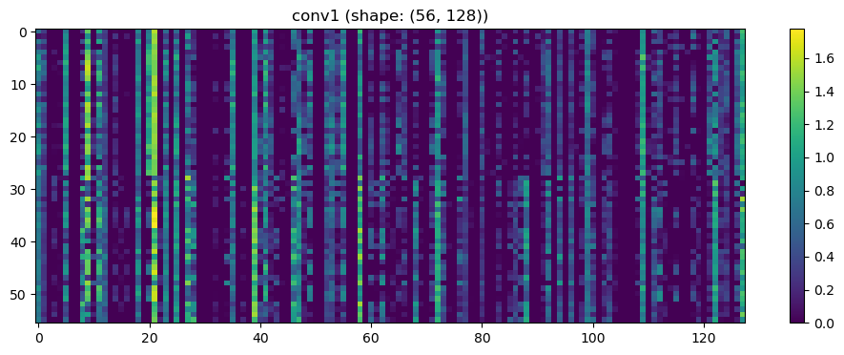

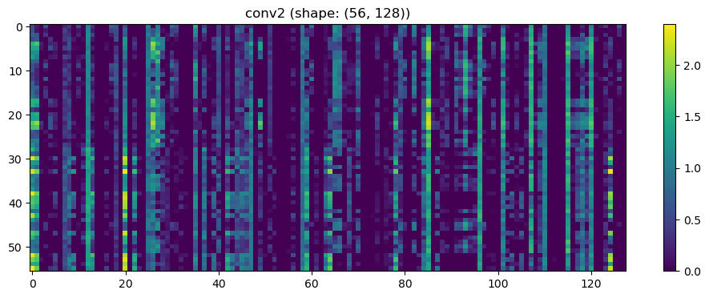

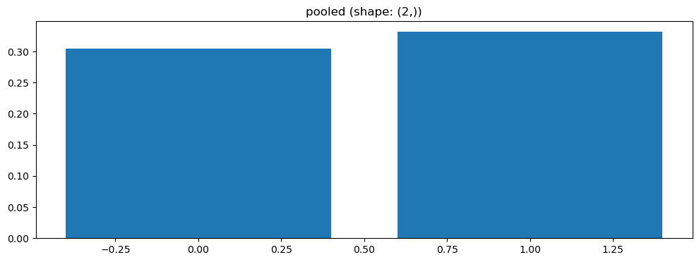

Split 3 Accuracy: 0.4286

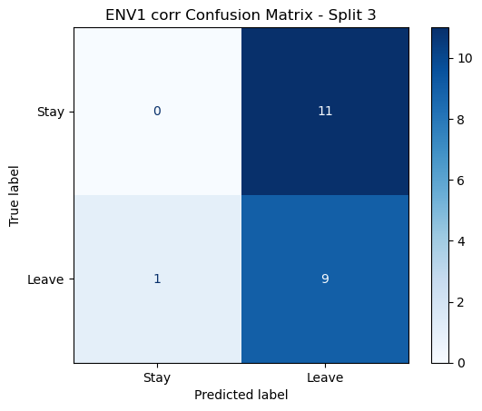

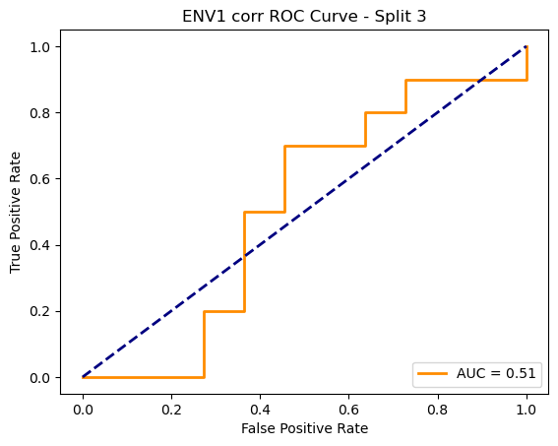

=== ENV1 Split 4/5 ===

After oversampling, class counts: Counter({1: 44, 0: 44})

C:\Users\sansk\miniconda3\Lib\site-packages\torch_geometric\deprecation.py:26: UserWarning: 'data.DataLoader' is deprecated, use 'loader.DataLoader' instead

warnings.warn(out)

Epoch 1/200 | Loss: 0.7103

Epoch 2/200 | Loss: 0.7182

Epoch 3/200 | Loss: 0.6994

Epoch 4/200 | Loss: 0.7784

Epoch 5/200 | Loss: 0.7532

Epoch 6/200 | Loss: 0.7391

Epoch 7/200 | Loss: 0.7313

Epoch 8/200 | Loss: 0.7491

Epoch 9/200 | Loss: 0.7339

Epoch 10/200 | Loss: 0.6851

Epoch 11/200 | Loss: 0.7091

Epoch 12/200 | Loss: 0.7082

Epoch 13/200 | Loss: 0.6930

Epoch 14/200 | Loss: 0.7245

Epoch 15/200 | Loss: 0.6818

Epoch 16/200 | Loss: 0.7261

Epoch 17/200 | Loss: 0.7501

Epoch 18/200 | Loss: 0.8083

Epoch 19/200 | Loss: 0.6654

Epoch 20/200 | Loss: 0.7484

Epoch 21/200 | Loss: 0.7077

Epoch 22/200 | Loss: 0.7246

Epoch 23/200 | Loss: 0.7543

Epoch 24/200 | Loss: 0.6959

Epoch 25/200 | Loss: 0.7412

Epoch 26/200 | Loss: 0.7917

Epoch 27/200 | Loss: 0.7546

Epoch 28/200 | Loss: 0.7842

Epoch 29/200 | Loss: 0.7146

Epoch 30/200 | Loss: 0.7533

Epoch 31/200 | Loss: 0.6943

Epoch 32/200 | Loss: 0.6911

Epoch 33/200 | Loss: 0.7562

Epoch 34/200 | Loss: 0.7032

Epoch 35/200 | Loss: 0.7340

Epoch 36/200 | Loss: 0.7025

Epoch 37/200 | Loss: 0.7219

Epoch 38/200 | Loss: 0.6981

Epoch 39/200 | Loss: 0.6935

Epoch 40/200 | Loss: 0.6288

Epoch 41/200 | Loss: 0.7617

Epoch 42/200 | Loss: 0.6940

Epoch 43/200 | Loss: 0.6893

Epoch 44/200 | Loss: 0.7180

Epoch 45/200 | Loss: 0.6947

Epoch 46/200 | Loss: 0.7076

Epoch 47/200 | Loss: 0.7530

Epoch 48/200 | Loss: 0.6482

Epoch 49/200 | Loss: 0.7868

Epoch 50/200 | Loss: 0.7307

Epoch 51/200 | Loss: 0.7183

Epoch 52/200 | Loss: 0.7463

Epoch 53/200 | Loss: 0.7261

Epoch 54/200 | Loss: 0.6904

Epoch 55/200 | Loss: 0.7521

Epoch 56/200 | Loss: 0.7209

Epoch 57/200 | Loss: 0.7436

Epoch 58/200 | Loss: 0.7505

Epoch 59/200 | Loss: 0.6554

Epoch 60/200 | Loss: 0.6948

Epoch 61/200 | Loss: 0.7236

Epoch 62/200 | Loss: 0.7229

Epoch 63/200 | Loss: 0.7473

Epoch 64/200 | Loss: 0.7445

Epoch 65/200 | Loss: 0.7203

Epoch 66/200 | Loss: 0.7001

Epoch 67/200 | Loss: 0.6920

Epoch 68/200 | Loss: 0.7101

Epoch 69/200 | Loss: 0.6934

Epoch 70/200 | Loss: 0.7231

Epoch 71/200 | Loss: 0.6729

Epoch 72/200 | Loss: 0.7210

Epoch 73/200 | Loss: 0.7598

Epoch 74/200 | Loss: 0.6664

Epoch 75/200 | Loss: 0.6743

Epoch 76/200 | Loss: 0.7220

Epoch 77/200 | Loss: 0.7255

Epoch 78/200 | Loss: 0.6757

Epoch 79/200 | Loss: 0.6956

Epoch 80/200 | Loss: 0.6903

Epoch 81/200 | Loss: 0.7073

Epoch 82/200 | Loss: 0.6610

Epoch 83/200 | Loss: 0.6698

Epoch 84/200 | Loss: 0.6452

Epoch 85/200 | Loss: 0.6966

Epoch 86/200 | Loss: 0.6574

Epoch 87/200 | Loss: 0.6218

Epoch 88/200 | Loss: 0.6874

Epoch 89/200 | Loss: 0.7038

Epoch 90/200 | Loss: 0.6955

Epoch 91/200 | Loss: 0.6665

Epoch 92/200 | Loss: 0.7821

Epoch 93/200 | Loss: 0.7116

Epoch 94/200 | Loss: 0.7488

Epoch 95/200 | Loss: 0.6578

Epoch 96/200 | Loss: 0.6971

Epoch 97/200 | Loss: 0.6662

Epoch 98/200 | Loss: 0.7435

Epoch 99/200 | Loss: 0.7757

Epoch 100/200 | Loss: 0.6499

Epoch 101/200 | Loss: 0.6628

Epoch 102/200 | Loss: 0.7024

Epoch 103/200 | Loss: 0.6842

Epoch 104/200 | Loss: 0.6782

Epoch 105/200 | Loss: 0.7326

Epoch 106/200 | Loss: 0.7416

Epoch 107/200 | Loss: 0.6630

Epoch 108/200 | Loss: 0.7533

Epoch 109/200 | Loss: 0.6885

Epoch 110/200 | Loss: 0.6509

Epoch 111/200 | Loss: 0.6608

Epoch 112/200 | Loss: 0.7367

Epoch 113/200 | Loss: 0.7112

Epoch 114/200 | Loss: 0.6554

Epoch 115/200 | Loss: 0.6902

Epoch 116/200 | Loss: 0.6898

Epoch 117/200 | Loss: 0.6837

Epoch 118/200 | Loss: 0.6487

Epoch 119/200 | Loss: 0.6833

Epoch 120/200 | Loss: 0.6824

Epoch 121/200 | Loss: 0.7081

Epoch 122/200 | Loss: 0.6832

Epoch 123/200 | Loss: 0.7183

Epoch 124/200 | Loss: 0.6770

Epoch 125/200 | Loss: 0.7294

Epoch 126/200 | Loss: 0.7178

Epoch 127/200 | Loss: 0.6756

Epoch 128/200 | Loss: 0.6157

Epoch 129/200 | Loss: 0.7034

Epoch 130/200 | Loss: 0.7405

Epoch 131/200 | Loss: 0.6759

Epoch 132/200 | Loss: 0.6486

Epoch 133/200 | Loss: 0.6537

Epoch 134/200 | Loss: 0.6190

Epoch 135/200 | Loss: 0.6654

Epoch 136/200 | Loss: 0.6853

Epoch 137/200 | Loss: 0.6249

Epoch 138/200 | Loss: 0.6899

Epoch 139/200 | Loss: 0.7119

Epoch 140/200 | Loss: 0.6642

Epoch 141/200 | Loss: 0.7550

Epoch 142/200 | Loss: 0.6600

Epoch 143/200 | Loss: 0.6693

Epoch 144/200 | Loss: 0.6481

Epoch 145/200 | Loss: 0.7057

Epoch 146/200 | Loss: 0.6588

Epoch 147/200 | Loss: 0.6686

Epoch 148/200 | Loss: 0.5998

Epoch 149/200 | Loss: 0.6815

Epoch 150/200 | Loss: 0.7119

Epoch 151/200 | Loss: 0.6788

Epoch 152/200 | Loss: 0.6758

Epoch 153/200 | Loss: 0.6895

Epoch 154/200 | Loss: 0.7119

Epoch 155/200 | Loss: 0.6701

Epoch 156/200 | Loss: 0.7052

Epoch 157/200 | Loss: 0.6846

Epoch 158/200 | Loss: 0.6374

Epoch 159/200 | Loss: 0.6150

Epoch 160/200 | Loss: 0.6570

Epoch 161/200 | Loss: 0.6827

Epoch 162/200 | Loss: 0.6098

Epoch 163/200 | Loss: 0.6520

Epoch 164/200 | Loss: 0.6429

Epoch 165/200 | Loss: 0.6486

Epoch 166/200 | Loss: 0.6581

Epoch 167/200 | Loss: 0.6294

Epoch 168/200 | Loss: 0.6690

Epoch 169/200 | Loss: 0.5982

Epoch 170/200 | Loss: 0.6530

Epoch 171/200 | Loss: 0.6566

Epoch 172/200 | Loss: 0.6024

Epoch 173/200 | Loss: 0.6415

Epoch 174/200 | Loss: 0.7155

Epoch 175/200 | Loss: 0.6902

Epoch 176/200 | Loss: 0.6985

Epoch 177/200 | Loss: 0.6976

Epoch 178/200 | Loss: 0.6535

Epoch 179/200 | Loss: 0.6866

Epoch 180/200 | Loss: 0.7434

Epoch 181/200 | Loss: 0.7124

Epoch 182/200 | Loss: 0.6981

Epoch 183/200 | Loss: 0.6596

Epoch 184/200 | Loss: 0.6914

Epoch 185/200 | Loss: 0.7371

Epoch 186/200 | Loss: 0.7045

Epoch 187/200 | Loss: 0.6645

Epoch 188/200 | Loss: 0.7172

Epoch 189/200 | Loss: 0.6920

Epoch 190/200 | Loss: 0.6246

Epoch 191/200 | Loss: 0.6866

Epoch 192/200 | Loss: 0.6917

Epoch 193/200 | Loss: 0.6836

Epoch 194/200 | Loss: 0.6727

Epoch 195/200 | Loss: 0.6960

Epoch 196/200 | Loss: 0.6411

Epoch 197/200 | Loss: 0.6617

Epoch 198/200 | Loss: 0.6804

Epoch 199/200 | Loss: 0.6514

Epoch 200/200 | Loss: 0.6373

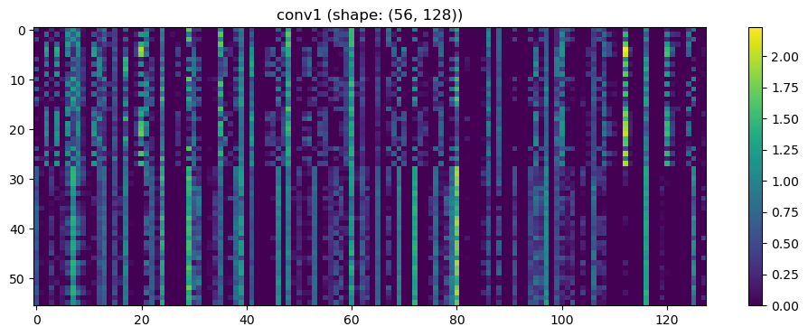

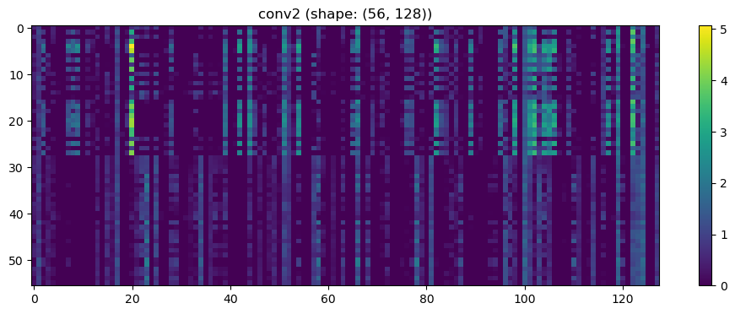

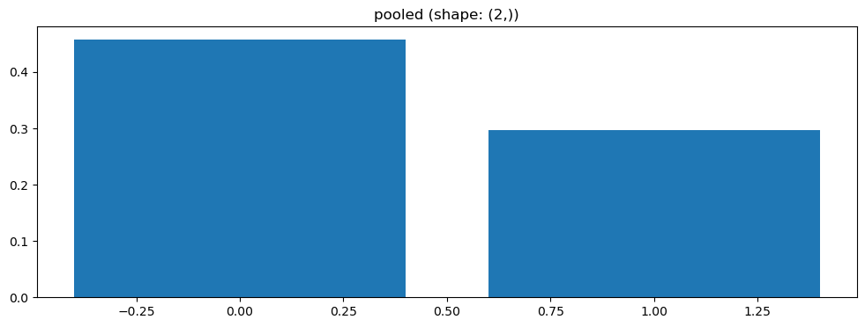

Split 4 Accuracy: 0.5238

After oversampling, class counts: Counter({1: 44, 0: 44})

Epoch 1/200 | Loss: 0.7701

Epoch 2/200 | Loss: 0.7470

Epoch 3/200 | Loss: 0.6983

Epoch 4/200 | Loss: 0.7277

Epoch 5/200 | Loss: 0.7571

Epoch 6/200 | Loss: 0.8269

Epoch 7/200 | Loss: 0.7536

Epoch 8/200 | Loss: 0.6833

Epoch 9/200 | Loss: 0.7805

Epoch 10/200 | Loss: 0.7398

Epoch 11/200 | Loss: 0.7007

Epoch 12/200 | Loss: 0.7109

Epoch 13/200 | Loss: 0.7605

Epoch 14/200 | Loss: 0.7164

Epoch 15/200 | Loss: 0.7767

Epoch 16/200 | Loss: 0.7398

Epoch 17/200 | Loss: 0.7488

Epoch 18/200 | Loss: 0.6857

Epoch 19/200 | Loss: 0.7091

Epoch 20/200 | Loss: 0.7366

Epoch 21/200 | Loss: 0.6919

Epoch 22/200 | Loss: 0.8240

Epoch 23/200 | Loss: 0.6985

Epoch 24/200 | Loss: 0.7197

Epoch 25/200 | Loss: 0.8036

Epoch 26/200 | Loss: 0.7019

Epoch 27/200 | Loss: 0.7138

Epoch 28/200 | Loss: 0.7216

Epoch 29/200 | Loss: 0.7580

Epoch 30/200 | Loss: 0.6607

Epoch 31/200 | Loss: 0.6858

Epoch 32/200 | Loss: 0.7231

Epoch 33/200 | Loss: 0.8705

Epoch 34/200 | Loss: 0.6810

Epoch 35/200 | Loss: 0.7006

Epoch 36/200 | Loss: 0.7370

Epoch 37/200 | Loss: 0.6594

Epoch 38/200 | Loss: 0.6843

Epoch 39/200 | Loss: 0.6480

Epoch 40/200 | Loss: 0.6667

Epoch 41/200 | Loss: 0.7643

Epoch 42/200 | Loss: 0.7711

Epoch 43/200 | Loss: 0.7425

Epoch 44/200 | Loss: 0.6945

Epoch 45/200 | Loss: 0.7003

Epoch 46/200 | Loss: 0.7143

Epoch 47/200 | Loss: 0.6978

Epoch 48/200 | Loss: 0.7481

Epoch 49/200 | Loss: 0.7574

Epoch 50/200 | Loss: 0.6926

Epoch 51/200 | Loss: 0.6765

Epoch 52/200 | Loss: 0.7210

Epoch 53/200 | Loss: 0.7168

Epoch 54/200 | Loss: 0.6725

Epoch 55/200 | Loss: 0.6973

Epoch 56/200 | Loss: 0.7387

Epoch 57/200 | Loss: 0.7218

Epoch 58/200 | Loss: 0.6343

Epoch 59/200 | Loss: 0.7240

Epoch 60/200 | Loss: 0.7381

Epoch 61/200 | Loss: 0.7052

Epoch 62/200 | Loss: 0.7658

Epoch 63/200 | Loss: 0.7373

Epoch 64/200 | Loss: 0.7431

Epoch 65/200 | Loss: 0.7379

Epoch 66/200 | Loss: 0.7231

Epoch 67/200 | Loss: 0.7418

Epoch 68/200 | Loss: 0.6597

Epoch 69/200 | Loss: 0.7414

Epoch 70/200 | Loss: 0.7050

Epoch 71/200 | Loss: 0.7679

Epoch 72/200 | Loss: 0.6826

Epoch 73/200 | Loss: 0.6925

Epoch 74/200 | Loss: 0.6788

Epoch 75/200 | Loss: 0.6974

Epoch 76/200 | Loss: 0.7017

Epoch 77/200 | Loss: 0.6750

Epoch 78/200 | Loss: 0.7115

Epoch 79/200 | Loss: 0.7198

Epoch 80/200 | Loss: 0.6797

Epoch 81/200 | Loss: 0.7290

Epoch 82/200 | Loss: 0.6640

Epoch 83/200 | Loss: 0.6816

Epoch 84/200 | Loss: 0.6855

Epoch 85/200 | Loss: 0.7278

Epoch 86/200 | Loss: 0.6541

Epoch 87/200 | Loss: 0.7222

Epoch 88/200 | Loss: 0.7156

Epoch 89/200 | Loss: 0.7166

Epoch 90/200 | Loss: 0.7511

Epoch 91/200 | Loss: 0.7215

Epoch 92/200 | Loss: 0.6647

Epoch 93/200 | Loss: 0.6155

Epoch 94/200 | Loss: 0.6665

Epoch 95/200 | Loss: 0.6800

Epoch 96/200 | Loss: 0.6685

Epoch 97/200 | Loss: 0.7245

Epoch 98/200 | Loss: 0.7483

Epoch 99/200 | Loss: 0.6178

Epoch 100/200 | Loss: 0.7212

Epoch 101/200 | Loss: 0.7308

Epoch 102/200 | Loss: 0.6966

Epoch 103/200 | Loss: 0.6391

Epoch 104/200 | Loss: 0.7086

Epoch 105/200 | Loss: 0.7010

Epoch 106/200 | Loss: 0.6935

Epoch 107/200 | Loss: 0.6991

Epoch 108/200 | Loss: 0.6622

Epoch 109/200 | Loss: 0.6545

Epoch 110/200 | Loss: 0.7073

Epoch 111/200 | Loss: 0.7096

Epoch 112/200 | Loss: 0.6832

Epoch 113/200 | Loss: 0.6945

Epoch 114/200 | Loss: 0.7281

Epoch 115/200 | Loss: 0.6291

Epoch 116/200 | Loss: 0.7038

Epoch 117/200 | Loss: 0.6787

Epoch 118/200 | Loss: 0.7490

Epoch 119/200 | Loss: 0.6275

Epoch 120/200 | Loss: 0.6819

Epoch 121/200 | Loss: 0.6553

Epoch 122/200 | Loss: 0.6696

Epoch 123/200 | Loss: 0.6229

Epoch 124/200 | Loss: 0.6305

Epoch 125/200 | Loss: 0.6695

Epoch 126/200 | Loss: 0.6337

Epoch 127/200 | Loss: 0.6499

Epoch 128/200 | Loss: 0.7403

Epoch 129/200 | Loss: 0.6887

Epoch 130/200 | Loss: 0.6296

Epoch 131/200 | Loss: 0.7020

Epoch 132/200 | Loss: 0.6959

Epoch 133/200 | Loss: 0.6314

Epoch 134/200 | Loss: 0.6599

Epoch 135/200 | Loss: 0.6423

Epoch 136/200 | Loss: 0.6580

Epoch 137/200 | Loss: 0.6835

Epoch 138/200 | Loss: 0.7432

Epoch 139/200 | Loss: 0.6931

Epoch 140/200 | Loss: 0.6211

Epoch 141/200 | Loss: 0.6310

Epoch 142/200 | Loss: 0.7053

Epoch 143/200 | Loss: 0.7104

Epoch 144/200 | Loss: 0.7340

Epoch 145/200 | Loss: 0.6884

Epoch 146/200 | Loss: 0.7039

Epoch 147/200 | Loss: 0.6591

Epoch 148/200 | Loss: 0.6745

Epoch 149/200 | Loss: 0.6837

Epoch 150/200 | Loss: 0.6805

Epoch 151/200 | Loss: 0.6990

Epoch 152/200 | Loss: 0.6596

Epoch 153/200 | Loss: 0.6704

Epoch 154/200 | Loss: 0.6316

Epoch 155/200 | Loss: 0.6388

Epoch 156/200 | Loss: 0.7162

Epoch 157/200 | Loss: 0.6192

Epoch 158/200 | Loss: 0.6505

Epoch 159/200 | Loss: 0.7092

Epoch 160/200 | Loss: 0.6868

Epoch 161/200 | Loss: 0.6482

Epoch 162/200 | Loss: 0.6547

Epoch 163/200 | Loss: 0.6572

Epoch 164/200 | Loss: 0.6136

Epoch 165/200 | Loss: 0.6990

Epoch 166/200 | Loss: 0.6806

Epoch 167/200 | Loss: 0.6744

Epoch 168/200 | Loss: 0.5784

Epoch 169/200 | Loss: 0.7176

Epoch 170/200 | Loss: 0.7015

Epoch 171/200 | Loss: 0.6654

Epoch 172/200 | Loss: 0.6405

Epoch 173/200 | Loss: 0.6911

Epoch 174/200 | Loss: 0.6260

Epoch 175/200 | Loss: 0.6502

Epoch 176/200 | Loss: 0.6234

Epoch 177/200 | Loss: 0.6696

Epoch 178/200 | Loss: 0.6636

Epoch 179/200 | Loss: 0.6624

Epoch 180/200 | Loss: 0.6728

Epoch 181/200 | Loss: 0.6810

Epoch 182/200 | Loss: 0.6906

Epoch 183/200 | Loss: 0.6232

Epoch 184/200 | Loss: 0.6276

Epoch 185/200 | Loss: 0.6489

Epoch 186/200 | Loss: 0.6422

Epoch 187/200 | Loss: 0.6595

Epoch 188/200 | Loss: 0.7133

Epoch 189/200 | Loss: 0.5934

Epoch 190/200 | Loss: 0.7055

Epoch 191/200 | Loss: 0.7501

Epoch 192/200 | Loss: 0.6406

Epoch 193/200 | Loss: 0.6496

Epoch 194/200 | Loss: 0.6635

Epoch 195/200 | Loss: 0.7018

Epoch 196/200 | Loss: 0.6757

Epoch 197/200 | Loss: 0.6647

Epoch 198/200 | Loss: 0.5427

Epoch 199/200 | Loss: 0.6631

Epoch 200/200 | Loss: 0.6594

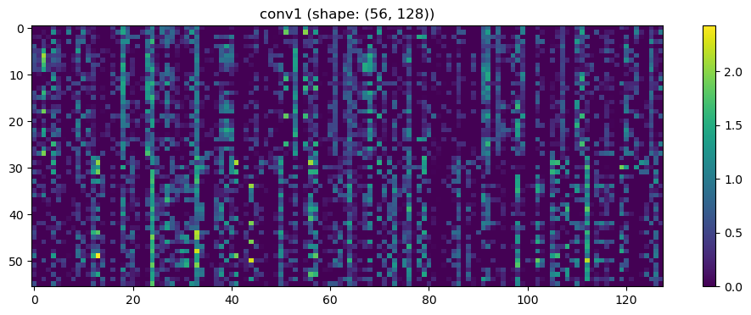

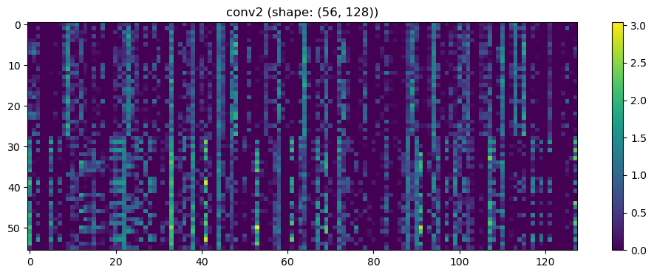

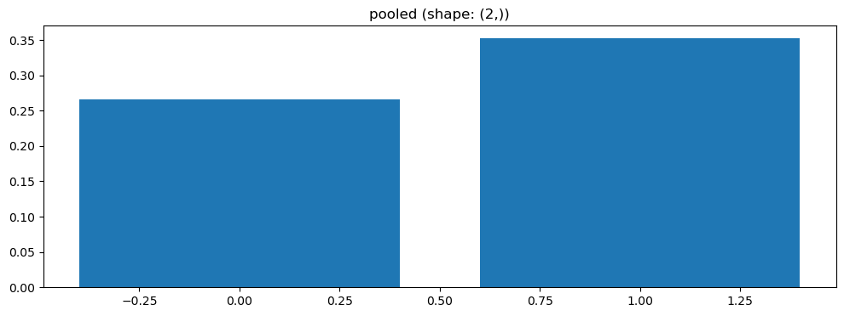

Split 5 Accuracy: 0.5238

ENV1 corr Average Accuracy: 0.4913 ± 0.0620

Running GNN with coh connectivity for ENV1...

Training GNN for ENV1 with coh connectivity

=== ENV1 Split 1/5 ===

C:\Users\sansk\miniconda3\Lib\site-packages\scipy\signal\_spectral_py.py:1668: RuntimeWarning: invalid value encountered in divide

Cxy = np.abs(Pxy)**2 / Pxx / Pyy

After oversampling, class counts: Counter({0: 43, 1: 43})

Epoch 1/200 | Loss: 0.7844

Epoch 2/200 | Loss: 0.7948

Epoch 3/200 | Loss: 0.8019

Epoch 4/200 | Loss: 0.8006

Epoch 5/200 | Loss: 0.6844

Epoch 6/200 | Loss: 0.7233

Epoch 7/200 | Loss: 0.7467

Epoch 8/200 | Loss: 0.7898

Epoch 9/200 | Loss: 0.7628

Epoch 10/200 | Loss: 0.8124

Epoch 11/200 | Loss: 0.7440

Epoch 12/200 | Loss: 0.7889

Epoch 13/200 | Loss: 0.7345

Epoch 14/200 | Loss: 0.8571

Epoch 15/200 | Loss: 0.7200

Epoch 16/200 | Loss: 0.7040

Epoch 17/200 | Loss: 0.8337

Epoch 18/200 | Loss: 0.7333

Epoch 19/200 | Loss: 0.7162

Epoch 20/200 | Loss: 0.7789

Epoch 21/200 | Loss: 0.7112

Epoch 22/200 | Loss: 0.7646

Epoch 23/200 | Loss: 0.7885

Epoch 24/200 | Loss: 0.7916

Epoch 25/200 | Loss: 0.7780

Epoch 26/200 | Loss: 0.7151

Epoch 27/200 | Loss: 0.7703

Epoch 28/200 | Loss: 0.7586

Epoch 29/200 | Loss: 0.6899

Epoch 30/200 | Loss: 0.7919

Epoch 31/200 | Loss: 0.7874

Epoch 32/200 | Loss: 0.8139

Epoch 33/200 | Loss: 0.7481

Epoch 34/200 | Loss: 0.6866

Epoch 35/200 | Loss: 0.7576

Epoch 36/200 | Loss: 0.7929

Epoch 37/200 | Loss: 0.8305

Epoch 38/200 | Loss: 0.7525

Epoch 39/200 | Loss: 0.7253

Epoch 40/200 | Loss: 0.7354

Epoch 41/200 | Loss: 0.8406

Epoch 42/200 | Loss: 0.6645

Epoch 43/200 | Loss: 0.7461

Epoch 44/200 | Loss: 0.8034

Epoch 45/200 | Loss: 0.7448

Epoch 46/200 | Loss: 0.7794

Epoch 47/200 | Loss: 0.7290

Epoch 48/200 | Loss: 0.7547

Epoch 49/200 | Loss: 0.6998

Epoch 50/200 | Loss: 0.6967

Epoch 51/200 | Loss: 0.7359

Epoch 52/200 | Loss: 0.7230

Epoch 53/200 | Loss: 0.6847

Epoch 54/200 | Loss: 0.7320

Epoch 55/200 | Loss: 0.8101

Epoch 56/200 | Loss: 0.7609

Epoch 57/200 | Loss: 0.7202

Epoch 58/200 | Loss: 0.7803

Epoch 59/200 | Loss: 0.7843

Epoch 60/200 | Loss: 0.7111

Epoch 61/200 | Loss: 0.7367

Epoch 62/200 | Loss: 0.7017

Epoch 63/200 | Loss: 0.7167

Epoch 64/200 | Loss: 0.7795

Epoch 65/200 | Loss: 0.7567

Epoch 66/200 | Loss: 0.7065

Epoch 67/200 | Loss: 0.7918

Epoch 68/200 | Loss: 0.7403

Epoch 69/200 | Loss: 0.6969

Epoch 70/200 | Loss: 0.6870

Epoch 71/200 | Loss: 0.7299

Epoch 72/200 | Loss: 0.7761

Epoch 73/200 | Loss: 0.7141

Epoch 74/200 | Loss: 0.7342

Epoch 75/200 | Loss: 0.7097

Epoch 76/200 | Loss: 0.7559

Epoch 77/200 | Loss: 0.7136

Epoch 78/200 | Loss: 0.7672

Epoch 79/200 | Loss: 0.7147

Epoch 80/200 | Loss: 0.7408

Epoch 81/200 | Loss: 0.6525

Epoch 82/200 | Loss: 0.7486

Epoch 83/200 | Loss: 0.7415

Epoch 84/200 | Loss: 0.6988

Epoch 85/200 | Loss: 0.7531

Epoch 86/200 | Loss: 0.7814

Epoch 87/200 | Loss: 0.7170

Epoch 88/200 | Loss: 0.7248

Epoch 89/200 | Loss: 0.7467

Epoch 90/200 | Loss: 0.6811

Epoch 91/200 | Loss: 0.7712

Epoch 92/200 | Loss: 0.7278

Epoch 93/200 | Loss: 0.7714

Epoch 94/200 | Loss: 0.6909

Epoch 95/200 | Loss: 0.7205

Epoch 96/200 | Loss: 0.7507

Epoch 97/200 | Loss: 0.6869

Epoch 98/200 | Loss: 0.7623

Epoch 99/200 | Loss: 0.7141

Epoch 100/200 | Loss: 0.7943

Epoch 101/200 | Loss: 0.7052

Epoch 102/200 | Loss: 0.7204

Epoch 103/200 | Loss: 0.6384

Epoch 104/200 | Loss: 0.6856

Epoch 105/200 | Loss: 0.8093

Epoch 106/200 | Loss: 0.7377

Epoch 107/200 | Loss: 0.7284

Epoch 108/200 | Loss: 0.7011

Epoch 109/200 | Loss: 0.7321

Epoch 110/200 | Loss: 0.7644

Epoch 111/200 | Loss: 0.7951

Epoch 112/200 | Loss: 0.7269

Epoch 113/200 | Loss: 0.7447

Epoch 114/200 | Loss: 0.6863

Epoch 115/200 | Loss: 0.7946

Epoch 116/200 | Loss: 0.6865

Epoch 117/200 | Loss: 0.7944

Epoch 118/200 | Loss: 0.7697

Epoch 119/200 | Loss: 0.7597

Epoch 120/200 | Loss: 0.7074

Epoch 121/200 | Loss: 0.7678

Epoch 122/200 | Loss: 0.7367

Epoch 123/200 | Loss: 0.7170

Epoch 124/200 | Loss: 0.7453

Epoch 125/200 | Loss: 0.7048

Epoch 126/200 | Loss: 0.7636

Epoch 127/200 | Loss: 0.7465

Epoch 128/200 | Loss: 0.6270

Epoch 129/200 | Loss: 0.7266

Epoch 130/200 | Loss: 0.6382

Epoch 131/200 | Loss: 0.8127

Epoch 132/200 | Loss: 0.6778

Epoch 133/200 | Loss: 0.7286

Epoch 134/200 | Loss: 0.7517

Epoch 135/200 | Loss: 0.7531

Epoch 136/200 | Loss: 0.7654

Epoch 137/200 | Loss: 0.7865

Epoch 138/200 | Loss: 0.7355

Epoch 139/200 | Loss: 0.7225

Epoch 140/200 | Loss: 0.7320

Epoch 141/200 | Loss: 0.7514

Epoch 142/200 | Loss: 0.8305

Epoch 143/200 | Loss: 0.7156

Epoch 144/200 | Loss: 0.6837

Epoch 145/200 | Loss: 0.7194

Epoch 146/200 | Loss: 0.7515

Epoch 147/200 | Loss: 0.7539

Epoch 148/200 | Loss: 0.7298

Epoch 149/200 | Loss: 0.7652

Epoch 150/200 | Loss: 0.7182

Epoch 151/200 | Loss: 0.7567

Epoch 152/200 | Loss: 0.7339

Epoch 153/200 | Loss: 0.7016

Epoch 154/200 | Loss: 0.6878

Epoch 155/200 | Loss: 0.7203

Epoch 156/200 | Loss: 0.6891

Epoch 157/200 | Loss: 0.7389

Epoch 158/200 | Loss: 0.7050

Epoch 159/200 | Loss: 0.7042

Epoch 160/200 | Loss: 0.7322

Epoch 161/200 | Loss: 0.7314

Epoch 162/200 | Loss: 0.6892

Epoch 163/200 | Loss: 0.6935

Epoch 164/200 | Loss: 0.7495

Epoch 165/200 | Loss: 0.7642

Epoch 166/200 | Loss: 0.7212

Epoch 167/200 | Loss: 0.7221

Epoch 168/200 | Loss: 0.6975

Epoch 169/200 | Loss: 0.6804

Epoch 170/200 | Loss: 0.7512

Epoch 171/200 | Loss: 0.6813

Epoch 172/200 | Loss: 0.6777

Epoch 173/200 | Loss: 0.7030

Epoch 174/200 | Loss: 0.6912

Epoch 175/200 | Loss: 0.6735

Epoch 176/200 | Loss: 0.7627

Epoch 177/200 | Loss: 0.7275

Epoch 178/200 | Loss: 0.6624

Epoch 179/200 | Loss: 0.7464

Epoch 180/200 | Loss: 0.7021

Epoch 181/200 | Loss: 0.7136

Epoch 182/200 | Loss: 0.7440

Epoch 183/200 | Loss: 0.7210

Epoch 184/200 | Loss: 0.7465

Epoch 185/200 | Loss: 0.7386

Epoch 186/200 | Loss: 0.8122

Epoch 187/200 | Loss: 0.7380

Epoch 188/200 | Loss: 0.7162

Epoch 189/200 | Loss: 0.7097

Epoch 190/200 | Loss: 0.7353

Epoch 191/200 | Loss: 0.6911

Epoch 192/200 | Loss: 0.7513

Epoch 193/200 | Loss: 0.6567

Epoch 194/200 | Loss: 0.6771

Epoch 195/200 | Loss: 0.7014

Epoch 196/200 | Loss: 0.6585

Epoch 197/200 | Loss: 0.7571

Epoch 198/200 | Loss: 0.7252

Epoch 199/200 | Loss: 0.7171

Epoch 200/200 | Loss: 0.7037

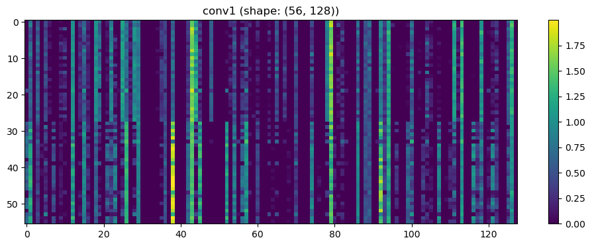

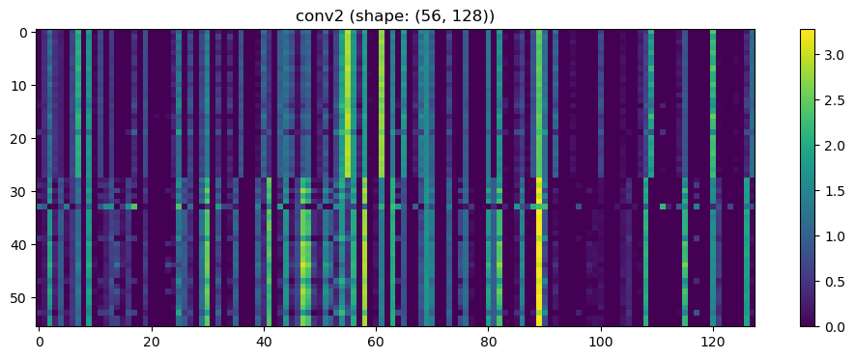

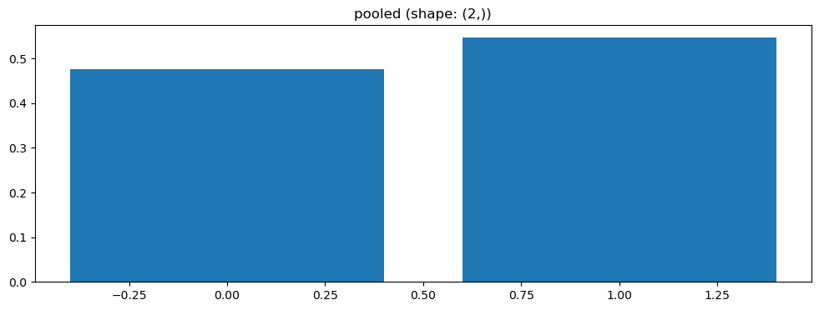

Split 1 Accuracy: 0.5000

=== ENV1 Split 2/5 ===

C:\Users\sansk\miniconda3\Lib\site-packages\scipy\signal\_spectral_py.py:1668: RuntimeWarning: invalid value encountered in divide

Cxy = np.abs(Pxy)**2 / Pxx / Pyy

After oversampling, class counts: Counter({1: 43, 0: 43})

Epoch 1/200 | Loss: 0.7461

Epoch 2/200 | Loss: 0.7600

Epoch 3/200 | Loss: 0.7266

Epoch 4/200 | Loss: 0.7605

Epoch 5/200 | Loss: 0.7425

Epoch 6/200 | Loss: 0.8236

Epoch 7/200 | Loss: 0.8093

Epoch 8/200 | Loss: 0.7526

Epoch 9/200 | Loss: 0.7818

Epoch 10/200 | Loss: 0.6965

Epoch 11/200 | Loss: 0.7968

Epoch 12/200 | Loss: 0.7440

Epoch 13/200 | Loss: 0.7924

Epoch 14/200 | Loss: 0.7555

Epoch 15/200 | Loss: 0.7271

Epoch 16/200 | Loss: 0.7347

Epoch 17/200 | Loss: 0.7795

Epoch 18/200 | Loss: 0.7078

Epoch 19/200 | Loss: 0.8577

Epoch 20/200 | Loss: 0.6579

Epoch 21/200 | Loss: 0.7453

Epoch 22/200 | Loss: 0.8005

Epoch 23/200 | Loss: 0.7247

Epoch 24/200 | Loss: 0.7210

Epoch 25/200 | Loss: 0.7202

Epoch 26/200 | Loss: 0.7022

Epoch 27/200 | Loss: 0.7336

Epoch 28/200 | Loss: 0.7929

Epoch 29/200 | Loss: 0.8378

Epoch 30/200 | Loss: 0.7355

Epoch 31/200 | Loss: 0.7432

Epoch 32/200 | Loss: 0.7276

Epoch 33/200 | Loss: 0.7530

Epoch 34/200 | Loss: 0.7404

Epoch 35/200 | Loss: 0.7083

Epoch 36/200 | Loss: 0.7552

Epoch 37/200 | Loss: 0.7537

Epoch 38/200 | Loss: 0.7479

Epoch 39/200 | Loss: 0.7244

Epoch 40/200 | Loss: 0.7398

Epoch 41/200 | Loss: 0.7264

Epoch 42/200 | Loss: 0.7170

Epoch 43/200 | Loss: 0.6864

Epoch 44/200 | Loss: 0.7040

Epoch 45/200 | Loss: 0.7490

Epoch 46/200 | Loss: 0.6825

Epoch 47/200 | Loss: 0.7523

Epoch 48/200 | Loss: 0.6810

Epoch 49/200 | Loss: 0.7566

Epoch 50/200 | Loss: 0.7177

Epoch 51/200 | Loss: 0.7066

Epoch 52/200 | Loss: 0.7567

Epoch 53/200 | Loss: 0.7067

Epoch 54/200 | Loss: 0.7161

Epoch 55/200 | Loss: 0.7884

Epoch 56/200 | Loss: 0.7579

Epoch 57/200 | Loss: 0.7856

Epoch 58/200 | Loss: 0.6854

Epoch 59/200 | Loss: 0.6822

Epoch 60/200 | Loss: 0.7660

Epoch 61/200 | Loss: 0.7059

Epoch 62/200 | Loss: 0.7372

Epoch 63/200 | Loss: 0.7198

Epoch 64/200 | Loss: 0.7618

Epoch 65/200 | Loss: 0.7172

Epoch 66/200 | Loss: 0.7172

Epoch 67/200 | Loss: 0.6937

Epoch 68/200 | Loss: 0.7776

Epoch 69/200 | Loss: 0.6821

Epoch 70/200 | Loss: 0.7363

Epoch 71/200 | Loss: 0.7346

Epoch 72/200 | Loss: 0.6995

Epoch 73/200 | Loss: 0.7341

Epoch 74/200 | Loss: 0.7419

Epoch 75/200 | Loss: 0.7594

Epoch 76/200 | Loss: 0.7400

Epoch 77/200 | Loss: 0.8100

Epoch 78/200 | Loss: 0.7131

Epoch 79/200 | Loss: 0.7517

Epoch 80/200 | Loss: 0.7639

Epoch 81/200 | Loss: 0.7834

Epoch 82/200 | Loss: 0.7539

Epoch 83/200 | Loss: 0.7890

Epoch 84/200 | Loss: 0.7006

Epoch 85/200 | Loss: 0.7379

Epoch 86/200 | Loss: 0.7362

Epoch 87/200 | Loss: 0.7275

Epoch 88/200 | Loss: 0.7228

Epoch 89/200 | Loss: 0.7566

Epoch 90/200 | Loss: 0.7703

Epoch 91/200 | Loss: 0.7239

Epoch 92/200 | Loss: 0.7821

Epoch 93/200 | Loss: 0.7651

Epoch 94/200 | Loss: 0.6901

Epoch 95/200 | Loss: 0.6929

Epoch 96/200 | Loss: 0.7060

Epoch 97/200 | Loss: 0.7685

Epoch 98/200 | Loss: 0.7218

Epoch 99/200 | Loss: 0.7015

Epoch 100/200 | Loss: 0.7045

Epoch 101/200 | Loss: 0.7159

Epoch 102/200 | Loss: 0.7297

Epoch 103/200 | Loss: 0.6797

Epoch 104/200 | Loss: 0.7625

Epoch 105/200 | Loss: 0.7340

Epoch 106/200 | Loss: 0.7253

Epoch 107/200 | Loss: 0.7437

Epoch 108/200 | Loss: 0.7210

Epoch 109/200 | Loss: 0.7207

Epoch 110/200 | Loss: 0.7259

Epoch 111/200 | Loss: 0.7037

Epoch 112/200 | Loss: 0.7148

Epoch 113/200 | Loss: 0.7519

Epoch 114/200 | Loss: 0.7003

Epoch 115/200 | Loss: 0.6913

Epoch 116/200 | Loss: 0.7088

Epoch 117/200 | Loss: 0.7657

Epoch 118/200 | Loss: 0.6927

Epoch 119/200 | Loss: 0.7003

Epoch 120/200 | Loss: 0.7573

Epoch 121/200 | Loss: 0.6975

Epoch 122/200 | Loss: 0.7375

Epoch 123/200 | Loss: 0.7339

Epoch 124/200 | Loss: 0.7243

Epoch 125/200 | Loss: 0.7059

Epoch 126/200 | Loss: 0.7964

Epoch 127/200 | Loss: 0.7002

Epoch 128/200 | Loss: 0.7711

Epoch 129/200 | Loss: 0.7577

Epoch 130/200 | Loss: 0.7382

Epoch 131/200 | Loss: 0.7333

Epoch 132/200 | Loss: 0.7643

Epoch 133/200 | Loss: 0.6742

Epoch 134/200 | Loss: 0.7066

Epoch 135/200 | Loss: 0.7582

Epoch 136/200 | Loss: 0.7177

Epoch 137/200 | Loss: 0.7527

Epoch 138/200 | Loss: 0.7908

Epoch 139/200 | Loss: 0.7075

Epoch 140/200 | Loss: 0.6598

Epoch 141/200 | Loss: 0.7036

Epoch 142/200 | Loss: 0.7049

Epoch 143/200 | Loss: 0.7929

Epoch 144/200 | Loss: 0.7154

Epoch 145/200 | Loss: 0.7228

Epoch 146/200 | Loss: 0.7022

Epoch 147/200 | Loss: 0.7073

Epoch 148/200 | Loss: 0.7098

Epoch 149/200 | Loss: 0.6998

Epoch 150/200 | Loss: 0.7381

Epoch 151/200 | Loss: 0.6908

Epoch 152/200 | Loss: 0.7290

Epoch 153/200 | Loss: 0.6907

Epoch 154/200 | Loss: 0.7179

Epoch 155/200 | Loss: 0.7472

Epoch 156/200 | Loss: 0.7403

Epoch 157/200 | Loss: 0.7315

Epoch 158/200 | Loss: 0.7578

Epoch 159/200 | Loss: 0.7326

Epoch 160/200 | Loss: 0.7423

Epoch 161/200 | Loss: 0.6902

Epoch 162/200 | Loss: 0.7037

Epoch 163/200 | Loss: 0.7049

Epoch 164/200 | Loss: 0.6918

Epoch 165/200 | Loss: 0.6552

Epoch 166/200 | Loss: 0.7031

Epoch 167/200 | Loss: 0.7188

Epoch 168/200 | Loss: 0.6601

Epoch 169/200 | Loss: 0.7193

Epoch 170/200 | Loss: 0.7555

Epoch 171/200 | Loss: 0.7199

Epoch 172/200 | Loss: 0.7117

Epoch 173/200 | Loss: 0.7481

Epoch 174/200 | Loss: 0.7308

Epoch 175/200 | Loss: 0.6339

Epoch 176/200 | Loss: 0.7377

Epoch 177/200 | Loss: 0.7171

Epoch 178/200 | Loss: 0.7079

Epoch 179/200 | Loss: 0.7340

Epoch 180/200 | Loss: 0.6718

Epoch 181/200 | Loss: 0.7224

Epoch 182/200 | Loss: 0.7267

Epoch 183/200 | Loss: 0.7049

Epoch 184/200 | Loss: 0.6945

Epoch 185/200 | Loss: 0.6915

Epoch 186/200 | Loss: 0.7382

Epoch 187/200 | Loss: 0.7435

Epoch 188/200 | Loss: 0.7104

Epoch 189/200 | Loss: 0.7132

Epoch 190/200 | Loss: 0.7287

Epoch 191/200 | Loss: 0.7109

Epoch 192/200 | Loss: 0.7591

Epoch 193/200 | Loss: 0.7474

Epoch 194/200 | Loss: 0.7321

Epoch 195/200 | Loss: 0.7360

Epoch 196/200 | Loss: 0.7447

Epoch 197/200 | Loss: 0.6719

Epoch 198/200 | Loss: 0.7162

Epoch 199/200 | Loss: 0.7029

Epoch 200/200 | Loss: 0.6955

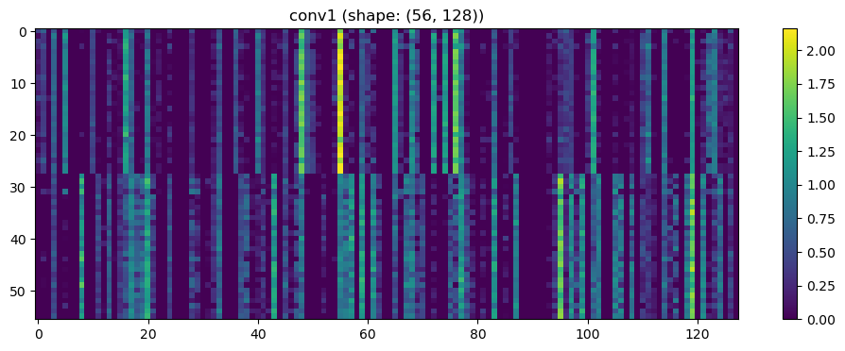

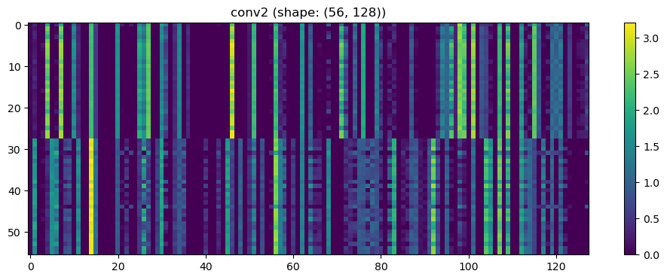

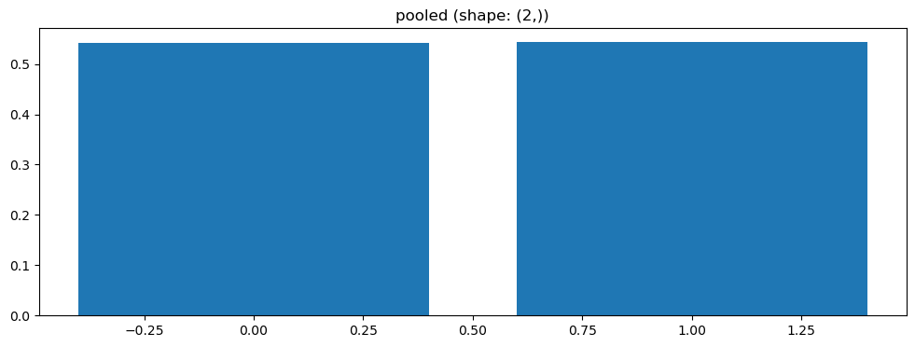

=== ENV1 Split 3/5 ===

C:\Users\sansk\miniconda3\Lib\site-packages\scipy\signal\_spectral_py.py:1668: RuntimeWarning: invalid value encountered in divide

Cxy = np.abs(Pxy)**2 / Pxx / Pyy

After oversampling, class counts: Counter({1: 43, 0: 43})

Epoch 1/200 | Loss: 0.7910

Epoch 2/200 | Loss: 0.7552

Epoch 3/200 | Loss: 0.7883

Epoch 4/200 | Loss: 0.8024

Epoch 5/200 | Loss: 0.7607

Epoch 6/200 | Loss: 0.7652

Epoch 7/200 | Loss: 0.8098

Epoch 8/200 | Loss: 0.7878

Epoch 9/200 | Loss: 0.7870

Epoch 10/200 | Loss: 0.7629

Epoch 11/200 | Loss: 0.8078

Epoch 12/200 | Loss: 0.7649

Epoch 13/200 | Loss: 0.7843

Epoch 14/200 | Loss: 0.8289

Epoch 15/200 | Loss: 0.9120

Epoch 16/200 | Loss: 0.8880

Epoch 17/200 | Loss: 0.8044

Epoch 18/200 | Loss: 0.7255

Epoch 19/200 | Loss: 0.7262

Epoch 20/200 | Loss: 0.7996

Epoch 21/200 | Loss: 0.7717

Epoch 22/200 | Loss: 0.7643

Epoch 23/200 | Loss: 0.6760

Epoch 24/200 | Loss: 0.8356

Epoch 25/200 | Loss: 0.7460

Epoch 26/200 | Loss: 0.7987

Epoch 27/200 | Loss: 0.7628

Epoch 28/200 | Loss: 0.7765

Epoch 29/200 | Loss: 0.7684

Epoch 30/200 | Loss: 0.7066

Epoch 31/200 | Loss: 0.7790

Epoch 32/200 | Loss: 0.8084

Epoch 33/200 | Loss: 0.8276

Epoch 34/200 | Loss: 0.7420

Epoch 35/200 | Loss: 0.7784

Epoch 36/200 | Loss: 0.8001

Epoch 37/200 | Loss: 0.7748

Epoch 38/200 | Loss: 0.8193

Epoch 39/200 | Loss: 0.7825

Epoch 40/200 | Loss: 0.7991

Epoch 41/200 | Loss: 0.8342

Epoch 42/200 | Loss: 0.6981

Epoch 43/200 | Loss: 0.8412

Epoch 44/200 | Loss: 0.7694

Epoch 45/200 | Loss: 0.7745

Epoch 46/200 | Loss: 0.7025

Epoch 47/200 | Loss: 0.7440

Epoch 48/200 | Loss: 0.7862

Epoch 49/200 | Loss: 0.7055

Epoch 50/200 | Loss: 0.7619

Epoch 51/200 | Loss: 0.7711

Epoch 52/200 | Loss: 0.8009

Epoch 53/200 | Loss: 0.8094

Epoch 54/200 | Loss: 0.7457

Epoch 55/200 | Loss: 0.7034

Epoch 56/200 | Loss: 0.7269

Epoch 57/200 | Loss: 0.7220

Epoch 58/200 | Loss: 0.7438

Epoch 59/200 | Loss: 0.7694

Epoch 60/200 | Loss: 0.7241

Epoch 61/200 | Loss: 0.7203

Epoch 62/200 | Loss: 0.6992

Epoch 63/200 | Loss: 0.7375

Epoch 64/200 | Loss: 0.7256

Epoch 65/200 | Loss: 0.7954

Epoch 66/200 | Loss: 0.7271

Epoch 67/200 | Loss: 0.7109

Epoch 68/200 | Loss: 0.7284

Epoch 69/200 | Loss: 0.7498

Epoch 70/200 | Loss: 0.7542

Epoch 71/200 | Loss: 0.7583

Epoch 72/200 | Loss: 0.7461

Epoch 73/200 | Loss: 0.7024

Epoch 74/200 | Loss: 0.7410

Epoch 75/200 | Loss: 0.7108

Epoch 76/200 | Loss: 0.7098

Epoch 77/200 | Loss: 0.7056

Epoch 78/200 | Loss: 0.7366

Epoch 79/200 | Loss: 0.7244

Epoch 80/200 | Loss: 0.6843

Epoch 81/200 | Loss: 0.7349

Epoch 82/200 | Loss: 0.7533

Epoch 83/200 | Loss: 0.7289

Epoch 84/200 | Loss: 0.7094

Epoch 85/200 | Loss: 0.7266

Epoch 86/200 | Loss: 0.7539

Epoch 87/200 | Loss: 0.7459

Epoch 88/200 | Loss: 0.7679

Epoch 89/200 | Loss: 0.7246

Epoch 90/200 | Loss: 0.6947

Epoch 91/200 | Loss: 0.7305

Epoch 92/200 | Loss: 0.7708

Epoch 93/200 | Loss: 0.7287

Epoch 94/200 | Loss: 0.7425

Epoch 95/200 | Loss: 0.7121

Epoch 96/200 | Loss: 0.7599

Epoch 97/200 | Loss: 0.7130

Epoch 98/200 | Loss: 0.7371

Epoch 99/200 | Loss: 0.7454

Epoch 100/200 | Loss: 0.7552

Epoch 101/200 | Loss: 0.7844

Epoch 102/200 | Loss: 0.7590

Epoch 103/200 | Loss: 0.7664

Epoch 104/200 | Loss: 0.7340

Epoch 105/200 | Loss: 0.6901

Epoch 106/200 | Loss: 0.7408

Epoch 107/200 | Loss: 0.7208

Epoch 108/200 | Loss: 0.7780

Epoch 109/200 | Loss: 0.7098

Epoch 110/200 | Loss: 0.6757

Epoch 111/200 | Loss: 0.7424

Epoch 112/200 | Loss: 0.7535

Epoch 113/200 | Loss: 0.7469

Epoch 114/200 | Loss: 0.7841

Epoch 115/200 | Loss: 0.7205

Epoch 116/200 | Loss: 0.7441

Epoch 117/200 | Loss: 0.7734

Epoch 118/200 | Loss: 0.7428

Epoch 119/200 | Loss: 0.7588

Epoch 120/200 | Loss: 0.8075

Epoch 121/200 | Loss: 0.7060

Epoch 122/200 | Loss: 0.7448

Epoch 123/200 | Loss: 0.6782

Epoch 124/200 | Loss: 0.7098

Epoch 125/200 | Loss: 0.7054

Epoch 126/200 | Loss: 0.6858

Epoch 127/200 | Loss: 0.8100

Epoch 128/200 | Loss: 0.6958

Epoch 129/200 | Loss: 0.7091

Epoch 130/200 | Loss: 0.6959

Epoch 131/200 | Loss: 0.7368

Epoch 132/200 | Loss: 0.7252

Epoch 133/200 | Loss: 0.7225

Epoch 134/200 | Loss: 0.7942

Epoch 135/200 | Loss: 0.7687

Epoch 136/200 | Loss: 0.6739

Epoch 137/200 | Loss: 0.6800

Epoch 138/200 | Loss: 0.7456

Epoch 139/200 | Loss: 0.6859

Epoch 140/200 | Loss: 0.6839

Epoch 141/200 | Loss: 0.6572

Epoch 142/200 | Loss: 0.7727

Epoch 143/200 | Loss: 0.6983

Epoch 144/200 | Loss: 0.6925

Epoch 145/200 | Loss: 0.6744

Epoch 146/200 | Loss: 0.6885

Epoch 147/200 | Loss: 0.7684

Epoch 148/200 | Loss: 0.7165

Epoch 149/200 | Loss: 0.7017

Epoch 150/200 | Loss: 0.7687

Epoch 151/200 | Loss: 0.6935

Epoch 152/200 | Loss: 0.7197

Epoch 153/200 | Loss: 0.7063

Epoch 154/200 | Loss: 0.7312

Epoch 155/200 | Loss: 0.7384

Epoch 156/200 | Loss: 0.7419

Epoch 157/200 | Loss: 0.6978

Epoch 158/200 | Loss: 0.6963

Epoch 159/200 | Loss: 0.6953

Epoch 160/200 | Loss: 0.7369

Epoch 161/200 | Loss: 0.7202

Epoch 162/200 | Loss: 0.7529

Epoch 163/200 | Loss: 0.7267

Epoch 164/200 | Loss: 0.6623

Epoch 165/200 | Loss: 0.7488

Epoch 166/200 | Loss: 0.7505

Epoch 167/200 | Loss: 0.7709

Epoch 168/200 | Loss: 0.7396

Epoch 169/200 | Loss: 0.7176

Epoch 170/200 | Loss: 0.7106

Epoch 171/200 | Loss: 0.7121

Epoch 172/200 | Loss: 0.6809

Epoch 173/200 | Loss: 0.7139

Epoch 174/200 | Loss: 0.6921

Epoch 175/200 | Loss: 0.7191

Epoch 176/200 | Loss: 0.7047

Epoch 177/200 | Loss: 0.7638

Epoch 178/200 | Loss: 0.6939

Epoch 179/200 | Loss: 0.6528

Epoch 180/200 | Loss: 0.6939

Epoch 181/200 | Loss: 0.7500

Epoch 182/200 | Loss: 0.7354

Epoch 183/200 | Loss: 0.7179

Epoch 184/200 | Loss: 0.7126

Epoch 185/200 | Loss: 0.6145

Epoch 186/200 | Loss: 0.7240

Epoch 187/200 | Loss: 0.7130

Epoch 188/200 | Loss: 0.7099

Epoch 189/200 | Loss: 0.6692

Epoch 190/200 | Loss: 0.7161

Epoch 191/200 | Loss: 0.7039

Epoch 192/200 | Loss: 0.7691

Epoch 193/200 | Loss: 0.7427

Epoch 194/200 | Loss: 0.6669

Epoch 195/200 | Loss: 0.7288

Epoch 196/200 | Loss: 0.7358

Epoch 197/200 | Loss: 0.7662

Epoch 198/200 | Loss: 0.7197

Epoch 199/200 | Loss: 0.7546

Epoch 200/200 | Loss: 0.7440

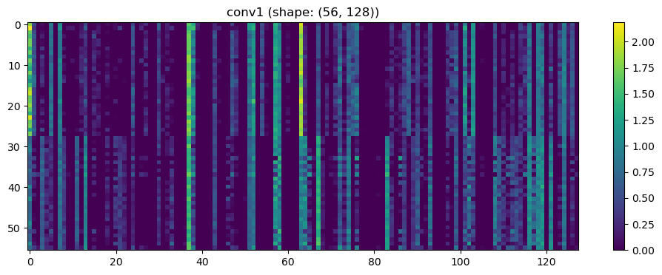

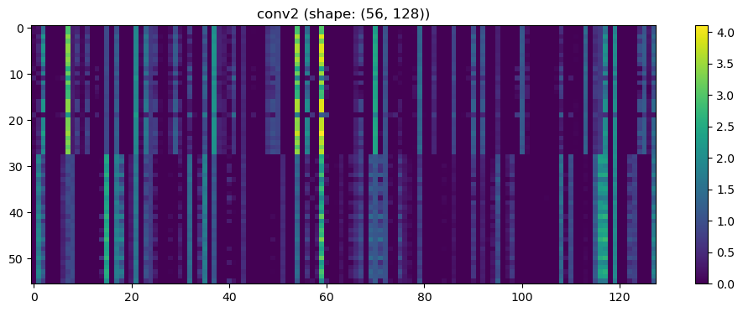

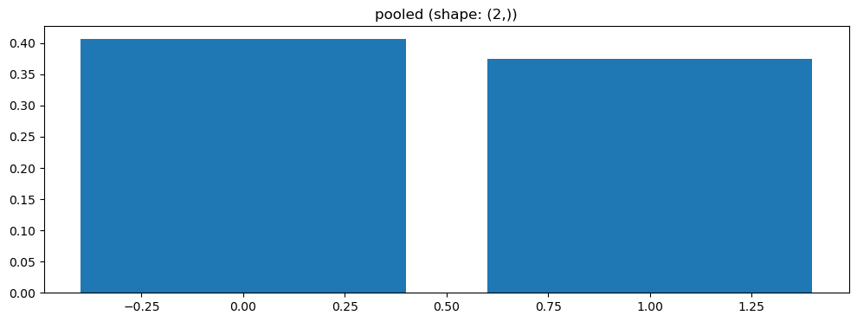

Split 3 Accuracy: 0.5238

=== ENV1 Split 4/5 ===

C:\Users\sansk\miniconda3\Lib\site-packages\scipy\signal\_spectral_py.py:1668: RuntimeWarning: invalid value encountered in divide

Cxy = np.abs(Pxy)**2 / Pxx / Pyy

After oversampling, class counts: Counter({1: 44, 0: 44})

Epoch 1/200 | Loss: 0.7419

Epoch 2/200 | Loss: 0.8052

Epoch 3/200 | Loss: 0.7193

Epoch 4/200 | Loss: 0.8023

Epoch 5/200 | Loss: 0.7242

Epoch 6/200 | Loss: 0.7434

Epoch 7/200 | Loss: 0.7748

Epoch 8/200 | Loss: 0.7502

Epoch 9/200 | Loss: 0.7471

Epoch 10/200 | Loss: 0.7799

Epoch 11/200 | Loss: 0.8460

Epoch 12/200 | Loss: 0.7758

Epoch 13/200 | Loss: 0.8289

Epoch 14/200 | Loss: 0.8388

Epoch 15/200 | Loss: 0.7439

Epoch 16/200 | Loss: 0.7364

Epoch 17/200 | Loss: 0.7468

Epoch 18/200 | Loss: 0.7571

Epoch 19/200 | Loss: 0.8504

Epoch 20/200 | Loss: 0.7159

Epoch 21/200 | Loss: 0.8157

Epoch 22/200 | Loss: 0.7273

Epoch 23/200 | Loss: 0.6855

Epoch 24/200 | Loss: 0.7682

Epoch 25/200 | Loss: 0.7619

Epoch 26/200 | Loss: 0.7359

Epoch 27/200 | Loss: 0.8082

Epoch 28/200 | Loss: 0.8300

Epoch 29/200 | Loss: 0.7725

Epoch 30/200 | Loss: 0.6976

Epoch 31/200 | Loss: 0.8258

Epoch 32/200 | Loss: 0.7752

Epoch 33/200 | Loss: 0.7781

Epoch 34/200 | Loss: 0.7594

Epoch 35/200 | Loss: 0.7225

Epoch 36/200 | Loss: 0.7414

Epoch 37/200 | Loss: 0.7444

Epoch 38/200 | Loss: 0.7097

Epoch 39/200 | Loss: 0.7246

Epoch 40/200 | Loss: 0.7180

Epoch 41/200 | Loss: 0.7590

Epoch 42/200 | Loss: 0.7420

Epoch 43/200 | Loss: 0.7481

Epoch 44/200 | Loss: 0.7124

Epoch 45/200 | Loss: 0.6873

Epoch 46/200 | Loss: 0.7060

Epoch 47/200 | Loss: 0.7401

Epoch 48/200 | Loss: 0.7106

Epoch 49/200 | Loss: 0.7126

Epoch 50/200 | Loss: 0.7786

Epoch 51/200 | Loss: 0.7185

Epoch 52/200 | Loss: 0.7595

Epoch 53/200 | Loss: 0.7215

Epoch 54/200 | Loss: 0.7194

Epoch 55/200 | Loss: 0.7345

Epoch 56/200 | Loss: 0.7282

Epoch 57/200 | Loss: 0.7939

Epoch 58/200 | Loss: 0.7851

Epoch 59/200 | Loss: 0.8055

Epoch 60/200 | Loss: 0.7090

Epoch 61/200 | Loss: 0.7137

Epoch 62/200 | Loss: 0.7015

Epoch 63/200 | Loss: 0.8058

Epoch 64/200 | Loss: 0.7109

Epoch 65/200 | Loss: 0.6709

Epoch 66/200 | Loss: 0.7453

Epoch 67/200 | Loss: 0.6888

Epoch 68/200 | Loss: 0.7348

Epoch 69/200 | Loss: 0.7787

Epoch 70/200 | Loss: 0.7820

Epoch 71/200 | Loss: 0.7597

Epoch 72/200 | Loss: 0.6652

Epoch 73/200 | Loss: 0.6870

Epoch 74/200 | Loss: 0.7105

Epoch 75/200 | Loss: 0.6865

Epoch 76/200 | Loss: 0.7542

Epoch 77/200 | Loss: 0.6933

Epoch 78/200 | Loss: 0.6634

Epoch 79/200 | Loss: 0.7562

Epoch 80/200 | Loss: 0.7548

Epoch 81/200 | Loss: 0.6902

Epoch 82/200 | Loss: 0.7802

Epoch 83/200 | Loss: 0.7009

Epoch 84/200 | Loss: 0.8239

Epoch 85/200 | Loss: 0.7627

Epoch 86/200 | Loss: 0.7868

Epoch 87/200 | Loss: 0.7410

Epoch 88/200 | Loss: 0.6921

Epoch 89/200 | Loss: 0.7803

Epoch 90/200 | Loss: 0.7234

Epoch 91/200 | Loss: 0.7366

Epoch 92/200 | Loss: 0.7496

Epoch 93/200 | Loss: 0.7350

Epoch 94/200 | Loss: 0.6910

Epoch 95/200 | Loss: 0.7471

Epoch 96/200 | Loss: 0.7555

Epoch 97/200 | Loss: 0.7292

Epoch 98/200 | Loss: 0.6791

Epoch 99/200 | Loss: 0.6985

Epoch 100/200 | Loss: 0.7466

Epoch 101/200 | Loss: 0.7684

Epoch 102/200 | Loss: 0.7210

Epoch 103/200 | Loss: 0.6871

Epoch 104/200 | Loss: 0.6735

Epoch 105/200 | Loss: 0.7140

Epoch 106/200 | Loss: 0.7161

Epoch 107/200 | Loss: 0.7222

Epoch 108/200 | Loss: 0.6935

Epoch 109/200 | Loss: 0.7873

Epoch 110/200 | Loss: 0.7584

Epoch 111/200 | Loss: 0.7145

Epoch 112/200 | Loss: 0.7191

Epoch 113/200 | Loss: 0.7065

Epoch 114/200 | Loss: 0.6750

Epoch 115/200 | Loss: 0.7197

Epoch 116/200 | Loss: 0.6948

Epoch 117/200 | Loss: 0.7066

Epoch 118/200 | Loss: 0.6889

Epoch 119/200 | Loss: 0.7330

Epoch 120/200 | Loss: 0.7405

Epoch 121/200 | Loss: 0.7524

Epoch 122/200 | Loss: 0.7313

Epoch 123/200 | Loss: 0.7226

Epoch 124/200 | Loss: 0.7565

Epoch 125/200 | Loss: 0.6928

Epoch 126/200 | Loss: 0.6913

Epoch 127/200 | Loss: 0.6959

Epoch 128/200 | Loss: 0.7377

Epoch 129/200 | Loss: 0.7882

Epoch 130/200 | Loss: 0.7270

Epoch 131/200 | Loss: 0.7201

Epoch 132/200 | Loss: 0.7784

Epoch 133/200 | Loss: 0.7117

Epoch 134/200 | Loss: 0.7018

Epoch 135/200 | Loss: 0.6933

Epoch 136/200 | Loss: 0.7781

Epoch 137/200 | Loss: 0.6458

Epoch 138/200 | Loss: 0.7285

Epoch 139/200 | Loss: 0.7173

Epoch 140/200 | Loss: 0.7551

Epoch 141/200 | Loss: 0.7282

Epoch 142/200 | Loss: 0.7037

Epoch 143/200 | Loss: 0.7064

Epoch 144/200 | Loss: 0.7145

Epoch 145/200 | Loss: 0.7252

Epoch 146/200 | Loss: 0.7090

Epoch 147/200 | Loss: 0.7323

Epoch 148/200 | Loss: 0.6467

Epoch 149/200 | Loss: 0.7989

Epoch 150/200 | Loss: 0.7520

Epoch 151/200 | Loss: 0.7037

Epoch 152/200 | Loss: 0.7315

Epoch 153/200 | Loss: 0.6879

Epoch 154/200 | Loss: 0.6249

Epoch 155/200 | Loss: 0.7448

Epoch 156/200 | Loss: 0.6835

Epoch 157/200 | Loss: 0.6145

Epoch 158/200 | Loss: 0.7051

Epoch 159/200 | Loss: 0.7029

Epoch 160/200 | Loss: 0.6648

Epoch 161/200 | Loss: 0.7030

Epoch 162/200 | Loss: 0.6650

Epoch 163/200 | Loss: 0.6571

Epoch 164/200 | Loss: 0.7256

Epoch 165/200 | Loss: 0.7599

Epoch 166/200 | Loss: 0.6947

Epoch 167/200 | Loss: 0.7280

Epoch 168/200 | Loss: 0.6902

Epoch 169/200 | Loss: 0.7037

Epoch 170/200 | Loss: 0.6839

Epoch 171/200 | Loss: 0.7296

Epoch 172/200 | Loss: 0.7778

Epoch 173/200 | Loss: 0.7361

Epoch 174/200 | Loss: 0.7279

Epoch 175/200 | Loss: 0.7028

Epoch 176/200 | Loss: 0.6919

Epoch 177/200 | Loss: 0.6661

Epoch 178/200 | Loss: 0.7309

Epoch 179/200 | Loss: 0.7161

Epoch 180/200 | Loss: 0.6776

Epoch 181/200 | Loss: 0.6608

Epoch 182/200 | Loss: 0.7482

Epoch 183/200 | Loss: 0.6885

Epoch 184/200 | Loss: 0.7052

Epoch 185/200 | Loss: 0.7147

Epoch 186/200 | Loss: 0.6980

Epoch 187/200 | Loss: 0.6900

Epoch 188/200 | Loss: 0.6756

Epoch 189/200 | Loss: 0.7195

Epoch 190/200 | Loss: 0.7302

Epoch 191/200 | Loss: 0.7735

Epoch 192/200 | Loss: 0.7156

Epoch 193/200 | Loss: 0.7226

Epoch 194/200 | Loss: 0.6622

Epoch 195/200 | Loss: 0.7091

Epoch 196/200 | Loss: 0.8333

Epoch 197/200 | Loss: 0.7220

Epoch 198/200 | Loss: 0.6962

Epoch 199/200 | Loss: 0.7396

Epoch 200/200 | Loss: 0.7015

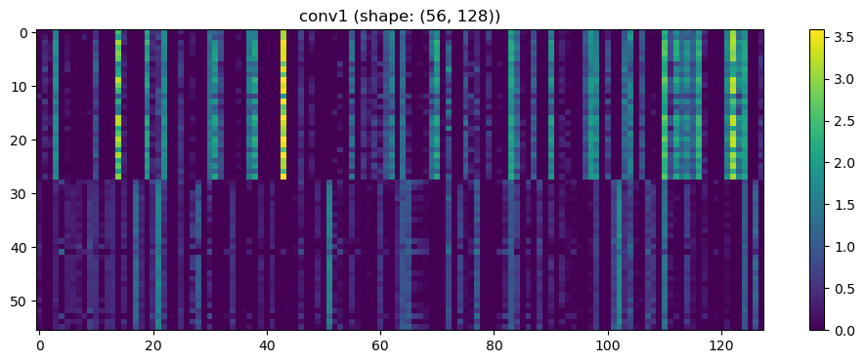

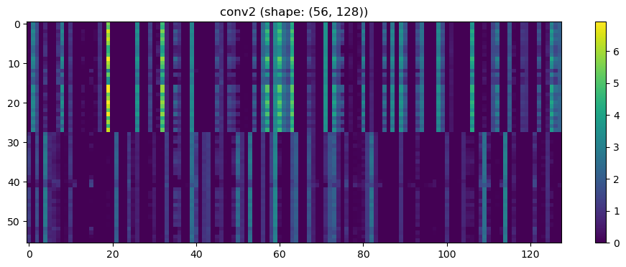

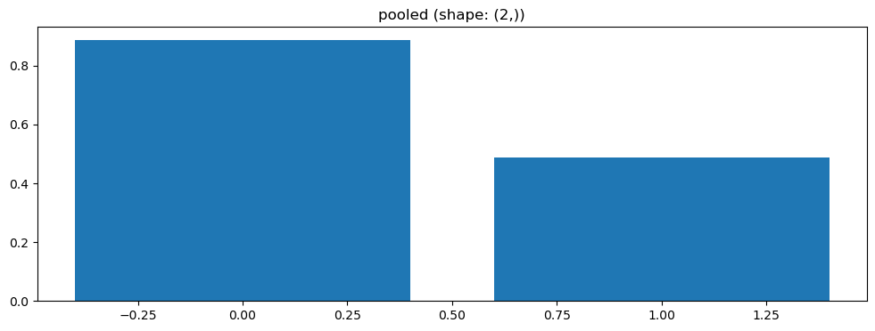

Split 4 Accuracy: 0.3810

=== ENV1 Split 5/5 ===

C:\Users\sansk\miniconda3\Lib\site-packages\scipy\signal\_spectral_py.py:1668: RuntimeWarning: invalid value encountered in divide

Cxy = np.abs(Pxy)**2 / Pxx / Pyy

After oversampling, class counts: Counter({1: 44, 0: 44})

Epoch 1/200 | Loss: 0.7488

Epoch 2/200 | Loss: 0.7360

Epoch 3/200 | Loss: 0.7233

Epoch 4/200 | Loss: 0.7474

Epoch 5/200 | Loss: 0.7508

Epoch 6/200 | Loss: 0.7409

Epoch 7/200 | Loss: 0.7453

Epoch 8/200 | Loss: 0.7189

Epoch 9/200 | Loss: 0.7507

Epoch 10/200 | Loss: 0.7278

Epoch 11/200 | Loss: 0.7275

Epoch 12/200 | Loss: 0.7710

Epoch 13/200 | Loss: 0.7724

Epoch 14/200 | Loss: 0.7727

Epoch 15/200 | Loss: 0.7172

Epoch 16/200 | Loss: 0.7545

Epoch 17/200 | Loss: 0.7287

Epoch 18/200 | Loss: 0.7297

Epoch 19/200 | Loss: 0.7198

Epoch 20/200 | Loss: 0.7208

Epoch 21/200 | Loss: 0.7613

Epoch 22/200 | Loss: 0.7749

Epoch 23/200 | Loss: 0.7333

Epoch 24/200 | Loss: 0.7407

Epoch 25/200 | Loss: 0.7686

Epoch 26/200 | Loss: 0.7296

Epoch 27/200 | Loss: 0.7358

Epoch 28/200 | Loss: 0.7753

Epoch 29/200 | Loss: 0.7103

Epoch 30/200 | Loss: 0.7545

Epoch 31/200 | Loss: 0.7866

Epoch 32/200 | Loss: 0.7379

Epoch 33/200 | Loss: 0.7337

Epoch 34/200 | Loss: 0.7480

Epoch 35/200 | Loss: 0.7357

Epoch 36/200 | Loss: 0.6577

Epoch 37/200 | Loss: 0.7868

Epoch 38/200 | Loss: 0.7829

Epoch 39/200 | Loss: 0.7207

Epoch 40/200 | Loss: 0.7314

Epoch 41/200 | Loss: 0.8026

Epoch 42/200 | Loss: 0.6761

Epoch 43/200 | Loss: 0.7007

Epoch 44/200 | Loss: 0.7315

Epoch 45/200 | Loss: 0.7234

Epoch 46/200 | Loss: 0.7562

Epoch 47/200 | Loss: 0.7139

Epoch 48/200 | Loss: 0.7203

Epoch 49/200 | Loss: 0.7123

Epoch 50/200 | Loss: 0.7453

Epoch 51/200 | Loss: 0.7139

Epoch 52/200 | Loss: 0.6918

Epoch 53/200 | Loss: 0.7338

Epoch 54/200 | Loss: 0.7087

Epoch 55/200 | Loss: 0.6708

Epoch 56/200 | Loss: 0.7974

Epoch 57/200 | Loss: 0.7311

Epoch 58/200 | Loss: 0.7505

Epoch 59/200 | Loss: 0.7591

Epoch 60/200 | Loss: 0.7553

Epoch 61/200 | Loss: 0.7539

Epoch 62/200 | Loss: 0.7252

Epoch 63/200 | Loss: 0.7113

Epoch 64/200 | Loss: 0.7642

Epoch 65/200 | Loss: 0.7481

Epoch 66/200 | Loss: 0.7395

Epoch 67/200 | Loss: 0.7256

Epoch 68/200 | Loss: 0.7064

Epoch 69/200 | Loss: 0.7427

Epoch 70/200 | Loss: 0.6886

Epoch 71/200 | Loss: 0.7025

Epoch 72/200 | Loss: 0.7179

Epoch 73/200 | Loss: 0.6786

Epoch 74/200 | Loss: 0.7156

Epoch 75/200 | Loss: 0.7625

Epoch 76/200 | Loss: 0.6698

Epoch 77/200 | Loss: 0.7708

Epoch 78/200 | Loss: 0.7507

Epoch 79/200 | Loss: 0.7837

Epoch 80/200 | Loss: 0.7166

Epoch 81/200 | Loss: 0.7770

Epoch 82/200 | Loss: 0.7166

Epoch 83/200 | Loss: 0.6905

Epoch 84/200 | Loss: 0.7054

Epoch 85/200 | Loss: 0.7363

Epoch 86/200 | Loss: 0.6791

Epoch 87/200 | Loss: 0.6697

Epoch 88/200 | Loss: 0.6789

Epoch 89/200 | Loss: 0.7005

Epoch 90/200 | Loss: 0.6614

Epoch 91/200 | Loss: 0.7040

Epoch 92/200 | Loss: 0.7657

Epoch 93/200 | Loss: 0.7055

Epoch 8/100 | Loss: 0.7704

Epoch 9/100 | Loss: 0.7537

Epoch 10/100 | Loss: 0.6678

Epoch 11/100 | Loss: 0.7154

Epoch 12/100 | Loss: 0.6822

Epoch 13/100 | Loss: 0.6975

Epoch 14/100 | Loss: 0.7268

Epoch 15/100 | Loss: 0.6907

Epoch 16/100 | Loss: 0.6933

Epoch 17/100 | Loss: 0.7182

Epoch 18/100 | Loss: 0.7157

Epoch 19/100 | Loss: 0.6675

Epoch 20/100 | Loss: 0.6535

Epoch 21/100 | Loss: 0.6727

Epoch 22/100 | Loss: 0.6909

Epoch 23/100 | Loss: 0.7419

Epoch 24/100 | Loss: 0.6906

Epoch 25/100 | Loss: 0.6770

Epoch 26/100 | Loss: 0.6664

Epoch 27/100 | Loss: 0.6506

Epoch 28/100 | Loss: 0.6493

Epoch 29/100 | Loss: 0.6571

Epoch 30/100 | Loss: 0.7099

Epoch 31/100 | Loss: 0.6821

Epoch 32/100 | Loss: 0.6728

Epoch 33/100 | Loss: 0.6833

Epoch 34/100 | Loss: 0.6561

Epoch 35/100 | Loss: 0.6526

Epoch 36/100 | Loss: 0.6340

Epoch 37/100 | Loss: 0.6856

Epoch 38/100 | Loss: 0.7398

Epoch 39/100 | Loss: 0.6079

Epoch 40/100 | Loss: 0.6433

Epoch 41/100 | Loss: 0.6683

Epoch 42/100 | Loss: 0.6290

Epoch 43/100 | Loss: 0.6972

Epoch 44/100 | Loss: 0.7111

Epoch 45/100 | Loss: 0.6848

Epoch 46/100 | Loss: 0.6841

Epoch 47/100 | Loss: 0.7725

Epoch 48/100 | Loss: 0.7596

Epoch 49/100 | Loss: 0.6310

Epoch 50/100 | Loss: 0.7242

Epoch 51/100 | Loss: 0.6733

Epoch 52/100 | Loss: 0.6926

Epoch 53/100 | Loss: 0.6632

Epoch 54/100 | Loss: 0.7488

Epoch 55/100 | Loss: 0.6496

Epoch 56/100 | Loss: 0.6194

Epoch 57/100 | Loss: 0.6644

Epoch 58/100 | Loss: 0.5918

Epoch 59/100 | Loss: 0.6662

Epoch 60/100 | Loss: 0.6835

Epoch 61/100 | Loss: 0.6468

Epoch 62/100 | Loss: 0.6922

Epoch 63/100 | Loss: 0.6709

Epoch 64/100 | Loss: 0.6141

Epoch 65/100 | Loss: 0.6951

Epoch 66/100 | Loss: 0.6487

Epoch 67/100 | Loss: 0.6595

Epoch 68/100 | Loss: 0.6854

Epoch 69/100 | Loss: 0.6396

Epoch 70/100 | Loss: 0.6278

Epoch 71/100 | Loss: 0.6491

Epoch 72/100 | Loss: 0.6104

Epoch 73/100 | Loss: 0.5869

Epoch 74/100 | Loss: 0.6135

Epoch 75/100 | Loss: 0.6938

Epoch 76/100 | Loss: 0.6535

Epoch 77/100 | Loss: 0.5799

Epoch 78/100 | Loss: 0.7128

Epoch 79/100 | Loss: 0.6507

Epoch 80/100 | Loss: 0.5900

Epoch 81/100 | Loss: 0.6584

Epoch 82/100 | Loss: 0.6184

Epoch 83/100 | Loss: 0.5781

Epoch 84/100 | Loss: 0.6634

Epoch 85/100 | Loss: 0.6015

Epoch 86/100 | Loss: 0.5881

Epoch 87/100 | Loss: 0.6902

Epoch 88/100 | Loss: 0.6427

Epoch 89/100 | Loss: 0.7230

Epoch 90/100 | Loss: 0.6312

Epoch 91/100 | Loss: 0.5702

Epoch 92/100 | Loss: 0.6257

Epoch 93/100 | Loss: 0.5881

Epoch 94/100 | Loss: 0.6382

Epoch 95/100 | Loss: 0.6316

Epoch 96/100 | Loss: 0.5899

Epoch 97/100 | Loss: 0.6056

Epoch 98/100 | Loss: 0.6681

Epoch 99/100 | Loss: 0.5648

Epoch 100/100 | Loss: 0.5915

Split 3 Accuracy: 0.4762

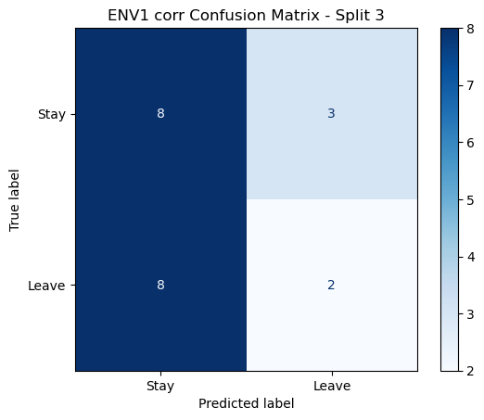

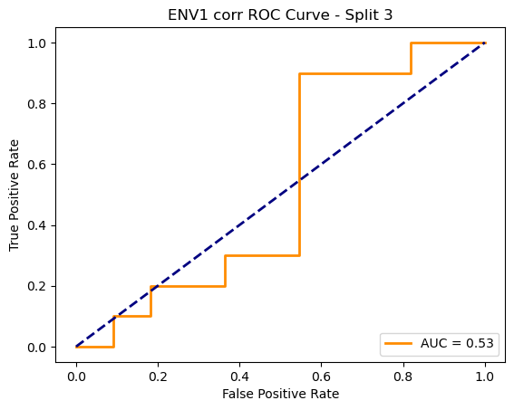

After oversampling, class counts: Counter({1: 44, 0: 44})

Epoch 94/200 | Loss: 0.7421

Epoch 95/200 | Loss: 0.7430

Epoch 96/200 | Loss: 0.6835

Epoch 97/200 | Loss: 0.6511

Epoch 98/200 | Loss: 0.7008

Epoch 99/200 | Loss: 0.6889

Epoch 100/200 | Loss: 0.7058

Epoch 101/200 | Loss: 0.7262

Epoch 102/200 | Loss: 0.7487

Epoch 103/200 | Loss: 0.7417

Epoch 104/200 | Loss: 0.7337

Epoch 105/200 | Loss: 0.7099

Epoch 106/200 | Loss: 0.7565

Epoch 107/200 | Loss: 0.7558

Epoch 108/200 | Loss: 0.6641

Epoch 109/200 | Loss: 0.7196

Epoch 110/200 | Loss: 0.7114

Epoch 111/200 | Loss: 0.7110

Epoch 112/200 | Loss: 0.7120

Epoch 113/200 | Loss: 0.7529

Epoch 114/200 | Loss: 0.7496

Epoch 115/200 | Loss: 0.7424

Epoch 116/200 | Loss: 0.7047

Epoch 117/200 | Loss: 0.6948

Epoch 118/200 | Loss: 0.7190

Epoch 119/200 | Loss: 0.7238

Epoch 120/200 | Loss: 0.7035

Epoch 121/200 | Loss: 0.7313

Epoch 122/200 | Loss: 0.6546

Epoch 123/200 | Loss: 0.7318

Epoch 124/200 | Loss: 0.7011

Epoch 125/200 | Loss: 0.7226

Epoch 126/200 | Loss: 0.7168

Epoch 127/200 | Loss: 0.7543

Epoch 128/200 | Loss: 0.7267

Epoch 129/200 | Loss: 0.6606

Epoch 130/200 | Loss: 0.7138

Epoch 131/200 | Loss: 0.7033

Epoch 132/200 | Loss: 0.7449

Epoch 133/200 | Loss: 0.7408

Epoch 134/200 | Loss: 0.7098

Epoch 135/200 | Loss: 0.7175

Epoch 136/200 | Loss: 0.7067

Epoch 137/200 | Loss: 0.6542

Epoch 138/200 | Loss: 0.7518

Epoch 139/200 | Loss: 0.6949

Epoch 140/200 | Loss: 0.7297

Epoch 141/200 | Loss: 0.6989

Epoch 142/200 | Loss: 0.6962

Epoch 143/200 | Loss: 0.7012

Epoch 144/200 | Loss: 0.6974

Epoch 145/200 | Loss: 0.7275

Epoch 146/200 | Loss: 0.7158

Epoch 147/200 | Loss: 0.6904

Epoch 148/200 | Loss: 0.7092

Epoch 149/200 | Loss: 0.6886

Epoch 150/200 | Loss: 0.7415

Epoch 151/200 | Loss: 0.7055

Epoch 152/200 | Loss: 0.7434

Epoch 153/200 | Loss: 0.7195

Epoch 154/200 | Loss: 0.7640

Epoch 155/200 | Loss: 0.7250

Epoch 156/200 | Loss: 0.6738

Epoch 157/200 | Loss: 0.7234

Epoch 158/200 | Loss: 0.7244

Epoch 159/200 | Loss: 0.7835

Epoch 160/200 | Loss: 0.6731

Epoch 161/200 | Loss: 0.6694

Epoch 162/200 | Loss: 0.7278

Epoch 163/200 | Loss: 0.7433

Epoch 164/200 | Loss: 0.7242

Epoch 165/200 | Loss: 0.7489

Epoch 166/200 | Loss: 0.7068

Epoch 167/200 | Loss: 0.6833

Epoch 168/200 | Loss: 0.6655

Epoch 169/200 | Loss: 0.6768

Epoch 170/200 | Loss: 0.6863

Epoch 171/200 | Loss: 0.6581

Epoch 172/200 | Loss: 0.7016

Epoch 173/200 | Loss: 0.7307

Epoch 174/200 | Loss: 0.7040

Epoch 175/200 | Loss: 0.6941

Epoch 176/200 | Loss: 0.6943

Epoch 177/200 | Loss: 0.7050

Epoch 178/200 | Loss: 0.6946

Epoch 179/200 | Loss: 0.7284

Epoch 180/200 | Loss: 0.6927

Epoch 181/200 | Loss: 0.7365

Epoch 182/200 | Loss: 0.6713

Epoch 183/200 | Loss: 0.6660

Epoch 184/200 | Loss: 0.7193

Epoch 185/200 | Loss: 0.6947

Epoch 186/200 | Loss: 0.7358

Epoch 187/200 | Loss: 0.7679

Epoch 188/200 | Loss: 0.6780

Epoch 189/200 | Loss: 0.7094

Epoch 190/200 | Loss: 0.6873

Epoch 191/200 | Loss: 0.6588

Epoch 192/200 | Loss: 0.6881

Epoch 193/200 | Loss: 0.7311

Epoch 194/200 | Loss: 0.7071

Epoch 195/200 | Loss: 0.7186

Epoch 196/200 | Loss: 0.6368

Epoch 197/200 | Loss: 0.7231

Epoch 198/200 | Loss: 0.7312

Epoch 199/200 | Loss: 0.6929

Epoch 200/200 | Loss: 0.6318

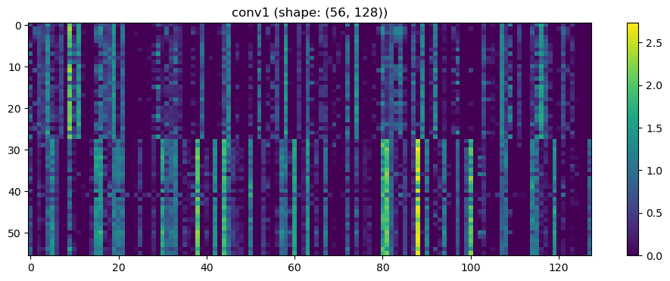

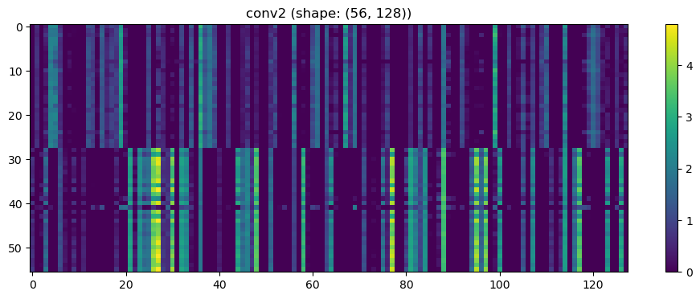

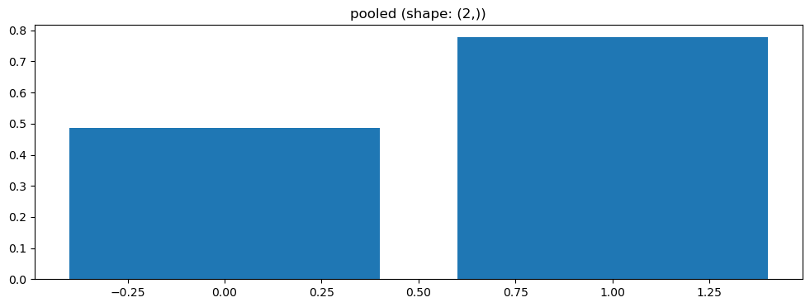

Split 5 Accuracy: 0.4762

ENV1 coh Average Accuracy: 0.4810 ± 0.0530

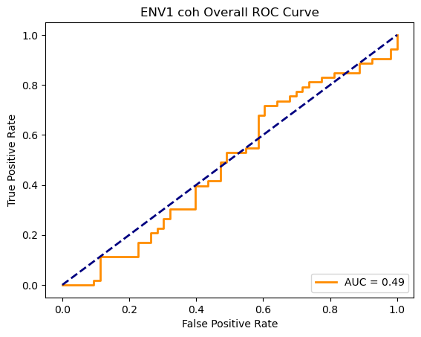

Running GNN with plv connectivity for ENV1...

==================================================

Training GNN for ENV1 with plv connectivity

==================================================

=== ENV1 Split 1/5 ===

After oversampling, class counts: Counter({0: 43, 1: 43})

C:\Users\sansk\miniconda3\Lib\site-packages\torch_geometric\deprecation.py:26: UserWarning: 'data.DataLoader' is deprecated, use 'loader.DataLoader' instead

warnings.warn(out)

Epoch 1/100 | Loss: 0.7297

Epoch 2/100 | Loss: 0.6978

Epoch 3/100 | Loss: 0.7497

Epoch 4/100 | Loss: 0.7167

Epoch 5/100 | Loss: 0.6797

Epoch 6/100 | Loss: 0.7019

Epoch 7/100 | Loss: 0.7186

Epoch 8/100 | Loss: 0.6399

Epoch 9/100 | Loss: 0.6915

Epoch 10/100 | Loss: 0.7252

Epoch 11/100 | Loss: 0.7326

Epoch 12/100 | Loss: 0.7100

Epoch 13/100 | Loss: 0.6888

Epoch 14/100 | Loss: 0.7463

Epoch 15/100 | Loss: 0.6740

Epoch 16/100 | Loss: 0.7791

Epoch 17/100 | Loss: 0.6269

Epoch 18/100 | Loss: 0.6660

Epoch 19/100 | Loss: 0.6477

Epoch 20/100 | Loss: 0.7331

Epoch 21/100 | Loss: 0.6484

Epoch 22/100 | Loss: 0.6759

Epoch 23/100 | Loss: 0.6785

Epoch 24/100 | Loss: 0.7188

Epoch 25/100 | Loss: 0.6890

Epoch 26/100 | Loss: 0.6631

Epoch 27/100 | Loss: 0.6743

Epoch 28/100 | Loss: 0.6608

Epoch 29/100 | Loss: 0.7411

Epoch 30/100 | Loss: 0.6788

Epoch 31/100 | Loss: 0.6791

Epoch 32/100 | Loss: 0.6993

Epoch 33/100 | Loss: 0.6796

Epoch 34/100 | Loss: 0.6553

Epoch 35/100 | Loss: 0.6875

Epoch 36/100 | Loss: 0.7123

Epoch 37/100 | Loss: 0.6911

Epoch 38/100 | Loss: 0.6964

Epoch 39/100 | Loss: 0.7046

Epoch 40/100 | Loss: 0.7057

Epoch 41/100 | Loss: 0.6824

Epoch 42/100 | Loss: 0.7189

Epoch 43/100 | Loss: 0.7643

Epoch 44/100 | Loss: 0.7049

Epoch 45/100 | Loss: 0.6611

Epoch 46/100 | Loss: 0.6495

Epoch 47/100 | Loss: 0.7025

Epoch 48/100 | Loss: 0.7352

Epoch 49/100 | Loss: 0.6567

Epoch 50/100 | Loss: 0.6738

Epoch 51/100 | Loss: 0.6761

Epoch 52/100 | Loss: 0.6740

Epoch 53/100 | Loss: 0.7397

Epoch 54/100 | Loss: 0.6875

Epoch 55/100 | Loss: 0.6344

Epoch 56/100 | Loss: 0.6985

Epoch 57/100 | Loss: 0.7081

Epoch 58/100 | Loss: 0.6744

Epoch 59/100 | Loss: 0.6848

Epoch 60/100 | Loss: 0.6552

Epoch 61/100 | Loss: 0.6670

Epoch 62/100 | Loss: 0.7056

Epoch 63/100 | Loss: 0.6656

Epoch 64/100 | Loss: 0.6976

Epoch 65/100 | Loss: 0.6621

Epoch 66/100 | Loss: 0.6602

Epoch 67/100 | Loss: 0.6551

Epoch 68/100 | Loss: 0.6558

Epoch 69/100 | Loss: 0.6835

Epoch 70/100 | Loss: 0.6547

Epoch 71/100 | Loss: 0.6310

Epoch 72/100 | Loss: 0.6229

Epoch 73/100 | Loss: 0.6438

Epoch 74/100 | Loss: 0.7031

Epoch 75/100 | Loss: 0.6850

Epoch 76/100 | Loss: 0.6129

Epoch 77/100 | Loss: 0.7079

Epoch 78/100 | Loss: 0.6361

Epoch 79/100 | Loss: 0.6334

Epoch 80/100 | Loss: 0.6515

Epoch 81/100 | Loss: 0.6603

Epoch 82/100 | Loss: 0.6097

Epoch 83/100 | Loss: 0.6674

Epoch 84/100 | Loss: 0.6704

Epoch 85/100 | Loss: 0.6287

Epoch 86/100 | Loss: 0.6729

Epoch 87/100 | Loss: 0.6839

Epoch 88/100 | Loss: 0.6186

Epoch 89/100 | Loss: 0.6923

Epoch 90/100 | Loss: 0.6384

Epoch 91/100 | Loss: 0.5961

Epoch 92/100 | Loss: 0.6319

Epoch 93/100 | Loss: 0.6214

Epoch 94/100 | Loss: 0.6301

Epoch 95/100 | Loss: 0.6200

Epoch 96/100 | Loss: 0.5891

Epoch 97/100 | Loss: 0.5698

Epoch 98/100 | Loss: 0.6135

Epoch 99/100 | Loss: 0.7127

Epoch 100/100 | Loss: 0.6361

Split 4 Accuracy: 0.6190

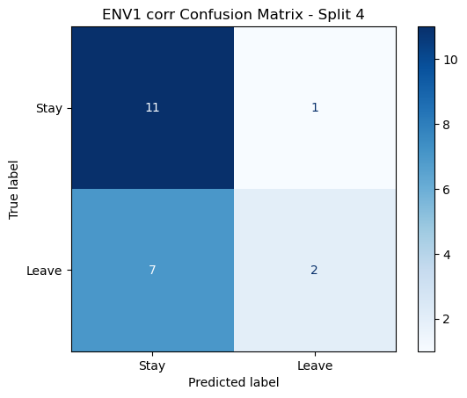

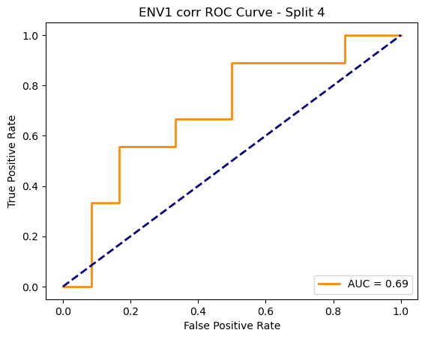

=== ENV1 Split 5/5 ===

After oversampling, class counts: Counter({1: 44, 0: 44})

Epoch 1/200 | Loss: 0.7501

Epoch 2/200 | Loss: 0.7860

Epoch 3/200 | Loss: 0.7227

Epoch 4/200 | Loss: 0.7183

Epoch 5/200 | Loss: 0.7077

Epoch 6/200 | Loss: 0.7420

Epoch 7/200 | Loss: 0.7129

Epoch 8/200 | Loss: 0.7813

Epoch 9/200 | Loss: 0.6900

Epoch 10/200 | Loss: 0.7466

Epoch 11/200 | Loss: 0.7190

Epoch 12/200 | Loss: 0.7422

Epoch 13/200 | Loss: 0.7217

Epoch 14/200 | Loss: 0.7640

Epoch 15/200 | Loss: 0.7510

Epoch 16/200 | Loss: 0.8309

Epoch 17/200 | Loss: 0.7281

Epoch 18/200 | Loss: 0.8533

Epoch 19/200 | Loss: 0.6896

Epoch 20/200 | Loss: 0.7558

Epoch 21/200 | Loss: 0.7365

Epoch 22/200 | Loss: 0.7533

Epoch 23/200 | Loss: 0.7643

Epoch 24/200 | Loss: 0.7818

Epoch 25/200 | Loss: 0.6962

Epoch 26/200 | Loss: 0.7546

Epoch 27/200 | Loss: 0.7324

Epoch 28/200 | Loss: 0.7059

Epoch 29/200 | Loss: 0.7810

Epoch 30/200 | Loss: 0.7382

Epoch 31/200 | Loss: 0.7255

Epoch 32/200 | Loss: 0.7398

Epoch 33/200 | Loss: 0.6991

Epoch 34/200 | Loss: 0.7165

Epoch 35/200 | Loss: 0.8423

Epoch 36/200 | Loss: 0.8129

Epoch 37/200 | Loss: 0.7452

Epoch 38/200 | Loss: 0.7111

Epoch 39/200 | Loss: 0.7783

Epoch 40/200 | Loss: 0.7086

Epoch 41/200 | Loss: 0.7248

Epoch 42/200 | Loss: 0.7467

Epoch 43/200 | Loss: 0.7722

Epoch 44/200 | Loss: 0.8010

Epoch 45/200 | Loss: 0.6702

Epoch 46/200 | Loss: 0.7219

Epoch 47/200 | Loss: 0.7424

Epoch 48/200 | Loss: 0.6727

Epoch 49/200 | Loss: 0.7501

Epoch 50/200 | Loss: 0.6692

Epoch 51/200 | Loss: 0.7399

Epoch 52/200 | Loss: 0.7568

Epoch 53/200 | Loss: 0.6805

Epoch 54/200 | Loss: 0.7436

Epoch 55/200 | Loss: 0.7505

Epoch 56/200 | Loss: 0.7149

Epoch 57/200 | Loss: 0.6751

Epoch 58/200 | Loss: 0.7525

Epoch 59/200 | Loss: 0.7140

Epoch 60/200 | Loss: 0.7491

Epoch 61/200 | Loss: 0.7289

Epoch 62/200 | Loss: 0.7368

Epoch 63/200 | Loss: 0.7041

Epoch 64/200 | Loss: 0.7087

Epoch 65/200 | Loss: 0.7350

Epoch 66/200 | Loss: 0.7188

Epoch 67/200 | Loss: 0.7753

Epoch 68/200 | Loss: 0.7473

Epoch 69/200 | Loss: 0.7660

Epoch 70/200 | Loss: 0.7137

Epoch 71/200 | Loss: 0.7144

Epoch 72/200 | Loss: 0.6918

Epoch 73/200 | Loss: 0.6541

Epoch 74/200 | Loss: 0.6895

Epoch 75/200 | Loss: 0.6972

Epoch 76/200 | Loss: 0.6156

Epoch 77/200 | Loss: 0.7434

Epoch 78/200 | Loss: 0.7647

Epoch 79/200 | Loss: 0.7044

Epoch 80/200 | Loss: 0.6933

Epoch 81/200 | Loss: 0.7333

Epoch 82/200 | Loss: 0.7157

Epoch 83/200 | Loss: 0.6879

Epoch 84/200 | Loss: 0.7372

Epoch 85/200 | Loss: 0.6918

Epoch 86/200 | Loss: 0.6957

Epoch 87/200 | Loss: 0.7908

Epoch 88/200 | Loss: 0.7048

Epoch 89/200 | Loss: 0.7143

Epoch 90/200 | Loss: 0.6951

Epoch 91/200 | Loss: 0.6990

Epoch 92/200 | Loss: 0.8005

Epoch 93/200 | Loss: 0.6742

Epoch 94/200 | Loss: 0.6647

Epoch 95/200 | Loss: 0.6524

Epoch 96/200 | Loss: 0.6698

Epoch 97/200 | Loss: 0.6825

Epoch 98/200 | Loss: 0.7038

Epoch 99/200 | Loss: 0.7408

Epoch 100/200 | Loss: 0.6904

Epoch 101/200 | Loss: 0.7395

Epoch 102/200 | Loss: 0.6770

Epoch 103/200 | Loss: 0.6669

Epoch 104/200 | Loss: 0.7573

Epoch 105/200 | Loss: 0.6631

Epoch 106/200 | Loss: 0.6785

Epoch 107/200 | Loss: 0.7240

Epoch 108/200 | Loss: 0.7372

Epoch 109/200 | Loss: 0.6641

Epoch 110/200 | Loss: 0.6426

Epoch 111/200 | Loss: 0.6299

Epoch 112/200 | Loss: 0.6982

Epoch 113/200 | Loss: 0.7647

Epoch 114/200 | Loss: 0.6835

Epoch 115/200 | Loss: 0.7130

Epoch 116/200 | Loss: 0.7507

Epoch 117/200 | Loss: 0.7404

Epoch 118/200 | Loss: 0.7043

Epoch 119/200 | Loss: 0.6993

Epoch 120/200 | Loss: 0.7162

Epoch 121/200 | Loss: 0.6966

Epoch 122/200 | Loss: 0.6790

Epoch 123/200 | Loss: 0.6841

Epoch 124/200 | Loss: 0.6262

Epoch 125/200 | Loss: 0.6963

Epoch 126/200 | Loss: 0.6885

Epoch 127/200 | Loss: 0.6877

Epoch 128/200 | Loss: 0.7323

Epoch 129/200 | Loss: 0.6625

Epoch 130/200 | Loss: 0.6819

Epoch 131/200 | Loss: 0.6629

Epoch 132/200 | Loss: 0.6684

Epoch 133/200 | Loss: 0.7017

Epoch 134/200 | Loss: 0.6725

Epoch 135/200 | Loss: 0.6827

Epoch 136/200 | Loss: 0.7424

Epoch 137/200 | Loss: 0.7191

Epoch 138/200 | Loss: 0.7645

Epoch 139/200 | Loss: 0.6703

Epoch 140/200 | Loss: 0.6586

Epoch 141/200 | Loss: 0.6581

Epoch 142/200 | Loss: 0.6492

Epoch 143/200 | Loss: 0.6402

Epoch 144/200 | Loss: 0.7111

Epoch 145/200 | Loss: 0.6954

Epoch 146/200 | Loss: 0.6779

Epoch 147/200 | Loss: 0.7186

Epoch 148/200 | Loss: 0.6242

Epoch 149/200 | Loss: 0.6944

Epoch 150/200 | Loss: 0.6384

Epoch 151/200 | Loss: 0.6725

Epoch 152/200 | Loss: 0.6484

Epoch 153/200 | Loss: 0.6585

Epoch 154/200 | Loss: 0.6945

Epoch 155/200 | Loss: 0.6829

Epoch 156/200 | Loss: 0.6504

Epoch 157/200 | Loss: 0.7429

Epoch 158/200 | Loss: 0.6753

Epoch 159/200 | Loss: 0.6723

Epoch 160/200 | Loss: 0.6431

Epoch 161/200 | Loss: 0.6401

Epoch 162/200 | Loss: 0.6826

Epoch 163/200 | Loss: 0.6702

Epoch 164/200 | Loss: 0.6790

Epoch 165/200 | Loss: 0.6777

Epoch 166/200 | Loss: 0.6893

Epoch 167/200 | Loss: 0.6997

Epoch 168/200 | Loss: 0.6690

Epoch 169/200 | Loss: 0.6505

Epoch 170/200 | Loss: 0.7169

Epoch 171/200 | Loss: 0.6583

Epoch 172/200 | Loss: 0.6112

Epoch 173/200 | Loss: 0.6702

Epoch 174/200 | Loss: 0.6565

Epoch 175/200 | Loss: 0.6858

Epoch 176/200 | Loss: 0.7156

Epoch 177/200 | Loss: 0.7095

Epoch 178/200 | Loss: 0.7424

Epoch 179/200 | Loss: 0.7471

Epoch 180/200 | Loss: 0.6847

Epoch 181/200 | Loss: 0.6257

Epoch 182/200 | Loss: 0.6945

Epoch 183/200 | Loss: 0.6299

Epoch 184/200 | Loss: 0.6959

Epoch 185/200 | Loss: 0.6631

Epoch 186/200 | Loss: 0.6897

Epoch 187/200 | Loss: 0.7107

Epoch 188/200 | Loss: 0.6845

Epoch 189/200 | Loss: 0.5874

Epoch 190/200 | Loss: 0.6499

Epoch 191/200 | Loss: 0.6875

Epoch 192/200 | Loss: 0.6290

Epoch 193/200 | Loss: 0.7197

Epoch 194/200 | Loss: 0.7102

Epoch 195/200 | Loss: 0.6866

Epoch 196/200 | Loss: 0.6072

Epoch 197/200 | Loss: 0.6506

Epoch 198/200 | Loss: 0.6263

Epoch 199/200 | Loss: 0.6210

Epoch 200/200 | Loss: 0.6675

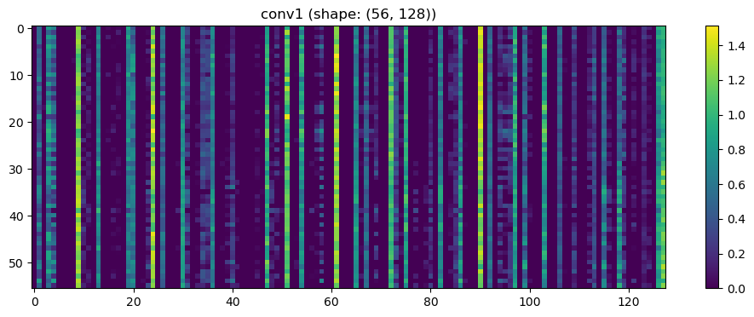

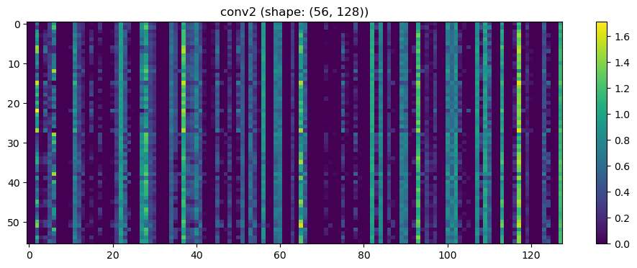

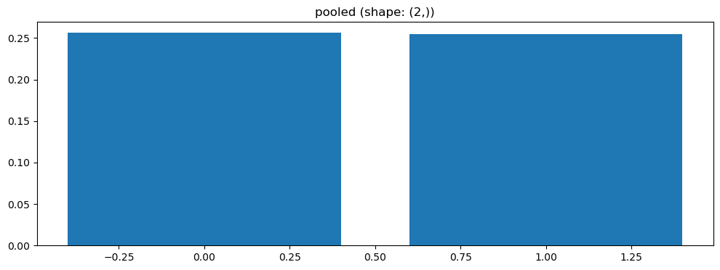

Split 1 Accuracy: 0.5455

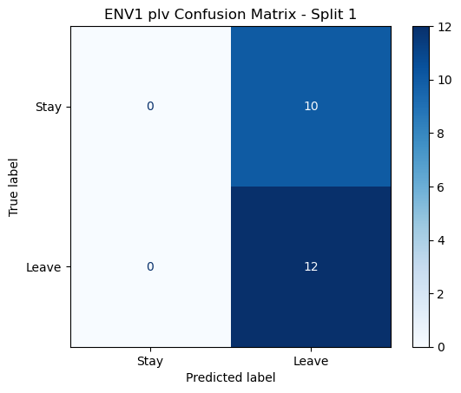

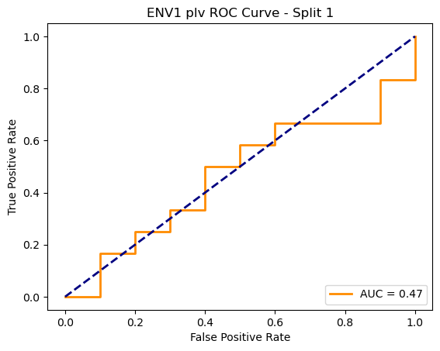

=== ENV1 Split 2/5 ===

After oversampling, class counts: Counter({1: 43, 0: 43})

C:\Users\sansk\miniconda3\Lib\site-packages\torch_geometric\deprecation.py:26: UserWarning: 'data.DataLoader' is deprecated, use 'loader.DataLoader' instead

warnings.warn(out)

Epoch 1/100 | Loss: 0.7536

Epoch 2/100 | Loss: 0.7802

Epoch 3/100 | Loss: 0.7462

Epoch 4/100 | Loss: 0.6641

Epoch 5/100 | Loss: 0.7666

Epoch 6/100 | Loss: 0.7337

Epoch 7/100 | Loss: 0.7147

Epoch 8/100 | Loss: 0.6769

Epoch 9/100 | Loss: 0.7326

Epoch 10/100 | Loss: 0.6936

Epoch 11/100 | Loss: 0.7047

Epoch 12/100 | Loss: 0.6585

Epoch 13/100 | Loss: 0.6746

Epoch 14/100 | Loss: 0.6884

Epoch 15/100 | Loss: 0.6279

Epoch 16/100 | Loss: 0.7354

Epoch 17/100 | Loss: 0.6674

Epoch 18/100 | Loss: 0.7260

Epoch 19/100 | Loss: 0.6867

Epoch 20/100 | Loss: 0.6155

Epoch 21/100 | Loss: 0.7403

Epoch 22/100 | Loss: 0.6676

Epoch 23/100 | Loss: 0.7235

Epoch 24/100 | Loss: 0.7247

Epoch 25/100 | Loss: 0.6814

Epoch 26/100 | Loss: 0.6995

Epoch 27/100 | Loss: 0.6875

Epoch 28/100 | Loss: 0.6714

Epoch 29/100 | Loss: 0.6795

Epoch 30/100 | Loss: 0.7009

Epoch 31/100 | Loss: 0.7071

Epoch 32/100 | Loss: 0.6758

Epoch 33/100 | Loss: 0.6355

Epoch 34/100 | Loss: 0.6940

Epoch 35/100 | Loss: 0.6541

Epoch 36/100 | Loss: 0.6748

Epoch 37/100 | Loss: 0.6523

Epoch 38/100 | Loss: 0.6770

Epoch 39/100 | Loss: 0.7066

Epoch 40/100 | Loss: 0.6759

Epoch 41/100 | Loss: 0.6827

Epoch 42/100 | Loss: 0.6008

Epoch 43/100 | Loss: 0.6559

Epoch 44/100 | Loss: 0.7048

Epoch 45/100 | Loss: 0.6477

Epoch 46/100 | Loss: 0.6466

Epoch 47/100 | Loss: 0.6710

Epoch 48/100 | Loss: 0.7149

Epoch 49/100 | Loss: 0.6568

Epoch 50/100 | Loss: 0.6115

Epoch 51/100 | Loss: 0.5869

Epoch 52/100 | Loss: 0.6763

Epoch 53/100 | Loss: 0.6789

Epoch 54/100 | Loss: 0.6482

Epoch 55/100 | Loss: 0.6822

Epoch 56/100 | Loss: 0.6119

Epoch 57/100 | Loss: 0.7138

Epoch 58/100 | Loss: 0.6710

Epoch 59/100 | Loss: 0.6533

Epoch 60/100 | Loss: 0.6594

Epoch 61/100 | Loss: 0.5816

Epoch 62/100 | Loss: 0.6263

Epoch 63/100 | Loss: 0.6601

Epoch 64/100 | Loss: 0.6240

Epoch 65/100 | Loss: 0.6075

Epoch 66/100 | Loss: 0.6687

Epoch 67/100 | Loss: 0.6353

Epoch 68/100 | Loss: 0.6673

Epoch 69/100 | Loss: 0.6362

Epoch 70/100 | Loss: 0.6764

Epoch 71/100 | Loss: 0.7124

Epoch 72/100 | Loss: 0.5738

Epoch 73/100 | Loss: 0.6482

Epoch 74/100 | Loss: 0.5322

Epoch 75/100 | Loss: 0.6262

Epoch 76/100 | Loss: 0.6321

Epoch 77/100 | Loss: 0.6294

Epoch 78/100 | Loss: 0.5603

Epoch 79/100 | Loss: 0.5869

Epoch 80/100 | Loss: 0.6191

Epoch 81/100 | Loss: 0.6562

Epoch 82/100 | Loss: 0.6460

Epoch 83/100 | Loss: 0.6983

Epoch 84/100 | Loss: 0.6351

Epoch 85/100 | Loss: 0.5851

Epoch 86/100 | Loss: 0.5721

Epoch 87/100 | Loss: 0.5949

Epoch 88/100 | Loss: 0.5746

Epoch 89/100 | Loss: 0.6290

Epoch 90/100 | Loss: 0.6601

Epoch 91/100 | Loss: 0.6926

Epoch 92/100 | Loss: 0.5732

Epoch 93/100 | Loss: 0.6253

Epoch 94/100 | Loss: 0.5646

Epoch 95/100 | Loss: 0.6154

Epoch 96/100 | Loss: 0.6017

Epoch 97/100 | Loss: 0.5948

Epoch 98/100 | Loss: 0.5800

Epoch 99/100 | Loss: 0.5647

Epoch 100/100 | Loss: 0.5471

Split 5 Accuracy: 0.6667

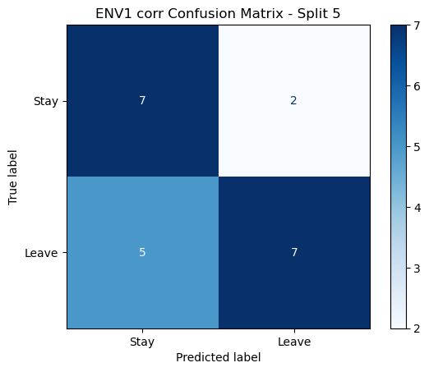

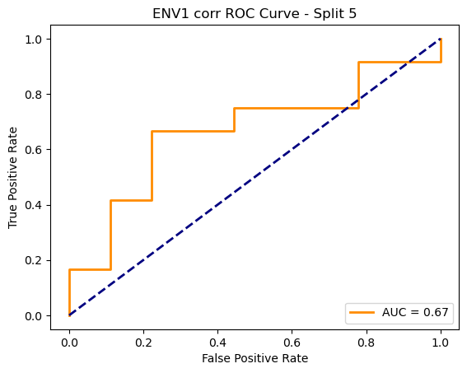

ENV1 corr Average Accuracy: 0.5294 ± 0.0970

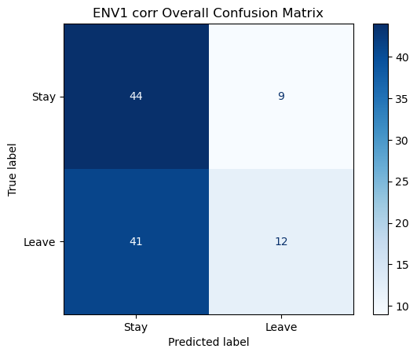

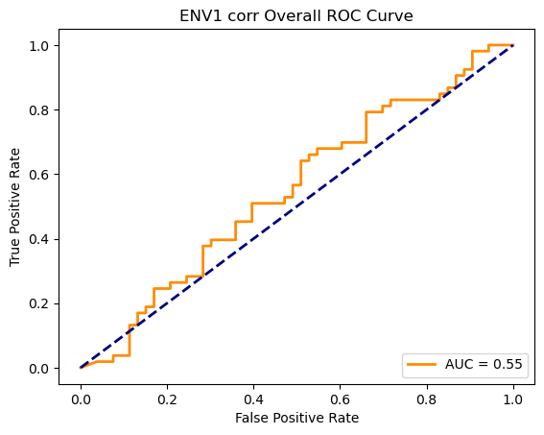

Running GNN with coh connectivity for ENV1...

==================================================

Training GNN for ENV1 with coh connectivity

==================================================

=== ENV1 Split 1/5 ===

C:\Users\sansk\miniconda3\Lib\site-packages\scipy\signal\_spectral_py.py:1668: RuntimeWarning: invalid value encountered in divide

Cxy = np.abs(Pxy)**2 / Pxx / Pyy

After oversampling, class counts: Counter({0: 43, 1: 43})

Epoch 1/200 | Loss: 0.7253

Epoch 2/200 | Loss: 0.7436

Epoch 3/200 | Loss: 0.7517

Epoch 4/200 | Loss: 0.7923

Epoch 5/200 | Loss: 0.7457

Epoch 6/200 | Loss: 0.7195

Epoch 7/200 | Loss: 0.7326

Epoch 8/200 | Loss: 0.7775

Epoch 9/200 | Loss: 0.7863

Epoch 10/200 | Loss: 0.7677

Epoch 11/200 | Loss: 0.7070

Epoch 12/200 | Loss: 0.7295

Epoch 13/200 | Loss: 0.7451

Epoch 14/200 | Loss: 0.8022

Epoch 15/200 | Loss: 0.7369

Epoch 16/200 | Loss: 0.7742

Epoch 17/200 | Loss: 0.8113

Epoch 18/200 | Loss: 0.7638

Epoch 19/200 | Loss: 0.7394

Epoch 20/200 | Loss: 0.6554

Epoch 21/200 | Loss: 0.7091

Epoch 22/200 | Loss: 0.7159

Epoch 23/200 | Loss: 0.7579

Epoch 24/200 | Loss: 0.6955

Epoch 25/200 | Loss: 0.7213

Epoch 26/200 | Loss: 0.7247

Epoch 27/200 | Loss: 0.7666

Epoch 28/200 | Loss: 0.7207

Epoch 29/200 | Loss: 0.7028

Epoch 30/200 | Loss: 0.7689

Epoch 31/200 | Loss: 0.7427

Epoch 32/200 | Loss: 0.7296

Epoch 33/200 | Loss: 0.7516

Epoch 34/200 | Loss: 0.7948

Epoch 35/200 | Loss: 0.7813

Epoch 36/200 | Loss: 0.7482

Epoch 37/200 | Loss: 0.7263

Epoch 38/200 | Loss: 0.7581

Epoch 39/200 | Loss: 0.7058

Epoch 40/200 | Loss: 0.7340

Epoch 41/200 | Loss: 0.7355

Epoch 42/200 | Loss: 0.7228

Epoch 43/200 | Loss: 0.7040

Epoch 44/200 | Loss: 0.7498

Epoch 45/200 | Loss: 0.7256

Epoch 46/200 | Loss: 0.6899

Epoch 47/200 | Loss: 0.7038

Epoch 48/200 | Loss: 0.7033

Epoch 49/200 | Loss: 0.7190

Epoch 50/200 | Loss: 0.7347

Epoch 51/200 | Loss: 0.7696

Epoch 52/200 | Loss: 0.7161

Epoch 53/200 | Loss: 0.7809

Epoch 54/200 | Loss: 0.7229

Epoch 55/200 | Loss: 0.6673

Epoch 56/200 | Loss: 0.7266

Epoch 57/200 | Loss: 0.6926

Epoch 58/200 | Loss: 0.7116

Epoch 59/200 | Loss: 0.7007

Epoch 60/200 | Loss: 0.7153

Epoch 61/200 | Loss: 0.7097

Epoch 62/200 | Loss: 0.6579

Epoch 63/200 | Loss: 0.7552

Epoch 64/200 | Loss: 0.7319

Epoch 65/200 | Loss: 0.6606

Epoch 66/200 | Loss: 0.7161

Epoch 67/200 | Loss: 0.6757

Epoch 68/200 | Loss: 0.6919

Epoch 69/200 | Loss: 0.6702

Epoch 70/200 | Loss: 0.7488

Epoch 71/200 | Loss: 0.7074

Epoch 72/200 | Loss: 0.6940

Epoch 73/200 | Loss: 0.6991

Epoch 74/200 | Loss: 0.6535

Epoch 75/200 | Loss: 0.6706

Epoch 76/200 | Loss: 0.7200

Epoch 77/200 | Loss: 0.7634

Epoch 78/200 | Loss: 0.7165

Epoch 79/200 | Loss: 0.7018

Epoch 80/200 | Loss: 0.6866

Epoch 81/200 | Loss: 0.6739

Epoch 82/200 | Loss: 0.7152

Epoch 83/200 | Loss: 0.7025

Epoch 84/200 | Loss: 0.6886

Epoch 85/200 | Loss: 0.7377

Epoch 86/200 | Loss: 0.6938

Epoch 87/200 | Loss: 0.7236

Epoch 88/200 | Loss: 0.7745

Epoch 89/200 | Loss: 0.7088

Epoch 90/200 | Loss: 0.6806

Epoch 91/200 | Loss: 0.7019

Epoch 92/200 | Loss: 0.7372

Epoch 93/200 | Loss: 0.7071

Epoch 94/200 | Loss: 0.7590

Epoch 95/200 | Loss: 0.7526

Epoch 96/200 | Loss: 0.6397

Epoch 97/200 | Loss: 0.6459

Epoch 98/200 | Loss: 0.6574

Epoch 99/200 | Loss: 0.6694

Epoch 100/200 | Loss: 0.7147

Epoch 101/200 | Loss: 0.7089

Epoch 102/200 | Loss: 0.6710

Epoch 103/200 | Loss: 0.7041

Epoch 104/200 | Loss: 0.7483

Epoch 105/200 | Loss: 0.7247

Epoch 106/200 | Loss: 0.6853

Epoch 107/200 | Loss: 0.6753

Epoch 108/200 | Loss: 0.6805

Epoch 109/200 | Loss: 0.7202

Epoch 110/200 | Loss: 0.7158

Epoch 111/200 | Loss: 0.7038

Epoch 112/200 | Loss: 0.7459

Epoch 113/200 | Loss: 0.6842

Epoch 114/200 | Loss: 0.7458

Epoch 115/200 | Loss: 0.7105

Epoch 116/200 | Loss: 0.6533

Epoch 117/200 | Loss: 0.6814

Epoch 118/200 | Loss: 0.7176

Epoch 119/200 | Loss: 0.6230

Epoch 120/200 | Loss: 0.6429

Epoch 121/200 | Loss: 0.7385

Epoch 122/200 | Loss: 0.6777

Epoch 123/200 | Loss: 0.6492

Epoch 124/200 | Loss: 0.6273

Epoch 125/200 | Loss: 0.6319

Epoch 126/200 | Loss: 0.6882

Epoch 127/200 | Loss: 0.6478

Epoch 128/200 | Loss: 0.6901

Epoch 129/200 | Loss: 0.7742

Epoch 130/200 | Loss: 0.6330

Epoch 131/200 | Loss: 0.6732

Epoch 132/200 | Loss: 0.6640

Epoch 133/200 | Loss: 0.6899

Epoch 134/200 | Loss: 0.6971

Epoch 135/200 | Loss: 0.8060

Epoch 136/200 | Loss: 0.7524

Epoch 137/200 | Loss: 0.6639

Epoch 138/200 | Loss: 0.7143

Epoch 139/200 | Loss: 0.6714

Epoch 140/200 | Loss: 0.6444

Epoch 141/200 | Loss: 0.6777

Epoch 142/200 | Loss: 0.6730

Epoch 143/200 | Loss: 0.6255

Epoch 144/200 | Loss: 0.5895

Epoch 145/200 | Loss: 0.6800

Epoch 146/200 | Loss: 0.7071

Epoch 147/200 | Loss: 0.6710

Epoch 148/200 | Loss: 0.5936

Epoch 149/200 | Loss: 0.6582

Epoch 150/200 | Loss: 0.6501

Epoch 151/200 | Loss: 0.6626

Epoch 152/200 | Loss: 0.6600

Epoch 153/200 | Loss: 0.6956

Epoch 154/200 | Loss: 0.6909

Epoch 155/200 | Loss: 0.6591

Epoch 156/200 | Loss: 0.6223

Epoch 157/200 | Loss: 0.6129

Epoch 158/200 | Loss: 0.6857

Epoch 159/200 | Loss: 0.6211

Epoch 160/200 | Loss: 0.6722

Epoch 161/200 | Loss: 0.6490

Epoch 162/200 | Loss: 0.6094

Epoch 163/200 | Loss: 0.6621

Epoch 164/200 | Loss: 0.7201

Epoch 165/200 | Loss: 0.6458

Epoch 166/200 | Loss: 0.6602

Epoch 167/200 | Loss: 0.6712

Epoch 168/200 | Loss: 0.7151

Epoch 169/200 | Loss: 0.6717

Epoch 170/200 | Loss: 0.6699

Epoch 171/200 | Loss: 0.6939

Epoch 172/200 | Loss: 0.6708

Epoch 173/200 | Loss: 0.6603

Epoch 174/200 | Loss: 0.6925

Epoch 175/200 | Loss: 0.6675

Epoch 176/200 | Loss: 0.6123

Epoch 177/200 | Loss: 0.6421

Epoch 178/200 | Loss: 0.6961

Epoch 179/200 | Loss: 0.6084

Epoch 180/200 | Loss: 0.6143

Epoch 181/200 | Loss: 0.6609

Epoch 182/200 | Loss: 0.6502

Epoch 183/200 | Loss: 0.6845

Epoch 184/200 | Loss: 0.6600

Epoch 185/200 | Loss: 0.6736

Epoch 186/200 | Loss: 0.7035

Epoch 187/200 | Loss: 0.6719

Epoch 188/200 | Loss: 0.6499

Epoch 189/200 | Loss: 0.6922

Epoch 190/200 | Loss: 0.6194

Epoch 191/200 | Loss: 0.6434

Epoch 192/200 | Loss: 0.6447

Epoch 193/200 | Loss: 0.6196

Epoch 194/200 | Loss: 0.6643

Epoch 195/200 | Loss: 0.6578

Epoch 196/200 | Loss: 0.6404

Epoch 197/200 | Loss: 0.6444

Epoch 198/200 | Loss: 0.6198

Epoch 199/200 | Loss: 0.6610

Epoch 200/200 | Loss: 0.7231

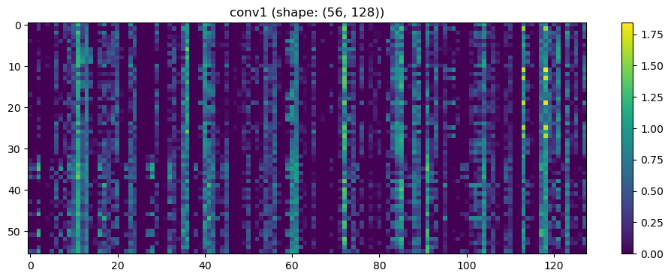

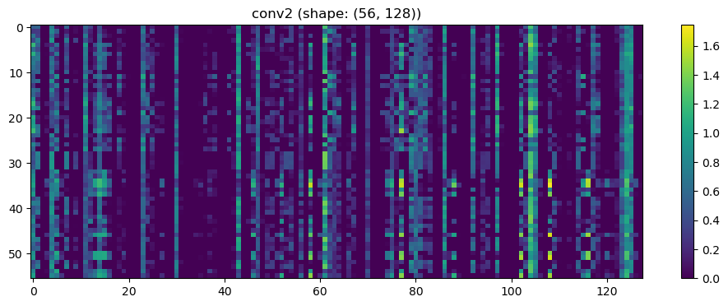

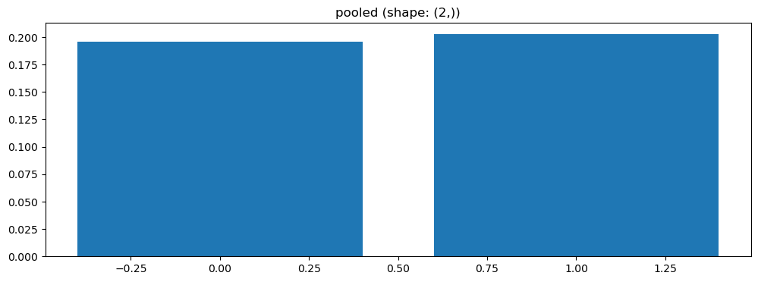

Split 2 Accuracy: 0.4286

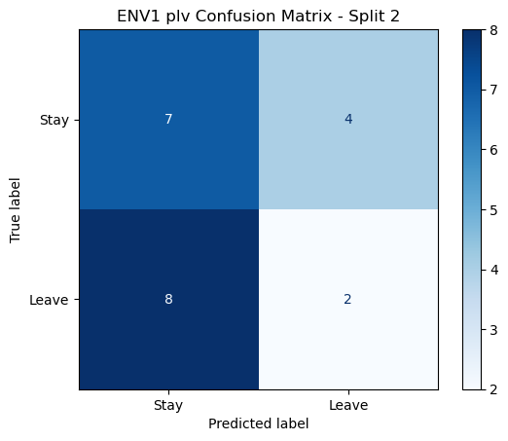

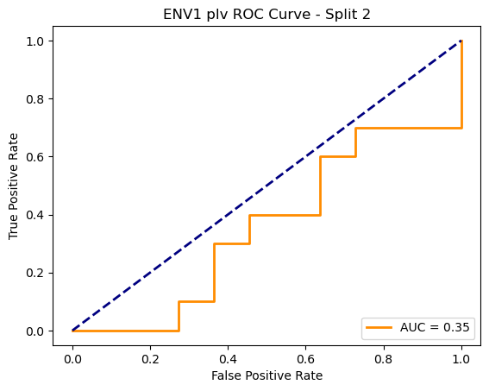

=== ENV1 Split 3/5 ===

After oversampling, class counts: Counter({1: 43, 0: 43})

C:\Users\sansk\miniconda3\Lib\site-packages\torch_geometric\deprecation.py:26: UserWarning: 'data.DataLoader' is deprecated, use 'loader.DataLoader' instead

warnings.warn(out)

Epoch 1/200 | Loss: 0.6867

Epoch 2/200 | Loss: 0.7293

Epoch 3/200 | Loss: 0.7514

Epoch 4/200 | Loss: 0.7444

Epoch 5/200 | Loss: 0.6998

Epoch 6/200 | Loss: 0.6995

Epoch 7/200 | Loss: 0.7409

Epoch 8/200 | Loss: 0.7183

Epoch 9/200 | Loss: 0.7562

Epoch 10/200 | Loss: 0.7096

Epoch 11/200 | Loss: 0.7190

Epoch 12/200 | Loss: 0.7485

Epoch 13/200 | Loss: 0.7323

Epoch 14/200 | Loss: 0.7588

Epoch 15/200 | Loss: 0.7014

Epoch 16/200 | Loss: 0.6994

Epoch 17/200 | Loss: 0.6952

Epoch 18/200 | Loss: 0.7535

Epoch 19/200 | Loss: 0.7028

Epoch 20/200 | Loss: 0.6851

Epoch 21/200 | Loss: 0.7006

Epoch 22/200 | Loss: 0.7588

Epoch 23/200 | Loss: 0.7696

Epoch 24/200 | Loss: 0.7223

Epoch 25/200 | Loss: 0.7589

Epoch 26/200 | Loss: 0.7550

Epoch 27/200 | Loss: 0.7498

Epoch 28/200 | Loss: 0.6745

Epoch 29/200 | Loss: 0.7687

Epoch 30/200 | Loss: 0.6235

Epoch 31/200 | Loss: 0.7269

Epoch 32/200 | Loss: 0.7381

Epoch 33/200 | Loss: 0.7912

Epoch 34/200 | Loss: 0.7095

Epoch 35/200 | Loss: 0.7406

Epoch 36/200 | Loss: 0.6682

Epoch 37/200 | Loss: 0.7299

Epoch 38/200 | Loss: 0.7284

Epoch 39/200 | Loss: 0.7609

Epoch 40/200 | Loss: 0.6740

Epoch 41/200 | Loss: 0.7580

Epoch 42/200 | Loss: 0.7366

Epoch 43/200 | Loss: 0.6752

Epoch 44/200 | Loss: 0.6900

Epoch 45/200 | Loss: 0.6981

Epoch 46/200 | Loss: 0.6243

Epoch 47/200 | Loss: 0.7127

Epoch 48/200 | Loss: 0.7238

Epoch 49/200 | Loss: 0.7099

Epoch 50/200 | Loss: 0.7538

Epoch 51/200 | Loss: 0.7433

Epoch 52/200 | Loss: 0.6994

Epoch 53/200 | Loss: 0.7633

Epoch 54/200 | Loss: 0.6874

Epoch 55/200 | Loss: 0.6509

Epoch 56/200 | Loss: 0.6416

Epoch 57/200 | Loss: 0.7009

Epoch 58/200 | Loss: 0.7404

Epoch 59/200 | Loss: 0.6904

Epoch 60/200 | Loss: 0.7673

Epoch 61/200 | Loss: 0.6293

Epoch 62/200 | Loss: 0.7197

Epoch 63/200 | Loss: 0.6910

Epoch 64/200 | Loss: 0.6885

Epoch 65/200 | Loss: 0.7679

Epoch 66/200 | Loss: 0.7046

Epoch 67/200 | Loss: 0.7151

Epoch 68/200 | Loss: 0.6952

Epoch 69/200 | Loss: 0.6872

Epoch 70/200 | Loss: 0.7525

Epoch 71/200 | Loss: 0.7279

Epoch 72/200 | Loss: 0.6479

Epoch 73/200 | Loss: 0.6546

Epoch 74/200 | Loss: 0.6951

Epoch 75/200 | Loss: 0.6709

Epoch 76/200 | Loss: 0.6817

Epoch 77/200 | Loss: 0.6919

Epoch 78/200 | Loss: 0.7024

Epoch 79/200 | Loss: 0.7711

Epoch 80/200 | Loss: 0.7116

Epoch 81/200 | Loss: 0.7338

Epoch 82/200 | Loss: 0.6770

Epoch 83/200 | Loss: 0.7232

Epoch 84/200 | Loss: 0.6853

Epoch 85/200 | Loss: 0.7612

Epoch 86/200 | Loss: 0.7162

Epoch 87/200 | Loss: 0.6781

Epoch 88/200 | Loss: 0.7088

Epoch 89/200 | Loss: 0.6647

Epoch 90/200 | Loss: 0.6714

Epoch 91/200 | Loss: 0.7354

Epoch 92/200 | Loss: 0.7140

Epoch 93/200 | Loss: 0.6876

Epoch 94/200 | Loss: 0.7199

Epoch 95/200 | Loss: 0.6810

Epoch 96/200 | Loss: 0.7199

Epoch 97/200 | Loss: 0.6968

Epoch 98/200 | Loss: 0.6806

Epoch 99/200 | Loss: 0.6158

Epoch 100/200 | Loss: 0.7784

Epoch 101/200 | Loss: 0.6719

Epoch 102/200 | Loss: 0.6698

Epoch 103/200 | Loss: 0.6894

Epoch 104/200 | Loss: 0.6159

Epoch 105/200 | Loss: 0.6769

Epoch 106/200 | Loss: 0.7518

Epoch 107/200 | Loss: 0.6788

Epoch 108/200 | Loss: 0.7406

Epoch 109/200 | Loss: 0.6899

Epoch 110/200 | Loss: 0.7147

Epoch 111/200 | Loss: 0.6993

Epoch 112/200 | Loss: 0.6636

Epoch 113/200 | Loss: 0.6796

Epoch 114/200 | Loss: 0.7131

Epoch 115/200 | Loss: 0.6344

Epoch 116/200 | Loss: 0.6482

Epoch 117/200 | Loss: 0.6785

Epoch 118/200 | Loss: 0.7236

Epoch 119/200 | Loss: 0.6173

Epoch 120/200 | Loss: 0.6496

Epoch 121/200 | Loss: 0.7412

Epoch 122/200 | Loss: 0.6931

Epoch 123/200 | Loss: 0.6866

Epoch 124/200 | Loss: 0.6734

Epoch 125/200 | Loss: 0.6484

Epoch 126/200 | Loss: 0.6136

Epoch 127/200 | Loss: 0.7247

Epoch 128/200 | Loss: 0.6684

Epoch 129/200 | Loss: 0.7325

Epoch 130/200 | Loss: 0.7361

Epoch 131/200 | Loss: 0.7091

Epoch 132/200 | Loss: 0.6991

Epoch 133/200 | Loss: 0.6639

Epoch 134/200 | Loss: 0.6796

Epoch 135/200 | Loss: 0.6486

Epoch 136/200 | Loss: 0.6789

Epoch 137/200 | Loss: 0.7111

Epoch 138/200 | Loss: 0.6827

Epoch 139/200 | Loss: 0.6461

Epoch 140/200 | Loss: 0.7059

Epoch 141/200 | Loss: 0.6707

Epoch 142/200 | Loss: 0.6482

Epoch 143/200 | Loss: 0.6038

Epoch 144/200 | Loss: 0.6311

Epoch 145/200 | Loss: 0.6742

Epoch 146/200 | Loss: 0.6931

Epoch 147/200 | Loss: 0.6656

Epoch 148/200 | Loss: 0.6135

Epoch 149/200 | Loss: 0.5779

Epoch 150/200 | Loss: 0.7032

Epoch 151/200 | Loss: 0.6567

Epoch 152/200 | Loss: 0.6839

Epoch 153/200 | Loss: 0.6478

Epoch 154/200 | Loss: 0.6509

Epoch 155/200 | Loss: 0.6447

Epoch 156/200 | Loss: 0.6345

Epoch 157/200 | Loss: 0.6436

Epoch 158/200 | Loss: 0.7135

Epoch 159/200 | Loss: 0.6632

Epoch 160/200 | Loss: 0.6527

Epoch 161/200 | Loss: 0.7127

Epoch 162/200 | Loss: 0.6835

Epoch 163/200 | Loss: 0.6043

Epoch 164/200 | Loss: 0.6050

Epoch 165/200 | Loss: 0.6615

Epoch 166/200 | Loss: 0.7249

Epoch 167/200 | Loss: 0.6534

Epoch 168/200 | Loss: 0.6919

Epoch 169/200 | Loss: 0.7043

Epoch 170/200 | Loss: 0.6364

Epoch 171/200 | Loss: 0.6022

Epoch 172/200 | Loss: 0.6300

Epoch 173/200 | Loss: 0.7328

Epoch 174/200 | Loss: 0.6288

Epoch 175/200 | Loss: 0.6790

Epoch 176/200 | Loss: 0.6251

Epoch 177/200 | Loss: 0.6027

Epoch 178/200 | Loss: 0.6699

Epoch 179/200 | Loss: 0.7186

Epoch 180/200 | Loss: 0.6385

Epoch 181/200 | Loss: 0.6624

Epoch 182/200 | Loss: 0.6830

Epoch 183/200 | Loss: 0.7052

Epoch 184/200 | Loss: 0.6740

Epoch 185/200 | Loss: 0.5979

Epoch 186/200 | Loss: 0.6613

Epoch 187/200 | Loss: 0.6576

Epoch 188/200 | Loss: 0.6228

Epoch 189/200 | Loss: 0.6996

Epoch 190/200 | Loss: 0.6076

Epoch 191/200 | Loss: 0.6768

Epoch 192/200 | Loss: 0.7211

Epoch 193/200 | Loss: 0.6211

Epoch 194/200 | Loss: 0.6640

Epoch 195/200 | Loss: 0.6232

Epoch 196/200 | Loss: 0.5909

Epoch 197/200 | Loss: 0.6292

Epoch 198/200 | Loss: 0.7170

Epoch 199/200 | Loss: 0.6579

Epoch 200/200 | Loss: 0.6804

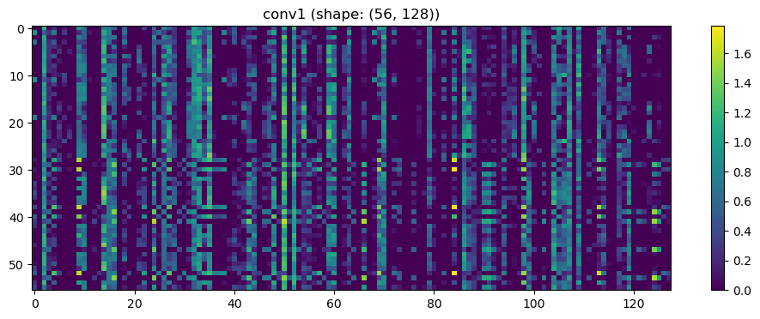

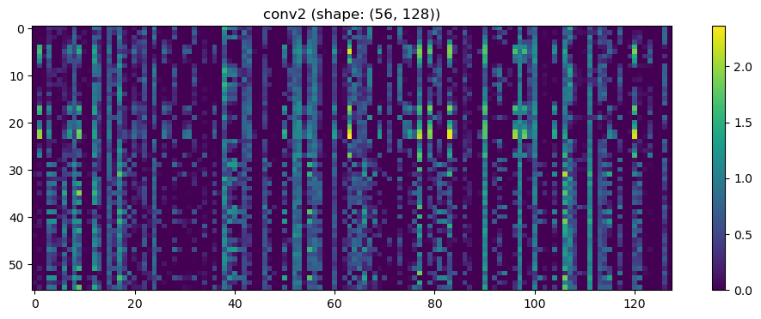

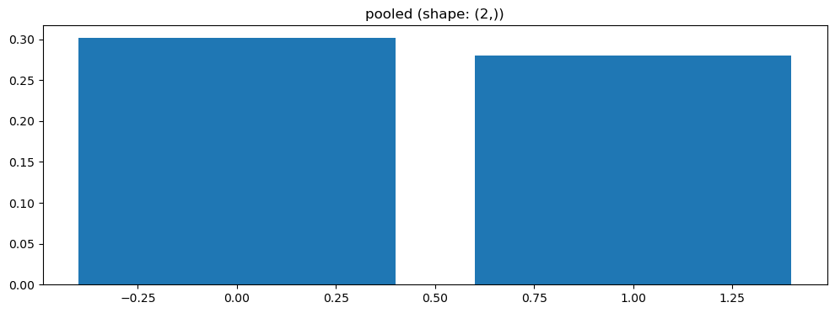

Split 3 Accuracy: 0.7619

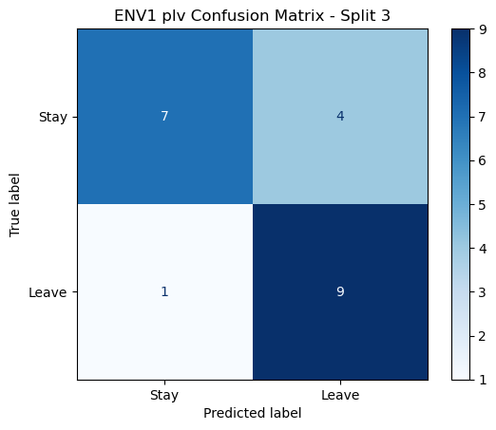

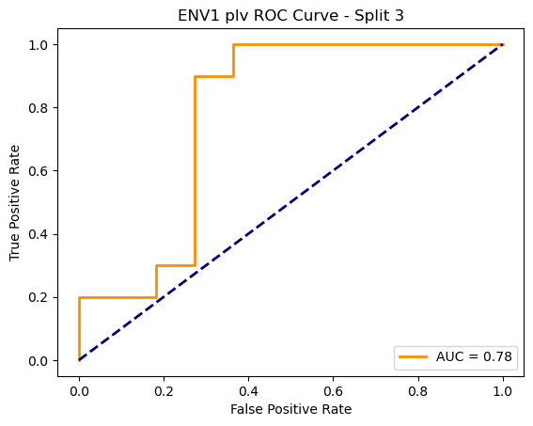

=== ENV1 Split 4/5 ===

After oversampling, class counts: Counter({1: 44, 0: 44})

C:\Users\sansk\miniconda3\Lib\site-packages\torch_geometric\deprecation.py:26: UserWarning: 'data.DataLoader' is deprecated, use 'loader.DataLoader' instead

warnings.warn(out)

Epoch 1/200 | Loss: 0.7897

Epoch 2/200 | Loss: 0.7801

Epoch 3/200 | Loss: 0.7701

Epoch 4/200 | Loss: 0.7381

Epoch 5/200 | Loss: 0.8125

Epoch 6/200 | Loss: 0.7637

Epoch 7/200 | Loss: 0.8430

Epoch 8/200 | Loss: 0.7903

Epoch 9/200 | Loss: 0.8212

Epoch 10/200 | Loss: 0.8008

Epoch 11/200 | Loss: 0.8344

Epoch 12/200 | Loss: 0.7966

Epoch 13/200 | Loss: 0.7949

Epoch 14/200 | Loss: 0.7878

Epoch 15/200 | Loss: 0.7715

Epoch 16/200 | Loss: 0.7993

Epoch 17/200 | Loss: 0.7414

Epoch 18/200 | Loss: 0.8064

Epoch 19/200 | Loss: 0.7651

Epoch 20/200 | Loss: 0.8162

Epoch 21/200 | Loss: 0.7071

Epoch 22/200 | Loss: 0.8268

Epoch 23/200 | Loss: 0.7449

Epoch 24/200 | Loss: 0.7313

Epoch 25/200 | Loss: 0.6993

Epoch 26/200 | Loss: 0.7384

Epoch 27/200 | Loss: 0.6698

Epoch 28/200 | Loss: 0.7219

Epoch 29/200 | Loss: 0.7649

Epoch 30/200 | Loss: 0.8168

Epoch 31/200 | Loss: 0.7296

Epoch 32/200 | Loss: 0.7493

Epoch 33/200 | Loss: 0.7729

Epoch 34/200 | Loss: 0.8099

Epoch 35/200 | Loss: 0.7115

Epoch 36/200 | Loss: 0.7969

Epoch 37/200 | Loss: 0.7652

Epoch 38/200 | Loss: 0.7474

Epoch 39/200 | Loss: 0.6968

Epoch 40/200 | Loss: 0.7380

Epoch 41/200 | Loss: 0.7904

Epoch 42/200 | Loss: 0.7406

Epoch 43/200 | Loss: 0.7337

Epoch 44/200 | Loss: 0.7438

Epoch 45/200 | Loss: 0.7842

Epoch 46/200 | Loss: 0.7930

Epoch 47/200 | Loss: 0.6786

Epoch 48/200 | Loss: 0.7253

Epoch 49/200 | Loss: 0.7523

Epoch 50/200 | Loss: 0.7527

Epoch 51/200 | Loss: 0.7388

Epoch 52/200 | Loss: 0.7100

Epoch 53/200 | Loss: 0.7588

Epoch 54/200 | Loss: 0.6972

Epoch 55/200 | Loss: 0.7352

Epoch 56/200 | Loss: 0.7581

Epoch 57/200 | Loss: 0.7366

Epoch 58/200 | Loss: 0.7824

Epoch 59/200 | Loss: 0.7618

Epoch 60/200 | Loss: 0.6960

Epoch 61/200 | Loss: 0.6873

Epoch 62/200 | Loss: 0.7631

Epoch 63/200 | Loss: 0.7173

Epoch 64/200 | Loss: 0.7591

Epoch 65/200 | Loss: 0.7526

Epoch 66/200 | Loss: 0.6955

Epoch 67/200 | Loss: 0.7457

Epoch 68/200 | Loss: 0.7522

Epoch 69/200 | Loss: 0.7664

Epoch 70/200 | Loss: 0.7254

Epoch 71/200 | Loss: 0.6854

Epoch 72/200 | Loss: 0.7566

Epoch 73/200 | Loss: 0.7121

Epoch 74/200 | Loss: 0.6903

Epoch 75/200 | Loss: 0.7013

Epoch 76/200 | Loss: 0.7205

Epoch 77/200 | Loss: 0.7197

Epoch 78/200 | Loss: 0.7216

Epoch 79/200 | Loss: 0.6997

Epoch 80/200 | Loss: 0.6479

Epoch 81/200 | Loss: 0.7210

Epoch 82/200 | Loss: 0.7021

Epoch 83/200 | Loss: 0.7352

Epoch 84/200 | Loss: 0.7576

Epoch 85/200 | Loss: 0.7783

Epoch 86/200 | Loss: 0.6538

Epoch 87/200 | Loss: 0.6901

Epoch 88/200 | Loss: 0.7415

Epoch 89/200 | Loss: 0.7419

Epoch 90/200 | Loss: 0.6981

Epoch 91/200 | Loss: 0.7088

Epoch 92/200 | Loss: 0.7295

Epoch 93/200 | Loss: 0.7325

Epoch 94/200 | Loss: 0.7296

Epoch 95/200 | Loss: 0.7255

Epoch 96/200 | Loss: 0.6747

Epoch 97/200 | Loss: 0.7074

Epoch 98/200 | Loss: 0.7525

Epoch 99/200 | Loss: 0.6953

Epoch 100/200 | Loss: 0.7655

Epoch 101/200 | Loss: 0.7060

Epoch 102/200 | Loss: 0.6922

Epoch 103/200 | Loss: 0.6267

Epoch 104/200 | Loss: 0.7194

Epoch 105/200 | Loss: 0.7108

Epoch 106/200 | Loss: 0.6663

Epoch 107/200 | Loss: 0.7038

Epoch 108/200 | Loss: 0.7010

Epoch 109/200 | Loss: 0.7635

Epoch 110/200 | Loss: 0.7193

Epoch 111/200 | Loss: 0.6888

Epoch 112/200 | Loss: 0.6139

Epoch 113/200 | Loss: 0.7372

Epoch 114/200 | Loss: 0.6643

Epoch 115/200 | Loss: 0.6729

Epoch 116/200 | Loss: 0.7193

Epoch 117/200 | Loss: 0.7279

Epoch 118/200 | Loss: 0.7227

Epoch 119/200 | Loss: 0.6765

Epoch 120/200 | Loss: 0.7394

Epoch 121/200 | Loss: 0.6666

Epoch 122/200 | Loss: 0.7099

Epoch 123/200 | Loss: 0.6089

Epoch 124/200 | Loss: 0.6713

Epoch 125/200 | Loss: 0.6729

Epoch 126/200 | Loss: 0.6619

Epoch 127/200 | Loss: 0.7707

Epoch 128/200 | Loss: 0.6149

Epoch 129/200 | Loss: 0.7013

Epoch 130/200 | Loss: 0.7188

Epoch 131/200 | Loss: 0.6987

Epoch 132/200 | Loss: 0.6635

Epoch 133/200 | Loss: 0.7014

Epoch 134/200 | Loss: 0.7192

Epoch 135/200 | Loss: 0.7133

Epoch 136/200 | Loss: 0.6899

Epoch 137/200 | Loss: 0.6805

Epoch 138/200 | Loss: 0.6884

Epoch 139/200 | Loss: 0.6407

Epoch 140/200 | Loss: 0.6926

Epoch 141/200 | Loss: 0.6904

Epoch 142/200 | Loss: 0.6751

Epoch 143/200 | Loss: 0.7023

Epoch 144/200 | Loss: 0.6407

Epoch 145/200 | Loss: 0.6574

Epoch 146/200 | Loss: 0.6628

Epoch 147/200 | Loss: 0.6586

Epoch 148/200 | Loss: 0.6625

Epoch 149/200 | Loss: 0.6944

Epoch 150/200 | Loss: 0.6600

Epoch 151/200 | Loss: 0.6500

Epoch 152/200 | Loss: 0.6968

Epoch 153/200 | Loss: 0.6238

Epoch 154/200 | Loss: 0.7127

Epoch 155/200 | Loss: 0.6691

Epoch 156/200 | Loss: 0.6247

Epoch 157/200 | Loss: 0.6947

Epoch 158/200 | Loss: 0.6680

Epoch 159/200 | Loss: 0.6435

Epoch 160/200 | Loss: 0.6688

Epoch 161/200 | Loss: 0.7060

Epoch 162/200 | Loss: 0.7243

Epoch 163/200 | Loss: 0.6758

Epoch 164/200 | Loss: 0.6641

Epoch 165/200 | Loss: 0.6674

Epoch 166/200 | Loss: 0.6459

Epoch 167/200 | Loss: 0.7191

Epoch 168/200 | Loss: 0.6466

Epoch 169/200 | Loss: 0.6185

Epoch 170/200 | Loss: 0.6619

Epoch 171/200 | Loss: 0.5908

Epoch 172/200 | Loss: 0.6826

Epoch 173/200 | Loss: 0.6544

Epoch 174/200 | Loss: 0.6375

Epoch 175/200 | Loss: 0.7424

Epoch 176/200 | Loss: 0.6555

Epoch 177/200 | Loss: 0.6925

Epoch 178/200 | Loss: 0.6474

Epoch 179/200 | Loss: 0.6728

Epoch 180/200 | Loss: 0.7071

Epoch 181/200 | Loss: 0.6731

Epoch 182/200 | Loss: 0.6754

Epoch 183/200 | Loss: 0.7148

Epoch 184/200 | Loss: 0.6090

Epoch 185/200 | Loss: 0.6821

Epoch 186/200 | Loss: 0.6558

Epoch 187/200 | Loss: 0.6661

Epoch 188/200 | Loss: 0.6602

Epoch 189/200 | Loss: 0.6174

Epoch 190/200 | Loss: 0.6327

Epoch 191/200 | Loss: 0.6850

Epoch 192/200 | Loss: 0.6430

Epoch 193/200 | Loss: 0.6016

Epoch 194/200 | Loss: 0.6698

Epoch 195/200 | Loss: 0.7034

Epoch 196/200 | Loss: 0.6941

Epoch 197/200 | Loss: 0.6831

Epoch 198/200 | Loss: 0.6261

Epoch 199/200 | Loss: 0.7202

Epoch 200/200 | Loss: 0.6464

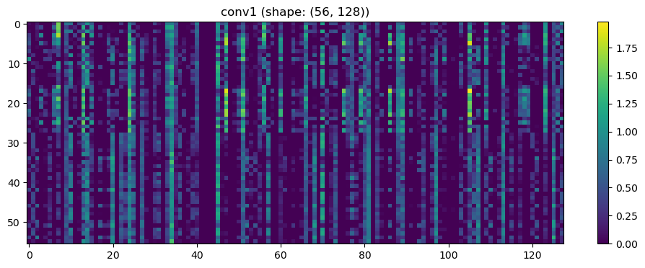

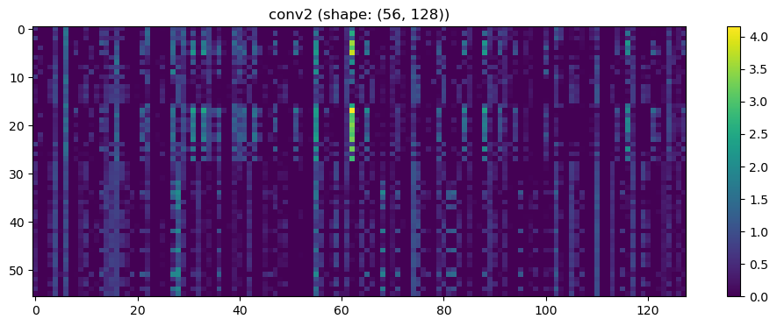

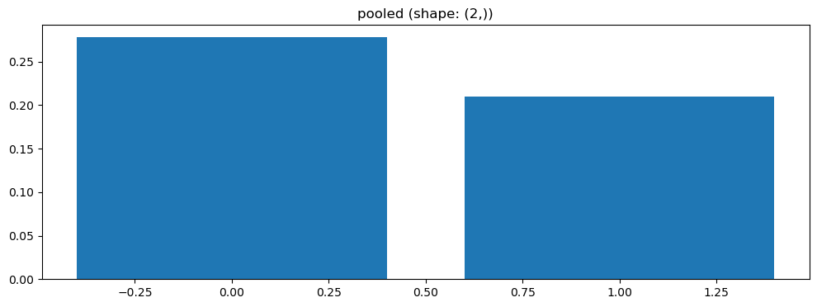

Split 4 Accuracy: 0.6190

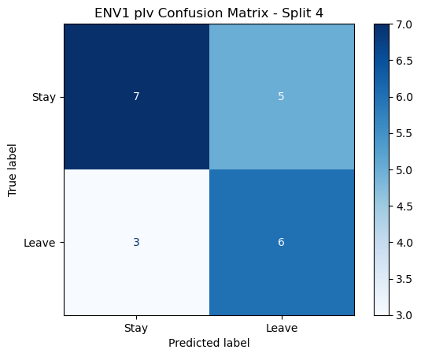

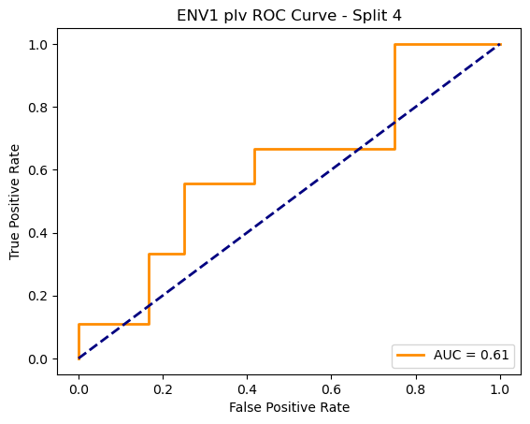

=== ENV1 Split 5/5 ===

After oversampling, class counts: Counter({1: 44, 0: 44})

C:\Users\sansk\miniconda3\Lib\site-packages\torch_geometric\deprecation.py:26: UserWarning: 'data.DataLoader' is deprecated, use 'loader.DataLoader' instead

warnings.warn(out)

Epoch 1/100 | Loss: 0.7598

Epoch 2/100 | Loss: 0.7133

Epoch 3/100 | Loss: 0.7119

Epoch 4/100 | Loss: 0.7217

Epoch 5/100 | Loss: 0.7027

Epoch 6/100 | Loss: 0.7270

Epoch 7/100 | Loss: 0.7330

Epoch 8/100 | Loss: 0.7727

Epoch 9/100 | Loss: 0.6929

Epoch 10/100 | Loss: 0.7604

Epoch 11/100 | Loss: 0.7657

Epoch 12/100 | Loss: 0.6977

Epoch 13/100 | Loss: 0.7214

Epoch 14/100 | Loss: 0.7327

Epoch 15/100 | Loss: 0.7127

Epoch 16/100 | Loss: 0.7025

Epoch 17/100 | Loss: 0.7595

Epoch 18/100 | Loss: 0.6820

Epoch 19/100 | Loss: 0.7304

Epoch 20/100 | Loss: 0.6290

Epoch 21/100 | Loss: 0.7391

Epoch 22/100 | Loss: 0.6704

Epoch 23/100 | Loss: 0.7499

Epoch 24/100 | Loss: 0.7225

Epoch 25/100 | Loss: 0.6973

Epoch 26/100 | Loss: 0.7197

Epoch 27/100 | Loss: 0.6993

Epoch 28/100 | Loss: 0.7293

Epoch 29/100 | Loss: 0.7147

Epoch 30/100 | Loss: 0.7033

Epoch 31/100 | Loss: 0.7003

Epoch 32/100 | Loss: 0.6389

Epoch 33/100 | Loss: 0.7527

Epoch 34/100 | Loss: 0.6971

Epoch 35/100 | Loss: 0.7016

Epoch 36/100 | Loss: 0.6697

Epoch 37/100 | Loss: 0.7186

Epoch 38/100 | Loss: 0.6983

Epoch 39/100 | Loss: 0.7135

Epoch 40/100 | Loss: 0.6448

Epoch 41/100 | Loss: 0.6840

Epoch 42/100 | Loss: 0.7337

Epoch 43/100 | Loss: 0.6638

Epoch 44/100 | Loss: 0.7090

Epoch 45/100 | Loss: 0.7414

Epoch 46/100 | Loss: 0.6929

Epoch 47/100 | Loss: 0.7092

Epoch 48/100 | Loss: 0.6580

Epoch 49/100 | Loss: 0.7074

Epoch 50/100 | Loss: 0.6884

Epoch 51/100 | Loss: 0.6802

Epoch 52/100 | Loss: 0.6760

Epoch 53/100 | Loss: 0.7182

Epoch 54/100 | Loss: 0.7257

Epoch 55/100 | Loss: 0.7165

Epoch 56/100 | Loss: 0.6732

Epoch 57/100 | Loss: 0.7123

Epoch 58/100 | Loss: 0.6690

Epoch 59/100 | Loss: 0.6809

Epoch 60/100 | Loss: 0.6600

Epoch 61/100 | Loss: 0.6853

Epoch 62/100 | Loss: 0.7184

Epoch 63/100 | Loss: 0.7024

Epoch 64/100 | Loss: 0.7054

Epoch 65/100 | Loss: 0.7391

Epoch 66/100 | Loss: 0.7357

Epoch 67/100 | Loss: 0.6923

Epoch 68/100 | Loss: 0.6846

Epoch 69/100 | Loss: 0.6899

Epoch 70/100 | Loss: 0.6846

Epoch 71/100 | Loss: 0.6840

Epoch 72/100 | Loss: 0.7107

Epoch 73/100 | Loss: 0.6765

Epoch 74/100 | Loss: 0.6973

Epoch 75/100 | Loss: 0.7023

Epoch 76/100 | Loss: 0.6914

Epoch 77/100 | Loss: 0.7309

Epoch 78/100 | Loss: 0.7075

Epoch 79/100 | Loss: 0.7013

Epoch 80/100 | Loss: 0.7208

Epoch 81/100 | Loss: 0.7413

Epoch 82/100 | Loss: 0.7544

Epoch 83/100 | Loss: 0.7195

Epoch 84/100 | Loss: 0.6490

Epoch 85/100 | Loss: 0.7239

Epoch 86/100 | Loss: 0.6868

Epoch 87/100 | Loss: 0.6895

Epoch 88/100 | Loss: 0.7203

Epoch 89/100 | Loss: 0.6611

Epoch 90/100 | Loss: 0.6537

Epoch 91/100 | Loss: 0.6821

Epoch 92/100 | Loss: 0.6779

Epoch 93/100 | Loss: 0.7235

Epoch 94/100 | Loss: 0.6796

Epoch 95/100 | Loss: 0.7089

Epoch 96/100 | Loss: 0.7713

Epoch 97/100 | Loss: 0.7096

Epoch 98/100 | Loss: 0.7079

Epoch 99/100 | Loss: 0.6739

Epoch 100/100 | Loss: 0.6957

Split 1 Accuracy: 0.4545

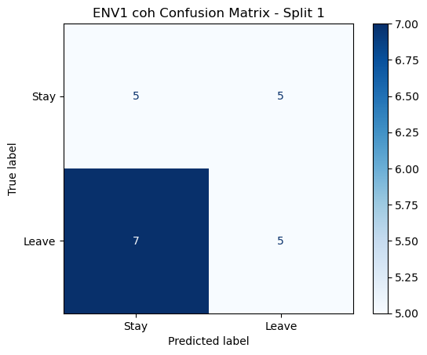

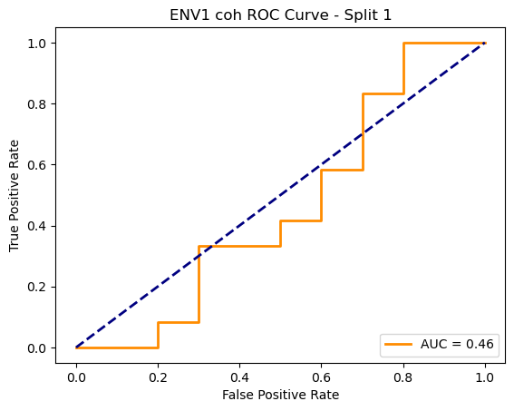

=== ENV1 Split 2/5 ===

Epoch 1/200 | Loss: 0.6908

Epoch 2/200 | Loss: 0.8105

Epoch 3/200 | Loss: 0.7496

Epoch 4/200 | Loss: 0.7298

Epoch 5/200 | Loss: 0.7643

Epoch 6/200 | Loss: 0.6649

Epoch 7/200 | Loss: 0.7018

Epoch 8/200 | Loss: 0.7493

Epoch 9/200 | Loss: 0.7432

Epoch 10/200 | Loss: 0.7133

Epoch 11/200 | Loss: 0.7794

Epoch 12/200 | Loss: 0.7172

Epoch 13/200 | Loss: 0.7239

Epoch 14/200 | Loss: 0.6975

Epoch 15/200 | Loss: 0.6958

Epoch 16/200 | Loss: 0.7393

Epoch 17/200 | Loss: 0.6949

Epoch 18/200 | Loss: 0.7252

Epoch 19/200 | Loss: 0.7684

Epoch 20/200 | Loss: 0.7463

Epoch 21/200 | Loss: 0.7360

Epoch 22/200 | Loss: 0.7132

Epoch 23/200 | Loss: 0.7772

Epoch 24/200 | Loss: 0.6945

Epoch 25/200 | Loss: 0.7393

Epoch 26/200 | Loss: 0.7069

Epoch 27/200 | Loss: 0.6701

Epoch 28/200 | Loss: 0.6664

Epoch 29/200 | Loss: 0.7818

Epoch 30/200 | Loss: 0.7769

Epoch 31/200 | Loss: 0.8030

Epoch 32/200 | Loss: 0.7662

Epoch 33/200 | Loss: 0.7190

Epoch 34/200 | Loss: 0.6677

Epoch 35/200 | Loss: 0.6921

Epoch 36/200 | Loss: 0.6758

Epoch 37/200 | Loss: 0.6650

Epoch 38/200 | Loss: 0.6681

Epoch 39/200 | Loss: 0.7371

Epoch 40/200 | Loss: 0.7018

Epoch 41/200 | Loss: 0.6953

Epoch 42/200 | Loss: 0.6678

Epoch 43/200 | Loss: 0.6637

Epoch 44/200 | Loss: 0.7953

Epoch 45/200 | Loss: 0.7590

Epoch 46/200 | Loss: 0.6464

Epoch 47/200 | Loss: 0.6928

Epoch 48/200 | Loss: 0.7027

Epoch 49/200 | Loss: 0.7355

Epoch 50/200 | Loss: 0.7319

Epoch 51/200 | Loss: 0.6963

Epoch 52/200 | Loss: 0.7025

Epoch 53/200 | Loss: 0.7359

Epoch 54/200 | Loss: 0.6991

Epoch 55/200 | Loss: 0.6990

Epoch 56/200 | Loss: 0.7544

Epoch 57/200 | Loss: 0.6786

Epoch 58/200 | Loss: 0.6908

Epoch 59/200 | Loss: 0.6818

Epoch 60/200 | Loss: 0.6880

Epoch 61/200 | Loss: 0.6632

Epoch 62/200 | Loss: 0.7108

Epoch 63/200 | Loss: 0.7468

Epoch 64/200 | Loss: 0.6734

Epoch 65/200 | Loss: 0.7351

Epoch 66/200 | Loss: 0.7324

Epoch 67/200 | Loss: 0.7089

Epoch 68/200 | Loss: 0.6991

Epoch 69/200 | Loss: 0.7199

Epoch 70/200 | Loss: 0.7220

Epoch 71/200 | Loss: 0.7494

Epoch 72/200 | Loss: 0.6958

Epoch 73/200 | Loss: 0.6954

Epoch 74/200 | Loss: 0.7221

Epoch 75/200 | Loss: 0.6864

Epoch 76/200 | Loss: 0.7096

Epoch 77/200 | Loss: 0.7457

Epoch 78/200 | Loss: 0.7155

Epoch 79/200 | Loss: 0.6831

Epoch 80/200 | Loss: 0.6776

Epoch 81/200 | Loss: 0.6958

Epoch 82/200 | Loss: 0.7513

Epoch 83/200 | Loss: 0.6685

Epoch 84/200 | Loss: 0.6425

Epoch 85/200 | Loss: 0.6840

Epoch 86/200 | Loss: 0.7175

Epoch 87/200 | Loss: 0.6988

Epoch 88/200 | Loss: 0.7368

Epoch 89/200 | Loss: 0.6397

Epoch 90/200 | Loss: 0.6263

Epoch 91/200 | Loss: 0.6355

Epoch 92/200 | Loss: 0.6861

Epoch 93/200 | Loss: 0.6065

Epoch 94/200 | Loss: 0.6607

Epoch 95/200 | Loss: 0.6427

Epoch 96/200 | Loss: 0.7235

Epoch 97/200 | Loss: 0.6717

Epoch 98/200 | Loss: 0.6282

Epoch 99/200 | Loss: 0.6770

Epoch 100/200 | Loss: 0.6419

Epoch 101/200 | Loss: 0.7312

Epoch 102/200 | Loss: 0.6548

Epoch 103/200 | Loss: 0.6273

Epoch 104/200 | Loss: 0.6885

Epoch 105/200 | Loss: 0.7375

Epoch 106/200 | Loss: 0.6664

Epoch 107/200 | Loss: 0.7266

Epoch 108/200 | Loss: 0.7544

Epoch 109/200 | Loss: 0.6932

Epoch 110/200 | Loss: 0.6273

Epoch 111/200 | Loss: 0.6360

Epoch 112/200 | Loss: 0.6585

Epoch 113/200 | Loss: 0.6772

Epoch 114/200 | Loss: 0.6366

Epoch 115/200 | Loss: 0.6620

Epoch 116/200 | Loss: 0.6931

Epoch 117/200 | Loss: 0.6495

Epoch 118/200 | Loss: 0.6605

Epoch 119/200 | Loss: 0.6672

Epoch 120/200 | Loss: 0.6558

Epoch 121/200 | Loss: 0.6914

Epoch 122/200 | Loss: 0.6807

Epoch 123/200 | Loss: 0.5737

Epoch 124/200 | Loss: 0.6083

Epoch 125/200 | Loss: 0.7305

Epoch 126/200 | Loss: 0.6166

Epoch 127/200 | Loss: 0.6531

Epoch 128/200 | Loss: 0.5896

Epoch 129/200 | Loss: 0.6208

Epoch 130/200 | Loss: 0.6409

Epoch 131/200 | Loss: 0.6866

Epoch 132/200 | Loss: 0.6377

Epoch 133/200 | Loss: 0.6689

Epoch 134/200 | Loss: 0.6880

Epoch 135/200 | Loss: 0.7069

Epoch 136/200 | Loss: 0.6703

Epoch 137/200 | Loss: 0.6263

Epoch 138/200 | Loss: 0.7327

Epoch 139/200 | Loss: 0.6582

Epoch 140/200 | Loss: 0.6541

Epoch 141/200 | Loss: 0.6632

Epoch 142/200 | Loss: 0.6825

Epoch 143/200 | Loss: 0.6183

Epoch 144/200 | Loss: 0.6642

Epoch 145/200 | Loss: 0.6477

Epoch 146/200 | Loss: 0.6742

Epoch 147/200 | Loss: 0.5840

Epoch 148/200 | Loss: 0.6263

Epoch 149/200 | Loss: 0.7105

Epoch 150/200 | Loss: 0.6853

Epoch 151/200 | Loss: 0.6509

Epoch 152/200 | Loss: 0.6749

Epoch 153/200 | Loss: 0.7603

Epoch 154/200 | Loss: 0.6269

Epoch 155/200 | Loss: 0.6004

Epoch 156/200 | Loss: 0.5701

Epoch 157/200 | Loss: 0.7136

Epoch 158/200 | Loss: 0.6632

Epoch 159/200 | Loss: 0.6162

Epoch 160/200 | Loss: 0.7089

Epoch 161/200 | Loss: 0.6361

Epoch 162/200 | Loss: 0.6491

Epoch 163/200 | Loss: 0.6272

Epoch 164/200 | Loss: 0.6486

Epoch 165/200 | Loss: 0.6842

Epoch 166/200 | Loss: 0.6185

Epoch 167/200 | Loss: 0.6800

Epoch 168/200 | Loss: 0.6381

Epoch 169/200 | Loss: 0.6712

Epoch 170/200 | Loss: 0.6358

Epoch 171/200 | Loss: 0.6747

Epoch 172/200 | Loss: 0.5664

Epoch 173/200 | Loss: 0.6619

Epoch 174/200 | Loss: 0.6521

Epoch 175/200 | Loss: 0.6405

Epoch 176/200 | Loss: 0.5923

Epoch 177/200 | Loss: 0.6469

Epoch 178/200 | Loss: 0.6958

Epoch 179/200 | Loss: 0.6362

Epoch 180/200 | Loss: 0.6449

Epoch 181/200 | Loss: 0.6316

Epoch 182/200 | Loss: 0.5929

Epoch 183/200 | Loss: 0.6175

Epoch 184/200 | Loss: 0.6363

Epoch 185/200 | Loss: 0.6363

Epoch 186/200 | Loss: 0.6100

Epoch 187/200 | Loss: 0.6859

Epoch 188/200 | Loss: 0.6416

Epoch 189/200 | Loss: 0.6112

Epoch 190/200 | Loss: 0.5570

Epoch 191/200 | Loss: 0.6539

Epoch 192/200 | Loss: 0.6226

Epoch 193/200 | Loss: 0.6474

Epoch 194/200 | Loss: 0.6772

Epoch 195/200 | Loss: 0.6964

Epoch 196/200 | Loss: 0.6135

Epoch 197/200 | Loss: 0.6948

Epoch 198/200 | Loss: 0.6757

Epoch 199/200 | Loss: 0.6272

Epoch 200/200 | Loss: 0.6351

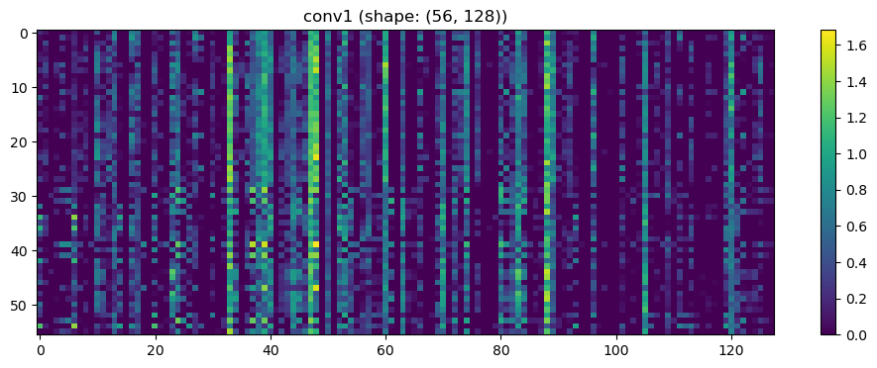

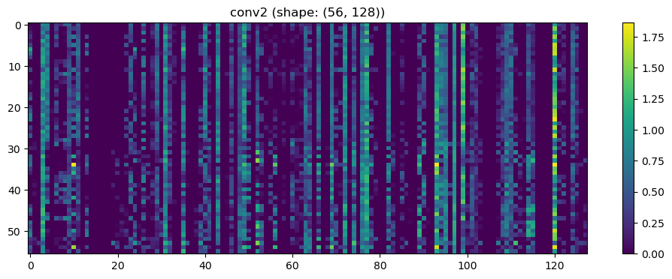

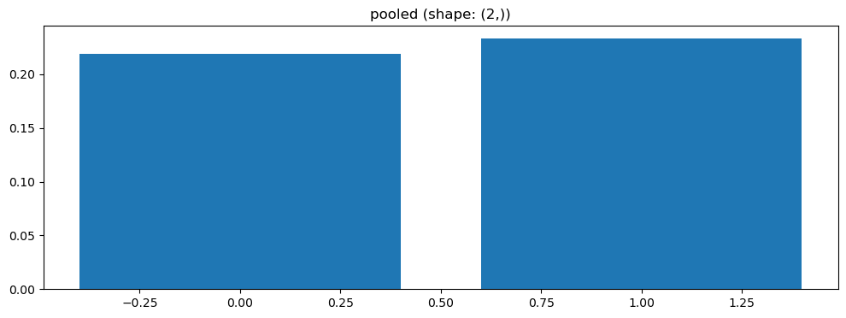

Split 5 Accuracy: 0.4286

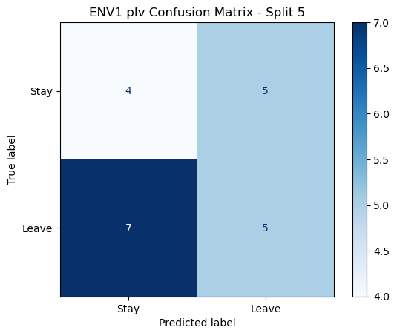

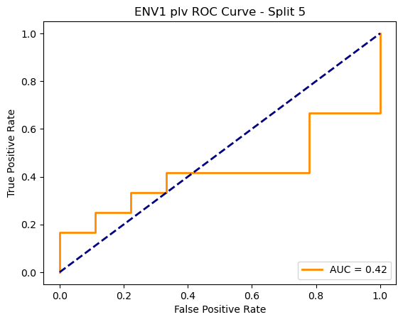

ENV1 plv Average Accuracy: 0.5567 ± 0.1257

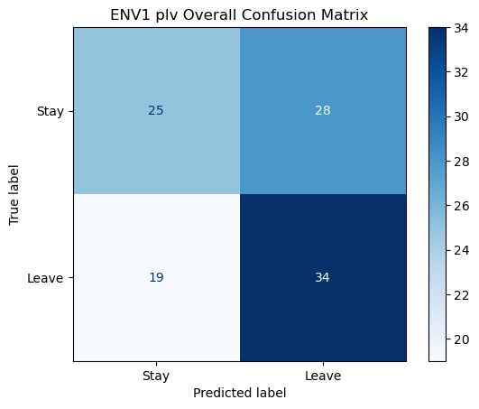

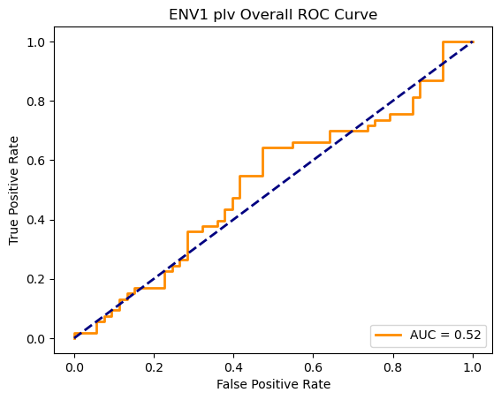

Loading ENV2 data...

ENV2: Loaded 106 trials (Stay: 53, Leave: 53)

Saving ENV2 connectivity matrices...

C:\Users\sansk\miniconda3\Lib\site-packages\scipy\signal\_spectral_py.py:1668: RuntimeWarning: invalid value encountered in divide

Cxy = np.abs(Pxy)**2 / Pxx / Pyy

Saved connectivity matrices to connectivity_matrices_env2

Shapes: (106, 28, 28) (106, 28, 28) (106, 28, 28)

Running GNN with corr connectivity for ENV2...

==================================================

Training GNN for ENV2 with corr connectivity

==================================================

=== ENV2 Split 1/5 ===

After oversampling, class counts: Counter({0: 43, 1: 43})

C:\Users\sansk\miniconda3\Lib\site-packages\torch_geometric\deprecation.py:26: UserWarning: 'data.DataLoader' is deprecated, use 'loader.DataLoader' instead

warnings.warn(out)

Epoch 1/200 | Loss: 0.8628

Epoch 2/200 | Loss: 0.6347

Epoch 3/200 | Loss: 0.7479

Epoch 4/200 | Loss: 0.7461

Epoch 5/200 | Loss: 0.7548

Epoch 6/200 | Loss: 0.7890

Epoch 7/200 | Loss: 0.7976

Epoch 8/200 | Loss: 0.7209

Epoch 9/200 | Loss: 0.7608

Epoch 10/200 | Loss: 0.7299

Epoch 11/200 | Loss: 0.7538

Epoch 12/200 | Loss: 0.7347

Epoch 13/200 | Loss: 0.7720

Epoch 14/200 | Loss: 0.6962

Epoch 15/200 | Loss: 0.7296

Epoch 16/200 | Loss: 0.6851

Epoch 17/200 | Loss: 0.7801

Epoch 18/200 | Loss: 0.7463

Epoch 19/200 | Loss: 0.7190

Epoch 20/200 | Loss: 0.7027

Epoch 21/200 | Loss: 0.7632

Epoch 22/200 | Loss: 0.7132

Epoch 23/200 | Loss: 0.7130

Epoch 24/200 | Loss: 0.6916

Epoch 25/200 | Loss: 0.7474

Epoch 26/200 | Loss: 0.7894

Epoch 27/200 | Loss: 0.7593

Epoch 28/200 | Loss: 0.7333

Epoch 29/200 | Loss: 0.7017

Epoch 30/200 | Loss: 0.7562

Epoch 31/200 | Loss: 0.7215

Epoch 32/200 | Loss: 0.7984

Epoch 33/200 | Loss: 0.7146

Epoch 34/200 | Loss: 0.7549

Epoch 35/200 | Loss: 0.7072

Epoch 36/200 | Loss: 0.7493

Epoch 37/200 | Loss: 0.7068

Epoch 38/200 | Loss: 0.6688

Epoch 39/200 | Loss: 0.7036

Epoch 40/200 | Loss: 0.7267

Epoch 41/200 | Loss: 0.7239

Epoch 42/200 | Loss: 0.7919

Epoch 43/200 | Loss: 0.7026

Epoch 44/200 | Loss: 0.7500

Epoch 45/200 | Loss: 0.7186

Epoch 46/200 | Loss: 0.7318

Epoch 47/200 | Loss: 0.7460

Epoch 48/200 | Loss: 0.7532

Epoch 49/200 | Loss: 0.6570

Epoch 50/200 | Loss: 0.6905

Epoch 51/200 | Loss: 0.6814

Epoch 52/200 | Loss: 0.7049

Epoch 53/200 | Loss: 0.8070

Epoch 54/200 | Loss: 0.7701

Epoch 55/200 | Loss: 0.7605

Epoch 56/200 | Loss: 0.6976

Epoch 57/200 | Loss: 0.7390

Epoch 58/200 | Loss: 0.7489

Epoch 59/200 | Loss: 0.6887

Epoch 60/200 | Loss: 0.7194

Epoch 61/200 | Loss: 0.7224

Epoch 62/200 | Loss: 0.7036

Epoch 63/200 | Loss: 0.7006

Epoch 64/200 | Loss: 0.6962

Epoch 65/200 | Loss: 0.7129

Epoch 66/200 | Loss: 0.6734

Epoch 67/200 | Loss: 0.6901

Epoch 68/200 | Loss: 0.7546

Epoch 69/200 | Loss: 0.7050

Epoch 70/200 | Loss: 0.6875

Epoch 71/200 | Loss: 0.7241

Epoch 72/200 | Loss: 0.7447

Epoch 73/200 | Loss: 0.7416

Epoch 74/200 | Loss: 0.6713

Epoch 75/200 | Loss: 0.7960

Epoch 76/200 | Loss: 0.7361

Epoch 77/200 | Loss: 0.7124

Epoch 78/200 | Loss: 0.6518

Epoch 79/200 | Loss: 0.7099

Epoch 80/200 | Loss: 0.6748

Epoch 81/200 | Loss: 0.6804

Epoch 82/200 | Loss: 0.7508

Epoch 83/200 | Loss: 0.7134

Epoch 84/200 | Loss: 0.6671

Epoch 85/200 | Loss: 0.6985

Epoch 86/200 | Loss: 0.6943

Epoch 87/200 | Loss: 0.6517

Epoch 88/200 | Loss: 0.6920

Epoch 89/200 | Loss: 0.7211

Epoch 90/200 | Loss: 0.6367

Epoch 91/200 | Loss: 0.7673

Epoch 92/200 | Loss: 0.6419

Epoch 93/200 | Loss: 0.6737

Epoch 94/200 | Loss: 0.6354

Epoch 95/200 | Loss: 0.7018

Epoch 96/200 | Loss: 0.6656

Epoch 97/200 | Loss: 0.6928

Epoch 98/200 | Loss: 0.6112

Epoch 99/200 | Loss: 0.6691

Epoch 100/200 | Loss: 0.7155

Epoch 101/200 | Loss: 0.7027

Epoch 102/200 | Loss: 0.7145

Epoch 103/200 | Loss: 0.7053

Epoch 104/200 | Loss: 0.6375

Epoch 105/200 | Loss: 0.7268

Epoch 106/200 | Loss: 0.6830

Epoch 107/200 | Loss: 0.7063

Epoch 108/200 | Loss: 0.6962

Epoch 109/200 | Loss: 0.6500

Epoch 110/200 | Loss: 0.6725

Epoch 111/200 | Loss: 0.6830

Epoch 112/200 | Loss: 0.7485

Epoch 113/200 | Loss: 0.6490

Epoch 114/200 | Loss: 0.7256

Epoch 115/200 | Loss: 0.7274

Epoch 116/200 | Loss: 0.7151

Epoch 117/200 | Loss: 0.6797

Epoch 118/200 | Loss: 0.6504

Epoch 119/200 | Loss: 0.6780

Epoch 120/200 | Loss: 0.7276

Epoch 121/200 | Loss: 0.7053

Epoch 122/200 | Loss: 0.6836

Epoch 123/200 | Loss: 0.6882

Epoch 124/200 | Loss: 0.7088

Epoch 125/200 | Loss: 0.6555

Epoch 126/200 | Loss: 0.7174

Epoch 127/200 | Loss: 0.7138

Epoch 128/200 | Loss: 0.7182

Epoch 129/200 | Loss: 0.7212

Epoch 130/200 | Loss: 0.6685

Epoch 131/200 | Loss: 0.6855

Epoch 132/200 | Loss: 0.6496

Epoch 133/200 | Loss: 0.6742

Epoch 134/200 | Loss: 0.6709

Epoch 135/200 | Loss: 0.6941

Epoch 136/200 | Loss: 0.6814

Epoch 137/200 | Loss: 0.6810

Epoch 138/200 | Loss: 0.7116

Epoch 139/200 | Loss: 0.7094

Epoch 140/200 | Loss: 0.7017

Epoch 141/200 | Loss: 0.6726

Epoch 142/200 | Loss: 0.6467

Epoch 143/200 | Loss: 0.6940

Epoch 144/200 | Loss: 0.6771

Epoch 145/200 | Loss: 0.6490

Epoch 146/200 | Loss: 0.6867

Epoch 147/200 | Loss: 0.6561

Epoch 148/200 | Loss: 0.6713

Epoch 149/200 | Loss: 0.6678

Epoch 150/200 | Loss: 0.7114

Epoch 151/200 | Loss: 0.7347

Epoch 152/200 | Loss: 0.6506

Epoch 153/200 | Loss: 0.6186

Epoch 154/200 | Loss: 0.6432

Epoch 155/200 | Loss: 0.6812

Epoch 156/200 | Loss: 0.6456

Epoch 157/200 | Loss: 0.6758

Epoch 158/200 | Loss: 0.7000

Epoch 159/200 | Loss: 0.6275

Epoch 160/200 | Loss: 0.7251

Epoch 161/200 | Loss: 0.6902

Epoch 162/200 | Loss: 0.6984

Epoch 163/200 | Loss: 0.6698

Epoch 164/200 | Loss: 0.7277

Epoch 165/200 | Loss: 0.6355

Epoch 166/200 | Loss: 0.7871

Epoch 167/200 | Loss: 0.6769

Epoch 168/200 | Loss: 0.6978

Epoch 169/200 | Loss: 0.6864

Epoch 170/200 | Loss: 0.6851

Epoch 171/200 | Loss: 0.6898

Epoch 172/200 | Loss: 0.7348

Epoch 173/200 | Loss: 0.7198

Epoch 174/200 | Loss: 0.6672

Epoch 175/200 | Loss: 0.6711

Epoch 176/200 | Loss: 0.6631

Epoch 177/200 | Loss: 0.6523

Epoch 178/200 | Loss: 0.7350

Epoch 179/200 | Loss: 0.6159

Epoch 180/200 | Loss: 0.6687

Epoch 181/200 | Loss: 0.7046

Epoch 182/200 | Loss: 0.7074

Epoch 183/200 | Loss: 0.7261

Epoch 184/200 | Loss: 0.6417

Epoch 185/200 | Loss: 0.6139

Epoch 186/200 | Loss: 0.7215

Epoch 187/200 | Loss: 0.7055

Epoch 188/200 | Loss: 0.7166

Epoch 189/200 | Loss: 0.6822

Epoch 190/200 | Loss: 0.7408

Epoch 191/200 | Loss: 0.6575

Epoch 192/200 | Loss: 0.6752

Epoch 193/200 | Loss: 0.6311

Epoch 194/200 | Loss: 0.6782

Epoch 195/200 | Loss: 0.6718

Epoch 196/200 | Loss: 0.6616

Epoch 197/200 | Loss: 0.6983

Epoch 198/200 | Loss: 0.6965

Epoch 199/200 | Loss: 0.6568

Epoch 200/200 | Loss: 0.7060

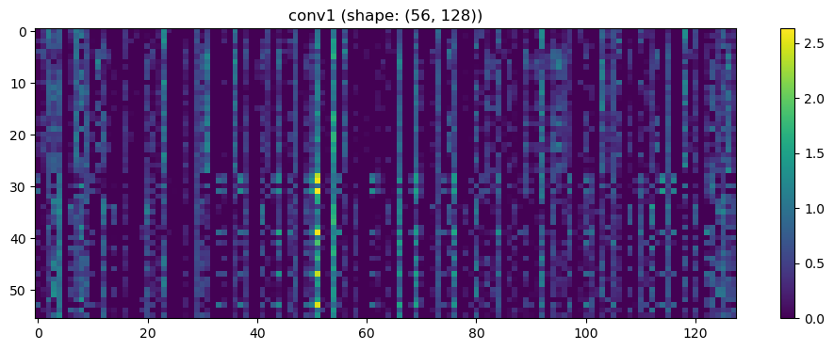

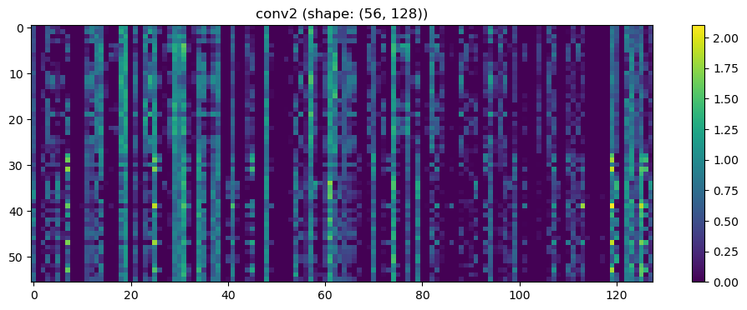

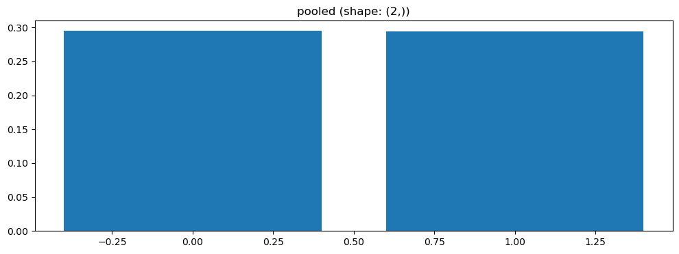

Split 1 Accuracy: 0.6818

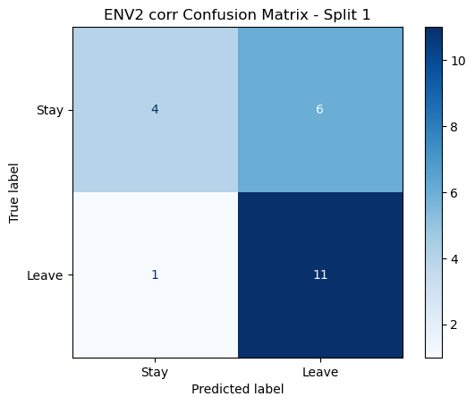

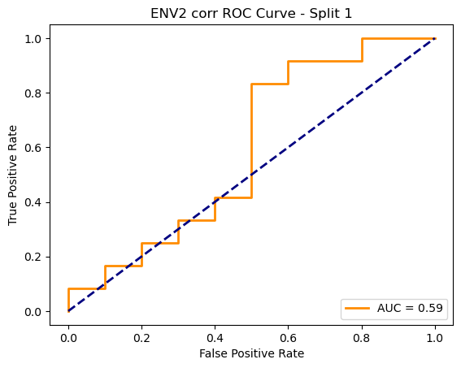

=== ENV2 Split 2/5 ===

After oversampling, class counts: Counter({1: 43, 0: 43})

C:\Users\sansk\miniconda3\Lib\site-packages\torch_geometric\deprecation.py:26: UserWarning: 'data.DataLoader' is deprecated, use 'loader.DataLoader' instead

warnings.warn(out)

Epoch 1/200 | Loss: 0.7400

Epoch 2/200 | Loss: 0.7566

Epoch 3/200 | Loss: 0.8183

Epoch 4/200 | Loss: 0.6973

Epoch 5/200 | Loss: 0.7599

Epoch 6/200 | Loss: 0.6949

Epoch 7/200 | Loss: 0.7450

Epoch 8/200 | Loss: 0.7468

Epoch 9/200 | Loss: 0.7544

Epoch 10/200 | Loss: 0.7428

Epoch 11/200 | Loss: 0.7152

Epoch 12/200 | Loss: 0.7539

Epoch 13/200 | Loss: 0.6951

Epoch 14/200 | Loss: 0.7122

Epoch 15/200 | Loss: 0.7983

Epoch 16/200 | Loss: 0.7446

Epoch 17/200 | Loss: 0.7097

Epoch 18/200 | Loss: 0.7443

Epoch 19/200 | Loss: 0.7778

Epoch 20/200 | Loss: 0.7912

Epoch 21/200 | Loss: 0.7393

Epoch 22/200 | Loss: 0.7045

Epoch 23/200 | Loss: 0.7516

Epoch 24/200 | Loss: 0.7067

Epoch 25/200 | Loss: 0.7334

Epoch 26/200 | Loss: 0.7351

Epoch 27/200 | Loss: 0.7621

Epoch 28/200 | Loss: 0.7222

Epoch 29/200 | Loss: 0.6829

Epoch 30/200 | Loss: 0.7171

Epoch 31/200 | Loss: 0.7316

Epoch 32/200 | Loss: 0.6974

Epoch 33/200 | Loss: 0.7477

Epoch 34/200 | Loss: 0.7443

Epoch 35/200 | Loss: 0.7921

Epoch 36/200 | Loss: 0.7621

Epoch 37/200 | Loss: 0.7542

Epoch 38/200 | Loss: 0.6991

Epoch 39/200 | Loss: 0.7835

Epoch 40/200 | Loss: 0.7323

Epoch 41/200 | Loss: 0.7253

Epoch 42/200 | Loss: 0.7434

Epoch 43/200 | Loss: 0.8252

Epoch 44/200 | Loss: 0.7318

Epoch 45/200 | Loss: 0.7151

Epoch 46/200 | Loss: 0.7853

Epoch 47/200 | Loss: 0.7065

Epoch 48/200 | Loss: 0.6943

Epoch 49/200 | Loss: 0.6522

Epoch 50/200 | Loss: 0.6951

Epoch 51/200 | Loss: 0.7025

Epoch 52/200 | Loss: 0.7503

Epoch 53/200 | Loss: 0.7885

Epoch 54/200 | Loss: 0.7115

Epoch 55/200 | Loss: 0.7053

Epoch 56/200 | Loss: 0.7182

Epoch 57/200 | Loss: 0.6939

Epoch 58/200 | Loss: 0.6816

Epoch 59/200 | Loss: 0.7876

Epoch 60/200 | Loss: 0.6999

Epoch 61/200 | Loss: 0.6446

Epoch 62/200 | Loss: 0.7376

Epoch 63/200 | Loss: 0.6658

Epoch 64/200 | Loss: 0.7859

Epoch 65/200 | Loss: 0.7639

Epoch 66/200 | Loss: 0.6639

Epoch 67/200 | Loss: 0.7907

Epoch 68/200 | Loss: 0.7817

Epoch 69/200 | Loss: 0.7494

Epoch 70/200 | Loss: 0.7180

Epoch 71/200 | Loss: 0.6784

Epoch 72/200 | Loss: 0.7571

Epoch 73/200 | Loss: 0.6680

Epoch 74/200 | Loss: 0.6562

Epoch 75/200 | Loss: 0.6544

Epoch 76/200 | Loss: 0.7810

Epoch 77/200 | Loss: 0.7083

Epoch 78/200 | Loss: 0.7606

Epoch 79/200 | Loss: 0.6793

Epoch 80/200 | Loss: 0.6419

Epoch 81/200 | Loss: 0.6997

Epoch 82/200 | Loss: 0.6870

Epoch 83/200 | Loss: 0.7463

Epoch 84/200 | Loss: 0.7304

Epoch 85/200 | Loss: 0.7409

Epoch 86/200 | Loss: 0.7065

Epoch 87/200 | Loss: 0.6695

Epoch 88/200 | Loss: 0.7107

Epoch 89/200 | Loss: 0.7741

Epoch 90/200 | Loss: 0.7100

Epoch 91/200 | Loss: 0.6999

Epoch 92/200 | Loss: 0.6459

Epoch 93/200 | Loss: 0.7146

Epoch 94/200 | Loss: 0.7009

Epoch 95/200 | Loss: 0.6730

Epoch 96/200 | Loss: 0.6234

Epoch 97/200 | Loss: 0.6908

Epoch 98/200 | Loss: 0.6873

Epoch 99/200 | Loss: 0.7305

Epoch 100/200 | Loss: 0.7030

Epoch 101/200 | Loss: 0.6550

Epoch 102/200 | Loss: 0.7039

Epoch 103/200 | Loss: 0.6862

Epoch 104/200 | Loss: 0.6647

Epoch 105/200 | Loss: 0.6513

Epoch 106/200 | Loss: 0.6510

Epoch 107/200 | Loss: 0.6962

Epoch 108/200 | Loss: 0.6908

Epoch 109/200 | Loss: 0.6977

Epoch 110/200 | Loss: 0.6945

Epoch 111/200 | Loss: 0.7177

Epoch 112/200 | Loss: 0.6193

Epoch 113/200 | Loss: 0.6940

Epoch 114/200 | Loss: 0.6657

Epoch 115/200 | Loss: 0.6487

Epoch 116/200 | Loss: 0.6608

Epoch 117/200 | Loss: 0.7183

Epoch 118/200 | Loss: 0.6186

Epoch 119/200 | Loss: 0.6517

Epoch 120/200 | Loss: 0.7314

Epoch 121/200 | Loss: 0.6950

Epoch 122/200 | Loss: 0.7109

Epoch 123/200 | Loss: 0.6915

Epoch 124/200 | Loss: 0.6578

Epoch 125/200 | Loss: 0.6698

Epoch 126/200 | Loss: 0.6752

Epoch 127/200 | Loss: 0.6553

Epoch 128/200 | Loss: 0.7148

Epoch 129/200 | Loss: 0.7023

Epoch 130/200 | Loss: 0.6898

Epoch 131/200 | Loss: 0.6299

Epoch 132/200 | Loss: 0.6591

Epoch 133/200 | Loss: 0.6908

Epoch 134/200 | Loss: 0.6893

Epoch 135/200 | Loss: 0.6735

Epoch 136/200 | Loss: 0.6686

Epoch 137/200 | Loss: 0.6734

Epoch 138/200 | Loss: 0.7274

Epoch 139/200 | Loss: 0.6701

Epoch 140/200 | Loss: 0.6882

Epoch 141/200 | Loss: 0.7301

Epoch 142/200 | Loss: 0.7145

Epoch 143/200 | Loss: 0.7294

Epoch 144/200 | Loss: 0.6876

Epoch 145/200 | Loss: 0.6828

Epoch 146/200 | Loss: 0.6457

Epoch 147/200 | Loss: 0.6744

Epoch 148/200 | Loss: 0.6704

Epoch 149/200 | Loss: 0.6133

Epoch 150/200 | Loss: 0.6524

Epoch 151/200 | Loss: 0.6495

Epoch 152/200 | Loss: 0.7529

Epoch 153/200 | Loss: 0.7478

Epoch 154/200 | Loss: 0.7362

Epoch 155/200 | Loss: 0.6136

Epoch 156/200 | Loss: 0.7273

Epoch 157/200 | Loss: 0.7397

Epoch 158/200 | Loss: 0.5584

Epoch 159/200 | Loss: 0.6015

Epoch 160/200 | Loss: 0.6497

Epoch 161/200 | Loss: 0.6526

Epoch 162/200 | Loss: 0.6150

Epoch 163/200 | Loss: 0.6479

Epoch 164/200 | Loss: 0.6661

Epoch 165/200 | Loss: 0.6446

Epoch 166/200 | Loss: 0.6305

Epoch 167/200 | Loss: 0.6265

Epoch 168/200 | Loss: 0.6576

Epoch 169/200 | Loss: 0.6713

Epoch 170/200 | Loss: 0.6746

Epoch 171/200 | Loss: 0.6177

Epoch 172/200 | Loss: 0.7301

Epoch 173/200 | Loss: 0.6342

Epoch 174/200 | Loss: 0.7033

Epoch 175/200 | Loss: 0.6097

Epoch 176/200 | Loss: 0.6814

Epoch 177/200 | Loss: 0.5983

Epoch 178/200 | Loss: 0.6466

Epoch 179/200 | Loss: 0.6413

Epoch 180/200 | Loss: 0.6578

Epoch 181/200 | Loss: 0.6319

Epoch 182/200 | Loss: 0.6358

Epoch 183/200 | Loss: 0.6714

Epoch 184/200 | Loss: 0.6090

Epoch 185/200 | Loss: 0.7156

Epoch 186/200 | Loss: 0.6779

Epoch 187/200 | Loss: 0.6714

Epoch 188/200 | Loss: 0.6778

Epoch 189/200 | Loss: 0.7212

Epoch 190/200 | Loss: 0.6247

Epoch 191/200 | Loss: 0.6580

Epoch 192/200 | Loss: 0.6421

Epoch 193/200 | Loss: 0.6846

Epoch 194/200 | Loss: 0.6802

Epoch 195/200 | Loss: 0.6029

Epoch 196/200 | Loss: 0.7087

Epoch 197/200 | Loss: 0.6918

Epoch 198/200 | Loss: 0.6234

Epoch 199/200 | Loss: 0.6185

Epoch 200/200 | Loss: 0.6514

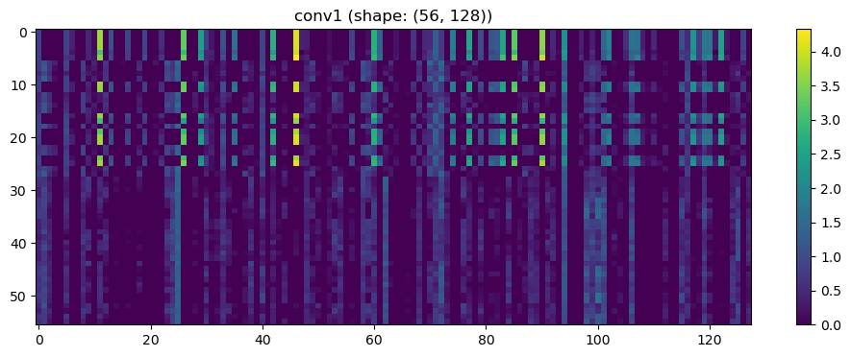

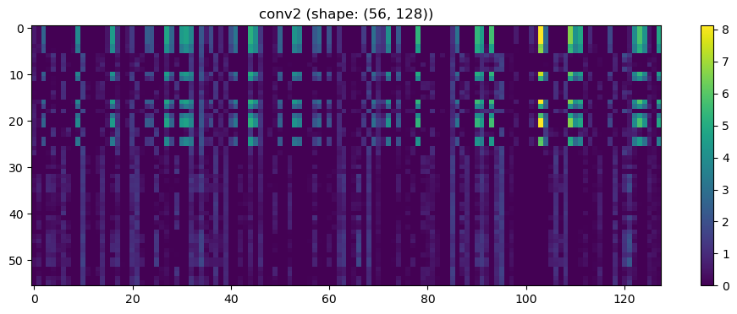

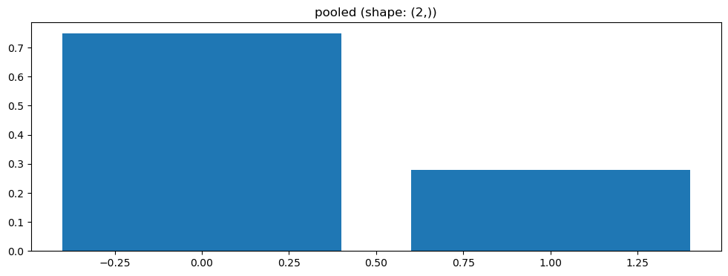

Split 2 Accuracy: 0.3810

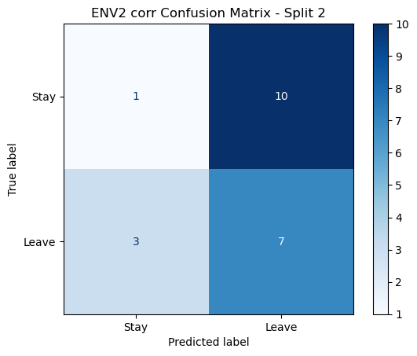

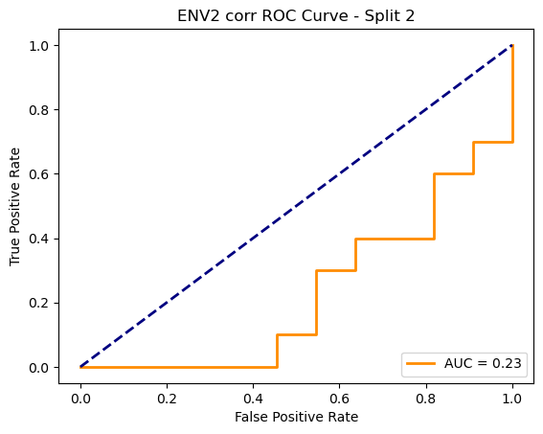

=== ENV2 Split 3/5 ===

After oversampling, class counts: Counter({1: 43, 0: 43})

C:\Users\sansk\miniconda3\Lib\site-packages\torch_geometric\deprecation.py:26: UserWarning: 'data.DataLoader' is deprecated, use 'loader.DataLoader' instead

warnings.warn(out)

Epoch 1/200 | Loss: 0.7326

Epoch 2/200 | Loss: 0.6538

Epoch 3/200 | Loss: 0.7712

Epoch 4/200 | Loss: 0.6698

Epoch 5/200 | Loss: 0.7076

Epoch 6/200 | Loss: 0.6813

Epoch 7/200 | Loss: 0.7240

Epoch 8/200 | Loss: 0.7031

Epoch 9/200 | Loss: 0.7720

Epoch 10/200 | Loss: 0.7473

Epoch 11/200 | Loss: 0.7318

Epoch 12/200 | Loss: 0.6811

Epoch 13/200 | Loss: 0.7353

Epoch 14/200 | Loss: 0.6691

Epoch 15/200 | Loss: 0.6487

Epoch 16/200 | Loss: 0.7401

Epoch 17/200 | Loss: 0.7223

Epoch 18/200 | Loss: 0.7017

Epoch 19/200 | Loss: 0.8260

Epoch 20/200 | Loss: 0.7370

Epoch 21/200 | Loss: 0.7371

Epoch 22/200 | Loss: 0.7208

Epoch 23/200 | Loss: 0.6881

Epoch 24/200 | Loss: 0.7212

Epoch 25/200 | Loss: 0.7366

Epoch 26/200 | Loss: 0.7402

Epoch 27/200 | Loss: 0.6897

Epoch 28/200 | Loss: 0.7038

Epoch 29/200 | Loss: 0.6811

Epoch 30/200 | Loss: 0.7647

Epoch 31/200 | Loss: 0.7452

Epoch 32/200 | Loss: 0.7052

Epoch 33/200 | Loss: 0.8303

Epoch 34/200 | Loss: 0.7083

Epoch 35/200 | Loss: 0.6680

Epoch 36/200 | Loss: 0.7292

Epoch 37/200 | Loss: 0.7787

Epoch 38/200 | Loss: 0.6871

Epoch 39/200 | Loss: 0.7948

Epoch 40/200 | Loss: 0.6796

Epoch 41/200 | Loss: 0.6796

Epoch 42/200 | Loss: 0.6872

Epoch 43/200 | Loss: 0.7036

Epoch 44/200 | Loss: 0.6549

Epoch 45/200 | Loss: 0.7314

Epoch 46/200 | Loss: 0.6650

Epoch 47/200 | Loss: 0.6537

Epoch 48/200 | Loss: 0.6296

Epoch 49/200 | Loss: 0.7272

Epoch 50/200 | Loss: 0.6816

Epoch 51/200 | Loss: 0.6699

Epoch 52/200 | Loss: 0.7615

Epoch 53/200 | Loss: 0.7150

Epoch 54/200 | Loss: 0.7175

Epoch 55/200 | Loss: 0.7074

Epoch 56/200 | Loss: 0.6912

Epoch 57/200 | Loss: 0.6939

Epoch 58/200 | Loss: 0.6792

Epoch 59/200 | Loss: 0.7218

Epoch 60/200 | Loss: 0.7442

Epoch 61/200 | Loss: 0.6695

Epoch 62/200 | Loss: 0.6938

Epoch 63/200 | Loss: 0.7551

Epoch 64/200 | Loss: 0.7599

Epoch 65/200 | Loss: 0.7089

Epoch 66/200 | Loss: 0.7143

Epoch 67/200 | Loss: 0.7021

Epoch 68/200 | Loss: 0.7527

Epoch 69/200 | Loss: 0.6753

Epoch 70/200 | Loss: 0.6802

Epoch 71/200 | Loss: 0.6735

Epoch 72/200 | Loss: 0.7337

Epoch 73/200 | Loss: 0.7042

Epoch 74/200 | Loss: 0.7123

Epoch 75/200 | Loss: 0.7277

Epoch 76/200 | Loss: 0.6591

Epoch 77/200 | Loss: 0.6812

Epoch 78/200 | Loss: 0.7017

Epoch 79/200 | Loss: 0.6723

Epoch 80/200 | Loss: 0.6862

Epoch 81/200 | Loss: 0.6948

Epoch 82/200 | Loss: 0.7074

Epoch 83/200 | Loss: 0.6687

Epoch 84/200 | Loss: 0.6344

Epoch 85/200 | Loss: 0.6740

Epoch 86/200 | Loss: 0.7204

Epoch 87/200 | Loss: 0.7242

Epoch 88/200 | Loss: 0.7450

Epoch 89/200 | Loss: 0.6699

Epoch 90/200 | Loss: 0.6607

Epoch 91/200 | Loss: 0.7267

Epoch 92/200 | Loss: 0.7659

Epoch 93/200 | Loss: 0.6554

Epoch 94/200 | Loss: 0.7107

Epoch 95/200 | Loss: 0.6594

Epoch 96/200 | Loss: 0.7117

Epoch 97/200 | Loss: 0.7398

Epoch 98/200 | Loss: 0.6704

Epoch 99/200 | Loss: 0.6732

Epoch 100/200 | Loss: 0.6864

Epoch 101/200 | Loss: 0.6602

Epoch 102/200 | Loss: 0.7506

Epoch 103/200 | Loss: 0.7122

Epoch 104/200 | Loss: 0.7402

Epoch 105/200 | Loss: 0.7327

Epoch 106/200 | Loss: 0.6337

Epoch 107/200 | Loss: 0.7244

Epoch 108/200 | Loss: 0.7136

Epoch 109/200 | Loss: 0.6943

Epoch 110/200 | Loss: 0.7764

Epoch 111/200 | Loss: 0.6735

Epoch 112/200 | Loss: 0.6674

Epoch 113/200 | Loss: 0.7232

Epoch 114/200 | Loss: 0.6574

Epoch 115/200 | Loss: 0.6889

Epoch 116/200 | Loss: 0.6669

Epoch 117/200 | Loss: 0.7246

Epoch 118/200 | Loss: 0.7057

Epoch 119/200 | Loss: 0.6692

Epoch 120/200 | Loss: 0.6206

Epoch 121/200 | Loss: 0.7101

Epoch 122/200 | Loss: 0.7110

Epoch 123/200 | Loss: 0.6870

Epoch 124/200 | Loss: 0.7301

Epoch 125/200 | Loss: 0.6473

Epoch 126/200 | Loss: 0.6920

Epoch 127/200 | Loss: 0.6950

Epoch 128/200 | Loss: 0.6819

Epoch 129/200 | Loss: 0.6712

Epoch 130/200 | Loss: 0.7306

Epoch 131/200 | Loss: 0.6619

Epoch 132/200 | Loss: 0.7176

Epoch 133/200 | Loss: 0.7614

Epoch 134/200 | Loss: 0.7059

Epoch 135/200 | Loss: 0.7148

Epoch 136/200 | Loss: 0.6798

Epoch 137/200 | Loss: 0.7628

Epoch 138/200 | Loss: 0.6571

Epoch 139/200 | Loss: 0.6984

Epoch 140/200 | Loss: 0.7028

Epoch 141/200 | Loss: 0.6482

Epoch 142/200 | Loss: 0.7292

Epoch 143/200 | Loss: 0.6866

Epoch 144/200 | Loss: 0.6399

Epoch 145/200 | Loss: 0.7022

Epoch 146/200 | Loss: 0.6492

Epoch 147/200 | Loss: 0.6778

Epoch 148/200 | Loss: 0.6539

Epoch 149/200 | Loss: 0.7022

Epoch 150/200 | Loss: 0.7572

Epoch 151/200 | Loss: 0.6815

Epoch 152/200 | Loss: 0.6644

Epoch 153/200 | Loss: 0.7284

Epoch 154/200 | Loss: 0.7032

Epoch 155/200 | Loss: 0.7046

Epoch 156/200 | Loss: 0.6671

Epoch 157/200 | Loss: 0.7130

Epoch 158/200 | Loss: 0.7144

Epoch 159/200 | Loss: 0.6986

Epoch 160/200 | Loss: 0.6723

Epoch 161/200 | Loss: 0.6765

Epoch 162/200 | Loss: 0.6532

Epoch 163/200 | Loss: 0.6914

Epoch 164/200 | Loss: 0.6969

Epoch 165/200 | Loss: 0.6640

Epoch 166/200 | Loss: 0.7150

Epoch 167/200 | Loss: 0.6808

Epoch 168/200 | Loss: 0.6784

Epoch 169/200 | Loss: 0.6593

Epoch 170/200 | Loss: 0.7479

Epoch 171/200 | Loss: 0.6402

Epoch 172/200 | Loss: 0.6338

Epoch 173/200 | Loss: 0.7197

Epoch 174/200 | Loss: 0.7062

Epoch 175/200 | Loss: 0.7203

Epoch 176/200 | Loss: 0.6732

Epoch 177/200 | Loss: 0.6742

Epoch 178/200 | Loss: 0.6252

Epoch 179/200 | Loss: 0.6511

Epoch 180/200 | Loss: 0.6390

Epoch 181/200 | Loss: 0.6880

Epoch 182/200 | Loss: 0.6630

Epoch 183/200 | Loss: 0.6290

Epoch 184/200 | Loss: 0.6603

Epoch 185/200 | Loss: 0.6846

Epoch 186/200 | Loss: 0.6720

Epoch 187/200 | Loss: 0.7172

Epoch 188/200 | Loss: 0.7023

Epoch 189/200 | Loss: 0.7101

Epoch 190/200 | Loss: 0.6243

Epoch 191/200 | Loss: 0.6161

Epoch 192/200 | Loss: 0.6956

Epoch 193/200 | Loss: 0.6401

Epoch 194/200 | Loss: 0.6804

Epoch 195/200 | Loss: 0.7024

Epoch 196/200 | Loss: 0.6487

Epoch 197/200 | Loss: 0.6443

Epoch 198/200 | Loss: 0.6122

Epoch 199/200 | Loss: 0.6687

Epoch 200/200 | Loss: 0.6267

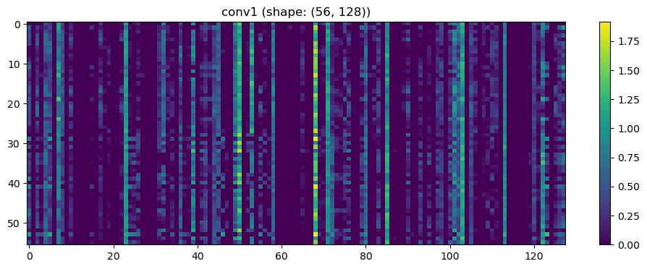

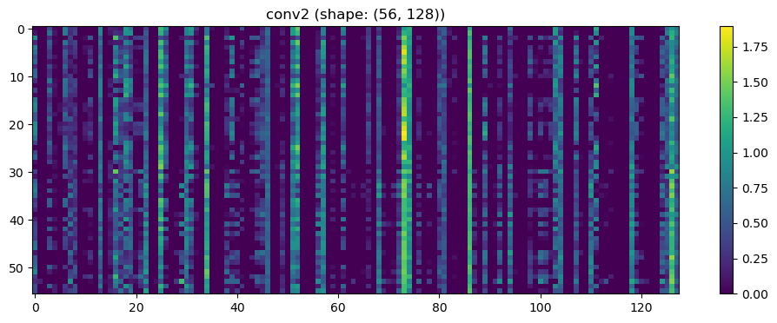

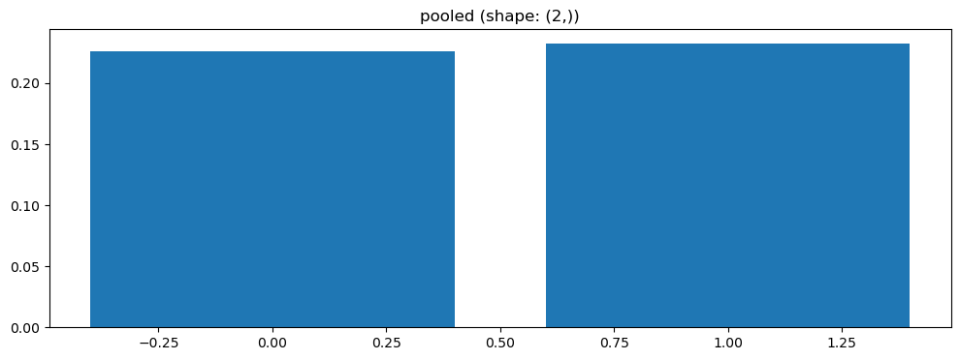

Split 3 Accuracy: 0.7143

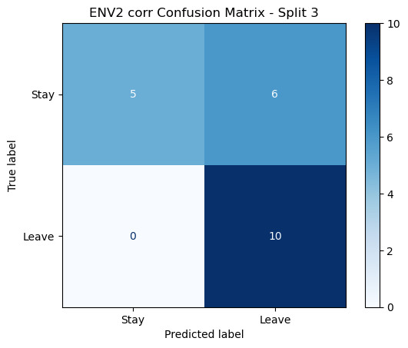

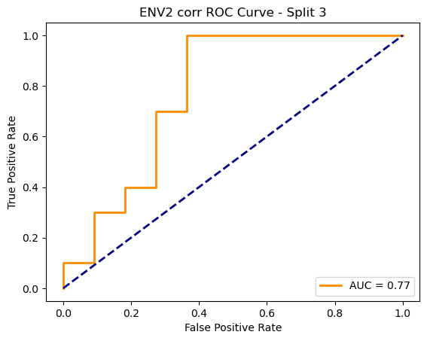

=== ENV2 Split 4/5 ===

After oversampling, class counts: Counter({1: 44, 0: 44})

C:\Users\sansk\miniconda3\Lib\site-packages\torch_geometric\deprecation.py:26: UserWarning: 'data.DataLoader' is deprecated, use 'loader.DataLoader' instead

warnings.warn(out)

Epoch 1/200 | Loss: 0.7365

Epoch 2/200 | Loss: 0.7794

Epoch 3/200 | Loss: 0.7775

Epoch 4/200 | Loss: 0.7565

Epoch 5/200 | Loss: 0.7675

Epoch 6/200 | Loss: 0.7740

Epoch 7/200 | Loss: 0.7106

Epoch 8/200 | Loss: 0.6997

Epoch 9/200 | Loss: 0.7967

Epoch 10/200 | Loss: 0.7207

Epoch 11/200 | Loss: 0.7855

Epoch 12/200 | Loss: 0.7814

Epoch 13/200 | Loss: 0.7831

Epoch 14/200 | Loss: 0.8373

Epoch 15/200 | Loss: 0.7046

Epoch 16/200 | Loss: 0.7396

Epoch 17/200 | Loss: 0.7269

Epoch 18/200 | Loss: 0.7806

Epoch 19/200 | Loss: 0.8696

Epoch 20/200 | Loss: 0.7621

Epoch 21/200 | Loss: 0.8178

Epoch 22/200 | Loss: 0.7349

Epoch 23/200 | Loss: 0.8484

Epoch 24/200 | Loss: 0.7779

Epoch 25/200 | Loss: 0.7353

Epoch 26/200 | Loss: 0.6523

Epoch 27/200 | Loss: 0.7168

Epoch 28/200 | Loss: 0.7378

Epoch 29/200 | Loss: 0.7154

Epoch 30/200 | Loss: 0.7316

Epoch 31/200 | Loss: 0.7308

Epoch 32/200 | Loss: 0.6995

Epoch 33/200 | Loss: 0.7259

Epoch 34/200 | Loss: 0.7496

Epoch 35/200 | Loss: 0.7484

Epoch 36/200 | Loss: 0.7321

Epoch 37/200 | Loss: 0.7678

Epoch 38/200 | Loss: 0.7603

Epoch 39/200 | Loss: 0.7291

Epoch 40/200 | Loss: 0.7807

Epoch 41/200 | Loss: 0.6811

Epoch 42/200 | Loss: 0.7639

Epoch 43/200 | Loss: 0.7595

Epoch 44/200 | Loss: 0.7246

Epoch 45/200 | Loss: 0.7812

Epoch 46/200 | Loss: 0.7855

Epoch 47/200 | Loss: 0.7055

Epoch 48/200 | Loss: 0.7486

Epoch 49/200 | Loss: 0.7392

Epoch 50/200 | Loss: 0.7155

Epoch 51/200 | Loss: 0.6985

Epoch 52/200 | Loss: 0.7191

Epoch 53/200 | Loss: 0.7222

Epoch 54/200 | Loss: 0.7487

Epoch 55/200 | Loss: 0.7624

Epoch 56/200 | Loss: 0.7130

Epoch 57/200 | Loss: 0.6955

Epoch 58/200 | Loss: 0.7341

Epoch 59/200 | Loss: 0.7272

Epoch 60/200 | Loss: 0.6988

Epoch 61/200 | Loss: 0.8011

Epoch 62/200 | Loss: 0.7424

Epoch 63/200 | Loss: 0.6870

Epoch 64/200 | Loss: 0.6989

Epoch 65/200 | Loss: 0.7283

Epoch 66/200 | Loss: 0.6978

Epoch 67/200 | Loss: 0.7784

Epoch 68/200 | Loss: 0.6205

Epoch 69/200 | Loss: 0.7494

Epoch 70/200 | Loss: 0.7667

Epoch 71/200 | Loss: 0.7547

Epoch 72/200 | Loss: 0.7009

Epoch 73/200 | Loss: 0.7132

Epoch 74/200 | Loss: 0.7422

Epoch 75/200 | Loss: 0.7387

Epoch 76/200 | Loss: 0.6898

Epoch 77/200 | Loss: 0.6953

Epoch 78/200 | Loss: 0.6483

Epoch 79/200 | Loss: 0.7176

Epoch 80/200 | Loss: 0.6917

Epoch 81/200 | Loss: 0.7410

Epoch 82/200 | Loss: 0.7313

Epoch 83/200 | Loss: 0.6992

Epoch 84/200 | Loss: 0.6490

Epoch 85/200 | Loss: 0.7231

Epoch 86/200 | Loss: 0.7490

Epoch 87/200 | Loss: 0.6672

Epoch 88/200 | Loss: 0.7665

Epoch 89/200 | Loss: 0.6447

Epoch 90/200 | Loss: 0.7169

Epoch 91/200 | Loss: 0.7117

Epoch 92/200 | Loss: 0.7349

Epoch 93/200 | Loss: 0.7272

Epoch 94/200 | Loss: 0.7380

Epoch 95/200 | Loss: 0.6675

Epoch 96/200 | Loss: 0.6707

Epoch 97/200 | Loss: 0.7329

Epoch 98/200 | Loss: 0.6686

Epoch 99/200 | Loss: 0.7537

Epoch 100/200 | Loss: 0.7159

Epoch 101/200 | Loss: 0.6766

Epoch 102/200 | Loss: 0.7162

Epoch 103/200 | Loss: 0.7343

Epoch 104/200 | Loss: 0.6634

Epoch 105/200 | Loss: 0.6876

Epoch 106/200 | Loss: 0.6952

Epoch 107/200 | Loss: 0.6728

Epoch 108/200 | Loss: 0.6889

Epoch 109/200 | Loss: 0.6504

Epoch 110/200 | Loss: 0.6994

Epoch 111/200 | Loss: 0.6621

Epoch 112/200 | Loss: 0.7040

Epoch 113/200 | Loss: 0.6825

Epoch 114/200 | Loss: 0.7106

Epoch 115/200 | Loss: 0.6665

Epoch 116/200 | Loss: 0.7069

Epoch 117/200 | Loss: 0.6799

Epoch 118/200 | Loss: 0.6494

Epoch 119/200 | Loss: 0.7038

Epoch 120/200 | Loss: 0.6808

Epoch 121/200 | Loss: 0.7388

Epoch 122/200 | Loss: 0.6932

Epoch 123/200 | Loss: 0.6961

Epoch 124/200 | Loss: 0.7210

Epoch 125/200 | Loss: 0.7104

Epoch 126/200 | Loss: 0.6758

Epoch 127/200 | Loss: 0.7450

Epoch 128/200 | Loss: 0.7586

Epoch 129/200 | Loss: 0.6297

Epoch 130/200 | Loss: 0.6298

Epoch 131/200 | Loss: 0.6772

Epoch 132/200 | Loss: 0.6622

Epoch 133/200 | Loss: 0.6980

Epoch 134/200 | Loss: 0.7806

Epoch 135/200 | Loss: 0.6439

Epoch 136/200 | Loss: 0.6552

Epoch 137/200 | Loss: 0.7318

Epoch 138/200 | Loss: 0.7001

Epoch 139/200 | Loss: 0.7150

Epoch 140/200 | Loss: 0.6930

Epoch 141/200 | Loss: 0.7022

Epoch 142/200 | Loss: 0.7277

Epoch 143/200 | Loss: 0.7292

Epoch 144/200 | Loss: 0.6412

Epoch 145/200 | Loss: 0.7029

Epoch 146/200 | Loss: 0.6767

Epoch 147/200 | Loss: 0.6363

Epoch 148/200 | Loss: 0.6407

Epoch 149/200 | Loss: 0.7374

Epoch 150/200 | Loss: 0.6726

Epoch 151/200 | Loss: 0.6740

Epoch 152/200 | Loss: 0.6313

Epoch 153/200 | Loss: 0.7266

Epoch 154/200 | Loss: 0.6892

Epoch 155/200 | Loss: 0.6905

Epoch 156/200 | Loss: 0.7233

Epoch 157/200 | Loss: 0.7396

Epoch 158/200 | Loss: 0.7596

Epoch 159/200 | Loss: 0.6993

Epoch 160/200 | Loss: 0.6647

Epoch 161/200 | Loss: 0.6705

Epoch 162/200 | Loss: 0.6859

Epoch 163/200 | Loss: 0.6711

Epoch 164/200 | Loss: 0.6864

Epoch 165/200 | Loss: 0.6917

Epoch 166/200 | Loss: 0.6935

Epoch 167/200 | Loss: 0.6842

Epoch 168/200 | Loss: 0.6064

Epoch 169/200 | Loss: 0.7227

Epoch 170/200 | Loss: 0.7126

Epoch 171/200 | Loss: 0.6750

Epoch 172/200 | Loss: 0.7106

Epoch 173/200 | Loss: 0.7288

Epoch 174/200 | Loss: 0.6624

Epoch 175/200 | Loss: 0.7058

Epoch 176/200 | Loss: 0.7334

Epoch 177/200 | Loss: 0.7248

Epoch 178/200 | Loss: 0.6693

Epoch 179/200 | Loss: 0.7072

Epoch 180/200 | Loss: 0.7342

Epoch 181/200 | Loss: 0.6790

Epoch 182/200 | Loss: 0.6477

Epoch 183/200 | Loss: 0.7080

Epoch 184/200 | Loss: 0.6586

Epoch 185/200 | Loss: 0.6698

Epoch 186/200 | Loss: 0.6353

Epoch 187/200 | Loss: 0.6783

Epoch 188/200 | Loss: 0.6780

Epoch 189/200 | Loss: 0.6992

Epoch 190/200 | Loss: 0.6783

Epoch 191/200 | Loss: 0.7035

Epoch 192/200 | Loss: 0.7649

Epoch 193/200 | Loss: 0.7123

Epoch 194/200 | Loss: 0.7575

Epoch 195/200 | Loss: 0.6275

Epoch 196/200 | Loss: 0.6753

Epoch 197/200 | Loss: 0.6175

Epoch 198/200 | Loss: 0.6521

Epoch 199/200 | Loss: 0.7043

Epoch 200/200 | Loss: 0.6152

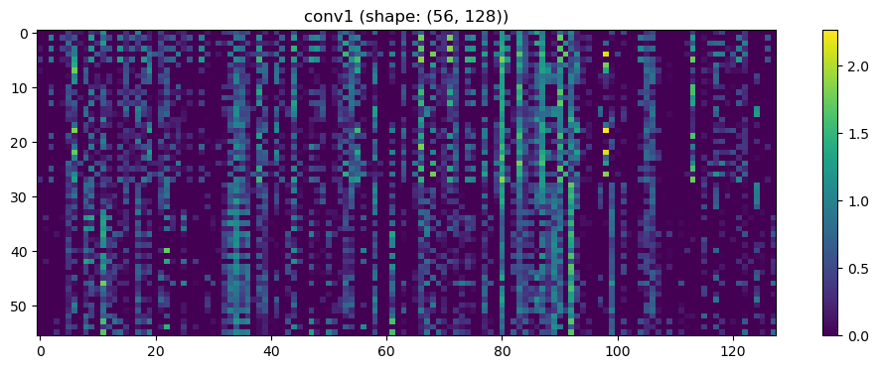

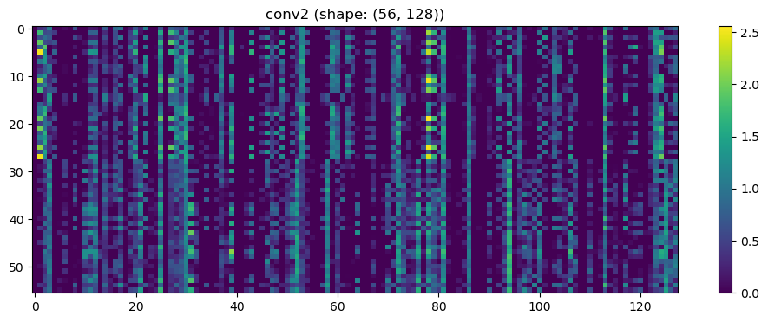

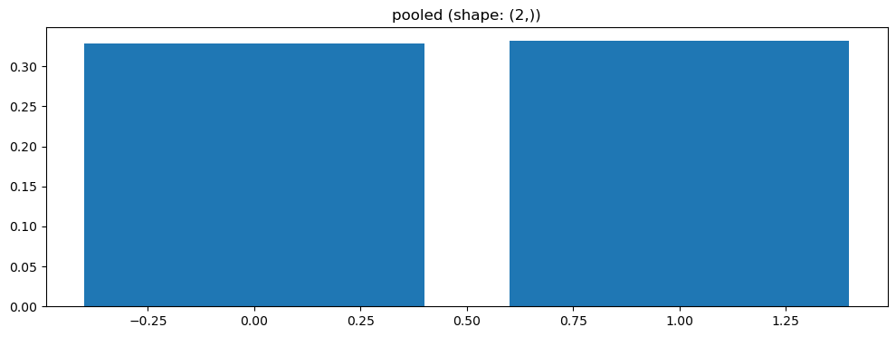

Split 4 Accuracy: 0.5238

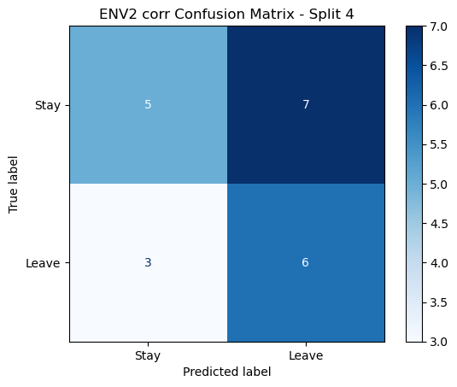

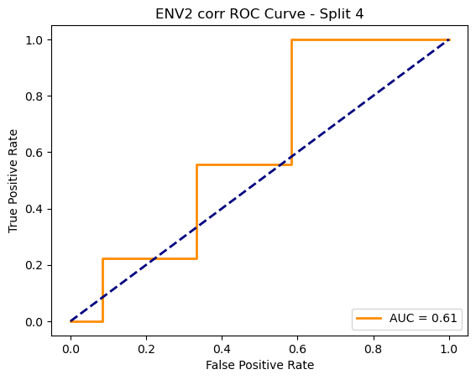

=== ENV2 Split 5/5 ===

After oversampling, class counts: Counter({1: 44, 0: 44})

C:\Users\sansk\miniconda3\Lib\site-packages\torch_geometric\deprecation.py:26: UserWarning: 'data.DataLoader' is deprecated, use 'loader.DataLoader' instead

warnings.warn(out)

Epoch 1/200 | Loss: 0.8267

Epoch 2/200 | Loss: 0.7103

Epoch 3/200 | Loss: 0.7000

Epoch 4/200 | Loss: 0.7794

Epoch 5/200 | Loss: 0.7479

Epoch 6/200 | Loss: 0.7567

Epoch 7/200 | Loss: 0.8504

Epoch 8/200 | Loss: 0.7250

Epoch 9/200 | Loss: 0.7752

Epoch 10/200 | Loss: 0.8042

Epoch 11/200 | Loss: 0.7954

Epoch 12/200 | Loss: 0.6708

Epoch 13/200 | Loss: 0.7640

Epoch 14/200 | Loss: 0.7610

Epoch 15/200 | Loss: 0.7321

Epoch 16/200 | Loss: 0.7212

Epoch 17/200 | Loss: 0.7354

Epoch 18/200 | Loss: 0.8099

Epoch 19/200 | Loss: 0.7525

Epoch 20/200 | Loss: 0.7263

Epoch 21/200 | Loss: 0.7579

Epoch 22/200 | Loss: 0.7371

Epoch 23/200 | Loss: 0.7302

Epoch 24/200 | Loss: 0.7283

Epoch 25/200 | Loss: 0.7426

Epoch 26/200 | Loss: 0.7487

Epoch 27/200 | Loss: 0.7686

Epoch 28/200 | Loss: 0.7163

Epoch 29/200 | Loss: 0.7586

Epoch 30/200 | Loss: 0.7877

Epoch 31/200 | Loss: 0.6857

Epoch 32/200 | Loss: 0.8015

Epoch 33/200 | Loss: 0.7096

Epoch 34/200 | Loss: 0.7148

Epoch 35/200 | Loss: 0.7114

Epoch 36/200 | Loss: 0.7630

Epoch 37/200 | Loss: 0.7676

Epoch 38/200 | Loss: 0.7725

Epoch 39/200 | Loss: 0.7746

Epoch 40/200 | Loss: 0.7464

Epoch 41/200 | Loss: 0.6985

Epoch 42/200 | Loss: 0.7405

Epoch 43/200 | Loss: 0.7826

Epoch 44/200 | Loss: 0.7966

Epoch 45/200 | Loss: 0.7193

Epoch 46/200 | Loss: 0.7531

Epoch 47/200 | Loss: 0.7352

Epoch 48/200 | Loss: 0.7550

Epoch 49/200 | Loss: 0.7700

Epoch 50/200 | Loss: 0.6828

Epoch 51/200 | Loss: 0.7783

Epoch 52/200 | Loss: 0.7562

Epoch 53/200 | Loss: 0.8283

Epoch 54/200 | Loss: 0.7032

Epoch 55/200 | Loss: 0.7926

Epoch 56/200 | Loss: 0.6934

Epoch 57/200 | Loss: 0.6889

Epoch 58/200 | Loss: 0.7744

Epoch 59/200 | Loss: 0.7299

Epoch 60/200 | Loss: 0.7807

Epoch 61/200 | Loss: 0.7292

Epoch 62/200 | Loss: 0.6844

Epoch 63/200 | Loss: 0.7287

Epoch 64/200 | Loss: 0.6887

Epoch 65/200 | Loss: 0.6860

Epoch 66/200 | Loss: 0.7970

Epoch 67/200 | Loss: 0.7162

Epoch 68/200 | Loss: 0.7204

Epoch 69/200 | Loss: 0.7499

Epoch 70/200 | Loss: 0.7363

Epoch 71/200 | Loss: 0.7641

Epoch 72/200 | Loss: 0.7712

Epoch 73/200 | Loss: 0.6883

Epoch 74/200 | Loss: 0.7163

Epoch 75/200 | Loss: 0.6502

Epoch 76/200 | Loss: 0.7066

Epoch 77/200 | Loss: 0.7200

Epoch 78/200 | Loss: 0.7342

Epoch 79/200 | Loss: 0.7248

Epoch 80/200 | Loss: 0.6782

Epoch 81/200 | Loss: 0.7328

Epoch 82/200 | Loss: 0.7209

Epoch 83/200 | Loss: 0.7268

Epoch 84/200 | Loss: 0.6813

Epoch 85/200 | Loss: 0.6737

Epoch 86/200 | Loss: 0.7305

Epoch 87/200 | Loss: 0.6609

Epoch 88/200 | Loss: 0.6955

Epoch 89/200 | Loss: 0.7827

Epoch 90/200 | Loss: 0.7165

Epoch 91/200 | Loss: 0.6544

Epoch 92/200 | Loss: 0.7851

Epoch 93/200 | Loss: 0.7093

Epoch 94/200 | Loss: 0.7592

Epoch 95/200 | Loss: 0.6800

Epoch 96/200 | Loss: 0.7146

Epoch 97/200 | Loss: 0.7519

Epoch 98/200 | Loss: 0.6514

Epoch 99/200 | Loss: 0.7382

Epoch 100/200 | Loss: 0.6508

Epoch 101/200 | Loss: 0.7198

Epoch 102/200 | Loss: 0.6905

Epoch 103/200 | Loss: 0.7244

Epoch 104/200 | Loss: 0.7594

Epoch 105/200 | Loss: 0.6724

Epoch 106/200 | Loss: 0.6541

Epoch 107/200 | Loss: 0.7145

Epoch 108/200 | Loss: 0.7500

Epoch 109/200 | Loss: 0.7158

Epoch 110/200 | Loss: 0.6328

Epoch 111/200 | Loss: 0.7357

Epoch 112/200 | Loss: 0.7366

Epoch 113/200 | Loss: 0.7026

Epoch 114/200 | Loss: 0.7133

Epoch 115/200 | Loss: 0.6968

Epoch 116/200 | Loss: 0.7146

Epoch 117/200 | Loss: 0.6877

Epoch 118/200 | Loss: 0.7262

Epoch 119/200 | Loss: 0.6587

Epoch 120/200 | Loss: 0.6428

Epoch 121/200 | Loss: 0.7862

Epoch 122/200 | Loss: 0.7040

Epoch 123/200 | Loss: 0.6541

Epoch 124/200 | Loss: 0.6351

Epoch 125/200 | Loss: 0.6505

Epoch 126/200 | Loss: 0.6933

Epoch 127/200 | Loss: 0.6470

Epoch 128/200 | Loss: 0.6701

Epoch 129/200 | Loss: 0.6710

Epoch 130/200 | Loss: 0.6626

Epoch 131/200 | Loss: 0.6747

Epoch 132/200 | Loss: 0.6599

Epoch 133/200 | Loss: 0.6321

Epoch 134/200 | Loss: 0.7055

Epoch 135/200 | Loss: 0.7540

Epoch 136/200 | Loss: 0.6501

Epoch 137/200 | Loss: 0.6763

Epoch 138/200 | Loss: 0.7458

Epoch 139/200 | Loss: 0.6980

Epoch 140/200 | Loss: 0.7227

Epoch 141/200 | Loss: 0.7507

Epoch 142/200 | Loss: 0.6552

Epoch 143/200 | Loss: 0.7281

Epoch 144/200 | Loss: 0.7210

Epoch 145/200 | Loss: 0.7131

Epoch 146/200 | Loss: 0.6930

Epoch 147/200 | Loss: 0.7040

Epoch 148/200 | Loss: 0.6638

Epoch 149/200 | Loss: 0.7274

Epoch 150/200 | Loss: 0.6753

Epoch 151/200 | Loss: 0.7012

Epoch 152/200 | Loss: 0.6715

Epoch 153/200 | Loss: 0.5959

Epoch 154/200 | Loss: 0.7348

Epoch 155/200 | Loss: 0.6600

Epoch 156/200 | Loss: 0.6921

Epoch 157/200 | Loss: 0.7003

Epoch 158/200 | Loss: 0.6782

Epoch 159/200 | Loss: 0.6833

Epoch 160/200 | Loss: 0.7273

Epoch 161/200 | Loss: 0.6492

Epoch 162/200 | Loss: 0.6942

Epoch 163/200 | Loss: 0.6221

Epoch 164/200 | Loss: 0.6650

Epoch 165/200 | Loss: 0.6464

Epoch 166/200 | Loss: 0.6965

Epoch 167/200 | Loss: 0.6897

Epoch 168/200 | Loss: 0.7059

Epoch 169/200 | Loss: 0.6540

Epoch 170/200 | Loss: 0.7364

Epoch 171/200 | Loss: 0.6619

Epoch 172/200 | Loss: 0.6901

Epoch 173/200 | Loss: 0.7732

Epoch 174/200 | Loss: 0.6744

Epoch 175/200 | Loss: 0.5795

Epoch 176/200 | Loss: 0.6807

Epoch 177/200 | Loss: 0.6478

Epoch 178/200 | Loss: 0.7279

Epoch 179/200 | Loss: 0.7012

Epoch 180/200 | Loss: 0.6939

Epoch 181/200 | Loss: 0.6252

Epoch 182/200 | Loss: 0.6745

Epoch 183/200 | Loss: 0.6566

Epoch 184/200 | Loss: 0.6996

Epoch 185/200 | Loss: 0.6796

Epoch 186/200 | Loss: 0.6978

Epoch 187/200 | Loss: 0.6360

Epoch 188/200 | Loss: 0.6807

Epoch 189/200 | Loss: 0.6639

Epoch 190/200 | Loss: 0.6600

Epoch 191/200 | Loss: 0.6672

Epoch 192/200 | Loss: 0.5992

Epoch 193/200 | Loss: 0.6544

Epoch 194/200 | Loss: 0.7360

Epoch 195/200 | Loss: 0.6260

Epoch 196/200 | Loss: 0.6799

Epoch 197/200 | Loss: 0.6707

Epoch 198/200 | Loss: 0.6316

Epoch 199/200 | Loss: 0.6249

Epoch 200/200 | Loss: 0.7490

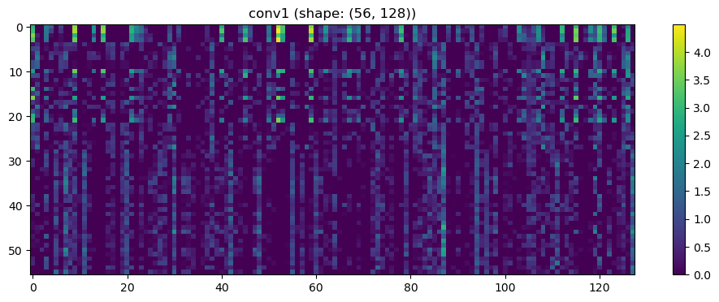

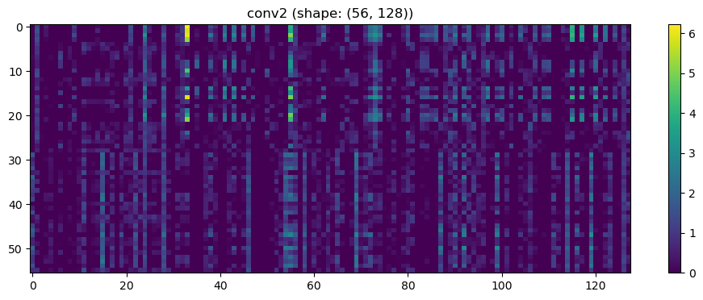

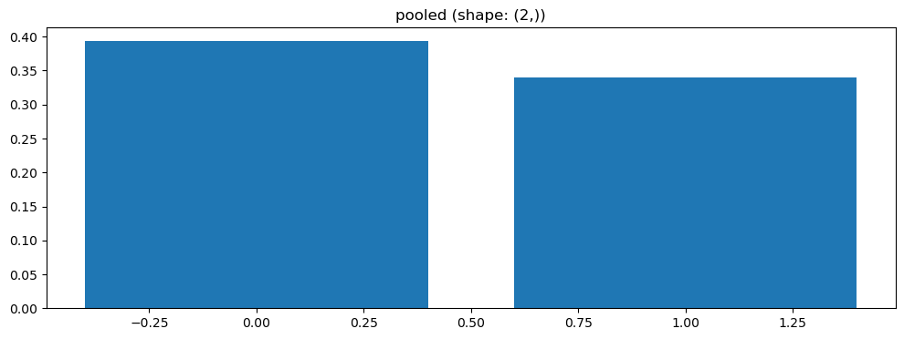

Split 5 Accuracy: 0.4762

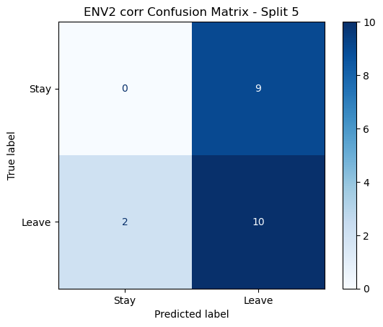

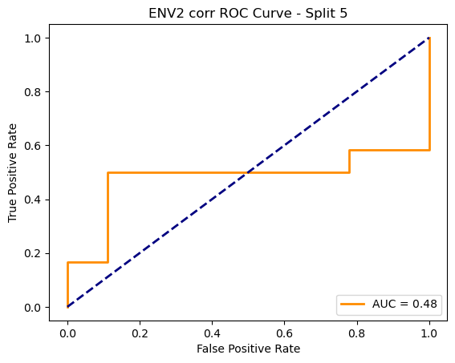

ENV2 corr Average Accuracy: 0.5554 ± 0.1256

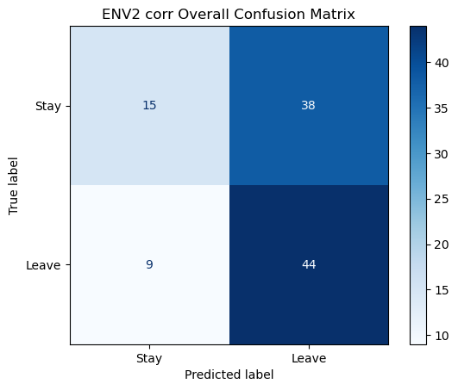

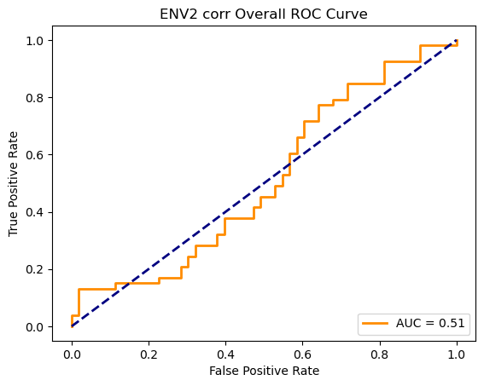

Running GNN with coh connectivity for ENV2...

==================================================

Training GNN for ENV2 with coh connectivity

==================================================

=== ENV2 Split 1/5 ===

C:\Users\sansk\miniconda3\Lib\site-packages\scipy\signal\_spectral_py.py:1668: RuntimeWarning: invalid value encountered in divide

Cxy = np.abs(Pxy)**2 / Pxx / Pyy

After oversampling, class counts: Counter({1: 43, 00: 43, 1: 43})

C:\Users\sansk\miniconda3\Lib\site-packages\torch_geometric\deprecation.py:26: UserWarning: 'data.DataLoader' is deprecated, use 'loader.DataLoader' instead

warnings.warn(out)

Epoch 1/100 | Loss: 0.7925

Epoch 2/100 | Loss: 0.7269

Epoch 3/100 | Loss: 0.8121

Epoch 4/100 | Loss: 0.6982

Epoch 5/100 | Loss: 0.6917

Epoch 6/100 | Loss: 0.7544

Epoch 7/100 | Loss: 0.7264

Epoch 8/100 | Loss: 0.8648

Epoch 9/100 | Loss: 0.6809

Epoch 10/100 | Loss: 0.7106

Epoch 11/100 | Loss: 0.7059

Epoch 12/100 | Loss: 0.7019

Epoch 13/100 | Loss: 0.7054

Epoch 14/100 | Loss: 0.7199

Epoch 15/100 | Loss: 0.7565

Epoch 16/100 | Loss: 0.7701

Epoch 17/100 | Loss: 0.7425

Epoch 18/100 | Loss: 0.6748

Epoch 19/100 | Loss: 0.7288

Epoch 20/100 | Loss: 0.7547

Epoch 21/100 | Loss: 0.6992

Epoch 22/100 | Loss: 0.7030

Epoch 23/100 | Loss: 0.7363

Epoch 24/100 | Loss: 0.7119

Epoch 25/100 | Loss: 0.6987

Epoch 26/100 | Loss: 0.7174

Epoch 27/100 | Loss: 0.7221

Epoch 28/100 | Loss: 0.6931

Epoch 29/100 | Loss: 0.7055

Epoch 30/100 | Loss: 0.6459

Epoch 31/100 | Loss: 0.7277

Epoch 32/100 | Loss: 0.7018

Epoch 33/100 | Loss: 0.6626

Epoch 34/100 | Loss: 0.6750

Epoch 35/100 | Loss: 0.6591

Epoch 36/100 | Loss: 0.6922

Epoch 37/100 | Loss: 0.6910

Epoch 38/100 | Loss: 0.6924

Epoch 39/100 | Loss: 0.6999

Epoch 40/100 | Loss: 0.7255

Epoch 41/100 | Loss: 0.6743

Epoch 42/100 | Loss: 0.7260

Epoch 43/100 | Loss: 0.6518

Epoch 44/100 | Loss: 0.7133

Epoch 45/100 | Loss: 0.6621

Epoch 46/100 | Loss: 0.7140

Epoch 47/100 | Loss: 0.6493

Epoch 48/100 | Loss: 0.7187

Epoch 49/100 | Loss: 0.7089

Epoch 50/100 | Loss: 0.7213

Epoch 51/100 | Loss: 0.7257

Epoch 52/100 | Loss: 0.6361

Epoch 53/100 | Loss: 0.6753

Epoch 54/100 | Loss: 0.6835

Epoch 55/100 | Loss: 0.6863

Epoch 56/100 | Loss: 0.6567

Epoch 57/100 | Loss: 0.7350

Epoch 58/100 | Loss: 0.6935

Epoch 59/100 | Loss: 0.6855

Epoch 60/100 | Loss: 0.7048

Epoch 61/100 | Loss: 0.6884

Epoch 62/100 | Loss: 0.6851

Epoch 63/100 | Loss: 0.6698

Epoch 64/100 | Loss: 0.6669

Epoch 65/100 | Loss: 0.7191

Epoch 66/100 | Loss: 0.6196

Epoch 67/100 | Loss: 0.6229

Epoch 68/100 | Loss: 0.7572

Epoch 69/100 | Loss: 0.6805

Epoch 70/100 | Loss: 0.7147

Epoch 71/100 | Loss: 0.6912

Epoch 72/100 | Loss: 0.6601

Epoch 73/100 | Loss: 0.6478

Epoch 74/100 | Loss: 0.7339

Epoch 75/100 | Loss: 0.6990

Epoch 76/100 | Loss: 0.6660

Epoch 77/100 | Loss: 0.7038

Epoch 78/100 | Loss: 0.6978

Epoch 79/100 | Loss: 0.6727

Epoch 80/100 | Loss: 0.7016

Epoch 81/100 | Loss: 0.7021

Epoch 82/100 | Loss: 0.6917

Epoch 83/100 | Loss: 0.6690

Epoch 84/100 | Loss: 0.7129

Epoch 85/100 | Loss: 0.6679

Epoch 86/100 | Loss: 0.6748

Epoch 87/100 | Loss: 0.7363

Epoch 88/100 | Loss: 0.6693

Epoch 89/100 | Loss: 0.6713

Epoch 90/100 | Loss: 0.6741

Epoch 91/100 | Loss: 0.6844

Epoch 92/100 | Loss: 0.6381

Epoch 93/100 | Loss: 0.7020

Epoch 94/100 | Loss: 0.6806

Epoch 95/100 | Loss: 0.6758

Epoch 96/100 | Loss: 0.7092

Epoch 97/100 | Loss: 0.6960

Epoch 98/100 | Loss: 0.6973

Epoch 99/100 | Loss: 0.7006

Epoch 100/100 | Loss: 0.7224

Split 2 Accuracy: 0.5238

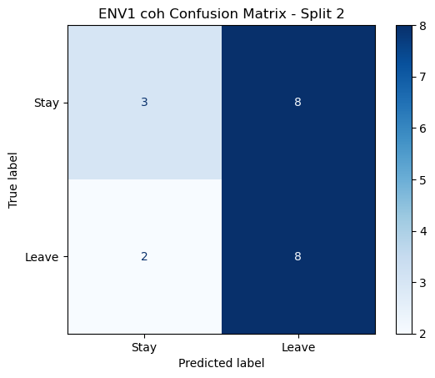

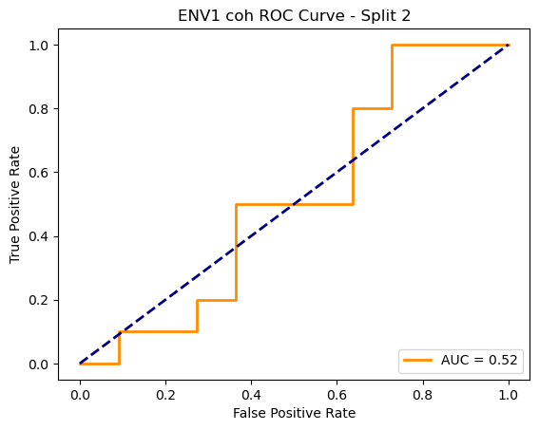

=== ENV1 Split 3/5 ===

Epoch 1/200 | Loss: 0.7718

Epoch 2/200 | Loss: 0.6760

Epoch 3/200 | Loss: 0.7399

Epoch 4/200 | Loss: 0.6976

Epoch 5/200 | Loss: 0.7629

Epoch 6/200 | Loss: 0.7651

Epoch 7/200 | Loss: 0.7110

Epoch 8/200 | Loss: 0.7569

Epoch 9/200 | Loss: 0.7161

Epoch 10/200 | Loss: 0.7810

Epoch 11/200 | Loss: 0.7315

Epoch 12/200 | Loss: 0.7167

Epoch 13/200 | Loss: 0.7571

Epoch 14/200 | Loss: 0.7095

Epoch 15/200 | Loss: 0.7539

Epoch 16/200 | Loss: 0.7030

Epoch 17/200 | Loss: 0.7781

Epoch 18/200 | Loss: 0.6754

Epoch 19/200 | Loss: 0.7701

Epoch 20/200 | Loss: 0.7871

Epoch 21/200 | Loss: 0.7602

Epoch 22/200 | Loss: 0.8082

Epoch 23/200 | Loss: 0.7170

Epoch 24/200 | Loss: 0.7655

Epoch 25/200 | Loss: 0.7574

Epoch 26/200 | Loss: 0.7403

Epoch 27/200 | Loss: 0.7309

Epoch 28/200 | Loss: 0.7888

Epoch 29/200 | Loss: 0.7225

Epoch 30/200 | Loss: 0.7737

Epoch 31/200 | Loss: 0.7258

Epoch 32/200 | Loss: 0.7214

Epoch 33/200 | Loss: 0.7308

Epoch 34/200 | Loss: 0.7124

Epoch 35/200 | Loss: 0.7842

Epoch 36/200 | Loss: 0.7368

Epoch 37/200 | Loss: 0.7350

Epoch 38/200 | Loss: 0.7417

Epoch 39/200 | Loss: 0.7509

Epoch 40/200 | Loss: 0.6952

Epoch 41/200 | Loss: 0.6934

Epoch 42/200 | Loss: 0.7770

Epoch 43/200 | Loss: 0.7400

Epoch 44/200 | Loss: 0.7727

Epoch 45/200 | Loss: 0.7596

Epoch 46/200 | Loss: 0.7293

Epoch 47/200 | Loss: 0.7674

Epoch 48/200 | Loss: 0.7131

Epoch 49/200 | Loss: 0.7617

Epoch 50/200 | Loss: 0.7471

Epoch 51/200 | Loss: 0.7020

Epoch 52/200 | Loss: 0.7570

Epoch 53/200 | Loss: 0.7364

Epoch 54/200 | Loss: 0.7526

Epoch 55/200 | Loss: 0.8291

Epoch 56/200 | Loss: 0.7192

Epoch 57/200 | Loss: 0.7190

Epoch 58/200 | Loss: 0.7177

Epoch 59/200 | Loss: 0.7438

Epoch 60/200 | Loss: 0.7414

Epoch 61/200 | Loss: 0.7361

Epoch 62/200 | Loss: 0.7287

Epoch 63/200 | Loss: 0.7370

Epoch 64/200 | Loss: 0.7252

Epoch 65/200 | Loss: 0.6617

Epoch 66/200 | Loss: 0.6732

Epoch 67/200 | Loss: 0.7252

Epoch 68/200 | Loss: 0.7770

Epoch 69/200 | Loss: 0.7362

Epoch 70/200 | Loss: 0.7387

Epoch 71/200 | Loss: 0.7137

Epoch 72/200 | Loss: 0.7135

Epoch 73/200 | Loss: 0.7436

Epoch 74/200 | Loss: 0.7161

Epoch 75/200 | Loss: 0.7120

Epoch 76/200 | Loss: 0.7298

Epoch 77/200 | Loss: 0.7401

Epoch 78/200 | Loss: 0.6650

Epoch 79/200 | Loss: 0.7343

Epoch 80/200 | Loss: 0.7300

Epoch 81/200 | Loss: 0.7019

Epoch 82/200 | Loss: 0.6737

Epoch 83/200 | Loss: 0.7455

Epoch 84/200 | Loss: 0.6823

Epoch 85/200 | Loss: 0.7313

Epoch 86/200 | Loss: 0.7228

Epoch 87/200 | Loss: 0.6399

Epoch 88/200 | Loss: 0.6886

Epoch 89/200 | Loss: 0.7953

Epoch 90/200 | Loss: 0.7555

Epoch 91/200 | Loss: 0.8389

Epoch 92/200 | Loss: 0.7326

Epoch 93/200 | Loss: 0.7180

Epoch 94/200 | Loss: 0.6872

Epoch 95/200 | Loss: 0.6913

Epoch 96/200 | Loss: 0.7547

Epoch 97/200 | Loss: 0.7852

Epoch 98/200 | Loss: 0.7256

Epoch 99/200 | Loss: 0.7393

Epoch 100/200 | Loss: 0.6825

Epoch 101/200 | Loss: 0.7294

Epoch 102/200 | Loss: 0.7135

Epoch 103/200 | Loss: 0.7614

Epoch 104/200 | Loss: 0.6553

Epoch 105/200 | Loss: 0.6988

Epoch 106/200 | Loss: 0.6684

Epoch 107/200 | Loss: 0.7174

Epoch 108/200 | Loss: 0.6690

Epoch 109/200 | Loss: 0.7003

Epoch 110/200 | Loss: 0.6644

Epoch 111/200 | Loss: 0.7023

Epoch 112/200 | Loss: 0.7479

Epoch 113/200 | Loss: 0.7256

Epoch 114/200 | Loss: 0.7104

Epoch 115/200 | Loss: 0.6942

Epoch 116/200 | Loss: 0.7491

Epoch 117/200 | Loss: 0.7064

Epoch 118/200 | Loss: 0.7226

Epoch 119/200 | Loss: 0.7439

Epoch 120/200 | Loss: 0.6903

Epoch 121/200 | Loss: 0.7073

Epoch 122/200 | Loss: 0.7300

Epoch 123/200 | Loss: 0.7260

Epoch 124/200 | Loss: 0.7643

Epoch 125/200 | Loss: 0.7312

Epoch 126/200 | Loss: 0.7456

Epoch 127/200 | Loss: 0.7102

Epoch 128/200 | Loss: 0.7214

Epoch 129/200 | Loss: 0.7170

Epoch 130/200 | Loss: 0.6678

Epoch 131/200 | Loss: 0.7211

Epoch 132/200 | Loss: 0.7434

Epoch 133/200 | Loss: 0.7337

Epoch 134/200 | Loss: 0.7091

Epoch 135/200 | Loss: 0.7195

Epoch 136/200 | Loss: 0.7464

Epoch 137/200 | Loss: 0.7513

Epoch 138/200 | Loss: 0.7350

Epoch 139/200 | Loss: 0.7276

Epoch 140/200 | Loss: 0.7112

Epoch 141/200 | Loss: 0.6774

Epoch 142/200 | Loss: 0.7257

Epoch 143/200 | Loss: 0.7230

Epoch 144/200 | Loss: 0.6986

Epoch 145/200 | Loss: 0.6792

Epoch 146/200 | Loss: 0.7590

Epoch 147/200 | Loss: 0.6983

Epoch 148/200 | Loss: 0.7005

Epoch 149/200 | Loss: 0.6948

Epoch 150/200 | Loss: 0.6504

Epoch 151/200 | Loss: 0.7412

Epoch 152/200 | Loss: 0.7053

Epoch 153/200 | Loss: 0.7143

Epoch 154/200 | Loss: 0.7376

Epoch 155/200 | Loss: 0.7575

Epoch 156/200 | Loss: 0.7397

Epoch 157/200 | Loss: 0.6807

Epoch 158/200 | Loss: 0.7298

Epoch 159/200 | Loss: 0.7240

Epoch 160/200 | Loss: 0.6935

Epoch 161/200 | Loss: 0.7036

Epoch 162/200 | Loss: 0.7306

Epoch 163/200 | Loss: 0.7285

Epoch 164/200 | Loss: 0.6656

Epoch 165/200 | Loss: 0.6781

Epoch 166/200 | Loss: 0.7155

Epoch 167/200 | Loss: 0.6335

Epoch 168/200 | Loss: 0.7063

Epoch 169/200 | Loss: 0.7181

Epoch 170/200 | Loss: 0.6905

Epoch 171/200 | Loss: 0.7267

Epoch 172/200 | Loss: 0.7023

Epoch 173/200 | Loss: 0.7202

Epoch 174/200 | Loss: 0.7882

Epoch 175/200 | Loss: 0.7340

Epoch 176/200 | Loss: 0.6717

Epoch 177/200 | Loss: 0.7113

Epoch 178/200 | Loss: 0.6816

Epoch 179/200 | Loss: 0.7158

Epoch 180/200 | Loss: 0.6495

Epoch 181/200 | Loss: 0.7191

Epoch 182/200 | Loss: 0.7206

Epoch 183/200 | Loss: 0.6972

Epoch 184/200 | Loss: 0.7375

Epoch 185/200 | Loss: 0.7132

Epoch 186/200 | Loss: 0.7466

Epoch 187/200 | Loss: 0.7179

Epoch 188/200 | Loss: 0.7066

Epoch 189/200 | Loss: 0.7107

Epoch 190/200 | Loss: 0.7415

Epoch 191/200 | Loss: 0.7304

Epoch 192/200 | Loss: 0.7279

Epoch 193/200 | Loss: 0.7335

Epoch 194/200 | Loss: 0.7582

Epoch 195/200 | Loss: 0.6539

Epoch 196/200 | Loss: 0.7191

Epoch 197/200 | Loss: 0.7686

Epoch 198/200 | Loss: 0.6940

Epoch 199/200 | Loss: 0.6903

Epoch 200/200 | Loss: 0.7730

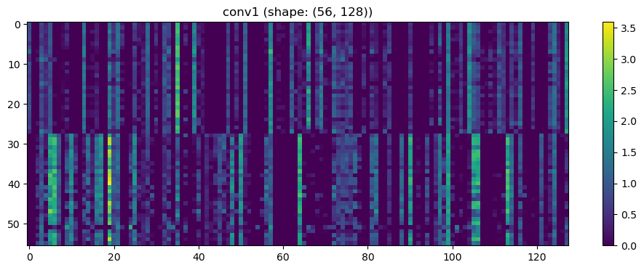

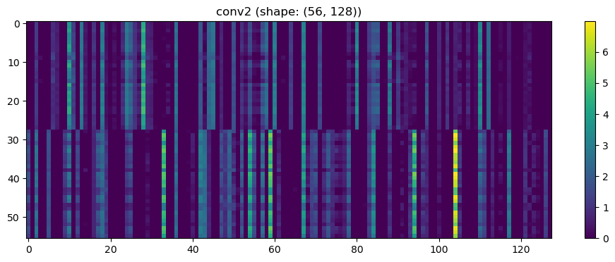

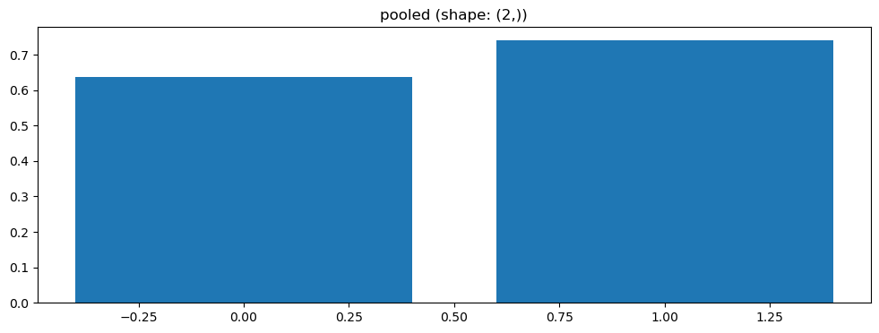

Split 1 Accuracy: 0.5455

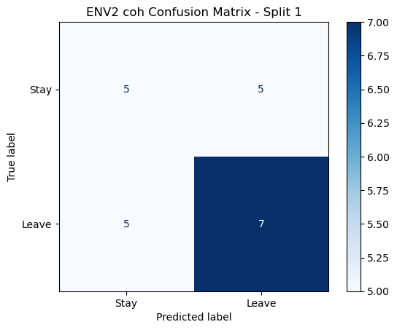

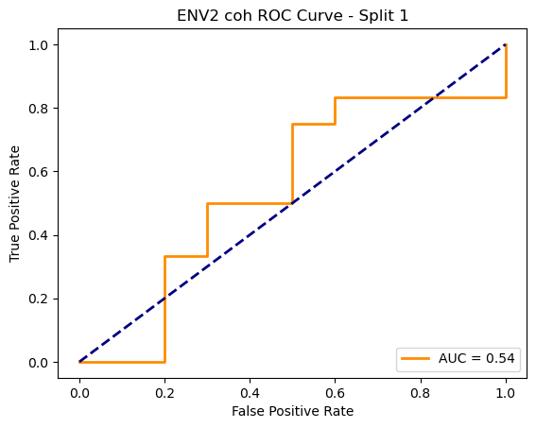

=== ENV2 Split 2/5 ===

C:\Users\sansk\miniconda3\Lib\site-packages\scipy\signal\_spectral_py.py:1668: RuntimeWarning: invalid value encountered in divide

Cxy = np.abs(Pxy)**2 / Pxx / Pyy

After oversampling, class counts: Counter({1: 43, 0: 43})

C:\Users\sansk\miniconda3\Lib\site-packages\torch_geometric\deprecation.py:26: UserWarning: 'data.DataLoader' is deprecated, use 'loader.DataLoader' instead

warnings.warn(out)

Epoch 1/100 | Loss: 0.8154

Epoch 2/100 | Loss: 0.7513

Epoch 3/100 | Loss: 0.7961

Epoch 4/100 | Loss: 0.7418

Epoch 5/100 | Loss: 0.7060

Epoch 6/100 | Loss: 0.8139

Epoch 7/100 | Loss: 0.7610

Epoch 8/100 | Loss: 0.7182

Epoch 9/100 | Loss: 0.7913

Epoch 10/100 | Loss: 0.7440

Epoch 11/100 | Loss: 0.7176

Epoch 12/100 | Loss: 0.7669

Epoch 13/100 | Loss: 0.7384

Epoch 14/100 | Loss: 0.7311

Epoch 15/100 | Loss: 0.7638

Epoch 16/100 | Loss: 0.7336

Epoch 17/100 | Loss: 0.7197

Epoch 18/100 | Loss: 0.7423

Epoch 19/100 | Loss: 0.7496

Epoch 20/100 | Loss: 0.7234

Epoch 21/100 | Loss: 0.7175

Epoch 22/100 | Loss: 0.7071

Epoch 23/100 | Loss: 0.7205

Epoch 24/100 | Loss: 0.7548

Epoch 25/100 | Loss: 0.7205

Epoch 26/100 | Loss: 0.7712

Epoch 27/100 | Loss: 0.6937

Epoch 28/100 | Loss: 0.7444

Epoch 29/100 | Loss: 0.7291

Epoch 30/100 | Loss: 0.7233

Epoch 31/100 | Loss: 0.6434

Epoch 32/100 | Loss: 0.6581

Epoch 33/100 | Loss: 0.6755

Epoch 34/100 | Loss: 0.7057

Epoch 35/100 | Loss: 0.7275

Epoch 36/100 | Loss: 0.6746

Epoch 37/100 | Loss: 0.7146

Epoch 38/100 | Loss: 0.7104

Epoch 39/100 | Loss: 0.6511

Epoch 40/100 | Loss: 0.7045

Epoch 41/100 | Loss: 0.7276

Epoch 42/100 | Loss: 0.7142

Epoch 43/100 | Loss: 0.7523

Epoch 44/100 | Loss: 0.6875

Epoch 45/100 | Loss: 0.6675

Epoch 46/100 | Loss: 0.7393

Epoch 47/100 | Loss: 0.7726

Epoch 48/100 | Loss: 0.7304

Epoch 49/100 | Loss: 0.6715

Epoch 50/100 | Loss: 0.7636

Epoch 51/100 | Loss: 0.7267

Epoch 52/100 | Loss: 0.6889

Epoch 53/100 | Loss: 0.7042

Epoch 54/100 | Loss: 0.7307

Epoch 55/100 | Loss: 0.7355

Epoch 56/100 | Loss: 0.6973

Epoch 57/100 | Loss: 0.6996

Epoch 58/100 | Loss: 0.7053

Epoch 59/100 | Loss: 0.6859

Epoch 60/100 | Loss: 0.6762

Epoch 61/100 | Loss: 0.7303

Epoch 62/100 | Loss: 0.7065

Epoch 63/100 | Loss: 0.7041

Epoch 64/100 | Loss: 0.7157

Epoch 65/100 | Loss: 0.7075

Epoch 66/100 | Loss: 0.7006

Epoch 67/100 | Loss: 0.7088

Epoch 68/100 | Loss: 0.6976

Epoch 69/100 | Loss: 0.7158

Epoch 70/100 | Loss: 0.7061

Epoch 71/100 | Loss: 0.6859

Epoch 72/100 | Loss: 0.7454

Epoch 73/100 | Loss: 0.7123

Epoch 74/100 | Loss: 0.7666

Epoch 75/100 | Loss: 0.6750

Epoch 76/100 | Loss: 0.6909

Epoch 77/100 | Loss: 0.6856

Epoch 78/100 | Loss: 0.6881

Epoch 79/100 | Loss: 0.7070

Epoch 80/100 | Loss: 0.7086

Epoch 81/100 | Loss: 0.6898

Epoch 82/100 | Loss: 0.7078

Epoch 83/100 | Loss: 0.6785

Epoch 84/100 | Loss: 0.7089

Epoch 85/100 | Loss: 0.6666

Epoch 86/100 | Loss: 0.7128

Epoch 87/100 | Loss: 0.7211

Epoch 88/100 | Loss: 0.6641

Epoch 89/100 | Loss: 0.7107

Epoch 90/100 | Loss: 0.6698

Epoch 91/100 | Loss: 0.6551

Epoch 92/100 | Loss: 0.7074

Epoch 93/100 | Loss: 0.7023

Epoch 94/100 | Loss: 0.6479

Epoch 95/100 | Loss: 0.7062

Epoch 96/100 | Loss: 0.6753

Epoch 97/100 | Loss: 0.6948

Epoch 98/100 | Loss: 0.7102

Epoch 99/100 | Loss: 0.6960

Epoch 100/100 | Loss: 0.7166

Split 3 Accuracy: 0.5238

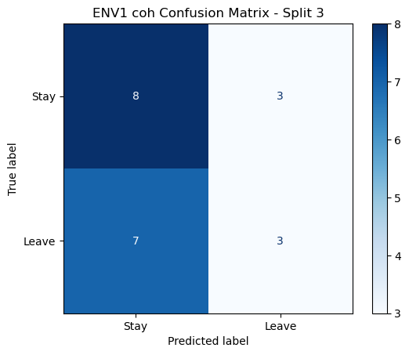

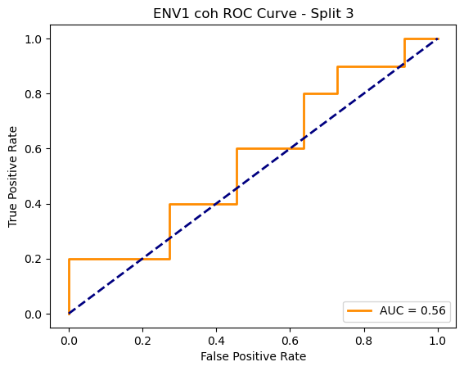

=== ENV1 Split 4/5 ===

Epoch 1/200 | Loss: 0.7867

Epoch 2/200 | Loss: 0.7399

Epoch 3/200 | Loss: 0.7404

Epoch 4/200 | Loss: 0.7684

Epoch 5/200 | Loss: 0.7505

Epoch 6/200 | Loss: 0.7668

Epoch 7/200 | Loss: 0.8045

Epoch 8/200 | Loss: 0.7871

Epoch 9/200 | Loss: 0.7856

Epoch 10/200 | Loss: 0.7461

Epoch 11/200 | Loss: 0.8951

Epoch 12/200 | Loss: 0.7561

Epoch 13/200 | Loss: 0.7273

Epoch 14/200 | Loss: 0.7099

Epoch 15/200 | Loss: 0.8054

Epoch 16/200 | Loss: 0.7635

Epoch 17/200 | Loss: 0.7469

Epoch 18/200 | Loss: 0.7092

Epoch 19/200 | Loss: 0.8009

Epoch 20/200 | Loss: 0.8151

Epoch 21/200 | Loss: 0.7771

Epoch 22/200 | Loss: 0.7454

Epoch 23/200 | Loss: 0.8128

Epoch 24/200 | Loss: 0.7881

Epoch 25/200 | Loss: 0.7618

Epoch 26/200 | Loss: 0.8207

Epoch 27/200 | Loss: 0.7659

Epoch 28/200 | Loss: 0.7586

Epoch 29/200 | Loss: 0.7709

Epoch 30/200 | Loss: 0.8305

Epoch 31/200 | Loss: 0.7920

Epoch 32/200 | Loss: 0.7869

Epoch 33/200 | Loss: 0.7670

Epoch 34/200 | Loss: 0.7207

Epoch 35/200 | Loss: 0.7112

Epoch 36/200 | Loss: 0.7907

Epoch 37/200 | Loss: 0.8201

Epoch 38/200 | Loss: 0.7211

Epoch 39/200 | Loss: 0.8064

Epoch 40/200 | Loss: 0.7387

Epoch 41/200 | Loss: 0.7094

Epoch 42/200 | Loss: 0.8234

Epoch 43/200 | Loss: 0.7203

Epoch 44/200 | Loss: 0.7072

Epoch 45/200 | Loss: 0.8190

Epoch 46/200 | Loss: 0.7202

Epoch 47/200 | Loss: 0.7148

Epoch 48/200 | Loss: 0.7405

Epoch 49/200 | Loss: 0.7509

Epoch 50/200 | Loss: 0.7987

Epoch 51/200 | Loss: 0.7571

Epoch 52/200 | Loss: 0.7541

Epoch 53/200 | Loss: 0.7416

Epoch 54/200 | Loss: 0.7706

Epoch 55/200 | Loss: 0.7390

Epoch 56/200 | Loss: 0.7289

Epoch 57/200 | Loss: 0.7766

Epoch 58/200 | Loss: 0.7603

Epoch 59/200 | Loss: 0.7388

Epoch 60/200 | Loss: 0.7762

Epoch 61/200 | Loss: 0.6924

Epoch 62/200 | Loss: 0.7428

Epoch 63/200 | Loss: 0.7215

Epoch 64/200 | Loss: 0.7259

Epoch 65/200 | Loss: 0.7162

Epoch 66/200 | Loss: 0.7789

Epoch 67/200 | Loss: 0.8060

Epoch 68/200 | Loss: 0.7793

Epoch 69/200 | Loss: 0.7883

Epoch 70/200 | Loss: 0.7123

Epoch 71/200 | Loss: 0.6710

Epoch 72/200 | Loss: 0.7358

Epoch 73/200 | Loss: 0.6954

Epoch 74/200 | Loss: 0.7758

Epoch 75/200 | Loss: 0.7652

Epoch 76/200 | Loss: 0.7445

Epoch 77/200 | Loss: 0.7592

Epoch 78/200 | Loss: 0.8156

Epoch 79/200 | Loss: 0.6869

Epoch 80/200 | Loss: 0.7320

Epoch 81/200 | Loss: 0.7563

Epoch 82/200 | Loss: 0.7529

Epoch 83/200 | Loss: 0.7810

Epoch 84/200 | Loss: 0.6974

Epoch 85/200 | Loss: 0.6999

Epoch 86/200 | Loss: 0.7227

Epoch 87/200 | Loss: 0.7795

Epoch 88/200 | Loss: 0.7701

Epoch 89/200 | Loss: 0.7303

Epoch 90/200 | Loss: 0.7544

Epoch 91/200 | Loss: 0.7498

Epoch 92/200 | Loss: 0.7261

Epoch 93/200 | Loss: 0.7780

Epoch 94/200 | Loss: 0.6829

Epoch 95/200 | Loss: 0.7538

Epoch 96/200 | Loss: 0.7819

Epoch 97/200 | Loss: 0.7165

Epoch 98/200 | Loss: 0.6709

Epoch 99/200 | Loss: 0.6761

Epoch 100/200 | Loss: 0.7159

Epoch 101/200 | Loss: 0.7308

Epoch 102/200 | Loss: 0.7269

Epoch 103/200 | Loss: 0.7406

Epoch 104/200 | Loss: 0.7630

Epoch 105/200 | Loss: 0.7863

Epoch 106/200 | Loss: 0.7928

Epoch 107/200 | Loss: 0.7231

Epoch 108/200 | Loss: 0.7819

Epoch 109/200 | Loss: 0.6895

Epoch 110/200 | Loss: 0.7688

Epoch 111/200 | Loss: 0.7699

Epoch 112/200 | Loss: 0.8190

Epoch 113/200 | Loss: 0.7177

Epoch 114/200 | Loss: 0.7618

Epoch 115/200 | Loss: 0.7300

Epoch 116/200 | Loss: 0.6713

Epoch 117/200 | Loss: 0.7316

Epoch 118/200 | Loss: 0.7731

Epoch 119/200 | Loss: 0.7472

Epoch 120/200 | Loss: 0.7989

Epoch 121/200 | Loss: 0.7556

Epoch 122/200 | Loss: 0.6664

Epoch 123/200 | Loss: 0.7474

Epoch 124/200 | Loss: 0.7186

Epoch 125/200 | Loss: 0.7246

Epoch 126/200 | Loss: 0.6703

Epoch 127/200 | Loss: 0.7443

Epoch 128/200 | Loss: 0.7921

Epoch 129/200 | Loss: 0.7383

Epoch 130/200 | Loss: 0.7527

Epoch 131/200 | Loss: 0.6898

Epoch 132/200 | Loss: 0.7540

Epoch 133/200 | Loss: 0.7376

Epoch 134/200 | Loss: 0.7239

Epoch 135/200 | Loss: 0.7547

Epoch 136/200 | Loss: 0.7694

Epoch 137/200 | Loss: 0.7621

Epoch 138/200 | Loss: 0.7001

Epoch 139/200 | Loss: 0.7395

Epoch 140/200 | Loss: 0.7240

Epoch 141/200 | Loss: 0.7097

Epoch 142/200 | Loss: 0.7347

Epoch 143/200 | Loss: 0.7405

Epoch 144/200 | Loss: 0.7441

Epoch 145/200 | Loss: 0.6923

Epoch 146/200 | Loss: 0.7275

Epoch 147/200 | Loss: 0.7956

Epoch 148/200 | Loss: 0.7222

Epoch 149/200 | Loss: 0.7245

Epoch 150/200 | Loss: 0.8156

Epoch 151/200 | Loss: 0.6677

Epoch 152/200 | Loss: 0.7857

Epoch 153/200 | Loss: 0.7733

Epoch 154/200 | Loss: 0.6810

Epoch 155/200 | Loss: 0.7388

Epoch 156/200 | Loss: 0.7399

Epoch 157/200 | Loss: 0.7251

Epoch 158/200 | Loss: 0.7185

Epoch 159/200 | Loss: 0.7138

Epoch 160/200 | Loss: 0.7793

Epoch 161/200 | Loss: 0.7727

Epoch 162/200 | Loss: 0.7251

Epoch 163/200 | Loss: 0.7485

Epoch 164/200 | Loss: 0.7337

Epoch 165/200 | Loss: 0.6994

Epoch 166/200 | Loss: 0.6943

Epoch 167/200 | Loss: 0.7535

Epoch 168/200 | Loss: 0.7113

Epoch 169/200 | Loss: 0.7537

Epoch 170/200 | Loss: 0.7978

Epoch 171/200 | Loss: 0.7670

Epoch 172/200 | Loss: 0.6784

Epoch 173/200 | Loss: 0.6974

Epoch 174/200 | Loss: 0.7754

Epoch 175/200 | Loss: 0.6896

Epoch 176/200 | Loss: 0.7783

Epoch 177/200 | Loss: 0.6728

Epoch 178/200 | Loss: 0.6744

Epoch 179/200 | Loss: 0.7087

Epoch 180/200 | Loss: 0.7260

Epoch 181/200 | Loss: 0.7879

Epoch 182/200 | Loss: 0.7018

Epoch 183/200 | Loss: 0.7035

Epoch 184/200 | Loss: 0.7265

Epoch 185/200 | Loss: 0.7341

Epoch 186/200 | Loss: 0.6898

Epoch 187/200 | Loss: 0.7385

Epoch 188/200 | Loss: 0.6823

Epoch 189/200 | Loss: 0.7430

Epoch 190/200 | Loss: 0.7527

Epoch 191/200 | Loss: 0.6517

Epoch 192/200 | Loss: 0.6742

Epoch 193/200 | Loss: 0.7629

Epoch 194/200 | Loss: 0.6979

Epoch 195/200 | Loss: 0.7241

Epoch 196/200 | Loss: 0.6974

Epoch 197/200 | Loss: 0.7258

Epoch 198/200 | Loss: 0.7161

Epoch 199/200 | Loss: 0.6927

Epoch 200/200 | Loss: 0.7418

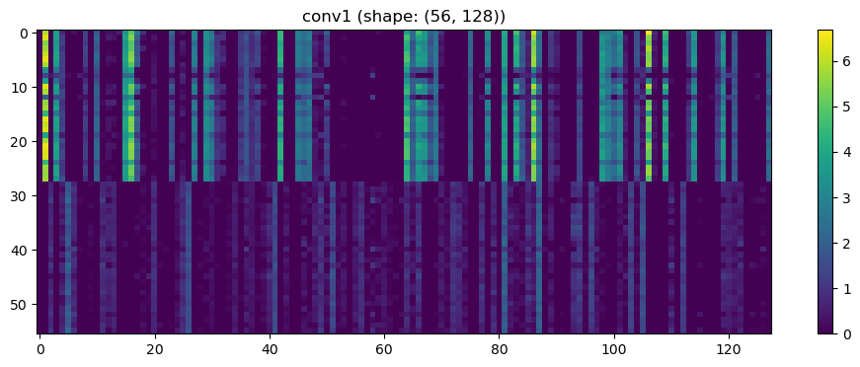

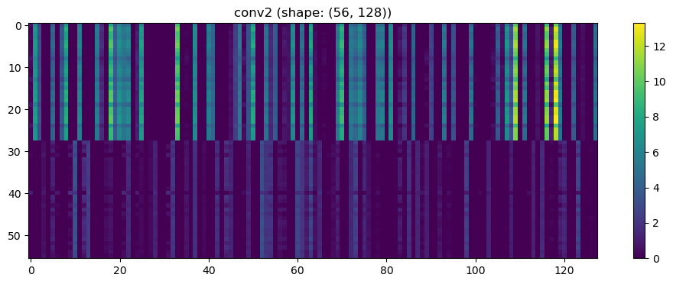

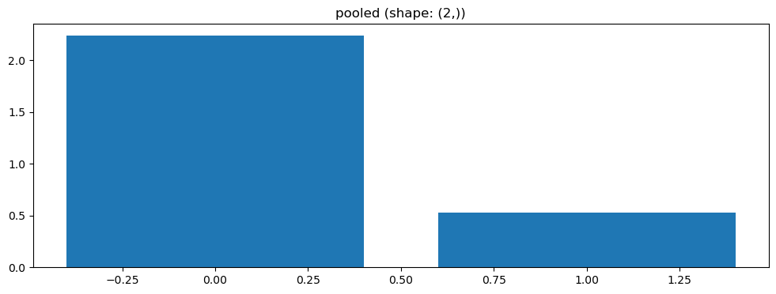

Split 2 Accuracy: 0.5714

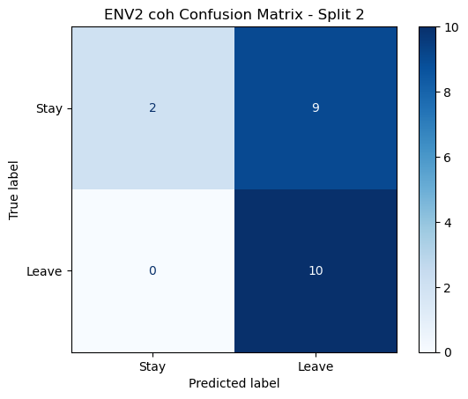

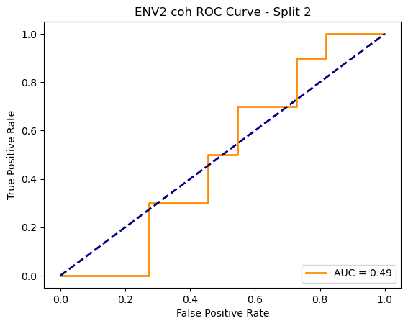

=== ENV2 Split 3/5 ===

C:\Users\sansk\miniconda3\Lib\site-packages\scipy\signal\_spectral_py.py:1668: RuntimeWarning: invalid value encountered in divide

Cxy = np.abs(Pxy)**2 / Pxx / Pyy

After oversampling, class counts: Counter({1: 44, 0: 4443, 0: 43})

C:\Users\sansk\miniconda3\Lib\site-packages\torch_geometric\deprecation.py:26: UserWarning: 'data.DataLoader' is deprecated, use 'loader.DataLoader' instead

warnings.warn(out)

Epoch 1/100 | Loss: 0.7237

Epoch 2/100 | Loss: 0.7427

Epoch 3/100 | Loss: 0.7480

Epoch 4/100 | Loss: 0.7460

Epoch 5/100 | Loss: 0.7324

Epoch 6/100 | Loss: 0.7158

Epoch 7/100 | Loss: 0.7013

Epoch 8/100 | Loss: 0.7541

Epoch 9/100 | Loss: 0.7517

Epoch 10/100 | Loss: 0.7268

Epoch 11/100 | Loss: 0.7421

Epoch 12/100 | Loss: 0.7655

Epoch 13/100 | Loss: 0.7306

Epoch 14/100 | Loss: 0.7298

Epoch 15/100 | Loss: 0.7696

Epoch 16/100 | Loss: 0.7072

Epoch 17/100 | Loss: 0.7157

Epoch 18/100 | Loss: 0.6947

Epoch 19/100 | Loss: 0.7460

Epoch 20/100 | Loss: 0.7785

Epoch 21/100 | Loss: 0.7038

Epoch 22/100 | Loss: 0.7445

Epoch 23/100 | Loss: 0.7614

Epoch 24/100 | Loss: 0.7378

Epoch 25/100 | Loss: 0.7360

Epoch 26/100 | Loss: 0.7178

Epoch 27/100 | Loss: 0.7202

Epoch 28/100 | Loss: 0.7423

Epoch 29/100 | Loss: 0.7003

Epoch 30/100 | Loss: 0.6893

Epoch 31/100 | Loss: 0.7449

Epoch 32/100 | Loss: 0.7085

Epoch 33/100 | Loss: 0.7884

Epoch 34/100 | Loss: 0.7629

Epoch 35/100 | Loss: 0.6916

Epoch 36/100 | Loss: 0.6734

Epoch 37/100 | Loss: 0.7062

Epoch 38/100 | Loss: 0.6956

Epoch 39/100 | Loss: 0.7209

Epoch 40/100 | Loss: 0.7278

Epoch 41/100 | Loss: 0.6961

Epoch 42/100 | Loss: 0.7174

Epoch 43/100 | Loss: 0.7051

Epoch 44/100 | Loss: 0.7275

Epoch 45/100 | Loss: 0.6511

Epoch 46/100 | Loss: 0.6529

Epoch 47/100 | Loss: 0.6614

Epoch 48/100 | Loss: 0.7098

Epoch 49/100 | Loss: 0.6490

Epoch 50/100 | Loss: 0.7513

Epoch 51/100 | Loss: 0.7180

Epoch 52/100 | Loss: 0.6670

Epoch 53/100 | Loss: 0.6686

Epoch 54/100 | Loss: 0.6777

Epoch 55/100 | Loss: 0.6876

Epoch 56/100 | Loss: 0.6876

Epoch 57/100 | Loss: 0.6938

Epoch 58/100 | Loss: 0.7160

Epoch 59/100 | Loss: 0.6722

Epoch 60/100 | Loss: 0.6832

Epoch 61/100 | Loss: 0.6560

Epoch 62/100 | Loss: 0.7106

Epoch 63/100 | Loss: 0.7419

Epoch 64/100 | Loss: 0.6822

Epoch 65/100 | Loss: 0.6704

Epoch 66/100 | Loss: 0.7245

Epoch 67/100 | Loss: 0.6981

Epoch 68/100 | Loss: 0.6899

Epoch 69/100 | Loss: 0.6863

Epoch 70/100 | Loss: 0.6901

Epoch 71/100 | Loss: 0.6867

Epoch 72/100 | Loss: 0.6487

Epoch 73/100 | Loss: 0.6728

Epoch 74/100 | Loss: 0.6862

Epoch 75/100 | Loss: 0.7102

Epoch 76/100 | Loss: 0.6561

Epoch 77/100 | Loss: 0.7013

Epoch 78/100 | Loss: 0.6934

Epoch 79/100 | Loss: 0.6641

Epoch 80/100 | Loss: 0.6483

Epoch 81/100 | Loss: 0.7005

Epoch 82/100 | Loss: 0.6229

Epoch 83/100 | Loss: 0.6630

Epoch 84/100 | Loss: 0.6828

Epoch 85/100 | Loss: 0.6894

Epoch 86/100 | Loss: 0.6785

Epoch 87/100 | Loss: 0.7077

Epoch 88/100 | Loss: 0.7403

Epoch 89/100 | Loss: 0.6589

Epoch 90/100 | Loss: 0.6314

Epoch 91/100 | Loss: 0.6470

Epoch 92/100 | Loss: 0.6292

Epoch 93/100 | Loss: 0.6588

Epoch 94/100 | Loss: 0.6579

Epoch 95/100 | Loss: 0.6564

Epoch 96/100 | Loss: 0.6433

Epoch 97/100 | Loss: 0.7016

Epoch 98/100 | Loss: 0.6461

Epoch 99/100 | Loss: 0.6793

Epoch 100/100 | Loss: 0.6877

Split 4 Accuracy: 0.4762

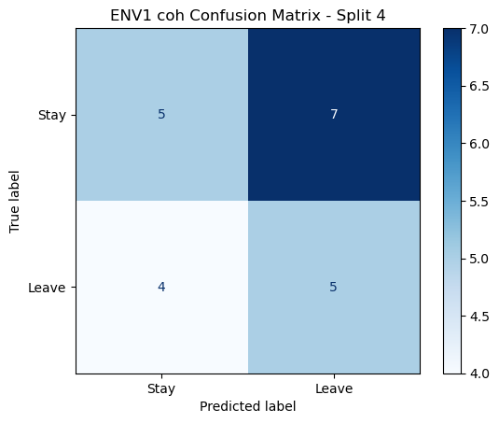

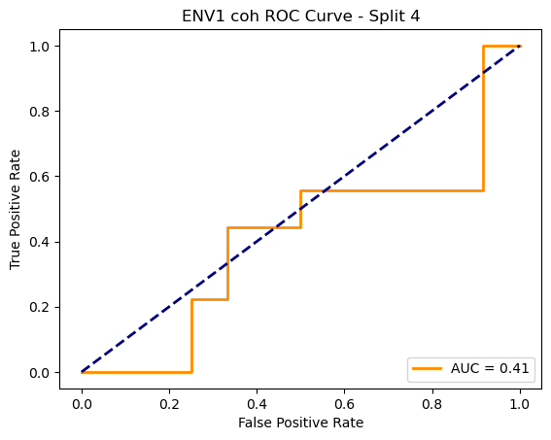

=== ENV1 Split 5/5 ===

Epoch 1/200 | Loss: 0.7462

Epoch 2/200 | Loss: 0.7487

Epoch 3/200 | Loss: 0.7648

Epoch 4/200 | Loss: 0.7082

Epoch 5/200 | Loss: 0.7374

Epoch 6/200 | Loss: 0.8073

Epoch 7/200 | Loss: 0.7253

Epoch 8/200 | Loss: 0.7724

Epoch 9/200 | Loss: 0.7256

Epoch 10/200 | Loss: 0.7638

Epoch 11/200 | Loss: 0.7542

Epoch 12/200 | Loss: 0.6987

Epoch 13/200 | Loss: 0.7784

Epoch 14/200 | Loss: 0.7266

Epoch 15/200 | Loss: 0.8171

Epoch 16/200 | Loss: 0.7864

Epoch 17/200 | Loss: 0.7533

Epoch 18/200 | Loss: 0.7769

Epoch 19/200 | Loss: 0.7892

Epoch 20/200 | Loss: 0.7463

Epoch 21/200 | Loss: 0.6861

Epoch 22/200 | Loss: 0.7566

Epoch 23/200 | Loss: 0.6876

Epoch 24/200 | Loss: 0.7069

Epoch 25/200 | Loss: 0.7138

Epoch 26/200 | Loss: 0.7885

Epoch 27/200 | Loss: 0.7612

Epoch 28/200 | Loss: 0.7494

Epoch 29/200 | Loss: 0.7422

Epoch 30/200 | Loss: 0.8025

Epoch 31/200 | Loss: 0.7506

Epoch 32/200 | Loss: 0.7174

Epoch 33/200 | Loss: 0.7968

Epoch 34/200 | Loss: 0.7713

Epoch 35/200 | Loss: 0.7269

Epoch 36/200 | Loss: 0.7774

Epoch 37/200 | Loss: 0.7936

Epoch 38/200 | Loss: 0.8359

Epoch 39/200 | Loss: 0.7627

Epoch 40/200 | Loss: 0.7234

Epoch 41/200 | Loss: 0.7123

Epoch 42/200 | Loss: 0.7218

Epoch 43/200 | Loss: 0.8180

Epoch 44/200 | Loss: 0.7940

Epoch 45/200 | Loss: 0.7553

Epoch 46/200 | Loss: 0.7380

Epoch 47/200 | Loss: 0.7799

Epoch 48/200 | Loss: 0.7134

Epoch 49/200 | Loss: 0.7479

Epoch 50/200 | Loss: 0.7046

Epoch 51/200 | Loss: 0.7555

Epoch 52/200 | Loss: 0.7990

Epoch 53/200 | Loss: 0.7115

Epoch 54/200 | Loss: 0.7439

Epoch 55/200 | Loss: 0.6548

Epoch 56/200 | Loss: 0.7524

Epoch 57/200 | Loss: 0.7263

Epoch 58/200 | Loss: 0.6937

Epoch 59/200 | Loss: 0.7532

Epoch 60/200 | Loss: 0.7239

Epoch 61/200 | Loss: 0.7301

Epoch 62/200 | Loss: 0.6878

Epoch 63/200 | Loss: 0.7758

Epoch 64/200 | Loss: 0.7215

Epoch 65/200 | Loss: 0.6982

Epoch 66/200 | Loss: 0.7027

Epoch 67/200 | Loss: 0.7224

Epoch 68/200 | Loss: 0.7320

Epoch 69/200 | Loss: 0.7426

Epoch 70/200 | Loss: 0.7676

Epoch 71/200 | Loss: 0.7524

Epoch 72/200 | Loss: 0.7568

Epoch 73/200 | Loss: 0.7558

Epoch 74/200 | Loss: 0.7726

Epoch 75/200 | Loss: 0.7323

Epoch 76/200 | Loss: 0.7055

Epoch 77/200 | Loss: 0.7148

Epoch 78/200 | Loss: 0.6882

Epoch 79/200 | Loss: 0.7333

Epoch 80/200 | Loss: 0.7321

Epoch 81/200 | Loss: 0.7495

Epoch 82/200 | Loss: 0.7145

Epoch 83/200 | Loss: 0.7441

Epoch 84/200 | Loss: 0.7071

Epoch 85/200 | Loss: 0.7388

Epoch 86/200 | Loss: 0.7043

Epoch 87/200 | Loss: 0.7761

Epoch 88/200 | Loss: 0.7225

Epoch 89/200 | Loss: 0.7630

Epoch 90/200 | Loss: 0.7275

Epoch 91/200 | Loss: 0.7538

Epoch 92/200 | Loss: 0.7398

Epoch 93/200 | Loss: 0.6981

Epoch 94/200 | Loss: 0.7529

Epoch 95/200 | Loss: 0.7723

Epoch 96/200 | Loss: 0.6996

Epoch 97/200 | Loss: 0.7338

Epoch 98/200 | Loss: 0.7087

Epoch 99/200 | Loss: 0.7304

Epoch 100/200 | Loss: 0.7274

Epoch 101/200 | Loss: 0.6618

Epoch 102/200 | Loss: 0.7121

Epoch 103/200 | Loss: 0.7511

Epoch 104/200 | Loss: 0.7328

Epoch 105/200 | Loss: 0.6970

Epoch 106/200 | Loss: 0.7157

Epoch 107/200 | Loss: 0.7484

Epoch 108/200 | Loss: 0.7322

Epoch 109/200 | Loss: 0.7046

Epoch 110/200 | Loss: 0.7238

Epoch 111/200 | Loss: 0.6905

Epoch 112/200 | Loss: 0.7250

Epoch 113/200 | Loss: 0.7573

Epoch 114/200 | Loss: 0.7583

Epoch 115/200 | Loss: 0.7538

Epoch 116/200 | Loss: 0.6932

Epoch 117/200 | Loss: 0.7847

Epoch 118/200 | Loss: 0.6761

Epoch 119/200 | Loss: 0.7171

Epoch 120/200 | Loss: 0.7262

Epoch 121/200 | Loss: 0.7723

Epoch 122/200 | Loss: 0.7299

Epoch 123/200 | Loss: 0.7464

Epoch 124/200 | Loss: 0.7288

Epoch 125/200 | Loss: 0.7437

Epoch 126/200 | Loss: 0.7540

Epoch 127/200 | Loss: 0.7415

Epoch 128/200 | Loss: 0.7052

Epoch 129/200 | Loss: 0.6840

Epoch 130/200 | Loss: 0.7501

Epoch 131/200 | Loss: 0.7035

Epoch 132/200 | Loss: 0.6972

Epoch 133/200 | Loss: 0.7104

Epoch 134/200 | Loss: 0.7916

Epoch 135/200 | Loss: 0.7554

Epoch 136/200 | Loss: 0.6991

Epoch 137/200 | Loss: 0.7531

Epoch 138/200 | Loss: 0.7166

Epoch 139/200 | Loss: 0.7241

Epoch 140/200 | Loss: 0.6685

Epoch 141/200 | Loss: 0.7002

Epoch 142/200 | Loss: 0.7167

Epoch 143/200 | Loss: 0.7121

Epoch 144/200 | Loss: 0.7541

Epoch 145/200 | Loss: 0.7687

Epoch 146/200 | Loss: 0.6959

Epoch 147/200 | Loss: 0.7228

Epoch 148/200 | Loss: 0.7587

Epoch 149/200 | Loss: 0.7628

Epoch 150/200 | Loss: 0.7689

Epoch 151/200 | Loss: 0.7171

Epoch 152/200 | Loss: 0.6898

Epoch 153/200 | Loss: 0.6905

Epoch 154/200 | Loss: 0.7938

Epoch 155/200 | Loss: 0.7100

Epoch 156/200 | Loss: 0.6743

Epoch 157/200 | Loss: 0.7522

Epoch 158/200 | Loss: 0.7049

Epoch 159/200 | Loss: 0.7032

Epoch 160/200 | Loss: 0.7048

Epoch 161/200 | Loss: 0.7076

Epoch 162/200 | Loss: 0.7481

Epoch 163/200 | Loss: 0.7801

Epoch 164/200 | Loss: 0.6832

Epoch 165/200 | Loss: 0.7278

Epoch 166/200 | Loss: 0.7181

Epoch 167/200 | Loss: 0.6680

Epoch 168/200 | Loss: 0.7488

Epoch 169/200 | Loss: 0.7636

Epoch 170/200 | Loss: 0.7096

Epoch 171/200 | Loss: 0.7586

Epoch 172/200 | Loss: 0.7404

Epoch 173/200 | Loss: 0.6785

Epoch 174/200 | Loss: 0.6515

Epoch 175/200 | Loss: 0.7530

Epoch 176/200 | Loss: 0.6422

Epoch 177/200 | Loss: 0.6957

Epoch 178/200 | Loss: 0.7580

Epoch 179/200 | Loss: 0.7546

Epoch 180/200 | Loss: 0.7273

Epoch 181/200 | Loss: 0.7594

Epoch 182/200 | Loss: 0.7304

Epoch 183/200 | Loss: 0.6810

Epoch 184/200 | Loss: 0.6997

Epoch 185/200 | Loss: 0.7435

Epoch 186/200 | Loss: 0.7182

Epoch 187/200 | Loss: 0.7140

Epoch 188/200 | Loss: 0.7376

Epoch 189/200 | Loss: 0.6663

Epoch 190/200 | Loss: 0.6577

Epoch 191/200 | Loss: 0.6772

Epoch 192/200 | Loss: 0.6905

Epoch 193/200 | Loss: 0.7557

Epoch 194/200 | Loss: 0.7218

Epoch 195/200 | Loss: 0.6725

Epoch 196/200 | Loss: 0.7189

Epoch 197/200 | Loss: 0.7524

Epoch 198/200 | Loss: 0.7391

Epoch 199/200 | Loss: 0.6794

Epoch 200/200 | Loss: 0.6688

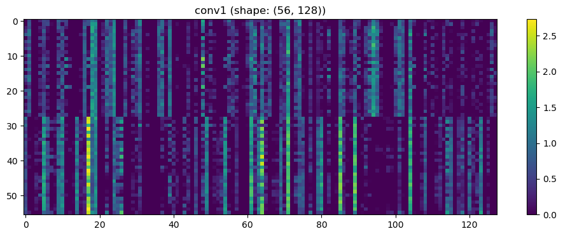

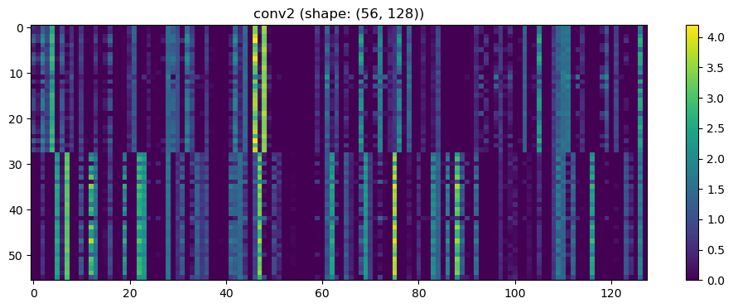

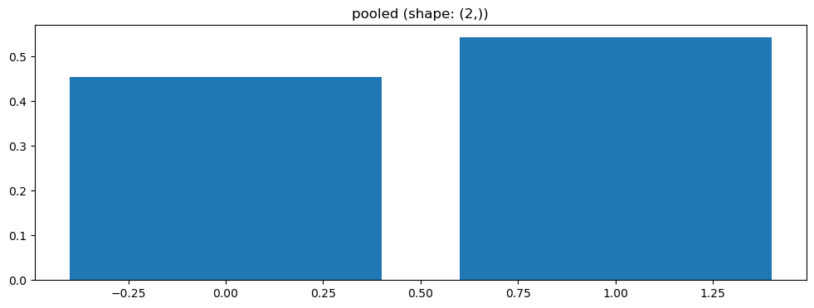

Split 3 Accuracy: 0.6190

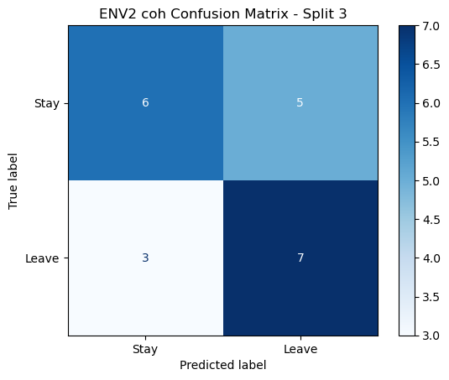

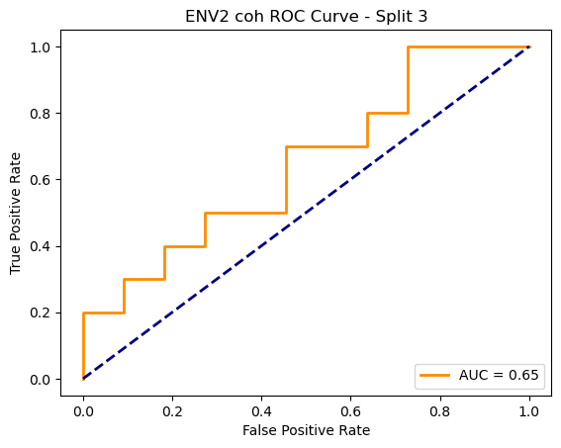

=== ENV2 Split 4/5 ===

C:\Users\sansk\miniconda3\Lib\site-packages\scipy\signal\_spectral_py.py:1668: RuntimeWarning: invalid value encountered in divide

Cxy = np.abs(Pxy)**2 / Pxx / Pyy

After oversampling, class counts: Counter({1: 44, 0: 44})

C:\Users\sansk\miniconda3\Lib\site-packages\torch_geometric\deprecation.py:26: UserWarning: 'data.DataLoader' is deprecated, use 'loader.DataLoader' instead

warnings.warn(out)

Epoch 1/100 | Loss: 0.7098

Epoch 2/100 | Loss: 0.7789

Epoch 3/100 | Loss: 0.7165

Epoch 4/100 | Loss: 0.7644

Epoch 5/100 | Loss: 0.7475

Epoch 6/100 | Loss: 0.7193

Epoch 7/100 | Loss: 0.8158

Epoch 8/100 | Loss: 0.7316

Epoch 9/100 | Loss: 0.7757

Epoch 10/100 | Loss: 0.6341

Epoch 11/100 | Loss: 0.6324

Epoch 12/100 | Loss: 0.7411

Epoch 13/100 | Loss: 0.7219

Epoch 14/100 | Loss: 0.7458

Epoch 15/100 | Loss: 0.7049

Epoch 16/100 | Loss: 0.6998

Epoch 17/100 | Loss: 0.7369

Epoch 18/100 | Loss: 0.7188

Epoch 19/100 | Loss: 0.7297

Epoch 20/100 | Loss: 0.6973

Epoch 21/100 | Loss: 0.7150

Epoch 22/100 | Loss: 0.6987

Epoch 23/100 | Loss: 0.7250

Epoch 24/100 | Loss: 0.6952

Epoch 25/100 | Loss: 0.7343

Epoch 26/100 | Loss: 0.7236

Epoch 27/100 | Loss: 0.7029

Epoch 28/100 | Loss: 0.7126

Epoch 29/100 | Loss: 0.7180

Epoch 30/100 | Loss: 0.6963

Epoch 31/100 | Loss: 0.6938

Epoch 32/100 | Loss: 0.6608

Epoch 33/100 | Loss: 0.6986

Epoch 34/100 | Loss: 0.6520

Epoch 35/100 | Loss: 0.6641

Epoch 36/100 | Loss: 0.6622

Epoch 37/100 | Loss: 0.6656

Epoch 38/100 | Loss: 0.7053

Epoch 39/100 | Loss: 0.6769

Epoch 40/100 | Loss: 0.7166

Epoch 41/100 | Loss: 0.6823

Epoch 42/100 | Loss: 0.6566

Epoch 43/100 | Loss: 0.6519

Epoch 44/100 | Loss: 0.6714

Epoch 45/100 | Loss: 0.6623

Epoch 46/100 | Loss: 0.6848

Epoch 47/100 | Loss: 0.6926

Epoch 48/100 | Loss: 0.7474

Epoch 49/100 | Loss: 0.7027

Epoch 50/100 | Loss: 0.6712

Epoch 51/100 | Loss: 0.7115

Epoch 52/100 | Loss: 0.6593

Epoch 53/100 | Loss: 0.7084

Epoch 54/100 | Loss: 0.7194

Epoch 55/100 | Loss: 0.7012

Epoch 56/100 | Loss: 0.6520

Epoch 57/100 | Loss: 0.6577

Epoch 58/100 | Loss: 0.6864

Epoch 59/100 | Loss: 0.7139

Epoch 60/100 | Loss: 0.6713

Epoch 61/100 | Loss: 0.6370

Epoch 62/100 | Loss: 0.6708

Epoch 63/100 | Loss: 0.7229

Epoch 64/100 | Loss: 0.6909

Epoch 65/100 | Loss: 0.6494

Epoch 66/100 | Loss: 0.6713

Epoch 67/100 | Loss: 0.6888

Epoch 68/100 | Loss: 0.6481

Epoch 69/100 | Loss: 0.6427

Epoch 70/100 | Loss: 0.6687

Epoch 71/100 | Loss: 0.6996

Epoch 72/100 | Loss: 0.7188

Epoch 73/100 | Loss: 0.6671

Epoch 74/100 | Loss: 0.6462

Epoch 75/100 | Loss: 0.6588

Epoch 76/100 | Loss: 0.7144

Epoch 77/100 | Loss: 0.6811

Epoch 78/100 | Loss: 0.6316

Epoch 79/100 | Loss: 0.7412

Epoch 80/100 | Loss: 0.6929

Epoch 81/100 | Loss: 0.6479

Epoch 82/100 | Loss: 0.6917

Epoch 83/100 | Loss: 0.6548

Epoch 84/100 | Loss: 0.6957

Epoch 85/100 | Loss: 0.6488

Epoch 86/100 | Loss: 0.6508

Epoch 87/100 | Loss: 0.6944

Epoch 88/100 | Loss: 0.6898

Epoch 89/100 | Loss: 0.6302

Epoch 90/100 | Loss: 0.6394

Epoch 91/100 | Loss: 0.6839

Epoch 92/100 | Loss: 0.6874

Epoch 93/100 | Loss: 0.6763

Epoch 94/100 | Loss: 0.6835

Epoch 95/100 | Loss: 0.6249

Epoch 96/100 | Loss: 0.6855

Epoch 97/100 | Loss: 0.6550

Epoch 98/100 | Loss: 0.6534

Epoch 99/100 | Loss: 0.6843

Epoch 100/100 | Loss: 0.6966

Split 5 Accuracy: 0.4286

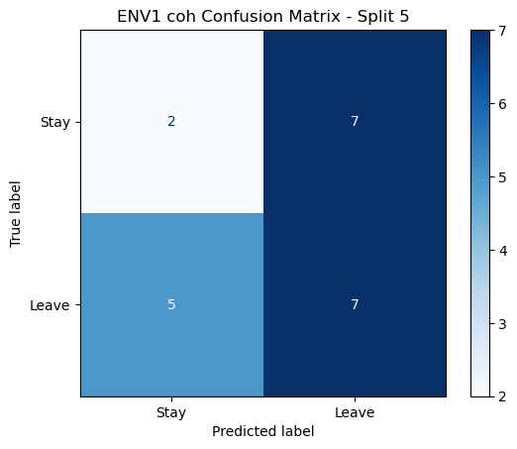

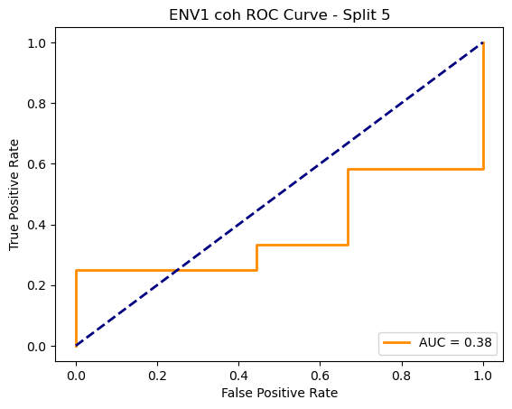

ENV1 coh Average Accuracy: 0.4814 ± 0.0378

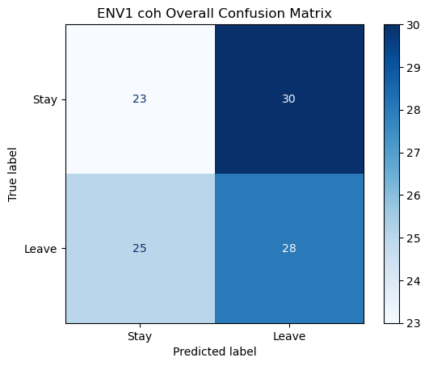

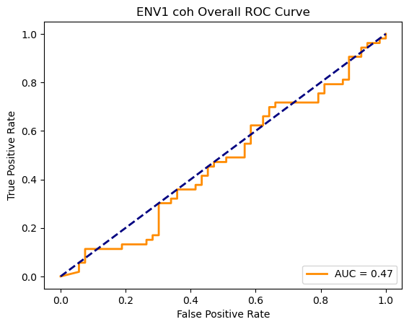

Running GNN with plv connectivity for ENV1...

==================================================

Training GNN for ENV1 with plv connectivity

==================================================

=== ENV1 Split 1/5 ===

After oversampling, class counts: Counter({0: 43, 1: 43})

Epoch 1/100 | Loss: 0.7696

Epoch 2/100 | Loss: 0.7853

Epoch 3/100 | Loss: 0.7522

Epoch 4/100 | Loss: 0.6992

Epoch 5/100 | Loss: 0.7941

Epoch 6/100 | Loss: 0.7946

Epoch 7/100 | Loss: 0.7149

Epoch 8/100 | Loss: 0.7158

Epoch 9/100 | Loss: 0.7577

Epoch 10/100 | Loss: 0.6724

Epoch 11/100 | Loss: 0.7174

Epoch 12/100 | Loss: 0.6921

Epoch 13/100 | Loss: 0.6856

Epoch 14/100 | Loss: 0.7593

Epoch 15/100 | Loss: 0.6702

Epoch 16/100 | Loss: 0.6883

Epoch 17/100 | Loss: 0.7631

Epoch 18/100 | Loss: 0.7268

Epoch 19/100 | Loss: 0.7111

Epoch 20/100 | Loss: 0.7101

Epoch 21/100 | Loss: 0.6214

Epoch 22/100 | Loss: 0.7121

Epoch 23/100 | Loss: 0.7046

Epoch 24/100 | Loss: 0.6728

Epoch 25/100 | Loss: 0.7036

Epoch 26/100 | Loss: 0.7136

Epoch 27/100 | Loss: 0.6938

Epoch 28/100 | Loss: 0.6675

Epoch 29/100 | Loss: 0.7659

Epoch 30/100 | Loss: 0.7335

Epoch 31/100 | Loss: 0.7244

Epoch 32/100 | Loss: 0.6716

Epoch 33/100 | Loss: 0.6866

Epoch 34/100 | Loss: 0.6398

Epoch 35/100 | Loss: 0.7191

Epoch 36/100 | Loss: 0.6966

Epoch 37/100 | Loss: 0.6784

Epoch 38/100 | Loss: 0.6758

Epoch 39/100 | Loss: 0.7200

Epoch 40/100 | Loss: 0.6786

Epoch 41/100 | Loss: 0.6279

Epoch 42/100 | Loss: 0.6714

Epoch 43/100 | Loss: 0.6326

Epoch 44/100 | Loss: 0.5837

Epoch 45/100 | Loss: 0.6457

Epoch 46/100 | Loss: 0.6388

Epoch 47/100 | Loss: 0.7117

Epoch 48/100 | Loss: 0.6856

Epoch 49/100 | Loss: 0.6647

Epoch 50/100 | Loss: 0.6797

Epoch 51/100 | Loss: 0.6889

Epoch 52/100 | Loss: 0.6872

Epoch 53/100 | Loss: 0.6161

Epoch 54/100 | Loss: 0.6551

Epoch 55/100 | Loss: 0.6367

Epoch 56/100 | Loss: 0.6523

Epoch 57/100 | Loss: 0.6366

Epoch 58/100 | Loss: 0.6469

Epoch 59/100 | Loss: 0.6449

Epoch 60/100 | Loss: 0.6522

Epoch 61/100 | Loss: 0.6539

Epoch 62/100 | Loss: 0.6154

Epoch 63/100 | Loss: 0.6896

Epoch 64/100 | Loss: 0.6614

Epoch 65/100 | Loss: 0.6394

Epoch 66/100 | Loss: 0.6260

Epoch 67/100 | Loss: 0.7035

Epoch 68/100 | Loss: 0.6723

Epoch 69/100 | Loss: 0.6935

Epoch 70/100 | Loss: 0.6235

Epoch 71/100 | Loss: 0.6317

Epoch 72/100 | Loss: 0.6271

Epoch 73/100 | Loss: 0.6657

Epoch 74/100 | Loss: 0.6298

Epoch 75/100 | Loss: 0.7075

Epoch 76/100 | Loss: 0.6282

Epoch 77/100 | Loss: 0.7128

Epoch 78/100 | Loss: 0.5790

Epoch 79/100 | Loss: 0.6671

Epoch 80/100 | Loss: 0.6166

Epoch 81/100 | Loss: 0.7088

Epoch 82/100 | Loss: 0.6684

Epoch 83/100 | Loss: 0.6198

Epoch 84/100 | Loss: 0.6744

Epoch 85/100 | Loss: 0.5979

Epoch 86/100 | Loss: 0.6503

Epoch 87/100 | Loss: 0.6073

Epoch 88/100 | Loss: 0.6027

Epoch 89/100 | Loss: 0.6128

Epoch 90/100 | Loss: 0.6909

Epoch 91/100 | Loss: 0.6542

Epoch 92/100 | Loss: 0.6941

Epoch 93/100 | Loss: 0.6037

Epoch 94/100 | Loss: 0.6701

Epoch 95/100 | Loss: 0.6274

Epoch 96/100 | Loss: 0.6822

Epoch 97/100 | Loss: 0.7176

Epoch 98/100 | Loss: 0.6145

Epoch 99/100 | Loss: 0.5887

Epoch 100/100 | Loss: 0.5976

Split 1 Accuracy: 0.4091

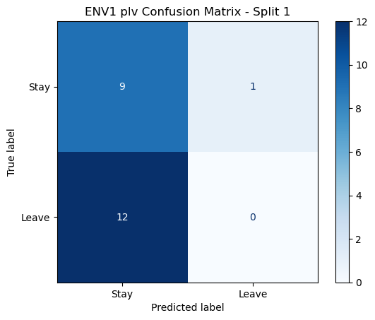

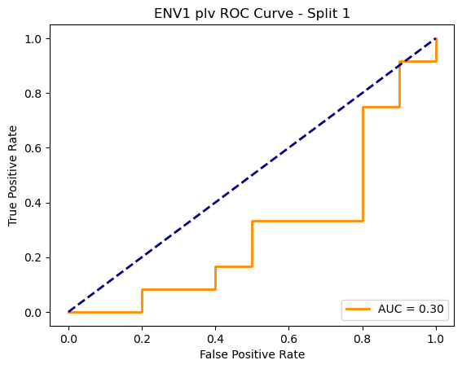

=== ENV1 Split 2/5 ===

After oversampling, class counts: Counter({1: 43, 0: 43})

Epoch 1/100 | Loss: 0.7879

Epoch 2/100 | Loss: 0.7114

Epoch 3/100 | Loss: 0.7423

Epoch 4/100 | Loss: 0.7496

Epoch 5/100 | Loss: 0.7178

Epoch 6/100 | Loss: 0.7258

Epoch 7/100 | Loss: 0.7392

Epoch 8/100 | Loss: 0.7247

Epoch 9/100 | Loss: 0.7302

Epoch 10/100 | Loss: 0.7312

Epoch 11/100 | Loss: 0.7167

Epoch 12/100 | Loss: 0.7204

Epoch 13/100 | Loss: 0.7177

Epoch 14/100 | Loss: 0.7069

Epoch 15/100 | Loss: 0.6646

Epoch 16/100 | Loss: 0.7528

Epoch 17/100 | Loss: 0.7391

Epoch 18/100 | Loss: 0.6585

Epoch 19/100 | Loss: 0.6803

Epoch 20/100 | Loss: 0.6908

Epoch 21/100 | Loss: 0.6966

Epoch 22/100 | Loss: 0.6715

Epoch 23/100 | Loss: 0.7332

Epoch 24/100 | Loss: 0.7023

Epoch 25/100 | Loss: 0.6900

Epoch 26/100 | Loss: 0.6766

Epoch 27/100 | Loss: 0.6606

Epoch 28/100 | Loss: 0.6791

Epoch 29/100 | Loss: 0.7157

Epoch 30/100 | Loss: 0.6519

Epoch 31/100 | Loss: 0.6568

Epoch 32/100 | Loss: 0.6646

Epoch 33/100 | Loss: 0.6470

Epoch 34/100 | Loss: 0.6876

Epoch 35/100 | Loss: 0.7128

Epoch 36/100 | Loss: 0.6827

Epoch 37/100 | Loss: 0.6952

Epoch 38/100 | Loss: 0.6481

Epoch 39/100 | Loss: 0.6754

Epoch 40/100 | Loss: 0.6605

Epoch 41/100 | Loss: 0.7147

Epoch 42/100 | Loss: 0.6321

Epoch 43/100 | Loss: 0.6443

Epoch 44/100 | Loss: 0.6656

Epoch 45/100 | Loss: 0.6041

Epoch 46/100 | Loss: 0.6695

Epoch 47/100 | Loss: 0.6559

Epoch 48/100 | Loss: 0.6714

Epoch 49/100 | Loss: 0.6909

Epoch 50/100 | Loss: 0.6811

Epoch 51/100 | Loss: 0.6193

Epoch 52/100 | Loss: 0.6517

Epoch 53/100 | Loss: 0.6087

Epoch 54/100 | Loss: 0.6865

Epoch 55/100 | Loss: 0.6745

Epoch 56/100 | Loss: 0.6808

Epoch 57/100 | Loss: 0.6681

Epoch 58/100 | Loss: 0.5730

Epoch 59/100 | Loss: 0.6645

Epoch 60/100 | Loss: 0.6487

Epoch 61/100 | Loss: 0.6786

Epoch 62/100 | Loss: 0.6547

Epoch 63/100 | Loss: 0.5924

Epoch 64/100 | Loss: 0.5828

Epoch 65/100 | Loss: 0.6161

Epoch 66/100 | Loss: 0.6073

Epoch 67/100 | Loss: 0.6271

Epoch 68/100 | Loss: 0.6363

Epoch 69/100 | Loss: 0.6560

Epoch 70/100 | Loss: 0.6209

Epoch 71/100 | Loss: 0.6505

Epoch 72/100 | Loss: 0.6294

Epoch 73/100 | Loss: 0.6349

Epoch 74/100 | Loss: 0.6545

Epoch 75/100 | Loss: 0.6537

Epoch 76/100 | Loss: 0.6129

Epoch 77/100 | Loss: 0.6206

Epoch 78/100 | Loss: 0.6144

Epoch 79/100 | Loss: 0.6874

Epoch 80/100 | Loss: 0.7141

Epoch 81/100 | Loss: 0.6257

Epoch 82/100 | Loss: 0.6376

Epoch 83/100 | Loss: 0.6122

Epoch 84/100 | Loss: 0.6413

Epoch 85/100 | Loss: 0.5275

Epoch 86/100 | Loss: 0.6973

Epoch 87/100 | Loss: 0.6125

Epoch 88/100 | Loss: 0.6422

Epoch 89/100 | Loss: 0.6165

Epoch 90/100 | Loss: 0.6171

Epoch 91/100 | Loss: 0.6061

Epoch 92/100 | Loss: 0.6053

Epoch 93/100 | Loss: 0.6091

Epoch 94/100 | Loss: 0.5914

Epoch 95/100 | Loss: 0.6070

Epoch 96/100 | Loss: 0.5804

Epoch 97/100 | Loss: 0.6193

Epoch 98/100 | Loss: 0.6411

Epoch 99/100 | Loss: 0.6155

Epoch 100/100 | Loss: 0.6434

Split 2 Accuracy: 0.3810

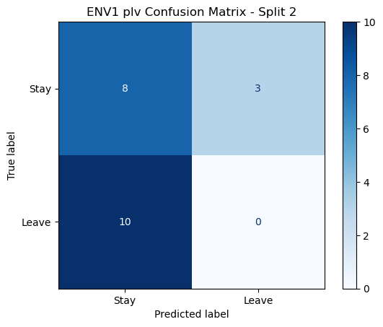

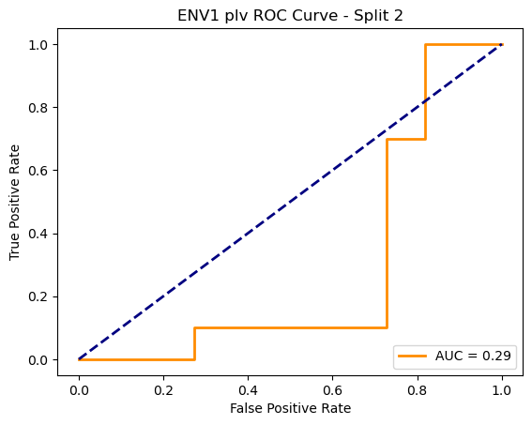

=== ENV1 Split 3/5 ===

After oversampling, class counts: Counter({1: 43, 0: 43})

C:\Users\sansk\miniconda3\Lib\site-packages\torch_geometric\deprecation.py:26: UserWarning: 'data.DataLoader' is deprecated, use 'loader.DataLoader' instead

warnings.warn(out)

Epoch 1/100 | Loss: 0.8520

Epoch 2/100 | Loss: 0.6974

Epoch 3/100 | Loss: 0.7474

Epoch 4/100 | Loss: 0.8048

Epoch 5/100 | Loss: 0.7265

Epoch 6/100 | Loss: 0.7578

Epoch 7/100 | Loss: 0.7087

Epoch 8/100 | Loss: 0.7221

Epoch 9/100 | Loss: 0.7600

Epoch 10/100 | Loss: 0.6913

Epoch 11/100 | Loss: 0.7343

Epoch 12/100 | Loss: 0.6987

Epoch 13/100 | Loss: 0.7512

Epoch 14/100 | Loss: 0.6143

Epoch 15/100 | Loss: 0.6963

Epoch 16/100 | Loss: 0.6842

Epoch 17/100 | Loss: 0.6724

Epoch 18/100 | Loss: 0.6773

Epoch 19/100 | Loss: 0.6687

Epoch 20/100 | Loss: 0.6994

Epoch 21/100 | Loss: 0.6807

Epoch 22/100 | Loss: 0.6342

Epoch 23/100 | Loss: 0.7084

Epoch 24/100 | Loss: 0.7346

Epoch 25/100 | Loss: 0.7044

Epoch 26/100 | Loss: 0.6738

Epoch 27/100 | Loss: 0.6616

Epoch 28/100 | Loss: 0.6889

Epoch 29/100 | Loss: 0.7238

Epoch 30/100 | Loss: 0.7677

Epoch 31/100 | Loss: 0.7290

Epoch 32/100 | Loss: 0.7114

Epoch 33/100 | Loss: 0.6656

Epoch 34/100 | Loss: 0.7304

Epoch 35/100 | Loss: 0.6412

Epoch 36/100 | Loss: 0.5936

Epoch 37/100 | Loss: 0.6786

Epoch 38/100 | Loss: 0.6602

Epoch 39/100 | Loss: 0.6463

Epoch 40/100 | Loss: 0.6357

Epoch 41/100 | Loss: 0.6663

Epoch 42/100 | Loss: 0.6444

Epoch 43/100 | Loss: 0.7196

Epoch 44/100 | Loss: 0.6460

Epoch 45/100 | Loss: 0.6359

Epoch 46/100 | Loss: 0.6920

Epoch 47/100 | Loss: 0.7082

Epoch 48/100 | Loss: 0.6685

Epoch 49/100 | Loss: 0.6043

Epoch 50/100 | Loss: 0.7005

Epoch 51/100 | Loss: 0.7020

Epoch 52/100 | Loss: 0.6515

Epoch 53/100 | Loss: 0.6987

Epoch 54/100 | Loss: 0.6753

Epoch 55/100 | Loss: 0.7083

Epoch 56/100 | Loss: 0.6072

Epoch 57/100 | Loss: 0.6469

Epoch 58/100 | Loss: 0.6197

Epoch 59/100 | Loss: 0.6572

Epoch 60/100 | Loss: 0.6095

Epoch 61/100 | Loss: 0.6814

Epoch 62/100 | Loss: 0.6514

Epoch 63/100 | Loss: 0.7060

Epoch 64/100 | Loss: 0.7139

Epoch 65/100 | Loss: 0.6483

Epoch 66/100 | Loss: 0.6833

Epoch 67/100 | Loss: 0.6243

Epoch 68/100 | Loss: 0.7025

Epoch 69/100 | Loss: 0.6423

Epoch 70/100 | Loss: 0.6418

Epoch 71/100 | Loss: 0.6506

Epoch 72/100 | Loss: 0.5830

Epoch 73/100 | Loss: 0.6028

Epoch 74/100 | Loss: 0.6032

Epoch 75/100 | Loss: 0.6296

Epoch 76/100 | Loss: 0.6086

Epoch 77/100 | Loss: 0.6404

Epoch 78/100 | Loss: 0.6138

Epoch 79/100 | Loss: 0.6575

Epoch 80/100 | Loss: 0.6557

Epoch 81/100 | Loss: 0.6158

Epoch 82/100 | Loss: 0.6159

Epoch 83/100 | Loss: 0.6429

Epoch 84/100 | Loss: 0.5568

Epoch 85/100 | Loss: 0.5618

Epoch 86/100 | Loss: 0.7260

Epoch 87/100 | Loss: 0.6164

Epoch 88/100 | Loss: 0.6514

Epoch 89/100 | Loss: 0.5566

Epoch 90/100 | Loss: 0.6017

Epoch 91/100 | Loss: 0.5958

Epoch 92/100 | Loss: 0.6309

Epoch 93/100 | Loss: 0.6066

Epoch 94/100 | Loss: 0.6485

Epoch 95/100 | Loss: 0.6179

Epoch 96/100 | Loss: 0.6608

Epoch 97/100 | Loss: 0.6344

Epoch 98/100 | Loss: 0.5457

Epoch 99/100 | Loss: 0.6630

Epoch 100/100 | Loss: 0.6184

Split 3 Accuracy: 0.5238

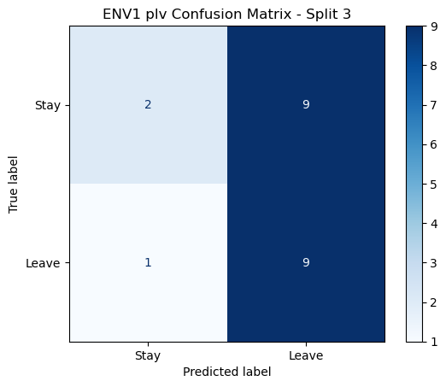

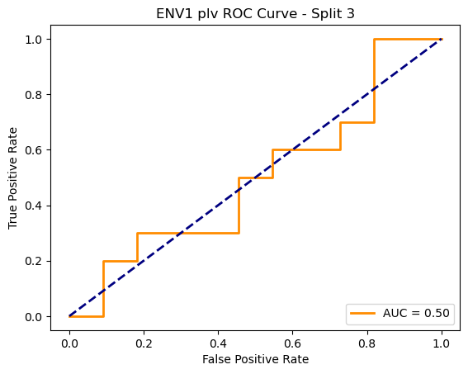

=== ENV1 Split 4/5 ===

After oversampling, class counts: Counter({1: 44, 0: 44})

C:\Users\sansk\miniconda3\Lib\site-packages\torch_geometric\deprecation.py:26: UserWarning: 'data.DataLoader' is deprecated, use 'loader.DataLoader' instead

warnings.warn(out)

Epoch 1/100 | Loss: 0.7616

Epoch 2/100 | Loss: 0.7724

Epoch 3/100 | Loss: 0.7591

Epoch 4/100 | Loss: 0.8000

Epoch 5/100 | Loss: 0.6526

Epoch 6/100 | Loss: 0.7592

Epoch 7/100 | Loss: 0.7284

Epoch 8/100 | Loss: 0.7599

Epoch 9/100 | Loss: 0.7603

Epoch 10/100 | Loss: 0.7300

Epoch 11/100 | Loss: 0.6774

Epoch 12/100 | Loss: 0.7028

Epoch 13/100 | Loss: 0.7587

Epoch 14/100 | Loss: 0.7710

Epoch 15/100 | Loss: 0.7258

Epoch 16/100 | Loss: 0.7302

Epoch 17/100 | Loss: 0.7462

Epoch 18/100 | Loss: 0.7018

Epoch 19/100 | Loss: 0.6878

Epoch 20/100 | Loss: 0.6718

Epoch 21/100 | Loss: 0.6953

Epoch 22/100 | Loss: 0.7513

Epoch 23/100 | Loss: 0.7476

Epoch 24/100 | Loss: 0.7186

Epoch 25/100 | Loss: 0.6972

Epoch 26/100 | Loss: 0.7716

Epoch 27/100 | Loss: 0.7051

Epoch 28/100 | Loss: 0.6952

Epoch 29/100 | Loss: 0.7106

Epoch 30/100 | Loss: 0.6399

Epoch 31/100 | Loss: 0.7582

Epoch 32/100 | Loss: 0.6910

Epoch 33/100 | Loss: 0.7284

Epoch 34/100 | Loss: 0.6954

Epoch 35/100 | Loss: 0.6596

Epoch 36/100 | Loss: 0.7032

Epoch 37/100 | Loss: 0.6893

Epoch 38/100 | Loss: 0.6473

Epoch 39/100 | Loss: 0.7041

Epoch 40/100 | Loss: 0.7032

Epoch 41/100 | Loss: 0.7262

Epoch 42/100 | Loss: 0.6585

Epoch 43/100 | Loss: 0.6847

Epoch 44/100 | Loss: 0.6712

Epoch 45/100 | Loss: 0.6640

Epoch 46/100 | Loss: 0.6523

Epoch 47/100 | Loss: 0.6523

Epoch 48/100 | Loss: 0.6443

Epoch 49/100 | Loss: 0.6683

Epoch 50/100 | Loss: 0.6796

Epoch 51/100 | Loss: 0.6740

Epoch 52/100 | Loss: 0.6639

Epoch 53/100 | Loss: 0.6715

Epoch 54/100 | Loss: 0.6680

Epoch 55/100 | Loss: 0.6437

Epoch 56/100 | Loss: 0.6742

Epoch 57/100 | Loss: 0.7014

Epoch 58/100 | Loss: 0.6842

Epoch 59/100 | Loss: 0.6562

Epoch 60/100 | Loss: 0.6954

Epoch 61/100 | Loss: 0.6662

Epoch 62/100 | Loss: 0.6760

Epoch 63/100 | Loss: 0.6318

Epoch 64/100 | Loss: 0.7143

Epoch 65/100 | Loss: 0.7157

Epoch 66/100 | Loss: 0.7062

Epoch 67/100 | Loss: 0.6450

Epoch 68/100 | Loss: 0.6649

Epoch 69/100 | Loss: 0.6176

Epoch 70/100 | Loss: 0.7311

Epoch 71/100 | Loss: 0.6457

Epoch 72/100 | Loss: 0.6480

Epoch 73/100 | Loss: 0.6785

Epoch 74/100 | Loss: 0.6423

Epoch 75/100 | Loss: 0.6308

Epoch 76/100 | Loss: 0.5965

Epoch 77/100 | Loss: 0.6884

Epoch 78/100 | Loss: 0.5858

Epoch 79/100 | Loss: 0.6468

Epoch 80/100 | Loss: 0.6504

Epoch 81/100 | Loss: 0.6748

Epoch 82/100 | Loss: 0.6852

Epoch 83/100 | Loss: 0.6363

Epoch 84/100 | Loss: 0.6434

Epoch 85/100 | Loss: 0.6362

Epoch 86/100 | Loss: 0.6320

Epoch 87/100 | Loss: 0.6728

Epoch 88/100 | Loss: 0.6741

Epoch 89/100 | Loss: 0.6536

Epoch 90/100 | Loss: 0.6036

Epoch 91/100 | Loss: 0.6467

Epoch 92/100 | Loss: 0.5995

Epoch 93/100 | Loss: 0.6680

Epoch 94/100 | Loss: 0.5811

Epoch 95/100 | Loss: 0.5739

Epoch 96/100 | Loss: 0.6185

Epoch 97/100 | Loss: 0.5700

Epoch 98/100 | Loss: 0.5431

Epoch 99/100 | Loss: 0.6317

Epoch 100/100 | Loss: 0.6153

Epoch 1/200 | Loss: 0.7256

Epoch 2/200 | Loss: 0.7703

Epoch 3/200 | Loss: 0.7707

Epoch 4/200 | Loss: 0.7703

Epoch 5/200 | Loss: 0.7903

Epoch 6/200 | Loss: 0.7072

Epoch 7/200 | Loss: 0.7461

Epoch 8/200 | Loss: 0.6608

Epoch 9/200 | Loss: 0.7279

Epoch 10/200 | Loss: 0.7115

Epoch 11/200 | Loss: 0.7423

Epoch 12/200 | Loss: 0.8413

Epoch 13/200 | Loss: 0.6978

Epoch 14/200 | Loss: 0.7558

Epoch 15/200 | Loss: 0.7179

Epoch 16/200 | Loss: 0.8030

Epoch 17/200 | Loss: 0.7272

Epoch 18/200 | Loss: 0.7706

Epoch 19/200 | Loss: 0.7631

Epoch 20/200 | Loss: 0.7194

Epoch 21/200 | Loss: 0.7183

Epoch 22/200 | Loss: 0.7720

Epoch 23/200 | Loss: 0.6830

Epoch 24/200 | Loss: 0.7661

Epoch 25/200 | Loss: 0.7147

Epoch 26/200 | Loss: 0.7188

Epoch 27/200 | Loss: 0.8112

Epoch 28/200 | Loss: 0.7336

Epoch 29/200 | Loss: 0.8063

Epoch 30/200 | Loss: 0.7543

Epoch 31/200 | Loss: 0.6942

Epoch 32/200 | Loss: 0.7195

Epoch 33/200 | Loss: 0.7192

Epoch 34/200 | Loss: 0.8078

Epoch 35/200 | Loss: 0.6565

Epoch 36/200 | Loss: 0.7749

Epoch 37/200 | Loss: 0.7237

Epoch 38/200 | Loss: 0.7715

Epoch 39/200 | Loss: 0.6992

Epoch 40/200 | Loss: 0.8005

Epoch 41/200 | Loss: 0.7527

Epoch 42/200 | Loss: 0.7479

Epoch 43/200 | Loss: 0.7576

Epoch 44/200 | Loss: 0.7272

Epoch 45/200 | Loss: 0.6918

Epoch 46/200 | Loss: 0.7728

Epoch 47/200 | Loss: 0.6953

Epoch 48/200 | Loss: 0.7567

Epoch 49/200 | Loss: 0.7720

Epoch 50/200 | Loss: 0.7694

Epoch 51/200 | Loss: 0.8013

Epoch 52/200 | Loss: 0.7228

Epoch 53/200 | Loss: 0.7719

Epoch 54/200 | Loss: 0.8236

Epoch 55/200 | Loss: 0.7489

Epoch 56/200 | Loss: 0.7367

Epoch 57/200 | Loss: 0.6782

Epoch 58/200 | Loss: 0.7372

Epoch 59/200 | Loss: 0.7059

Epoch 60/200 | Loss: 0.7415

Epoch 61/200 | Loss: 0.7668

Epoch 62/200 | Loss: 0.6919

Epoch 63/200 | Loss: 0.6823

Epoch 64/200 | Loss: 0.7510

Epoch 65/200 | Loss: 0.7470

Epoch 66/200 | Loss: 0.7697

Epoch 67/200 | Loss: 0.7336

Epoch 68/200 | Loss: 0.7499

Epoch 69/200 | Loss: 0.7848

Epoch 70/200 | Loss: 0.7118

Epoch 71/200 | Loss: 0.7189

Epoch 72/200 | Loss: 0.7501

Epoch 73/200 | Loss: 0.7540

Epoch 74/200 | Loss: 0.6816

Epoch 75/200 | Loss: 0.7724

Epoch 76/200 | Loss: 0.6808

Epoch 77/200 | Loss: 0.7450

Epoch 78/200 | Loss: 0.7491

Epoch 79/200 | Loss: 0.7402

Epoch 80/200 | Loss: 0.6654

Epoch 81/200 | Loss: 0.7251

Epoch 82/200 | Loss: 0.7299

Epoch 83/200 | Loss: 0.7329

Epoch 84/200 | Loss: 0.7260

Epoch 85/200 | Loss: 0.7713

Epoch 86/200 | Loss: 0.8110

Epoch 87/200 | Loss: 0.7165

Epoch 88/200 | Loss: 0.7463

Epoch 89/200 | Loss: 0.6846

Epoch 90/200 | Loss: 0.6965

Epoch 91/200 | Loss: 0.7394

Epoch 92/200 | Loss: 0.6792

Epoch 93/200 | Loss: 0.7084

Epoch 94/200 | Loss: 0.6858

Epoch 95/200 | Loss: 0.7592

Epoch 96/200 | Loss: 0.7169

Epoch 97/200 | Loss: 0.7432

Epoch 98/200 | Loss: 0.7939

Epoch 99/200 | Loss: 0.7415

Epoch 100/200 | Loss: 0.6876

Epoch 101/200 | Loss: 0.7357

Epoch 102/200 | Loss: 0.6766

Epoch 103/200 | Loss: 0.7340

Epoch 104/200 | Loss: 0.7334

Epoch 105/200 | Loss: 0.7660

Epoch 106/200 | Loss: 0.7217

Epoch 107/200 | Loss: 0.7794

Epoch 108/200 | Loss: 0.7487

Epoch 109/200 | Loss: 0.7689

Epoch 110/200 | Loss: 0.7739

Epoch 111/200 | Loss: 0.7728

Epoch 112/200 | Loss: 0.7524

Epoch 113/200 | Loss: 0.7549

Epoch 114/200 | Loss: 0.7067

Epoch 115/200 | Loss: 0.6955

Epoch 116/200 | Loss: 0.6875

Epoch 117/200 | Loss: 0.6976

Epoch 118/200 | Loss: 0.7423

Epoch 119/200 | Loss: 0.7016

Epoch 120/200 | Loss: 0.6696

Epoch 121/200 | Loss: 0.7138

Epoch 122/200 | Loss: 0.7584

Epoch 123/200 | Loss: 0.7975

Epoch 124/200 | Loss: 0.7471

Epoch 125/200 | Loss: 0.7272

Epoch 126/200 | Loss: 0.7590

Epoch 127/200 | Loss: 0.7050

Epoch 128/200 | Loss: 0.7429

Epoch 129/200 | Loss: 0.7020

Epoch 130/200 | Loss: 0.7225

Epoch 131/200 | Loss: 0.7511

Epoch 132/200 | Loss: 0.7657

Epoch 133/200 | Loss: 0.6923

Epoch 134/200 | Loss: 0.6956

Epoch 135/200 | Loss: 0.7381

Epoch 136/200 | Loss: 0.7017

Epoch 137/200 | Loss: 0.7381

Epoch 138/200 | Loss: 0.6928

Epoch 139/200 | Loss: 0.7433

Epoch 140/200 | Loss: 0.6530

Epoch 141/200 | Loss: 0.6703

Epoch 142/200 | Loss: 0.7160

Epoch 143/200 | Loss: 0.7841

Epoch 144/200 | Loss: 0.7562

Epoch 145/200 | Loss: 0.7522

Epoch 146/200 | Loss: 0.7710

Epoch 147/200 | Loss: 0.7021

Epoch 148/200 | Loss: 0.6975

Epoch 149/200 | Loss: 0.7229

Epoch 150/200 | Loss: 0.7303

Epoch 151/200 | Loss: 0.7295

Epoch 152/200 | Loss: 0.6866

Epoch 153/200 | Loss: 0.6701

Epoch 154/200 | Loss: 0.7073

Epoch 155/200 | Loss: 0.7847

Epoch 156/200 | Loss: 0.7122

Epoch 157/200 | Loss: 0.7325

Epoch 158/200 | Loss: 0.7198

Epoch 159/200 | Loss: 0.7223

Epoch 160/200 | Loss: 0.7052

Epoch 161/200 | Loss: 0.7051

Epoch 162/200 | Loss: 0.7090

Epoch 163/200 | Loss: 0.7779

Epoch 164/200 | Loss: 0.7421

Epoch 165/200 | Loss: 0.7028

Epoch 166/200 | Loss: 0.6706

Epoch 167/200 | Loss: 0.7952

Epoch 168/200 | Loss: 0.7243

Epoch 169/200 | Loss: 0.7017

Epoch 170/200 | Loss: 0.6632

Epoch 171/200 | Loss: 0.7046

Epoch 172/200 | Loss: 0.7006

Epoch 173/200 | Loss: 0.7025

Epoch 174/200 | Loss: 0.7200

Epoch 175/200 | Loss: 0.7113

Epoch 176/200 | Loss: 0.6857

Epoch 177/200 | Loss: 0.7265

Epoch 178/200 | Loss: 0.7378

Epoch 179/200 | Loss: 0.6793

Epoch 180/200 | Loss: 0.6744

Epoch 181/200 | Loss: 0.7469

Epoch 182/200 | Loss: 0.7965

Epoch 183/200 | Loss: 0.7254

Epoch 184/200 | Loss: 0.8001

Epoch 185/200 | Loss: 0.7568

Epoch 186/200 | Loss: 0.7376

Epoch 187/200 | Loss: 0.6786

Epoch 188/200 | Loss: 0.6748

Epoch 189/200 | Loss: 0.7196

Epoch 190/200 | Loss: 0.7316

Epoch 191/200 | Loss: 0.6844

Epoch 192/200 | Loss: 0.7242

Epoch 193/200 | Loss: 0.7251

Epoch 194/200 | Loss: 0.7489

Epoch 195/200 | Loss: 0.7215

Epoch 196/200 | Loss: 0.7125

Epoch 197/200 | Loss: 0.7145

Epoch 198/200 | Loss: 0.6515

Epoch 199/200 | Loss: 0.7149

Epoch 200/200 | Loss: 0.6736

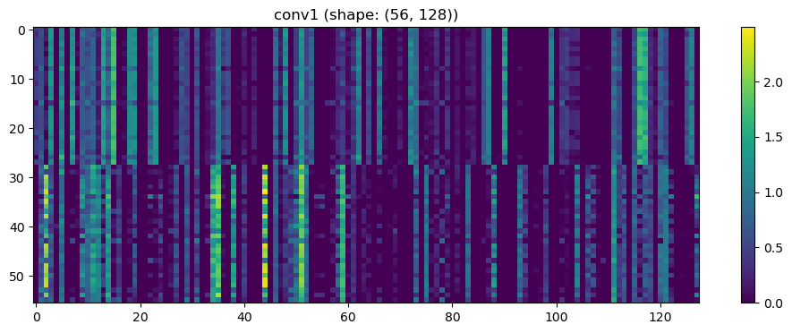

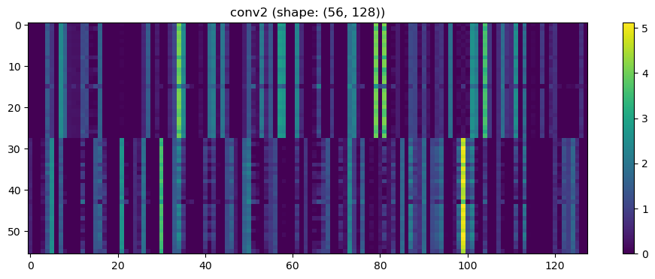

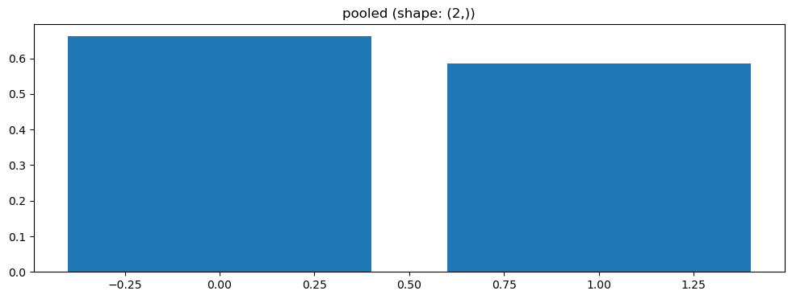

Split 4 Accuracy: 0.4762

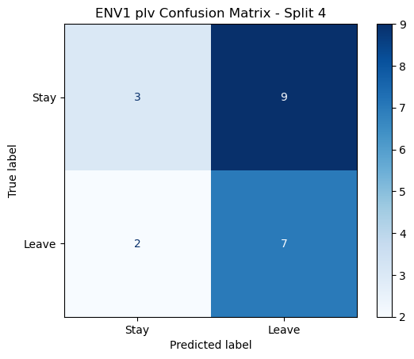

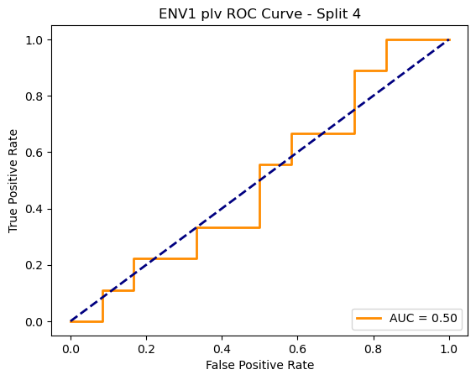

=== ENV1 Split 5/5 ===

After oversampling, class counts: Counter({1: 44, 0: 44})

C:\Users\sansk\miniconda3\Lib\site-packages\torch_geometric\deprecation.py:26: UserWarning: 'data.DataLoader' is deprecated, use 'loader.DataLoader' instead

warnings.warn(out)

Epoch 1/100 | Loss: 0.7388

Epoch 2/100 | Loss: 0.7233

Epoch 3/100 | Loss: 0.6744

Epoch 4/100 | Loss: 0.7382

Epoch 5/100 | Loss: 0.7333

Epoch 6/100 | Loss: 0.7450

Epoch 7/100 | Loss: 0.7314

Epoch 8/100 | Loss: 0.6716

Epoch 9/100 | Loss: 0.6475

Epoch 10/100 | Loss: 0.6809

Epoch 11/100 | Loss: 0.6802

Epoch 12/100 | Loss: 0.6762

Epoch 13/100 | Loss: 0.6562

Epoch 14/100 | Loss: 0.6554

Epoch 15/100 | Loss: 0.6422

Epoch 16/100 | Loss: 0.7024

Epoch 17/100 | Loss: 0.6565

Epoch 18/100 | Loss: 0.6751

Epoch 19/100 | Loss: 0.6771

Epoch 20/100 | Loss: 0.7081

Epoch 21/100 | Loss: 0.7106

Epoch 22/100 | Loss: 0.6621

Epoch 23/100 | Loss: 0.6611

Epoch 24/100 | Loss: 0.6274

Epoch 25/100 | Loss: 0.6450

Epoch 26/100 | Loss: 0.6484

Epoch 27/100 | Loss: 0.7186

Epoch 28/100 | Loss: 0.6242

Epoch 29/100 | Loss: 0.6961

Epoch 30/100 | Loss: 0.7285

Epoch 31/100 | Loss: 0.6139

Epoch 32/100 | Loss: 0.6499

Epoch 33/100 | Loss: 0.6603

Epoch 34/100 | Loss: 0.6640

Epoch 35/100 | Loss: 0.6508

Epoch 36/100 | Loss: 0.6445

Epoch 37/100 | Loss: 0.6255

Epoch 38/100 | Loss: 0.7185

Epoch 39/100 | Loss: 0.6359

Epoch 40/100 | Loss: 0.6149

Epoch 41/100 | Loss: 0.6096

Epoch 42/100 | Loss: 0.6704

Epoch 43/100 | Loss: 0.7087

Epoch 44/100 | Loss: 0.6316

Epoch 45/100 | Loss: 0.6443

Epoch 46/100 | Loss: 0.5924

Epoch 47/100 | Loss: 0.6610

Epoch 48/100 | Loss: 0.6257

Epoch 49/100 | Loss: 0.6413

Epoch 50/100 | Loss: 0.6392

Epoch 51/100 | Loss: 0.5886

Epoch 52/100 | Loss: 0.5736

Epoch 53/100 | Loss: 0.5819

Epoch 54/100 | Loss: 0.5975

Epoch 55/100 | Loss: 0.6227

Epoch 56/100 | Loss: 0.6081

Epoch 57/100 | Loss: 0.6694

Epoch 58/100 | Loss: 0.5877

Epoch 59/100 | Loss: 0.6850

Epoch 60/100 | Loss: 0.6505

Epoch 61/100 | Loss: 0.5643

Epoch 62/100 | Loss: 0.5976

Epoch 63/100 | Loss: 0.6488

Epoch 64/100 | Loss: 0.5986

Epoch 65/100 | Loss: 0.6356

Epoch 66/100 | Loss: 0.5080

Epoch 67/100 | Loss: 0.5384

Epoch 68/100 | Loss: 0.5550

Epoch 69/100 | Loss: 0.6190

Epoch 70/100 | Loss: 0.5861

Epoch 71/100 | Loss: 0.5526

Epoch 72/100 | Loss: 0.6384

Epoch 73/100 | Loss: 0.6122

Epoch 74/100 | Loss: 0.6354

Epoch 75/100 | Loss: 0.6205

Epoch 76/100 | Loss: 0.6228

Epoch 77/100 | Loss: 0.5413

Epoch 78/100 | Loss: 0.6127

Epoch 79/100 | Loss: 0.6027

Epoch 80/100 | Loss: 0.5794

Epoch 81/100 | Loss: 0.6539

Epoch 82/100 | Loss: 0.5466

Epoch 83/100 | Loss: 0.6297

Epoch 84/100 | Loss: 0.6444

Epoch 85/100 | Loss: 0.5799

Epoch 86/100 | Loss: 0.5917

Epoch 87/100 | Loss: 0.6037

Epoch 88/100 | Loss: 0.5694

Epoch 89/100 | Loss: 0.5243

Epoch 90/100 | Loss: 0.5740

Epoch 91/100 | Loss: 0.5714

Epoch 92/100 | Loss: 0.5944

Epoch 93/100 | Loss: 0.6333

Epoch 94/100 | Loss: 0.6161

Epoch 95/100 | Loss: 0.5951

Epoch 96/100 | Loss: 0.6094

Epoch 97/100 | Loss: 0.5476

Epoch 98/100 | Loss: 0.5641

Epoch 99/100 | Loss: 0.5611

Epoch 100/100 | Loss: 0.5515

Split 5 Accuracy: 0.4762

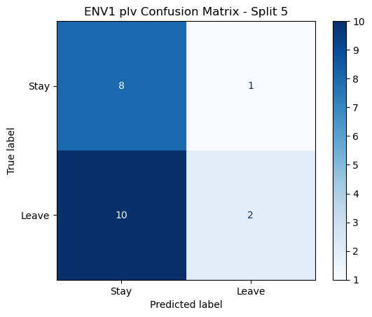

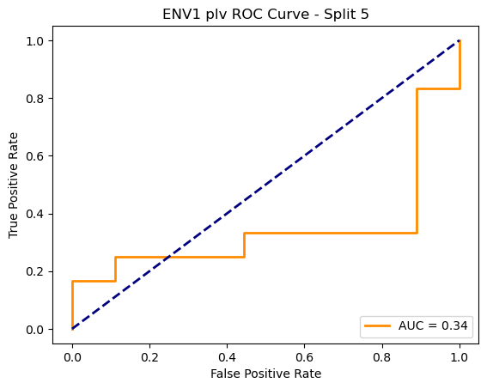

ENV1 plv Average Accuracy: 0.4532 ± 0.0514

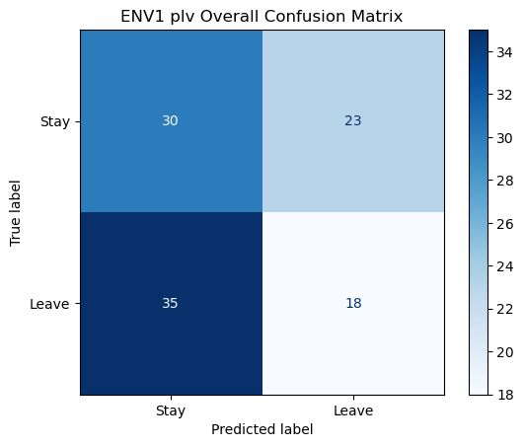

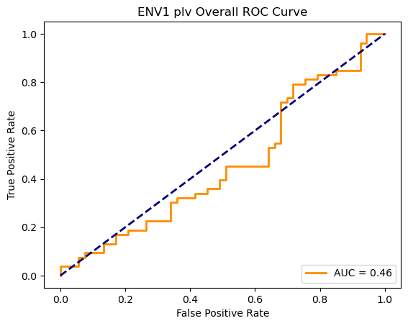

Loading ENV2 data...

ENV2: Loaded 106 trials (Stay: 53, Leave: 53)

Running GNN with corr connectivity for ENV2...

==================================================

Training GNN for ENV2 with corr connectivity

==================================================

=== ENV2 Split 1/5 ===

After oversampling, class counts: Counter({0: 43, 1: 43})

C:\Users\sansk\miniconda3\Lib\site-packages\torch_geometric\deprecation.py:26: UserWarning: 'data.DataLoader' is deprecated, use 'loader.DataLoader' instead

warnings.warn(out)

Epoch 1/100 | Loss: 0.8097

Epoch 2/100 | Loss: 0.8524

Epoch 3/100 | Loss: 0.7660

Epoch 4/100 | Loss: 0.7691

Epoch 5/100 | Loss: 0.7056

Epoch 6/100 | Loss: 0.6930

Epoch 7/100 | Loss: 0.7763

Epoch 8/100 | Loss: 0.6863

Epoch 9/100 | Loss: 0.7003

Epoch 10/100 | Loss: 0.7422

Epoch 11/100 | Loss: 0.7808

Epoch 12/100 | Loss: 0.6603

Epoch 13/100 | Loss: 0.7523

Epoch 14/100 | Loss: 0.7092

Epoch 15/100 | Loss: 0.7048

Epoch 16/100 | Loss: 0.7376

Epoch 17/100 | Loss: 0.7292

Epoch 18/100 | Loss: 0.6618

Epoch 19/100 | Loss: 0.6865

Epoch 20/100 | Loss: 0.6763

Epoch 21/100 | Loss: 0.7478

Epoch 22/100 | Loss: 0.6840

Epoch 23/100 | Loss: 0.7363

Epoch 24/100 | Loss: 0.7273

Epoch 25/100 | Loss: 0.7836

Epoch 26/100 | Loss: 0.7255

Epoch 27/100 | Loss: 0.6892

Epoch 28/100 | Loss: 0.6512

Epoch 29/100 | Loss: 0.6502

Epoch 30/100 | Loss: 0.6901

Epoch 31/100 | Loss: 0.6194

Epoch 32/100 | Loss: 0.6728

Epoch 33/100 | Loss: 0.7401

Epoch 34/100 | Loss: 0.6672

Epoch 35/100 | Loss: 0.6908

Epoch 36/100 | Loss: 0.6862

Epoch 37/100 | Loss: 0.7085

Epoch 38/100 | Loss: 0.7183

Epoch 39/100 | Loss: 0.7598

Epoch 40/100 | Loss: 0.7049

Epoch 41/100 | Loss: 0.6151

Epoch 42/100 | Loss: 0.6822

Epoch 43/100 | Loss: 0.7071

Epoch 44/100 | Loss: 0.6234

Epoch 45/100 | Loss: 0.7050

Epoch 46/100 | Loss: 0.7266

Epoch 47/100 | Loss: 0.6926

Epoch 48/100 | Loss: 0.6629

Epoch 49/100 | Loss: 0.7394

Epoch 50/100 | Loss: 0.6583

Epoch 51/100 | Loss: 0.7021

Epoch 52/100 | Loss: 0.7391

Epoch 53/100 | Loss: 0.6988

Epoch 54/100 | Loss: 0.6456

Epoch 55/100 | Loss: 0.6508

Epoch 56/100 | Loss: 0.6688

Epoch 57/100 | Loss: 0.6393

Epoch 58/100 | Loss: 0.7065

Epoch 59/100 | Loss: 0.6673

Epoch 60/100 | Loss: 0.5721

Epoch 61/100 | Loss: 0.6509

Epoch 62/100 | Loss: 0.6394

Epoch 63/100 | Loss: 0.7053

Epoch 64/100 | Loss: 0.7080

Epoch 65/100 | Loss: 0.6346

Epoch 66/100 | Loss: 0.6473

Epoch 67/100 | Loss: 0.6608

Epoch 68/100 | Loss: 0.6135

Epoch 69/100 | Loss: 0.6459

Epoch 70/100 | Loss: 0.6657

Epoch 71/100 | Loss: 0.6783

Epoch 72/100 | Loss: 0.6442

Epoch 73/100 | Loss: 0.6804

Epoch 74/100 | Loss: 0.6839

Epoch 75/100 | Loss: 0.6482

Epoch 76/100 | Loss: 0.6342

Epoch 77/100 | Loss: 0.6186

Epoch 78/100 | Loss: 0.6290

Epoch 79/100 | Loss: 0.6847

Epoch 80/100 | Loss: 0.6628

Epoch 81/100 | Loss: 0.6330

Epoch 82/100 | Loss: 0.6650

Epoch 83/100 | Loss: 0.6010

Epoch 84/100 | Loss: 0.6165

Epoch 85/100 | Loss: 0.6332

Epoch 86/100 | Loss: 0.6548

Epoch 87/100 | Loss: 0.6579

Epoch 88/100 | Loss: 0.6308

Epoch 89/100 | Loss: 0.7081

Epoch 90/100 | Loss: 0.6099

Epoch 91/100 | Loss: 0.6350

Epoch 92/100 | Loss: 0.6681

Epoch 93/100 | Loss: 0.6417

Epoch 94/100 | Loss: 0.6184

Epoch 95/100 | Loss: 0.6124

Epoch 96/100 | Loss: 0.7201

Epoch 97/100 | Loss: 0.6471

Epoch 98/100 | Loss: 0.6419

Epoch 99/100 | Loss: 0.6523

Epoch 100/100 | Loss: 0.6648

Split 1 Accuracy: 0.5455

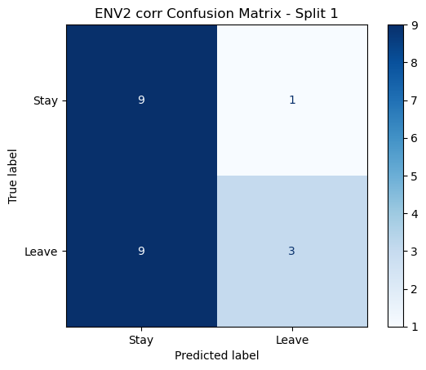

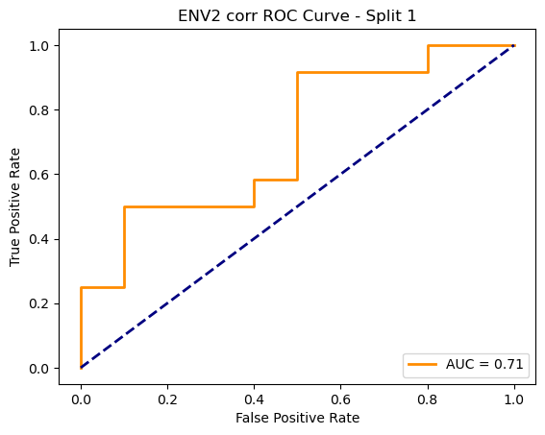

=== ENV2 Split 2/5 ===

After oversampling, class counts: Counter({1: 43, 0: 43})

C:\Users\sansk\miniconda3\Lib\site-packages\torch_geometric\deprecation.py:26: UserWarning: 'data.DataLoader' is deprecated, use 'loader.DataLoader' instead

warnings.warn(out)

Epoch 1/100 | Loss: 0.7610

Epoch 2/100 | Loss: 0.7939

Epoch 3/100 | Loss: 0.7574

Epoch 4/100 | Loss: 0.7988

Epoch 5/100 | Loss: 0.7209

Epoch 6/100 | Loss: 0.7352

Epoch 7/100 | Loss: 0.6957

Epoch 8/100 | Loss: 0.7760

Epoch 9/100 | Loss: 0.7168

Epoch 10/100 | Loss: 0.7102

Epoch 11/100 | Loss: 0.7011

Epoch 12/100 | Loss: 0.7148

Epoch 13/100 | Loss: 0.7464

Epoch 14/100 | Loss: 0.6161

Epoch 15/100 | Loss: 0.7797

Epoch 16/100 | Loss: 0.6861

Epoch 17/100 | Loss: 0.6979

Epoch 18/100 | Loss: 0.7094

Epoch 19/100 | Loss: 0.6601

Epoch 20/100 | Loss: 0.6664

Epoch 21/100 | Loss: 0.7204

Epoch 22/100 | Loss: 0.6598

Epoch 23/100 | Loss: 0.7094

Epoch 24/100 | Loss: 0.6777

Epoch 25/100 | Loss: 0.7071

Epoch 26/100 | Loss: 0.7179

Epoch 27/100 | Loss: 0.6682

Epoch 28/100 | Loss: 0.6245

Epoch 29/100 | Loss: 0.7072

Epoch 30/100 | Loss: 0.7239

Epoch 31/100 | Loss: 0.6926

Epoch 32/100 | Loss: 0.6883

Epoch 33/100 | Loss: 0.7095

Epoch 34/100 | Loss: 0.6862

Epoch 35/100 | Loss: 0.6799

Epoch 36/100 | Loss: 0.6471

Epoch 37/100 | Loss: 0.6959

Epoch 38/100 | Loss: 0.6235

Epoch 39/100 | Loss: 0.6958

Epoch 40/100 | Loss: 0.6673

Epoch 41/100 | Loss: 0.6887

Epoch 42/100 | Loss: 0.7405

Epoch 43/100 | Loss: 0.6521

Epoch 44/100 | Loss: 0.6657

Epoch 45/100 | Loss: 0.6696

Epoch 46/100 | Loss: 0.7012

Epoch 47/100 | Loss: 0.7297

Epoch 48/100 | Loss: 0.5849

Epoch 49/100 | Loss: 0.6279

Epoch 50/100 | Loss: 0.6622

Epoch 51/100 | Loss: 0.7101

Epoch 52/100 | Loss: 0.6612

Epoch 53/100 | Loss: 0.6715

Epoch 54/100 | Loss: 0.6036

Epoch 55/100 | Loss: 0.6408

Epoch 56/100 | Loss: 0.6202

Epoch 57/100 | Loss: 0.6682

Epoch 58/100 | Loss: 0.5959

Epoch 59/100 | Loss: 0.6845

Epoch 60/100 | Loss: 0.6736

Epoch 61/100 | Loss: 0.6297

Epoch 62/100 | Loss: 0.6456

Epoch 63/100 | Loss: 0.6246

Epoch 64/100 | Loss: 0.6391

Epoch 65/100 | Loss: 0.6685

Epoch 66/100 | Loss: 0.6680

Epoch 67/100 | Loss: 0.6310

Epoch 68/100 | Loss: 0.6232

Epoch 69/100 | Loss: 0.6671

Epoch 70/100 | Loss: 0.5930

Epoch 71/100 | Loss: 0.5859

Epoch 72/100 | Loss: 0.6984

Epoch 73/100 | Loss: 0.6443

Epoch 74/100 | Loss: 0.6144

Epoch 75/100 | Loss: 0.6482

Epoch 76/100 | Loss: 0.5791

Epoch 77/100 | Loss: 0.6862

Epoch 78/100 | Loss: 0.6432

Epoch 79/100 | Loss: 0.6718

Epoch 80/100 | Loss: 0.6505

Epoch 81/100 | Loss: 0.6024

Epoch 82/100 | Loss: 0.6669

Epoch 83/100 | Loss: 0.6232

Epoch 84/100 | Loss: 0.6395

Epoch 85/100 | Loss: 0.5961

Epoch 86/100 | Loss: 0.5726

Epoch 87/100 | Loss: 0.6179

Epoch 88/100 | Loss: 0.6277

Epoch 89/100 | Loss: 0.6289

Epoch 90/100 | Loss: 0.6489

Epoch 91/100 | Loss: 0.5781

Epoch 92/100 | Loss: 0.5936

Epoch 93/100 | Loss: 0.6351

Epoch 94/100 | Loss: 0.5860

Epoch 95/100 | Loss: 0.6074

Epoch 96/100 | Loss: 0.6367

Epoch 97/100 | Loss: 0.6592

Epoch 98/100 | Loss: 0.6005

Epoch 99/100 | Loss: 0.5354

Epoch 100/100 | Loss: 0.6378

Split 2 Accuracy: 0.4286

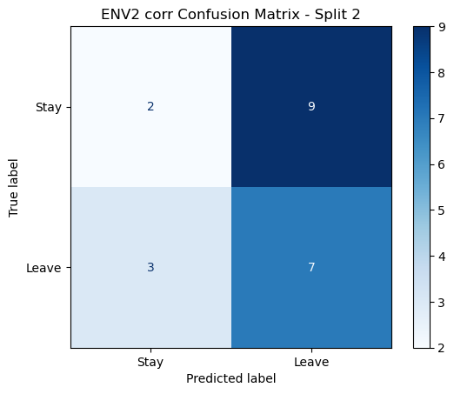

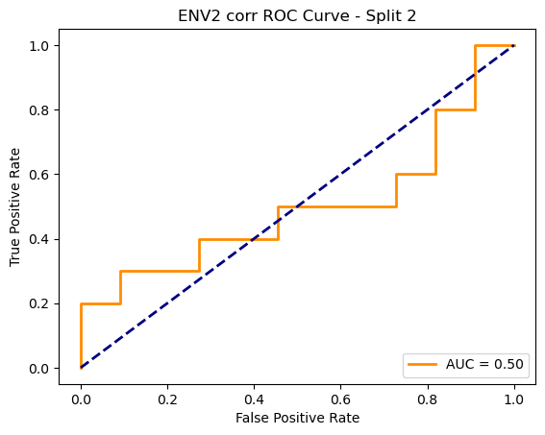

=== ENV2 Split 3/5 ===

After oversampling, class counts: Counter({1: 43, 0: 43})

C:\Users\sansk\miniconda3\Lib\site-packages\torch_geometric\deprecation.py:26: UserWarning: 'data.DataLoader' is deprecated, use 'loader.DataLoader' instead

warnings.warn(out)

Epoch 1/100 | Loss: 0.7972

Epoch 2/100 | Loss: 0.7671

Epoch 3/100 | Loss: 0.8395

Epoch 4/100 | Loss: 0.8084

Epoch 5/100 | Loss: 0.7921

Epoch 6/100 | Loss: 0.7964

Epoch 7/100 | Loss: 0.7226

Epoch 8/100 | Loss: 0.7342

Epoch 9/100 | Loss: 0.6812

Epoch 10/100 | Loss: 0.6576

Epoch 11/100 | Loss: 0.7406

Epoch 12/100 | Loss: 0.6938

Epoch 13/100 | Loss: 0.6740

Epoch 14/100 | Loss: 0.7347

Epoch 15/100 | Loss: 0.7836

Epoch 16/100 | Loss: 0.8198

Epoch 17/100 | Loss: 0.7702

Epoch 18/100 | Loss: 0.8055

Epoch 19/100 | Loss: 0.7670

Epoch 20/100 | Loss: 0.6682

Epoch 21/100 | Loss: 0.6410

Epoch 22/100 | Loss: 0.6785

Epoch 23/100 | Loss: 0.7052

Epoch 24/100 | Loss: 0.6714

Epoch 25/100 | Loss: 0.7124

Epoch 26/100 | Loss: 0.7602

Epoch 27/100 | Loss: 0.7053

Epoch 28/100 | Loss: 0.7285

Epoch 29/100 | Loss: 0.6400

Epoch 30/100 | Loss: 0.6754

Epoch 31/100 | Loss: 0.6733

Epoch 32/100 | Loss: 0.7470

Epoch 33/100 | Loss: 0.6068

Epoch 34/100 | Loss: 0.6776

Epoch 35/100 | Loss: 0.6695

Epoch 36/100 | Loss: 0.6417

Epoch 37/100 | Loss: 0.6885

Epoch 38/100 | Loss: 0.6959

Epoch 39/100 | Loss: 0.5719

Epoch 40/100 | Loss: 0.6680

Epoch 41/100 | Loss: 0.6765

Epoch 42/100 | Loss: 0.6150

Epoch 43/100 | Loss: 0.6268

Epoch 44/100 | Loss: 0.5708

Epoch 45/100 | Loss: 0.6686

Epoch 46/100 | Loss: 0.6061

Epoch 47/100 | Loss: 0.6117

Epoch 48/100 | Loss: 0.6953

Epoch 49/100 | Loss: 0.6325

Epoch 50/100 | Loss: 0.5646

Epoch 51/100 | Loss: 0.5967

Epoch 52/100 | Loss: 0.6012

Epoch 53/100 | Loss: 0.6274

Epoch 54/100 | Loss: 0.6328

Epoch 55/100 | Loss: 0.6764

Epoch 56/100 | Loss: 0.5817

Epoch 57/100 | Loss: 0.7002

Epoch 58/100 | Loss: 0.6228

Epoch 59/100 | Loss: 0.6773

Epoch 60/100 | Loss: 0.6173

Epoch 61/100 | Loss: 0.6635

Epoch 62/100 | Loss: 0.5534

Epoch 63/100 | Loss: 0.6472

Epoch 64/100 | Loss: 0.6290

Epoch 65/100 | Loss: 0.6438

Epoch 66/100 | Loss: 0.5868

Epoch 67/100 | Loss: 0.6194

Epoch 68/100 | Loss: 0.6480

Epoch 69/100 | Loss: 0.6689

Epoch 70/100 | Loss: 0.6214

Epoch 71/100 | Loss: 0.6172

Epoch 72/100 | Loss: 0.5773

Epoch 73/100 | Loss: 0.6213

Epoch 74/100 | Loss: 0.7128

Epoch 75/100 | Loss: 0.6178

Epoch 76/100 | Loss: 0.6955

Epoch 77/100 | Loss: 0.6107

Epoch 78/100 | Loss: 0.5831

Epoch 79/100 | Loss: 0.6302

Epoch 80/100 | Loss: 0.5823

Epoch 81/100 | Loss: 0.5637

Epoch 82/100 | Loss: 0.5630

Epoch 83/100 | Loss: 0.6214

Epoch 84/100 | Loss: 0.5997

Epoch 85/100 | Loss: 0.6400

Epoch 86/100 | Loss: 0.6185

Epoch 87/100 | Loss: 0.6268

Epoch 88/100 | Loss: 0.6168

Epoch 89/100 | Loss: 0.6237

Epoch 90/100 | Loss: 0.5941

Epoch 91/100 | Loss: 0.6548

Epoch 92/100 | Loss: 0.6071

Epoch 93/100 | Loss: 0.6284

Epoch 94/100 | Loss: 0.5604

Epoch 95/100 | Loss: 0.5442

Epoch 96/100 | Loss: 0.6438

Epoch 97/100 | Loss: 0.5891

Epoch 98/100 | Loss: 0.5973

Epoch 99/100 | Loss: 0.5687

Epoch 100/100 | Loss: 0.5595

Split 3 Accuracy: 0.4762

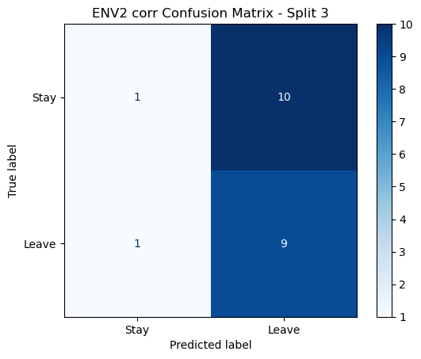

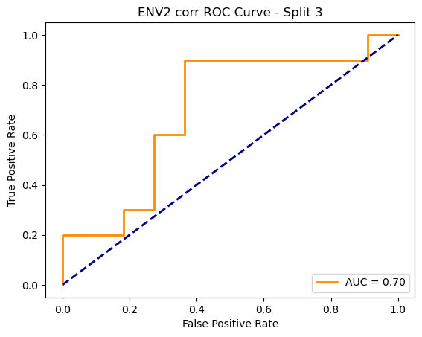

=== ENV2 Split 4/5 ===

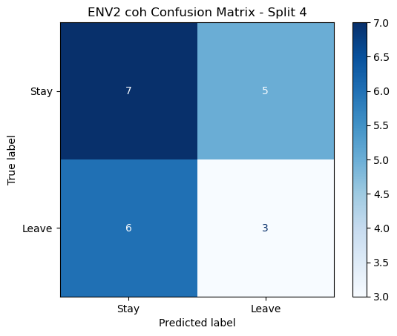

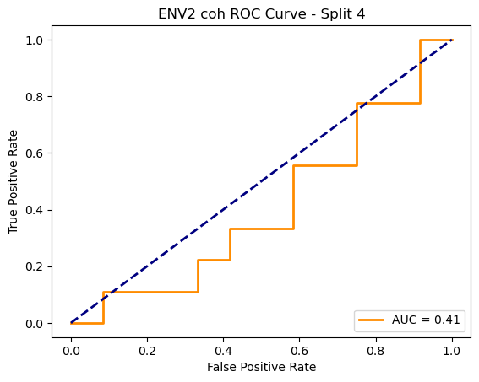

=== ENV2 Split 5/5 ===

C:\Users\sansk\miniconda3\Lib\site-packages\scipy\signal\_spectral_py.py:1668: RuntimeWarning: invalid value encountered in divide

Cxy = np.abs(Pxy)**2 / Pxx / Pyy

After oversampling, class counts: Counter({1: 44, 0: 44})

C:\Users\sansk\miniconda3\Lib\site-packages\torch_geometric\deprecation.py:26: UserWarning: 'data.DataLoader' is deprecated, use 'loader.DataLoader' instead

warnings.warn(out)

Epoch 1/100 | Loss: 0.7967

Epoch 2/100 | Loss: 0.6692

Epoch 3/100 | Loss: 0.7847

Epoch 4/100 | Loss: 0.8108

Epoch 5/100 | Loss: 0.7926

Epoch 6/100 | Loss: 0.7521

Epoch 7/100 | Loss: 0.7557

Epoch 8/100 | Loss: 0.7475

Epoch 9/100 | Loss: 0.7583

Epoch 10/100 | Loss: 0.6974

Epoch 11/100 | Loss: 0.7537

Epoch 12/100 | Loss: 0.7316

Epoch 13/100 | Loss: 0.7330

Epoch 14/100 | Loss: 0.6945

Epoch 15/100 | Loss: 0.7082

Epoch 16/100 | Loss: 0.8208

Epoch 17/100 | Loss: 0.6777

Epoch 18/100 | Loss: 0.6943

Epoch 19/100 | Loss: 0.7209

Epoch 20/100 | Loss: 0.7213

Epoch 21/100 | Loss: 0.6911

Epoch 22/100 | Loss: 0.7042

Epoch 23/100 | Loss: 0.6769

Epoch 24/100 | Loss: 0.7111

Epoch 25/100 | Loss: 0.7355

Epoch 26/100 | Loss: 0.7564

Epoch 27/100 | Loss: 0.7156

Epoch 28/100 | Loss: 0.7431

Epoch 29/100 | Loss: 0.6791

Epoch 30/100 | Loss: 0.7181

Epoch 31/100 | Loss: 0.6503

Epoch 32/100 | Loss: 0.7017

Epoch 33/100 | Loss: 0.6982

Epoch 34/100 | Loss: 0.7119

Epoch 35/100 | Loss: 0.6628

Epoch 36/100 | Loss: 0.6888

Epoch 37/100 | Loss: 0.7474

Epoch 38/100 | Loss: 0.6260

Epoch 39/100 | Loss: 0.6573

Epoch 40/100 | Loss: 0.6736

Epoch 41/100 | Loss: 0.7072

Epoch 42/100 | Loss: 0.6859

Epoch 43/100 | Loss: 0.6620

Epoch 44/100 | Loss: 0.7021

Epoch 45/100 | Loss: 0.6759

Epoch 46/100 | Loss: 0.6853

Epoch 47/100 | Loss: 0.6612

Epoch 48/100 | Loss: 0.6980

Epoch 49/100 | Loss: 0.7160

Epoch 50/100 | Loss: 0.6196

Epoch 51/100 | Loss: 0.6526

Epoch 52/100 | Loss: 0.6929

Epoch 53/100 | Loss: 0.6565

Epoch 54/100 | Loss: 0.6884

Epoch 55/100 | Loss: 0.6302

Epoch 56/100 | Loss: 0.6360

Epoch 57/100 | Loss: 0.6401

Epoch 58/100 | Loss: 0.6106

Epoch 59/100 | Loss: 0.7304

Epoch 60/100 | Loss: 0.7136

Epoch 61/100 | Loss: 0.6704

Epoch 62/100 | Loss: 0.6490

Epoch 63/100 | Loss: 0.7016

Epoch 64/100 | Loss: 0.6365

Epoch 65/100 | Loss: 0.7158

Epoch 66/100 | Loss: 0.6134

Epoch 67/100 | Loss: 0.6300

Epoch 68/100 | Loss: 0.6257

Epoch 69/100 | Loss: 0.5736

Epoch 70/100 | Loss: 0.6441

Epoch 71/100 | Loss: 0.6779

Epoch 72/100 | Loss: 0.6972

Epoch 73/100 | Loss: 0.6229

Epoch 74/100 | Loss: 0.6998

Epoch 75/100 | Loss: 0.6557

Epoch 76/100 | Loss: 0.6572

Epoch 77/100 | Loss: 0.5939

Epoch 78/100 | Loss: 0.6968

Epoch 79/100 | Loss: 0.6328

Epoch 80/100 | Loss: 0.6496

Epoch 81/100 | Loss: 0.6272

Epoch 82/100 | Loss: 0.6438

Epoch 83/100 | Loss: 0.6313

Epoch 84/100 | Loss: 0.6769

Epoch 85/100 | Loss: 0.6880

Epoch 86/100 | Loss: 0.6012

Epoch 87/100 | Loss: 0.6392

Epoch 88/100 | Loss: 0.7056

Epoch 89/100 | Loss: 0.6924

Epoch 90/100 | Loss: 0.6455

Epoch 91/100 | Loss: 0.6425

Epoch 92/100 | Loss: 0.6714

Epoch 93/100 | Loss: 0.6137

Epoch 94/100 | Loss: 0.6328

Epoch 95/100 | Loss: 0.6085

Epoch 96/100 | Loss: 0.6286

Epoch 97/100 | Loss: 0.5974

Epoch 98/100 | Loss: 0.6519

Epoch 99/100 | Loss: 0.5829

Epoch 100/100 | Loss: 0.5700

Split 4 Accuracy: 0.5238

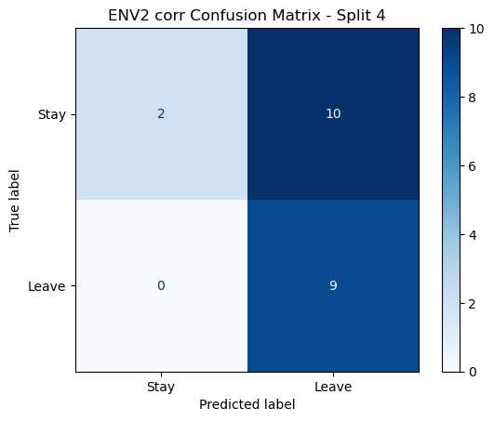

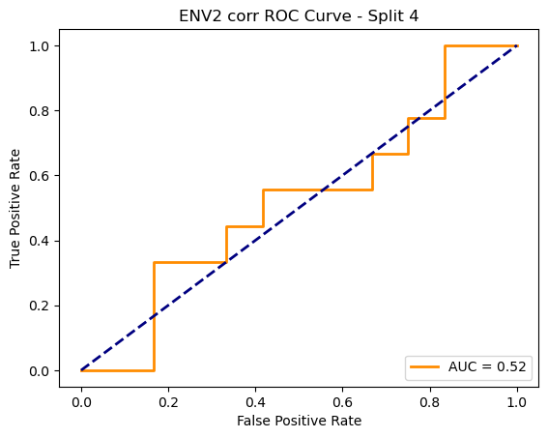

=== ENV2 Split 5/5 ===

After oversampling, class counts: Counter({1: 44, 0: 44})

Epoch 1/200 | Loss: 0.7746

Epoch 2/200 | Loss: 0.7597

Epoch 3/200 | Loss: 0.7429

Epoch 4/200 | Loss: 0.7789

Epoch 5/200 | Loss: 0.7452

Epoch 6/200 | Loss: 0.7148

Epoch 7/200 | Loss: 0.6939

Epoch 8/200 | Loss: 0.6690

Epoch 9/200 | Loss: 0.7103

Epoch 10/200 | Loss: 0.7853

Epoch 11/200 | Loss: 0.6965

Epoch 12/200 | Loss: 0.7857

Epoch 13/200 | Loss: 0.7538

Epoch 14/200 | Loss: 0.6635

Epoch 15/200 | Loss: 0.7268

Epoch 16/200 | Loss: 0.7339

Epoch 17/200 | Loss: 0.7813

Epoch 18/200 | Loss: 0.7630

Epoch 19/200 | Loss: 0.7161

Epoch 20/200 | Loss: 0.7528

Epoch 21/200 | Loss: 0.6819

Epoch 22/200 | Loss: 0.7376

Epoch 23/200 | Loss: 0.7853

Epoch 24/200 | Loss: 0.7857

Epoch 25/200 | Loss: 0.7900

Epoch 26/200 | Loss: 0.7825

Epoch 27/200 | Loss: 0.6649

Epoch 28/200 | Loss: 0.8032

Epoch 29/200 | Loss: 0.6809

Epoch 30/200 | Loss: 0.7110

Epoch 31/200 | Loss: 0.7479

Epoch 32/200 | Loss: 0.7158

Epoch 33/200 | Loss: 0.7268

Epoch 34/200 | Loss: 0.7790

Epoch 35/200 | Loss: 0.6889

Epoch 36/200 | Loss: 0.6977

Epoch 37/200 | Loss: 0.7195

Epoch 38/200 | Loss: 0.7548

Epoch 39/200 | Loss: 0.6582

Epoch 40/200 | Loss: 0.7648

Epoch 41/200 | Loss: 0.7535

Epoch 42/200 | Loss: 0.7159

Epoch 43/200 | Loss: 0.7170

Epoch 44/200 | Loss: 0.7871

Epoch 45/200 | Loss: 0.7401

Epoch 46/200 | Loss: 0.8170

Epoch 47/200 | Loss: 0.7535

Epoch 48/200 | Loss: 0.8367

Epoch 49/200 | Loss: 0.8277

Epoch 50/200 | Loss: 0.7311

Epoch 51/200 | Loss: 0.7458

Epoch 52/200 | Loss: 0.7335

Epoch 53/200 | Loss: 0.7447

Epoch 54/200 | Loss: 0.7667

Epoch 55/200 | Loss: 0.7556

Epoch 56/200 | Loss: 0.7660

Epoch 57/200 | Loss: 0.7563

Epoch 58/200 | Loss: 0.7329

Epoch 59/200 | Loss: 0.6594

Epoch 60/200 | Loss: 0.7587

Epoch 61/200 | Loss: 0.7211

Epoch 62/200 | Loss: 0.7672

Epoch 63/200 | Loss: 0.8420

Epoch 64/200 | Loss: 0.7909

Epoch 65/200 | Loss: 0.7198

Epoch 66/200 | Loss: 0.7600

Epoch 67/200 | Loss: 0.7062

Epoch 68/200 | Loss: 0.7008

Epoch 69/200 | Loss: 0.7554

Epoch 70/200 | Loss: 0.7377

Epoch 71/200 | Loss: 0.6940

Epoch 72/200 | Loss: 0.7188

Epoch 73/200 | Loss: 0.7095

Epoch 74/200 | Loss: 0.6706

Epoch 75/200 | Loss: 0.7635

Epoch 76/200 | Loss: 0.7223

Epoch 77/200 | Loss: 0.7316

Epoch 78/200 | Loss: 0.6903

Epoch 79/200 | Loss: 0.7120

Epoch 80/200 | Loss: 0.6855

Epoch 81/200 | Loss: 0.7705

Epoch 82/200 | Loss: 0.8136

Epoch 83/200 | Loss: 0.7990

Epoch 84/200 | Loss: 0.7144

Epoch 85/200 | Loss: 0.7457

Epoch 86/200 | Loss: 0.7329

Epoch 87/200 | Loss: 0.6906

Epoch 88/200 | Loss: 0.6557

Epoch 89/200 | Loss: 0.7944

Epoch 90/200 | Loss: 0.7532

Epoch 91/200 | Loss: 0.7268

Epoch 92/200 | Loss: 0.7776

Epoch 93/200 | Loss: 0.7495

Epoch 94/200 | Loss: 0.7371

Epoch 95/200 | Loss: 0.8266

Epoch 96/200 | Loss: 0.6811

Epoch 97/200 | Loss: 0.7685

Epoch 98/200 | Loss: 0.7003

Epoch 99/200 | Loss: 0.7030

Epoch 100/200 | Loss: 0.7085

Epoch 101/200 | Loss: 0.7099

Epoch 102/200 | Loss: 0.7326

Epoch 103/200 | Loss: 0.7856

Epoch 104/200 | Loss: 0.6800

Epoch 105/200 | Loss: 0.7119

Epoch 106/200 | Loss: 0.6945

Epoch 107/200 | Loss: 0.7570

Epoch 108/200 | Loss: 0.7703

Epoch 109/200 | Loss: 0.7078

Epoch 110/200 | Loss: 0.7411

Epoch 111/200 | Loss: 0.7138

Epoch 112/200 | Loss: 0.6767

Epoch 113/200 | Loss: 0.7051

Epoch 114/200 | Loss: 0.7417

Epoch 115/200 | Loss: 0.7971

Epoch 116/200 | Loss: 0.6758

Epoch 117/200 | Loss: 0.7110

Epoch 118/200 | Loss: 0.8149

Epoch 119/200 | Loss: 0.6832

Epoch 120/200 | Loss: 0.7636

Epoch 121/200 | Loss: 0.7652

Epoch 122/200 | Loss: 0.7386

Epoch 123/200 | Loss: 0.7792

Epoch 124/200 | Loss: 0.7230

Epoch 125/200 | Loss: 0.7234

Epoch 126/200 | Loss: 0.7657

Epoch 127/200 | Loss: 0.7471

Epoch 128/200 | Loss: 0.7032

Epoch 129/200 | Loss: 0.7431

Epoch 130/200 | Loss: 0.6974

Epoch 131/200 | Loss: 0.7347

Epoch 132/200 | Loss: 0.7648

Epoch 133/200 | Loss: 0.6676

Epoch 134/200 | Loss: 0.7411

Epoch 135/200 | Loss: 0.7013

Epoch 136/200 | Loss: 0.6654

Epoch 137/200 | Loss: 0.7687

Epoch 138/200 | Loss: 0.7302

Epoch 139/200 | Loss: 0.6516

Epoch 140/200 | Loss: 0.7524

Epoch 141/200 | Loss: 0.7295

Epoch 142/200 | Loss: 0.7540

Epoch 143/200 | Loss: 0.7170

Epoch 144/200 | Loss: 0.7406

Epoch 145/200 | Loss: 0.7065

Epoch 146/200 | Loss: 0.7189

Epoch 147/200 | Loss: 0.7523

Epoch 148/200 | Loss: 0.7300

Epoch 149/200 | Loss: 0.7136

Epoch 150/200 | Loss: 0.6832

Epoch 151/200 | Loss: 0.7180

Epoch 152/200 | Loss: 0.7060

Epoch 153/200 | Loss: 0.6913

Epoch 154/200 | Loss: 0.7125

Epoch 155/200 | Loss: 0.7378

Epoch 156/200 | Loss: 0.7302

Epoch 157/200 | Loss: 0.7030

Epoch 158/200 | Loss: 0.7195

Epoch 159/200 | Loss: 0.7094

Epoch 160/200 | Loss: 0.7246

Epoch 161/200 | Loss: 0.6541

Epoch 162/200 | Loss: 0.7478

Epoch 163/200 | Loss: 0.6819

Epoch 164/200 | Loss: 0.6836

Epoch 165/200 | Loss: 0.6980

Epoch 166/200 | Loss: 0.7478

Epoch 167/200 | Loss: 0.6786

Epoch 168/200 | Loss: 0.7041

Epoch 169/200 | Loss: 0.6768

Epoch 170/200 | Loss: 0.7374

Epoch 171/200 | Loss: 0.7290

Epoch 172/200 | Loss: 0.7346

Epoch 173/200 | Loss: 0.6897

Epoch 174/200 | Loss: 0.7290

Epoch 175/200 | Loss: 0.7344

Epoch 176/200 | Loss: 0.7256

Epoch 177/200 | Loss: 0.7229

Epoch 178/200 | Loss: 0.6779

Epoch 179/200 | Loss: 0.7413

Epoch 180/200 | Loss: 0.7160

Epoch 181/200 | Loss: 0.7024

Epoch 182/200 | Loss: 0.6842

Epoch 183/200 | Loss: 0.6844

Epoch 184/200 | Loss: 0.7520

Epoch 185/200 | Loss: 0.6746

Epoch 186/200 | Loss: 0.6876

Epoch 187/200 | Loss: 0.6692

Epoch 188/200 | Loss: 0.6860

Epoch 189/200 | Loss: 0.8005

Epoch 190/200 | Loss: 0.7016

Epoch 191/200 | Loss: 0.7102

Epoch 192/200 | Loss: 0.7166

Epoch 193/200 | Loss: 0.8403

Epoch 194/200 | Loss: 0.7407

Epoch 195/200 | Loss: 0.7123

Epoch 196/200 | Loss: 0.7319

Epoch 197/200 | Loss: 0.7534

Epoch 198/200 | Loss: 0.7209

Epoch 199/200 | Loss: 0.7532

Epoch 200/200 | Loss: 0.7061

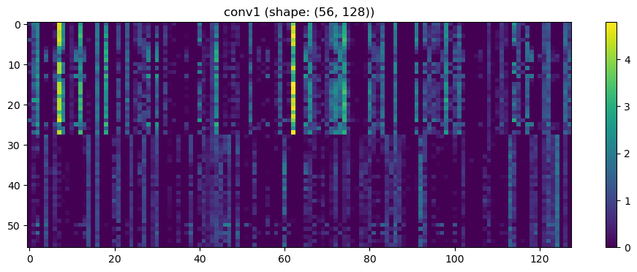

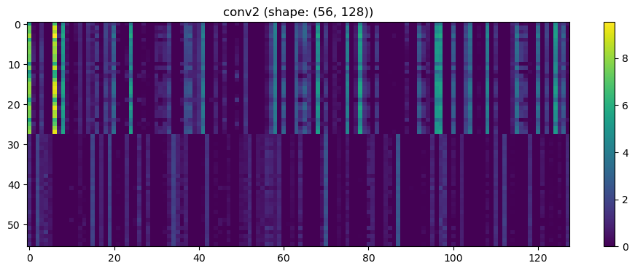

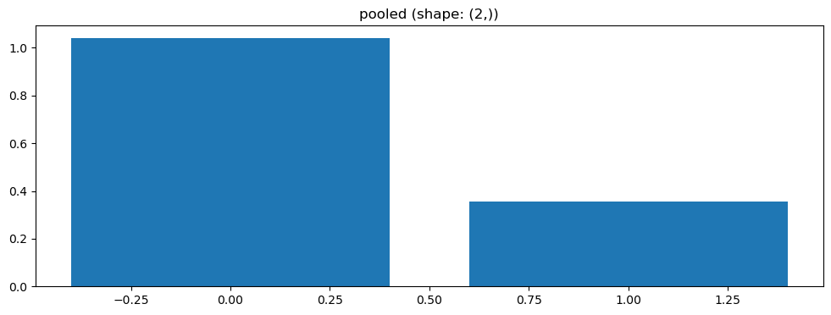

Split 5 Accuracy: 0.6190

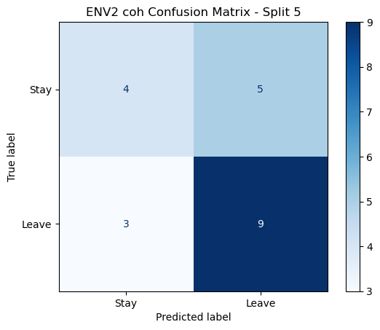

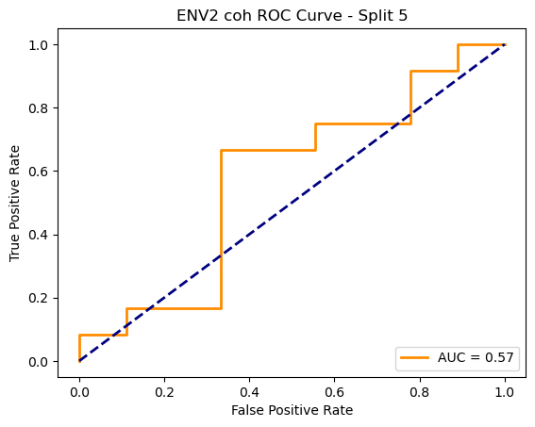

ENV2 coh Average Accuracy: 0.5662 ± 0.0532

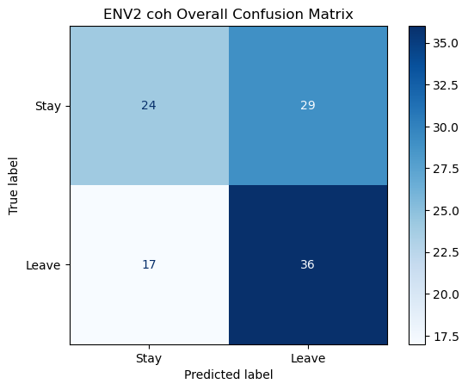

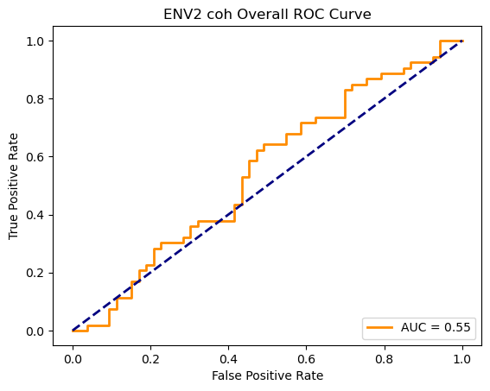

Running GNN with plv connectivity for ENV2...

==================================================

Training GNN for ENV2 with plv connectivity

==================================================

=== ENV2 Split 1/5 ===

After oversampling, class counts: Counter({0: 43, 1: 43})

C:\Users\sansk\miniconda3\Lib\site-packages\torch_geometric\deprecation.py:26: UserWarning: 'data.DataLoader' is deprecated, use 'loader.DataLoader' instead

warnings.warn(out)

Epoch 1/200 | Loss: 0.7291

Epoch 2/200 | Loss: 0.7724

Epoch 3/200 | Loss: 0.7041

Epoch 4/200 | Loss: 0.6822

Epoch 5/200 | Loss: 0.7685

Epoch 6/200 | Loss: 0.8281

Epoch 7/200 | Loss: 0.8104

Epoch 8/200 | Loss: 0.7446

Epoch 9/200 | Loss: 0.7768

Epoch 10/200 | Loss: 0.7093

Epoch 11/200 | Loss: 0.7426

Epoch 12/200 | Loss: 0.7778

Epoch 13/200 | Loss: 0.7053

Epoch 14/200 | Loss: 0.7167

Epoch 15/200 | Loss: 0.7266

Epoch 16/200 | Loss: 0.7096

Epoch 17/200 | Loss: 0.8231

Epoch 18/200 | Loss: 0.8109

Epoch 19/200 | Loss: 0.7279

Epoch 20/200 | Loss: 0.8005

Epoch 21/200 | Loss: 0.8184

Epoch 22/200 | Loss: 0.7328

Epoch 23/200 | Loss: 0.7144

Epoch 24/200 | Loss: 0.7765

Epoch 25/200 | Loss: 0.8304

Epoch 26/200 | Loss: 0.7345

Epoch 27/200 | Loss: 0.8010

Epoch 28/200 | Loss: 0.6547

Epoch 29/200 | Loss: 0.7495

Epoch 30/200 | Loss: 0.6973

Epoch 31/200 | Loss: 0.7152

Epoch 32/200 | Loss: 0.7495

Epoch 33/200 | Loss: 0.7233

Epoch 34/200 | Loss: 0.7283

Epoch 35/200 | Loss: 0.7085

Epoch 36/200 | Loss: 0.7410

Epoch 37/200 | Loss: 0.7150

Epoch 38/200 | Loss: 0.6772

Epoch 39/200 | Loss: 0.7301

Epoch 40/200 | Loss: 0.7588

Epoch 41/200 | Loss: 0.7417

Epoch 42/200 | Loss: 0.7168

Epoch 43/200 | Loss: 0.6725

Epoch 44/200 | Loss: 0.6645

Epoch 45/200 | Loss: 0.7068

Epoch 46/200 | Loss: 0.7434

Epoch 47/200 | Loss: 0.7149

Epoch 48/200 | Loss: 0.7294

Epoch 49/200 | Loss: 0.7926

Epoch 50/200 | Loss: 0.7181

Epoch 51/200 | Loss: 0.6759

Epoch 52/200 | Loss: 0.6993

Epoch 53/200 | Loss: 0.7136

Epoch 54/200 | Loss: 0.7125

Epoch 55/200 | Loss: 0.6974

Epoch 56/200 | Loss: 0.7307

Epoch 57/200 | Loss: 0.6939

Epoch 58/200 | Loss: 0.7156

Epoch 59/200 | Loss: 0.7375

Epoch 60/200 | Loss: 0.6942

Epoch 61/200 | Loss: 0.6701

Epoch 62/200 | Loss: 0.7081

Epoch 63/200 | Loss: 0.6753

Epoch 64/200 | Loss: 0.7494

Epoch 65/200 | Loss: 0.7301

Epoch 66/200 | Loss: 0.7509

Epoch 67/200 | Loss: 0.7032

Epoch 68/200 | Loss: 0.7149

Epoch 69/200 | Loss: 0.7069

Epoch 70/200 | Loss: 0.7006

Epoch 71/200 | Loss: 0.6740

Epoch 72/200 | Loss: 0.7230

Epoch 73/200 | Loss: 0.7689

Epoch 74/200 | Loss: 0.7507

Epoch 75/200 | Loss: 0.7175

Epoch 76/200 | Loss: 0.6998

Epoch 77/200 | Loss: 0.7251

Epoch 78/200 | Loss: 0.7660

Epoch 79/200 | Loss: 0.6984

Epoch 80/200 | Loss: 0.7140

Epoch 81/200 | Loss: 0.7150

Epoch 82/200 | Loss: 0.6712

Epoch 83/200 | Loss: 0.7068

Epoch 84/200 | Loss: 0.7307

Epoch 85/200 | Loss: 0.7286

Epoch 86/200 | Loss: 0.7229

Epoch 87/200 | Loss: 0.6919

Epoch 88/200 | Loss: 0.7164

Epoch 89/200 | Loss: 0.7392

Epoch 90/200 | Loss: 0.6754

Epoch 91/200 | Loss: 0.7585

Epoch 92/200 | Loss: 0.6993

Epoch 93/200 | Loss: 0.7350

Epoch 94/200 | Loss: 0.7476

Epoch 95/200 | Loss: 0.6434

Epoch 96/200 | Loss: 0.7523

Epoch 97/200 | Loss: 0.6968

Epoch 98/200 | Loss: 0.7374

Epoch 99/200 | Loss: 0.6627

Epoch 100/200 | Loss: 0.7049

Epoch 101/200 | Loss: 0.7222

Epoch 102/200 | Loss: 0.7374

Epoch 103/200 | Loss: 0.6601

Epoch 104/200 | Loss: 0.6942

Epoch 105/200 | Loss: 0.6633

Epoch 106/200 | Loss: 0.7318

Epoch 107/200 | Loss: 0.7007

Epoch 108/200 | Loss: 0.6804

Epoch 109/200 | Loss: 0.7316

Epoch 110/200 | Loss: 0.6688

Epoch 111/200 | Loss: 0.6638

Epoch 112/200 | Loss: 0.7215

Epoch 113/200 | Loss: 0.7156

Epoch 114/200 | Loss: 0.6550

Epoch 115/200 | Loss: 0.7011

Epoch 116/200 | Loss: 0.6561

Epoch 117/200 | Loss: 0.6393

Epoch 118/200 | Loss: 0.6714

Epoch 119/200 | Loss: 0.6481

Epoch 120/200 | Loss: 0.6723

Epoch 121/200 | Loss: 0.7356

Epoch 122/200 | Loss: 0.6565

Epoch 123/200 | Loss: 0.7110

Epoch 124/200 | Loss: 0.6727

Epoch 125/200 | Loss: 0.6220

Epoch 126/200 | Loss: 0.7003

Epoch 127/200 | Loss: 0.7059

Epoch 128/200 | Loss: 0.7148

Epoch 129/200 | Loss: 0.7325

Epoch 130/200 | Loss: 0.6918

Epoch 131/200 | Loss: 0.7277

Epoch 132/200 | Loss: 0.7082

Epoch 133/200 | Loss: 0.6845

Epoch 134/200 | Loss: 0.6963

Epoch 135/200 | Loss: 0.6334

Epoch 136/200 | Loss: 0.7450

Epoch 137/200 | Loss: 0.7339

Epoch 138/200 | Loss: 0.6753

Epoch 139/200 | Loss: 0.6722

Epoch 140/200 | Loss: 0.6667

Epoch 141/200 | Loss: 0.6971

Epoch 142/200 | Loss: 0.6653

Epoch 143/200 | Loss: 0.6745

Epoch 144/200 | Loss: 0.6866

Epoch 145/200 | Loss: 0.7544

Epoch 146/200 | Loss: 0.6449

Epoch 147/200 | Loss: 0.7701

Epoch 148/200 | Loss: 0.7012

Epoch 149/200 | Loss: 0.6905

Epoch 150/200 | Loss: 0.6733

Epoch 151/200 | Loss: 0.6296

Epoch 152/200 | Loss: 0.7165

Epoch 153/200 | Loss: 0.6567

Epoch 154/200 | Loss: 0.6448

Epoch 155/200 | Loss: 0.6658

Epoch 156/200 | Loss: 0.7492

Epoch 157/200 | Loss: 0.7345

Epoch 158/200 | Loss: 0.6607

Epoch 159/200 | Loss: 0.6819

Epoch 160/200 | Loss: 0.6823

Epoch 161/200 | Loss: 0.6363

Epoch 162/200 | Loss: 0.6843

Epoch 163/200 | Loss: 0.7028

Epoch 164/200 | Loss: 0.7031

Epoch 165/200 | Loss: 0.6483

Epoch 166/200 | Loss: 0.6923

Epoch 167/200 | Loss: 0.7108

Epoch 168/200 | Loss: 0.6580

Epoch 169/200 | Loss: 0.6547

Epoch 170/200 | Loss: 0.6915

Epoch 171/200 | Loss: 0.6331

Epoch 172/200 | Loss: 0.6432

Epoch 173/200 | Loss: 0.6643

Epoch 174/200 | Loss: 0.6708

Epoch 175/200 | Loss: 0.6020

Epoch 176/200 | Loss: 0.5836

Epoch 177/200 | Loss: 0.6100

Epoch 178/200 | Loss: 0.7087

Epoch 179/200 | Loss: 0.6668

Epoch 180/200 | Loss: 0.6464

Epoch 181/200 | Loss: 0.6905

Epoch 182/200 | Loss: 0.6003

Epoch 183/200 | Loss: 0.6459

Epoch 184/200 | Loss: 0.6275

Epoch 185/200 | Loss: 0.6665

Epoch 186/200 | Loss: 0.6625

Epoch 187/200 | Loss: 0.6688

Epoch 188/200 | Loss: 0.7012

Epoch 189/200 | Loss: 0.6497

Epoch 190/200 | Loss: 0.6862

Epoch 191/200 | Loss: 0.7983

Epoch 192/200 | Loss: 0.6514

Epoch 193/200 | Loss: 0.7102

Epoch 194/200 | Loss: 0.7219

Epoch 195/200 | Loss: 0.6733

Epoch 196/200 | Loss: 0.6998

Epoch 197/200 | Loss: 0.6438

Epoch 198/200 | Loss: 0.6806

Epoch 199/200 | Loss: 0.7088

Epoch 200/200 | Loss: 0.7566

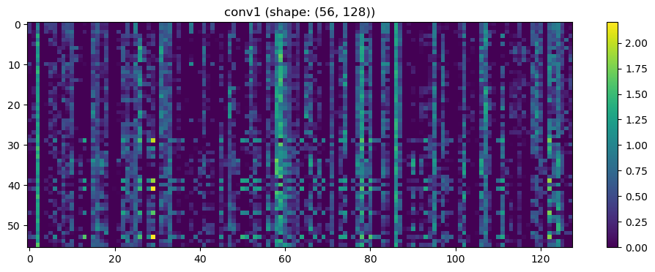

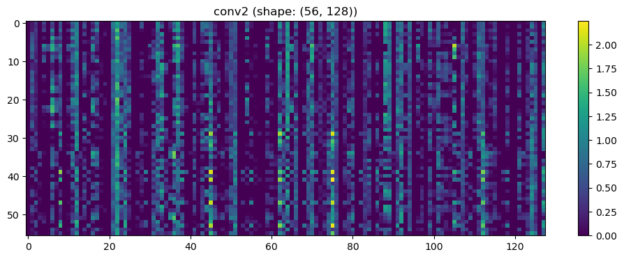

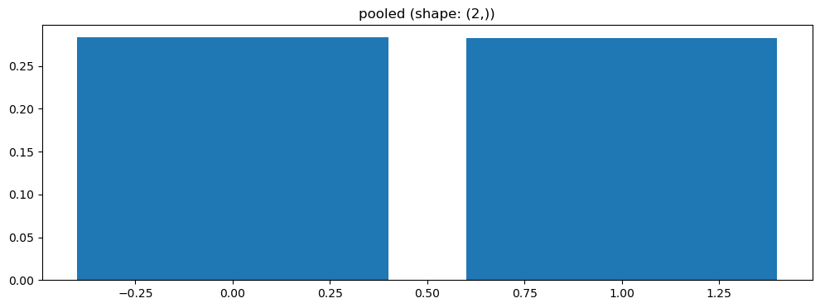

Split 1 Accuracy: 0.3636

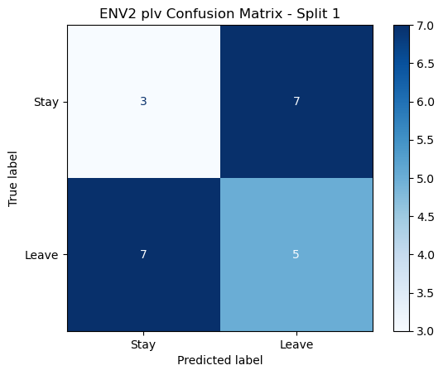

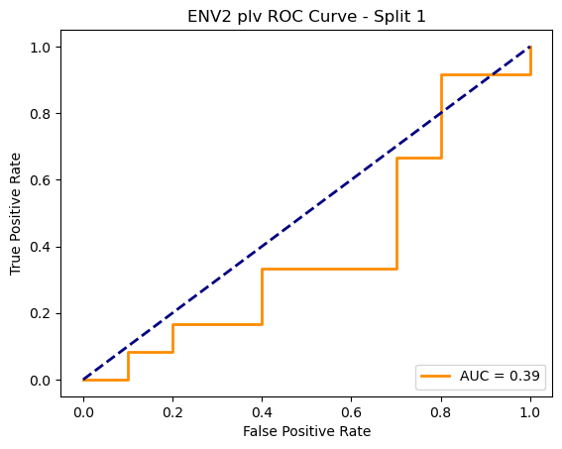

=== ENV2 Split 2/5 ===

After oversampling, class counts: Counter({1: 43, 0: 43})

C:\Users\sansk\miniconda3\Lib\site-packages\torch_geometric\deprecation.py:26: UserWarning: 'data.DataLoader' is deprecated, use 'loader.DataLoader' instead

warnings.warn(out)

Epoch 1/100 | Loss: 0.7103

Epoch 2/100 | Loss: 0.6929

Epoch 3/100 | Loss: 0.7731

Epoch 4/100 | Loss: 0.7508

Epoch 5/100 | Loss: 0.7694

Epoch 6/100 | Loss: 0.7584

Epoch 7/100 | Loss: 0.7526

Epoch 8/100 | Loss: 0.7270

Epoch 9/100 | Loss: 0.6754

Epoch 10/100 | Loss: 0.7251

Epoch 11/100 | Loss: 0.6974

Epoch 12/100 | Loss: 0.6871

Epoch 13/100 | Loss: 0.7144

Epoch 14/100 | Loss: 0.6430

Epoch 15/100 | Loss: 0.6708

Epoch 16/100 | Loss: 0.7025

Epoch 17/100 | Loss: 0.6702

Epoch 18/100 | Loss: 0.7541

Epoch 19/100 | Loss: 0.6541

Epoch 20/100 | Loss: 0.6291

Epoch 21/100 | Loss: 0.7187

Epoch 22/100 | Loss: 0.7470

Epoch 23/100 | Loss: 0.6873

Epoch 24/100 | Loss: 0.6587

Epoch 25/100 | Loss: 0.6839

Epoch 26/100 | Loss: 0.6648

Epoch 27/100 | Loss: 0.6374

Epoch 28/100 | Loss: 0.7194

Epoch 29/100 | Loss: 0.6878

Epoch 30/100 | Loss: 0.6257

Epoch 31/100 | Loss: 0.6064

Epoch 32/100 | Loss: 0.6122

Epoch 33/100 | Loss: 0.7023

Epoch 34/100 | Loss: 0.7332

Epoch 35/100 | Loss: 0.6153

Epoch 36/100 | Loss: 0.6227

Epoch 37/100 | Loss: 0.6745

Epoch 38/100 | Loss: 0.6296

Epoch 39/100 | Loss: 0.6638

Epoch 40/100 | Loss: 0.6350

Epoch 41/100 | Loss: 0.6869

Epoch 42/100 | Loss: 0.5843

Epoch 43/100 | Loss: 0.6366

Epoch 44/100 | Loss: 0.6120

Epoch 45/100 | Loss: 0.6539

Epoch 46/100 | Loss: 0.6089

Epoch 47/100 | Loss: 0.6215

Epoch 48/100 | Loss: 0.6433

Epoch 49/100 | Loss: 0.6297

Epoch 50/100 | Loss: 0.6686

Epoch 51/100 | Loss: 0.6918

Epoch 52/100 | Loss: 0.6099

Epoch 53/100 | Loss: 0.6447

Epoch 54/100 | Loss: 0.6282

Epoch 55/100 | Loss: 0.6655

Epoch 56/100 | Loss: 0.6732

Epoch 57/100 | Loss: 0.6024

Epoch 58/100 | Loss: 0.6003

Epoch 59/100 | Loss: 0.5953

Epoch 60/100 | Loss: 0.6291

Epoch 61/100 | Loss: 0.6380

Epoch 62/100 | Loss: 0.6843

Epoch 63/100 | Loss: 0.6015

Epoch 64/100 | Loss: 0.7070

Epoch 65/100 | Loss: 0.6456

Epoch 66/100 | Loss: 0.5322

Epoch 67/100 | Loss: 0.6069

Epoch 68/100 | Loss: 0.6762

Epoch 69/100 | Loss: 0.5595

Epoch 70/100 | Loss: 0.7014

Epoch 71/100 | Loss: 0.6900

Epoch 72/100 | Loss: 0.6179

Epoch 73/100 | Loss: 0.6762

Epoch 74/100 | Loss: 0.6489

Epoch 75/100 | Loss: 0.6326

Epoch 76/100 | Loss: 0.6299

Epoch 77/100 | Loss: 0.5336

Epoch 78/100 | Loss: 0.6504

Epoch 79/100 | Loss: 0.6729

Epoch 80/100 | Loss: 0.5578

Epoch 81/100 | Loss: 0.6190

Epoch 82/100 | Loss: 0.6319

Epoch 83/100 | Loss: 0.5961

Epoch 84/100 | Loss: 0.6812

Epoch 85/100 | Loss: 0.6449

Epoch 86/100 | Loss: 0.5882

Epoch 87/100 | Loss: 0.6081

Epoch 88/100 | Loss: 0.5845

Epoch 89/100 | Loss: 0.5434

Epoch 90/100 | Loss: 0.5884

Epoch 91/100 | Loss: 0.6544

Epoch 92/100 | Loss: 0.5450

Epoch 93/100 | Loss: 0.6097

Epoch 94/100 | Loss: 0.5560

Epoch 95/100 | Loss: 0.5934

Epoch 96/100 | Loss: 0.6211

Epoch 97/100 | Loss: 0.5507

Epoch 98/100 | Loss: 0.6014

Epoch 99/100 | Loss: 0.6100

Epoch 100/100 | Loss: 0.6154

Split 5 Accuracy: 0.4762



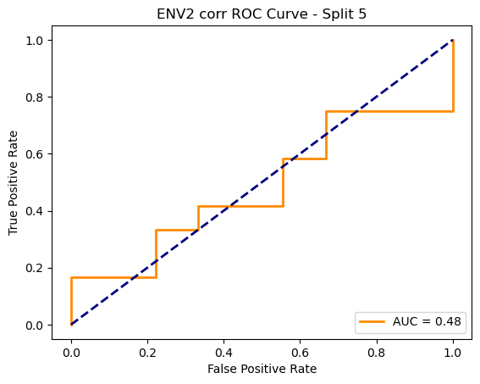

ENV2 corr Average Accuracy: 0.4900 ± 0.0409

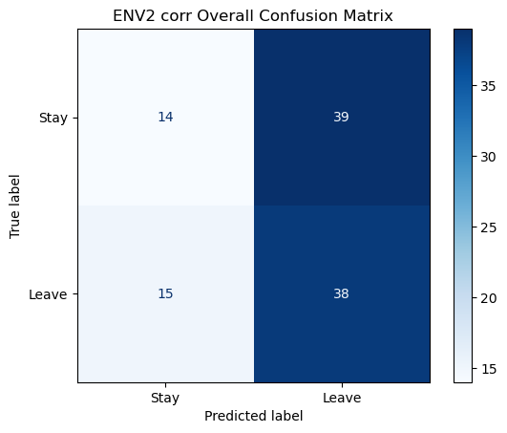

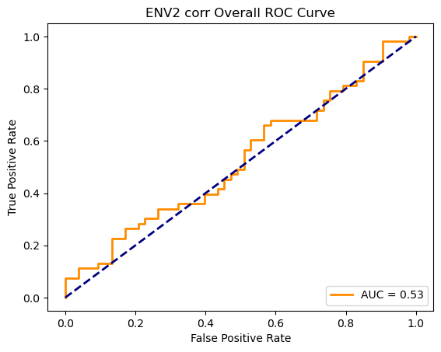

Running GNN with coh connectivity for ENV2...

==================================================

Training GNN for ENV2 with coh connectivity

==================================================

=== ENV2 Split 1/5 ===

C:\Users\sansk\miniconda3\Lib\site-packages\scipy\signal\_spectral_py.py:1668: RuntimeWarning: invalid value encountered in divide

Cxy = np.abs(Pxy)**2 / Pxx / Pyy

After oversampling, class counts: Counter({0: 43, 1: 43})

Epoch 1/200 | Loss: 0.8429

Epoch 2/200 | Loss: 0.8162

Epoch 3/200 | Loss: 0.7756

Epoch 4/200 | Loss: 0.8453

Epoch 5/200 | Loss: 0.7768

Epoch 6/200 | Loss: 0.7231

Epoch 7/200 | Loss: 0.8380

Epoch 8/200 | Loss: 0.7575

Epoch 9/200 | Loss: 0.8525

Epoch 10/200 | Loss: 0.8073

Epoch 11/200 | Loss: 0.8063

Epoch 12/200 | Loss: 0.8129

Epoch 13/200 | Loss: 0.7559

Epoch 14/200 | Loss: 0.7906

Epoch 15/200 | Loss: 0.8154

Epoch 16/200 | Loss: 0.7522

Epoch 17/200 | Loss: 0.7407

Epoch 18/200 | Loss: 0.7530

Epoch 19/200 | Loss: 0.7797

Epoch 20/200 | Loss: 0.7873

Epoch 21/200 | Loss: 0.8157

Epoch 22/200 | Loss: 0.7890

Epoch 23/200 | Loss: 0.7355

Epoch 24/200 | Loss: 0.7452

Epoch 25/200 | Loss: 0.8015

Epoch 26/200 | Loss: 0.7525

Epoch 27/200 | Loss: 0.8326

Epoch 28/200 | Loss: 0.7572

Epoch 29/200 | Loss: 0.7535

Epoch 30/200 | Loss: 0.7782

Epoch 31/200 | Loss: 0.6668

Epoch 32/200 | Loss: 0.7232

Epoch 33/200 | Loss: 0.8210

Epoch 34/200 | Loss: 0.7164

Epoch 35/200 | Loss: 0.8023

Epoch 36/200 | Loss: 0.7387

Epoch 37/200 | Loss: 0.7505

Epoch 38/200 | Loss: 0.7665

Epoch 39/200 | Loss: 0.7355

Epoch 40/200 | Loss: 0.7026

Epoch 41/200 | Loss: 0.7697

Epoch 42/200 | Loss: 0.7360

Epoch 43/200 | Loss: 0.7177

Epoch 44/200 | Loss: 0.7148

Epoch 45/200 | Loss: 0.7798

Epoch 46/200 | Loss: 0.7132

Epoch 47/200 | Loss: 0.7476

Epoch 48/200 | Loss: 0.7142

Epoch 49/200 | Loss: 0.7214

Epoch 50/200 | Loss: 0.7393

Epoch 51/200 | Loss: 0.7775

Epoch 52/200 | Loss: 0.7895

Epoch 53/200 | Loss: 0.7719

Epoch 54/200 | Loss: 0.7588

Epoch 55/200 | Loss: 0.7378

Epoch 56/200 | Loss: 0.7082

Epoch 57/200 | Loss: 0.7437

Epoch 58/200 | Loss: 0.7440

Epoch 59/200 | Loss: 0.7465

Epoch 60/200 | Loss: 0.7173

Epoch 61/200 | Loss: 0.6761

Epoch 62/200 | Loss: 0.7568

Epoch 63/200 | Loss: 0.7123

Epoch 64/200 | Loss: 0.7155

Epoch 65/200 | Loss: 0.7652

Epoch 66/200 | Loss: 0.7024

Epoch 67/200 | Loss: 0.7033

Epoch 68/200 | Loss: 0.7461

Epoch 69/200 | Loss: 0.7276

Epoch 70/200 | Loss: 0.6809

Epoch 71/200 | Loss: 0.7016

Epoch 72/200 | Loss: 0.7134

Epoch 73/200 | Loss: 0.7550

Epoch 74/200 | Loss: 0.6747

Epoch 75/200 | Loss: 0.7823

Epoch 76/200 | Loss: 0.7301

Epoch 77/200 | Loss: 0.7171

Epoch 78/200 | Loss: 0.6917

Epoch 79/200 | Loss: 0.7000

Epoch 80/200 | Loss: 0.6939

Epoch 81/200 | Loss: 0.6611

Epoch 82/200 | Loss: 0.6927

Epoch 83/200 | Loss: 0.7395

Epoch 84/200 | Loss: 0.6377

Epoch 85/200 | Loss: 0.7346

Epoch 86/200 | Loss: 0.7426

Epoch 87/200 | Loss: 0.7490

Epoch 88/200 | Loss: 0.6611

Epoch 89/200 | Loss: 0.6508

Epoch 90/200 | Loss: 0.6955

Epoch 91/200 | Loss: 0.6698

Epoch 92/200 | Loss: 0.6537

Epoch 93/200 | Loss: 0.6539

Epoch 94/200 | Loss: 0.6432

Epoch 95/200 | Loss: 0.7158

Epoch 96/200 | Loss: 0.7208

Epoch 97/200 | Loss: 0.6911

Epoch 98/200 | Loss: 0.7098

Epoch 99/200 | Loss: 0.6515

Epoch 100/200 | Loss: 0.7097

Epoch 101/200 | Loss: 0.7105

Epoch 102/200 | Loss: 0.6334

Epoch 103/200 | Loss: 0.6509

Epoch 104/200 | Loss: 0.6605

Epoch 105/200 | Loss: 0.6924

Epoch 106/200 | Loss: 0.7181

Epoch 107/200 | Loss: 0.7145

Epoch 108/200 | Loss: 0.7086

Epoch 109/200 | Loss: 0.6528

Epoch 110/200 | Loss: 0.7084

Epoch 111/200 | Loss: 0.7960

Epoch 112/200 | Loss: 0.7226

Epoch 113/200 | Loss: 0.7258

Epoch 114/200 | Loss: 0.6364

Epoch 115/200 | Loss: 0.6807

Epoch 116/200 | Loss: 0.6665

Epoch 117/200 | Loss: 0.7419

Epoch 118/200 | Loss: 0.6730

Epoch 119/200 | Loss: 0.6803

Epoch 120/200 | Loss: 0.6645

Epoch 121/200 | Loss: 0.7080

Epoch 122/200 | Loss: 0.7004

Epoch 123/200 | Loss: 0.7865

Epoch 124/200 | Loss: 0.7091

Epoch 125/200 | Loss: 0.6712

Epoch 126/200 | Loss: 0.6913

Epoch 127/200 | Loss: 0.6407

Epoch 128/200 | Loss: 0.6423

Epoch 129/200 | Loss: 0.7001

Epoch 130/200 | Loss: 0.6816

Epoch 131/200 | Loss: 0.6460

Epoch 132/200 | Loss: 0.6395

Epoch 133/200 | Loss: 0.5992

Epoch 134/200 | Loss: 0.6406

Epoch 135/200 | Loss: 0.7146

Epoch 136/200 | Loss: 0.6881

Epoch 137/200 | Loss: 0.6241

Epoch 138/200 | Loss: 0.6473

Epoch 139/200 | Loss: 0.6542

Epoch 140/200 | Loss: 0.6402

Epoch 141/200 | Loss: 0.6407

Epoch 142/200 | Loss: 0.6284

Epoch 143/200 | Loss: 0.6338

Epoch 144/200 | Loss: 0.6564

Epoch 145/200 | Loss: 0.6772

Epoch 146/200 | Loss: 0.6315

Epoch 147/200 | Loss: 0.6374

Epoch 148/200 | Loss: 0.6646

Epoch 149/200 | Loss: 0.6825

Epoch 150/200 | Loss: 0.6852

Epoch 151/200 | Loss: 0.6794

Epoch 152/200 | Loss: 0.6731

Epoch 153/200 | Loss: 0.6909

Epoch 154/200 | Loss: 0.6815

Epoch 155/200 | Loss: 0.5708

Epoch 156/200 | Loss: 0.6619

Epoch 157/200 | Loss: 0.6598

Epoch 158/200 | Loss: 0.6546

Epoch 159/200 | Loss: 0.6781

Epoch 160/200 | Loss: 0.6331

Epoch 161/200 | Loss: 0.6615

Epoch 162/200 | Loss: 0.6128

Epoch 163/200 | Loss: 0.6591

Epoch 164/200 | Loss: 0.6582

Epoch 165/200 | Loss: 0.7079

Epoch 166/200 | Loss: 0.5872

Epoch 167/200 | Loss: 0.6731

Epoch 168/200 | Loss: 0.5834

Epoch 169/200 | Loss: 0.6787

Epoch 170/200 | Loss: 0.6292

Epoch 171/200 | Loss: 0.7107

Epoch 172/200 | Loss: 0.6386

Epoch 173/200 | Loss: 0.7073

Epoch 174/200 | Loss: 0.6030

Epoch 175/200 | Loss: 0.6242

Epoch 176/200 | Loss: 0.6689

Epoch 177/200 | Loss: 0.6230

Epoch 178/200 | Loss: 0.6428

Epoch 179/200 | Loss: 0.6020

Epoch 180/200 | Loss: 0.6506

Epoch 181/200 | Loss: 0.6143

Epoch 182/200 | Loss: 0.5392

Epoch 183/200 | Loss: 0.7189

Epoch 184/200 | Loss: 0.6488

Epoch 185/200 | Loss: 0.6928

Epoch 186/200 | Loss: 0.6372

Epoch 187/200 | Loss: 0.6122

Epoch 188/200 | Loss: 0.5900

Epoch 189/200 | Loss: 0.6397

Epoch 190/200 | Loss: 0.6588

Epoch 191/200 | Loss: 0.6522

Epoch 192/200 | Loss: 0.6482

Epoch 193/200 | Loss: 0.6337

Epoch 194/200 | Loss: 0.6067

Epoch 195/200 | Loss: 0.6658

Epoch 196/200 | Loss: 0.6284

Epoch 197/200 | Loss: 0.7100

Epoch 198/200 | Loss: 0.6450

Epoch 199/200 | Loss: 0.6526

Epoch 200/200 | Loss: 0.6486

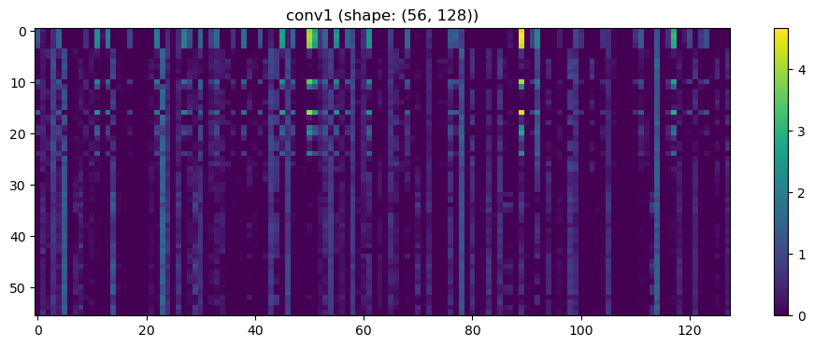

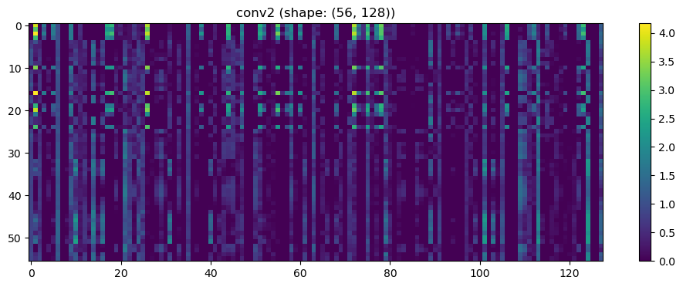

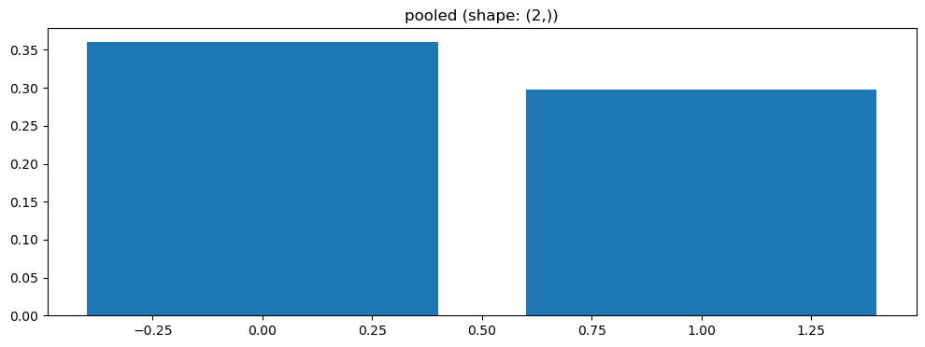

Split 2 Accuracy: 0.5238

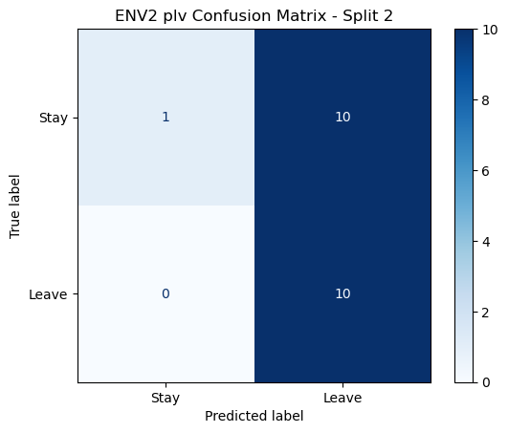

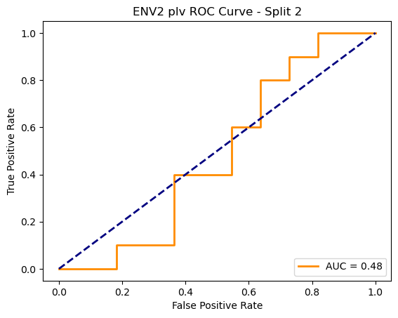

=== ENV2 Split 3/5 ===

After oversampling, class counts: Counter({1: 43, 0: 43})

C:\Users\sansk\miniconda3\Lib\site-packages\torch_geometric\deprecation.py:26: UserWarning: 'data.DataLoader' is deprecated, use 'loader.DataLoader' instead

warnings.warn(out)

Epoch 1/100 | Loss: 0.6724

Epoch 2/100 | Loss: 0.7716

Epoch 3/100 | Loss: 0.7902

Epoch 4/100 | Loss: 0.8034

Epoch 5/100 | Loss: 0.6644

Epoch 6/100 | Loss: 0.8076

Epoch 7/100 | Loss: 0.7185

Epoch 8/100 | Loss: 0.7292

Epoch 9/100 | Loss: 0.7387

Epoch 10/100 | Loss: 0.6931

Epoch 11/100 | Loss: 0.6747

Epoch 12/100 | Loss: 0.7278

Epoch 13/100 | Loss: 0.7267

Epoch 14/100 | Loss: 0.7884

Epoch 15/100 | Loss: 0.7076

Epoch 16/100 | Loss: 0.7426

Epoch 17/100 | Loss: 0.6424

Epoch 18/100 | Loss: 0.7347

Epoch 19/100 | Loss: 0.7470

Epoch 20/100 | Loss: 0.6644

Epoch 21/100 | Loss: 0.7148

Epoch 22/100 | Loss: 0.7370

Epoch 23/100 | Loss: 0.7085

Epoch 24/100 | Loss: 0.7430

Epoch 25/100 | Loss: 0.7959

Epoch 26/100 | Loss: 0.7431

Epoch 27/100 | Loss: 0.7365

Epoch 28/100 | Loss: 0.6759

Epoch 29/100 | Loss: 0.7596

Epoch 30/100 | Loss: 0.7218

Epoch 31/100 | Loss: 0.7216

Epoch 32/100 | Loss: 0.7569

Epoch 33/100 | Loss: 0.7504

Epoch 34/100 | Loss: 0.6918

Epoch 35/100 | Loss: 0.6927

Epoch 36/100 | Loss: 0.7048

Epoch 37/100 | Loss: 0.6872

Epoch 38/100 | Loss: 0.7118

Epoch 39/100 | Loss: 0.7411

Epoch 40/100 | Loss: 0.7336

Epoch 41/100 | Loss: 0.7443

Epoch 42/100 | Loss: 0.7451

Epoch 43/100 | Loss: 0.6733

Epoch 44/100 | Loss: 0.7140

Epoch 45/100 | Loss: 0.7315

Epoch 46/100 | Loss: 0.7169

Epoch 47/100 | Loss: 0.6943

Epoch 48/100 | Loss: 0.6590

Epoch 49/100 | Loss: 0.6843

Epoch 50/100 | Loss: 0.7190

Epoch 51/100 | Loss: 0.7121

Epoch 52/100 | Loss: 0.7542

Epoch 53/100 | Loss: 0.6980

Epoch 54/100 | Loss: 0.6702

Epoch 55/100 | Loss: 0.7856

Epoch 56/100 | Loss: 0.6711

Epoch 57/100 | Loss: 0.6895

Epoch 58/100 | Loss: 0.7085

Epoch 59/100 | Loss: 0.6878

Epoch 60/100 | Loss: 0.7282

Epoch 61/100 | Loss: 0.7330

Epoch 62/100 | Loss: 0.7014

Epoch 63/100 | Loss: 0.7141

Epoch 64/100 | Loss: 0.7012

Epoch 65/100 | Loss: 0.7066

Epoch 66/100 | Loss: 0.6610

Epoch 67/100 | Loss: 0.6590

Epoch 68/100 | Loss: 0.7230

Epoch 69/100 | Loss: 0.7248

Epoch 70/100 | Loss: 0.6689

Epoch 71/100 | Loss: 0.6732

Epoch 72/100 | Loss: 0.6948

Epoch 73/100 | Loss: 0.6463

Epoch 74/100 | Loss: 0.7061

Epoch 75/100 | Loss: 0.6649

Epoch 76/100 | Loss: 0.7168

Epoch 77/100 | Loss: 0.7099

Epoch 78/100 | Loss: 0.6802

Epoch 79/100 | Loss: 0.6931

Epoch 80/100 | Loss: 0.6877

Epoch 81/100 | Loss: 0.6655

Epoch 82/100 | Loss: 0.7539

Epoch 83/100 | Loss: 0.6354

Epoch 84/100 | Loss: 0.6593

Epoch 85/100 | Loss: 0.6352

Epoch 86/100 | Loss: 0.6870

Epoch 87/100 | Loss: 0.7097

Epoch 88/100 | Loss: 0.7341

Epoch 89/100 | Loss: 0.7510

Epoch 90/100 | Loss: 0.6925

Epoch 91/100 | Loss: 0.6726

Epoch 92/100 | Loss: 0.6966

Epoch 93/100 | Loss: 0.6914

Epoch 94/100 | Loss: 0.7494

Epoch 95/100 | Loss: 0.7061

Epoch 96/100 | Loss: 0.7025

Epoch 97/100 | Loss: 0.7247

Epoch 98/100 | Loss: 0.7079

Epoch 99/100 | Loss: 0.7073

Epoch 100/100 | Loss: 0.6814

Split 1 Accuracy: 0.5909

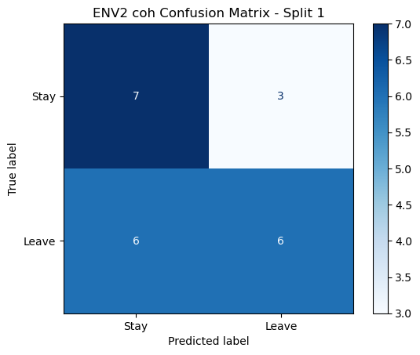

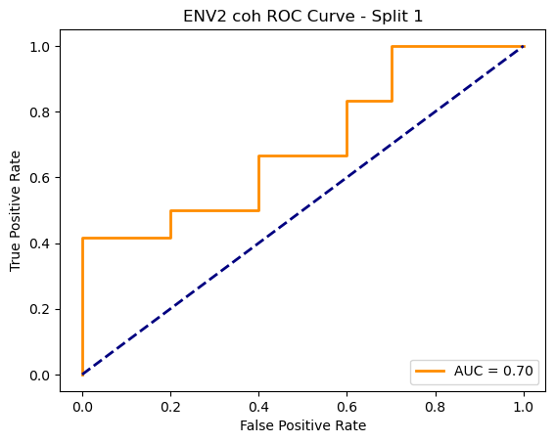

=== ENV2 Split 2/5 ===

C:\Users\sansk\miniconda3\Lib\site-packages\scipy\signal\_spectral_py.py:1668: RuntimeWarning: invalid value encountered in divide

Cxy = np.abs(Pxy)**2 / Pxx / Pyy

After oversampling, class counts: Counter({1: 43, 0: 43})

Epoch 1/200 | Loss: 0.7698

Epoch 2/200 | Loss: 0.7425

Epoch 3/200 | Loss: 0.7444

Epoch 4/200 | Loss: 0.7648

Epoch 5/200 | Loss: 0.7406

Epoch 6/200 | Loss: 0.7559

Epoch 7/200 | Loss: 0.7587

Epoch 8/200 | Loss: 0.7837

Epoch 9/200 | Loss: 0.8272

Epoch 10/200 | Loss: 0.7722

Epoch 11/200 | Loss: 0.6913

Epoch 12/200 | Loss: 0.7559

Epoch 13/200 | Loss: 0.7600

Epoch 14/200 | Loss: 0.7741

Epoch 15/200 | Loss: 0.7483

Epoch 16/200 | Loss: 0.7069

Epoch 17/200 | Loss: 0.7188

Epoch 18/200 | Loss: 0.8058

Epoch 19/200 | Loss: 0.7821

Epoch 20/200 | Loss: 0.7016

Epoch 21/200 | Loss: 0.7070

Epoch 22/200 | Loss: 0.7476

Epoch 23/200 | Loss: 0.7509

Epoch 24/200 | Loss: 0.7464

Epoch 25/200 | Loss: 0.7407

Epoch 26/200 | Loss: 0.7057

Epoch 27/200 | Loss: 0.7954

Epoch 28/200 | Loss: 0.7498

Epoch 29/200 | Loss: 0.7226

Epoch 30/200 | Loss: 0.7224

Epoch 31/200 | Loss: 0.6814

Epoch 32/200 | Loss: 0.7502

Epoch 33/200 | Loss: 0.7279

Epoch 34/200 | Loss: 0.6587

Epoch 35/200 | Loss: 0.6840

Epoch 36/200 | Loss: 0.7598

Epoch 37/200 | Loss: 0.6923

Epoch 38/200 | Loss: 0.7217

Epoch 39/200 | Loss: 0.7425

Epoch 40/200 | Loss: 0.7628

Epoch 41/200 | Loss: 0.7839

Epoch 42/200 | Loss: 0.7269

Epoch 43/200 | Loss: 0.7207

Epoch 44/200 | Loss: 0.6936

Epoch 45/200 | Loss: 0.7188

Epoch 46/200 | Loss: 0.6844

Epoch 47/200 | Loss: 0.6707

Epoch 48/200 | Loss: 0.7196

Epoch 49/200 | Loss: 0.7393

Epoch 50/200 | Loss: 0.7449

Epoch 51/200 | Loss: 0.7934

Epoch 52/200 | Loss: 0.7243

Epoch 53/200 | Loss: 0.7621

Epoch 54/200 | Loss: 0.7232

Epoch 55/200 | Loss: 0.6800

Epoch 56/200 | Loss: 0.6981

Epoch 57/200 | Loss: 0.7137

Epoch 58/200 | Loss: 0.7599

Epoch 59/200 | Loss: 0.7119

Epoch 60/200 | Loss: 0.7272

Epoch 61/200 | Loss: 0.7331

Epoch 62/200 | Loss: 0.7584

Epoch 63/200 | Loss: 0.6571

Epoch 64/200 | Loss: 0.7171

Epoch 65/200 | Loss: 0.6841

Epoch 66/200 | Loss: 0.7301

Epoch 67/200 | Loss: 0.7375

Epoch 68/200 | Loss: 0.7396

Epoch 69/200 | Loss: 0.6812

Epoch 70/200 | Loss: 0.7040

Epoch 71/200 | Loss: 0.7321

Epoch 72/200 | Loss: 0.6335

Epoch 73/200 | Loss: 0.6496

Epoch 74/200 | Loss: 0.7550

Epoch 75/200 | Loss: 0.7071

Epoch 76/200 | Loss: 0.6951

Epoch 77/200 | Loss: 0.7328

Epoch 78/200 | Loss: 0.6894

Epoch 79/200 | Loss: 0.7241

Epoch 80/200 | Loss: 0.6947

Epoch 81/200 | Loss: 0.6956

Epoch 82/200 | Loss: 0.7053

Epoch 83/200 | Loss: 0.6913

Epoch 84/200 | Loss: 0.6865

Epoch 85/200 | Loss: 0.6769

Epoch 86/200 | Loss: 0.6699

Epoch 87/200 | Loss: 0.6818

Epoch 88/200 | Loss: 0.7345

Epoch 89/200 | Loss: 0.6871

Epoch 90/200 | Loss: 0.6948

Epoch 91/200 | Loss: 0.6603

Epoch 92/200 | Loss: 0.6533

Epoch 93/200 | Loss: 0.6106

Epoch 94/200 | Loss: 0.7363

Epoch 95/200 | Loss: 0.6602

Epoch 96/200 | Loss: 0.7598

Epoch 97/200 | Loss: 0.7413

Epoch 98/200 | Loss: 0.7156

Epoch 99/200 | Loss: 0.6847

Epoch 100/200 | Loss: 0.6726

Epoch 101/200 | Loss: 0.7150

Epoch 102/200 | Loss: 0.7183

Epoch 103/200 | Loss: 0.6285

Epoch 104/200 | Loss: 0.6944

Epoch 105/200 | Loss: 0.6358

Epoch 106/200 | Loss: 0.6506

Epoch 107/200 | Loss: 0.7020

Epoch 108/200 | Loss: 0.7194

Epoch 109/200 | Loss: 0.7261

Epoch 110/200 | Loss: 0.6493

Epoch 111/200 | Loss: 0.7125

Epoch 112/200 | Loss: 0.6549

Epoch 113/200 | Loss: 0.7113

Epoch 114/200 | Loss: 0.7179

Epoch 115/200 | Loss: 0.6336

Epoch 116/200 | Loss: 0.6720

Epoch 117/200 | Loss: 0.7175

Epoch 118/200 | Loss: 0.6963

Epoch 119/200 | Loss: 0.6884

Epoch 120/200 | Loss: 0.6191

Epoch 121/200 | Loss: 0.7021

Epoch 122/200 | Loss: 0.6628

Epoch 123/200 | Loss: 0.7439

Epoch 124/200 | Loss: 0.6407

Epoch 125/200 | Loss: 0.6754

Epoch 126/200 | Loss: 0.7175

Epoch 127/200 | Loss: 0.6436

Epoch 128/200 | Loss: 0.6677

Epoch 129/200 | Loss: 0.6338

Epoch 130/200 | Loss: 0.7019

Epoch 131/200 | Loss: 0.6813

Epoch 132/200 | Loss: 0.6791

Epoch 133/200 | Loss: 0.6562

Epoch 134/200 | Loss: 0.7124

Epoch 135/200 | Loss: 0.6512

Epoch 136/200 | Loss: 0.6758

Epoch 137/200 | Loss: 0.6532

Epoch 138/200 | Loss: 0.6839

Epoch 139/200 | Loss: 0.6897

Epoch 140/200 | Loss: 0.7216

Epoch 141/200 | Loss: 0.6683

Epoch 142/200 | Loss: 0.6530

Epoch 143/200 | Loss: 0.6695

Epoch 144/200 | Loss: 0.6853

Epoch 145/200 | Loss: 0.7351

Epoch 146/200 | Loss: 0.6938

Epoch 147/200 | Loss: 0.7349

Epoch 148/200 | Loss: 0.6648

Epoch 149/200 | Loss: 0.7196

Epoch 150/200 | Loss: 0.7588

Epoch 151/200 | Loss: 0.6704

Epoch 152/200 | Loss: 0.6464

Epoch 153/200 | Loss: 0.6782

Epoch 154/200 | Loss: 0.6706

Epoch 155/200 | Loss: 0.6398

Epoch 156/200 | Loss: 0.6935

Epoch 157/200 | Loss: 0.6626

Epoch 158/200 | Loss: 0.7122

Epoch 159/200 | Loss: 0.6216

Epoch 160/200 | Loss: 0.6388

Epoch 161/200 | Loss: 0.6511

Epoch 162/200 | Loss: 0.6225

Epoch 163/200 | Loss: 0.6352

Epoch 164/200 | Loss: 0.6257

Epoch 165/200 | Loss: 0.6529

Epoch 166/200 | Loss: 0.6889

Epoch 167/200 | Loss: 0.6434

Epoch 168/200 | Loss: 0.6801

Epoch 169/200 | Loss: 0.6384

Epoch 170/200 | Loss: 0.6542

Epoch 171/200 | Loss: 0.6755

Epoch 172/200 | Loss: 0.6630

Epoch 173/200 | Loss: 0.6536

Epoch 174/200 | Loss: 0.6953

Epoch 175/200 | Loss: 0.6858

Epoch 176/200 | Loss: 0.6699

Epoch 177/200 | Loss: 0.6694

Epoch 178/200 | Loss: 0.6529

Epoch 179/200 | Loss: 0.7215

Epoch 180/200 | Loss: 0.6422

Epoch 181/200 | Loss: 0.6879

Epoch 182/200 | Loss: 0.6666

Epoch 183/200 | Loss: 0.6996

Epoch 184/200 | Loss: 0.6538

Epoch 185/200 | Loss: 0.6205

Epoch 186/200 | Loss: 0.6281

Epoch 187/200 | Loss: 0.6130

Epoch 188/200 | Loss: 0.6282

Epoch 189/200 | Loss: 0.6963

Epoch 190/200 | Loss: 0.6113

Epoch 191/200 | Loss: 0.6928

Epoch 192/200 | Loss: 0.6857

Epoch 193/200 | Loss: 0.6729

Epoch 194/200 | Loss: 0.6202

Epoch 195/200 | Loss: 0.6404

Epoch 196/200 | Loss: 0.5867

Epoch 197/200 | Loss: 0.6640

Epoch 198/200 | Loss: 0.6495

Epoch 199/200 | Loss: 0.6504

Epoch 200/200 | Loss: 0.6196

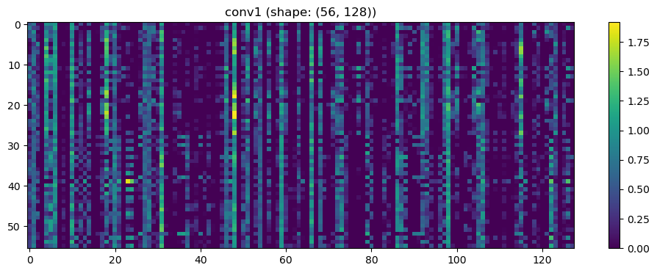

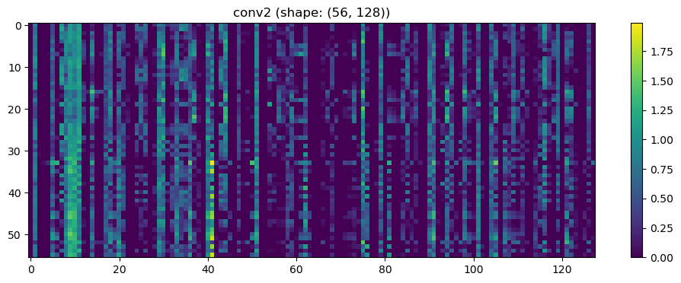

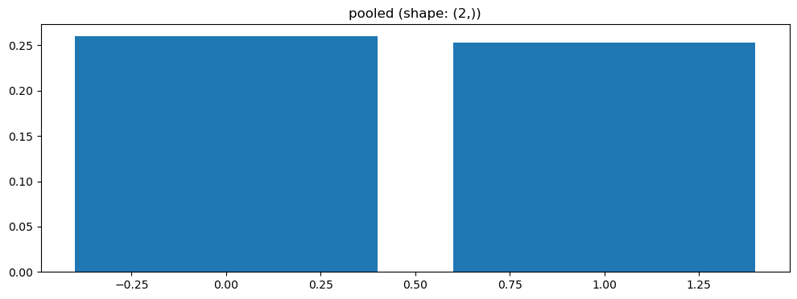

Split 3 Accuracy: 0.7143

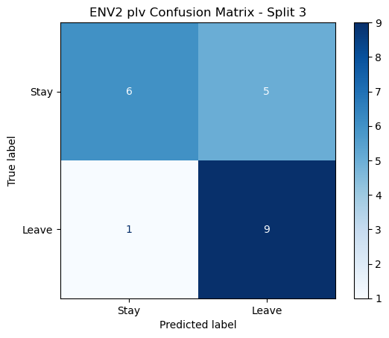

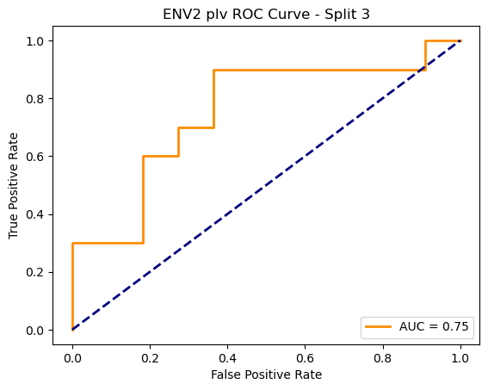

=== ENV2 Split 4/5 ===

After oversampling, class counts: Counter({1: 44, 0: 44})

C:\Users\sansk\miniconda3\Lib\site-packages\torch_geometric\deprecation.py:26: UserWarning: 'data.DataLoader' is deprecated, use 'loader.DataLoader' instead

warnings.warn(out)

Epoch 1/100 | Loss: 0.7637

Epoch 2/100 | Loss: 0.7467

Epoch 3/100 | Loss: 0.7230

Epoch 4/100 | Loss: 0.7511

Epoch 5/100 | Loss: 0.7520

Epoch 6/100 | Loss: 0.7359

Epoch 7/100 | Loss: 0.7681

Epoch 8/100 | Loss: 0.6684

Epoch 9/100 | Loss: 0.6907

Epoch 10/100 | Loss: 0.6595

Epoch 11/100 | Loss: 0.7440

Epoch 12/100 | Loss: 0.6757

Epoch 13/100 | Loss: 0.6959

Epoch 14/100 | Loss: 0.7587

Epoch 15/100 | Loss: 0.7140

Epoch 16/100 | Loss: 0.6886

Epoch 17/100 | Loss: 0.8186

Epoch 18/100 | Loss: 0.7157

Epoch 19/100 | Loss: 0.7731

Epoch 20/100 | Loss: 0.7353

Epoch 21/100 | Loss: 0.7468

Epoch 22/100 | Loss: 0.7354

Epoch 23/100 | Loss: 0.6720

Epoch 24/100 | Loss: 0.7030

Epoch 25/100 | Loss: 0.7098

Epoch 26/100 | Loss: 0.7164

Epoch 27/100 | Loss: 0.7126

Epoch 28/100 | Loss: 0.6675

Epoch 29/100 | Loss: 0.6552

Epoch 30/100 | Loss: 0.7142

Epoch 31/100 | Loss: 0.7508

Epoch 32/100 | Loss: 0.7252

Epoch 33/100 | Loss: 0.6992

Epoch 34/100 | Loss: 0.7421

Epoch 35/100 | Loss: 0.6861

Epoch 36/100 | Loss: 0.6978

Epoch 37/100 | Loss: 0.6792

Epoch 38/100 | Loss: 0.6826

Epoch 39/100 | Loss: 0.7229

Epoch 40/100 | Loss: 0.6474

Epoch 41/100 | Loss: 0.6857

Epoch 42/100 | Loss: 0.7135

Epoch 43/100 | Loss: 0.7143

Epoch 44/100 | Loss: 0.6705

Epoch 45/100 | Loss: 0.7004

Epoch 46/100 | Loss: 0.7527

Epoch 47/100 | Loss: 0.6731

Epoch 48/100 | Loss: 0.7020

Epoch 49/100 | Loss: 0.7333

Epoch 50/100 | Loss: 0.6672

Epoch 51/100 | Loss: 0.7217

Epoch 52/100 | Loss: 0.7438

Epoch 53/100 | Loss: 0.6938

Epoch 54/100 | Loss: 0.6795

Epoch 55/100 | Loss: 0.6588

Epoch 56/100 | Loss: 0.6969

Epoch 57/100 | Loss: 0.6955

Epoch 58/100 | Loss: 0.7466

Epoch 59/100 | Loss: 0.6589

Epoch 60/100 | Loss: 0.6439

Epoch 61/100 | Loss: 0.7064

Epoch 62/100 | Loss: 0.6430

Epoch 63/100 | Loss: 0.6796

Epoch 64/100 | Loss: 0.6805

Epoch 65/100 | Loss: 0.6425

Epoch 66/100 | Loss: 0.6643

Epoch 67/100 | Loss: 0.6582

Epoch 68/100 | Loss: 0.6670

Epoch 69/100 | Loss: 0.6955

Epoch 70/100 | Loss: 0.7094

Epoch 71/100 | Loss: 0.7210

Epoch 72/100 | Loss: 0.6597

Epoch 73/100 | Loss: 0.6801

Epoch 74/100 | Loss: 0.7104

Epoch 75/100 | Loss: 0.6319

Epoch 76/100 | Loss: 0.6862

Epoch 77/100 | Loss: 0.6468

Epoch 78/100 | Loss: 0.6567

Epoch 79/100 | Loss: 0.6805

Epoch 80/100 | Loss: 0.6743

Epoch 81/100 | Loss: 0.6964

Epoch 82/100 | Loss: 0.6742

Epoch 83/100 | Loss: 0.6934

Epoch 84/100 | Loss: 0.6837

Epoch 85/100 | Loss: 0.6646

Epoch 86/100 | Loss: 0.6570

Epoch 87/100 | Loss: 0.6690

Epoch 88/100 | Loss: 0.6323

Epoch 89/100 | Loss: 0.6584

Epoch 90/100 | Loss: 0.7088

Epoch 91/100 | Loss: 0.7045

Epoch 92/100 | Loss: 0.6590

Epoch 93/100 | Loss: 0.6750

Epoch 94/100 | Loss: 0.7048

Epoch 95/100 | Loss: 0.6463

Epoch 96/100 | Loss: 0.6573

Epoch 97/100 | Loss: 0.6969

Epoch 98/100 | Loss: 0.6390

Epoch 99/100 | Loss: 0.6434

Epoch 100/100 | Loss: 0.6969

Split 2 Accuracy: 0.3810

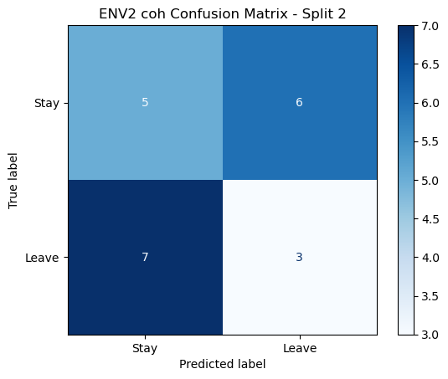

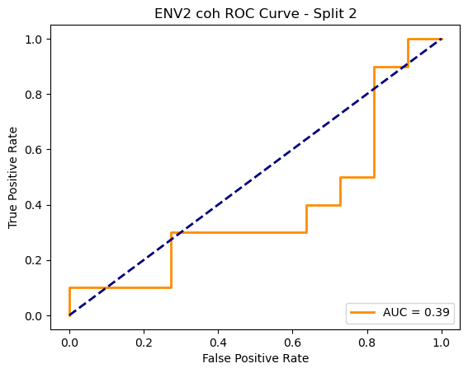

=== ENV2 Split 3/5 ===

C:\Users\sansk\miniconda3\Lib\site-packages\scipy\signal\_spectral_py.py:1668: RuntimeWarning: invalid value encountered in divide

Cxy = np.abs(Pxy)**2 / Pxx / Pyy

After oversampling, class counts: Counter({1: 43, 0: 43})

Epoch 1/200 | Loss: 0.6432

Epoch 2/200 | Loss: 0.7259

Epoch 3/200 | Loss: 0.7121

Epoch 4/200 | Loss: 0.8151

Epoch 5/200 | Loss: 0.7530

Epoch 6/200 | Loss: 0.7312

Epoch 7/200 | Loss: 0.6861

Epoch 8/200 | Loss: 0.7343

Epoch 9/200 | Loss: 0.7161

Epoch 10/200 | Loss: 0.7141

Epoch 11/200 | Loss: 0.7176

Epoch 12/200 | Loss: 0.6995

Epoch 13/200 | Loss: 0.7125

Epoch 14/200 | Loss: 0.7184

Epoch 15/200 | Loss: 0.7452

Epoch 16/200 | Loss: 0.7415

Epoch 17/200 | Loss: 0.7381

Epoch 18/200 | Loss: 0.7677

Epoch 19/200 | Loss: 0.6968

Epoch 20/200 | Loss: 0.7909

Epoch 21/200 | Loss: 0.7163

Epoch 22/200 | Loss: 0.7319

Epoch 23/200 | Loss: 0.6934

Epoch 24/200 | Loss: 0.7317

Epoch 25/200 | Loss: 0.7589

Epoch 26/200 | Loss: 0.7805

Epoch 27/200 | Loss: 0.7328

Epoch 28/200 | Loss: 0.7330

Epoch 29/200 | Loss: 0.6969

Epoch 30/200 | Loss: 0.7292

Epoch 31/200 | Loss: 0.7553

Epoch 32/200 | Loss: 0.7608

Epoch 33/200 | Loss: 0.7128

Epoch 34/200 | Loss: 0.6980

Epoch 35/200 | Loss: 0.7053

Epoch 36/200 | Loss: 0.7295

Epoch 37/200 | Loss: 0.6893

Epoch 38/200 | Loss: 0.7348

Epoch 39/200 | Loss: 0.6822

Epoch 40/200 | Loss: 0.6893

Epoch 41/200 | Loss: 0.6581

Epoch 42/200 | Loss: 0.6731

Epoch 43/200 | Loss: 0.7356

Epoch 44/200 | Loss: 0.7231

Epoch 45/200 | Loss: 0.7512

Epoch 46/200 | Loss: 0.6956

Epoch 47/200 | Loss: 0.7723

Epoch 48/200 | Loss: 0.7153

Epoch 49/200 | Loss: 0.6584

Epoch 50/200 | Loss: 0.6461

Epoch 51/200 | Loss: 0.6636

Epoch 52/200 | Loss: 0.7204

Epoch 53/200 | Loss: 0.6408

Epoch 54/200 | Loss: 0.6931

Epoch 55/200 | Loss: 0.7314

Epoch 56/200 | Loss: 0.6878

Epoch 57/200 | Loss: 0.7030

Epoch 58/200 | Loss: 0.6845

Epoch 59/200 | Loss: 0.7097

Epoch 60/200 | Loss: 0.7210

Epoch 61/200 | Loss: 0.6724

Epoch 62/200 | Loss: 0.6405

Epoch 63/200 | Loss: 0.6908

Epoch 64/200 | Loss: 0.7382

Epoch 65/200 | Loss: 0.7158

Epoch 66/200 | Loss: 0.6891

Epoch 67/200 | Loss: 0.6327

Epoch 68/200 | Loss: 0.6795

Epoch 69/200 | Loss: 0.6726

Epoch 70/200 | Loss: 0.6651

Epoch 71/200 | Loss: 0.6973

Epoch 72/200 | Loss: 0.6657

Epoch 73/200 | Loss: 0.6389

Epoch 74/200 | Loss: 0.7225

Epoch 75/200 | Loss: 0.6643

Epoch 76/200 | Loss: 0.6483

Epoch 77/200 | Loss: 0.6628

Epoch 78/200 | Loss: 0.6795

Epoch 79/200 | Loss: 0.6424

Epoch 80/200 | Loss: 0.6403

Epoch 81/200 | Loss: 0.7126

Epoch 82/200 | Loss: 0.7080

Epoch 83/200 | Loss: 0.6779

Epoch 84/200 | Loss: 0.6512

Epoch 85/200 | Loss: 0.7423

Epoch 86/200 | Loss: 0.7426

Epoch 87/200 | Loss: 0.6707

Epoch 88/200 | Loss: 0.6972

Epoch 89/200 | Loss: 0.6736

Epoch 90/200 | Loss: 0.6322

Epoch 91/200 | Loss: 0.7103

Epoch 92/200 | Loss: 0.6423

Epoch 93/200 | Loss: 0.7076

Epoch 94/200 | Loss: 0.6322

Epoch 95/200 | Loss: 0.6493

Epoch 96/200 | Loss: 0.7240

Epoch 97/200 | Loss: 0.7204

Epoch 98/200 | Loss: 0.6726

Epoch 99/200 | Loss: 0.6635

Epoch 100/200 | Loss: 0.6345

Epoch 101/200 | Loss: 0.6248

Epoch 102/200 | Loss: 0.7171

Epoch 103/200 | Loss: 0.6496

Epoch 104/200 | Loss: 0.6899

Epoch 105/200 | Loss: 0.6662

Epoch 106/200 | Loss: 0.7568

Epoch 107/200 | Loss: 0.7048

Epoch 108/200 | Loss: 0.6411

Epoch 109/200 | Loss: 0.6599

Epoch 110/200 | Loss: 0.7230

Epoch 111/200 | Loss: 0.6848

Epoch 112/200 | Loss: 0.7135

Epoch 113/200 | Loss: 0.6800

Epoch 114/200 | Loss: 0.6106

Epoch 115/200 | Loss: 0.6918

Epoch 116/200 | Loss: 0.7020

Epoch 117/200 | Loss: 0.6980

Epoch 118/200 | Loss: 0.7478

Epoch 119/200 | Loss: 0.6869

Epoch 120/200 | Loss: 0.6942

Epoch 121/200 | Loss: 0.7108

Epoch 122/200 | Loss: 0.6637

Epoch 123/200 | Loss: 0.6647

Epoch 124/200 | Loss: 0.6824

Epoch 125/200 | Loss: 0.7155

Epoch 126/200 | Loss: 0.6272

Epoch 127/200 | Loss: 0.6904

Epoch 128/200 | Loss: 0.6615

Epoch 129/200 | Loss: 0.6576

Epoch 130/200 | Loss: 0.6137

Epoch 131/200 | Loss: 0.6172

Epoch 132/200 | Loss: 0.6779

Epoch 133/200 | Loss: 0.6433

Epoch 134/200 | Loss: 0.6509

Epoch 135/200 | Loss: 0.6580

Epoch 136/200 | Loss: 0.6527

Epoch 137/200 | Loss: 0.7343

Epoch 138/200 | Loss: 0.6691

Epoch 139/200 | Loss: 0.7296

Epoch 140/200 | Loss: 0.7013

Epoch 141/200 | Loss: 0.6312

Epoch 142/200 | Loss: 0.6556

Epoch 143/200 | Loss: 0.7253

Epoch 144/200 | Loss: 0.6729

Epoch 145/200 | Loss: 0.6798

Epoch 146/200 | Loss: 0.6988

Epoch 147/200 | Loss: 0.6870

Epoch 148/200 | Loss: 0.6324

Epoch 149/200 | Loss: 0.6853

Epoch 150/200 | Loss: 0.6622

Epoch 151/200 | Loss: 0.6610

Epoch 152/200 | Loss: 0.7069

Epoch 153/200 | Loss: 0.7029

Epoch 154/200 | Loss: 0.7243

Epoch 155/200 | Loss: 0.6579

Epoch 156/200 | Loss: 0.6226

Epoch 157/200 | Loss: 0.6394

Epoch 158/200 | Loss: 0.6983

Epoch 159/200 | Loss: 0.6953

Epoch 160/200 | Loss: 0.6556

Epoch 161/200 | Loss: 0.6709

Epoch 162/200 | Loss: 0.7029

Epoch 163/200 | Loss: 0.6996

Epoch 164/200 | Loss: 0.6312

Epoch 165/200 | Loss: 0.7095

Epoch 166/200 | Loss: 0.6006

Epoch 167/200 | Loss: 0.6477

Epoch 168/200 | Loss: 0.7072

Epoch 169/200 | Loss: 0.6500

Epoch 170/200 | Loss: 0.6843

Epoch 171/200 | Loss: 0.6988

Epoch 172/200 | Loss: 0.6995

Epoch 173/200 | Loss: 0.6383

Epoch 174/200 | Loss: 0.6156

Epoch 175/200 | Loss: 0.6527

Epoch 176/200 | Loss: 0.6498

Epoch 177/200 | Loss: 0.6307

Epoch 178/200 | Loss: 0.5933

Epoch 179/200 | Loss: 0.6834

Epoch 180/200 | Loss: 0.6752

Epoch 181/200 | Loss: 0.6506

Epoch 182/200 | Loss: 0.6783

Epoch 183/200 | Loss: 0.6708

Epoch 184/200 | Loss: 0.7115

Epoch 185/200 | Loss: 0.6237

Epoch 186/200 | Loss: 0.6342

Epoch 187/200 | Loss: 0.6618

Epoch 188/200 | Loss: 0.6495

Epoch 189/200 | Loss: 0.6495

Epoch 190/200 | Loss: 0.6669

Epoch 191/200 | Loss: 0.6355

Epoch 192/200 | Loss: 0.6602

Epoch 193/200 | Loss: 0.6501

Epoch 194/200 | Loss: 0.6215

Epoch 195/200 | Loss: 0.6710

Epoch 196/200 | Loss: 0.6610

Epoch 197/200 | Loss: 0.6483

Epoch 198/200 | Loss: 0.6013

Epoch 199/200 | Loss: 0.6572

Epoch 200/200 | Loss: 0.6793

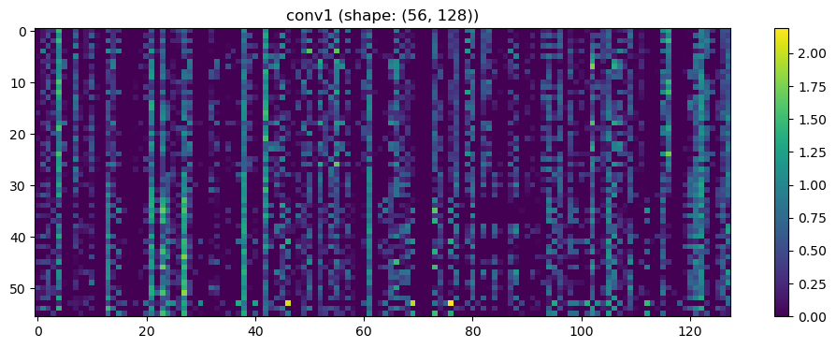

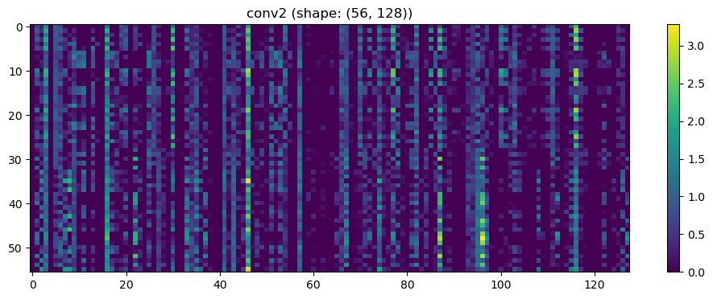

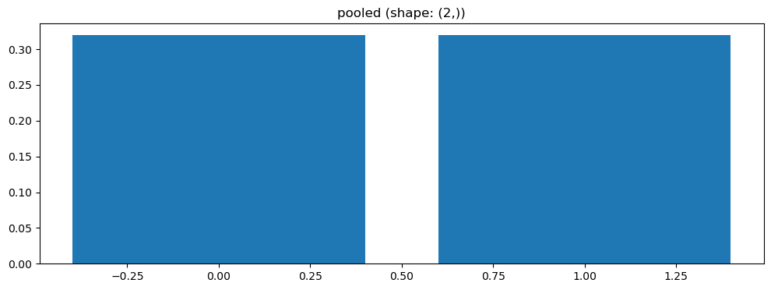

Split 4 Accuracy: 0.5714

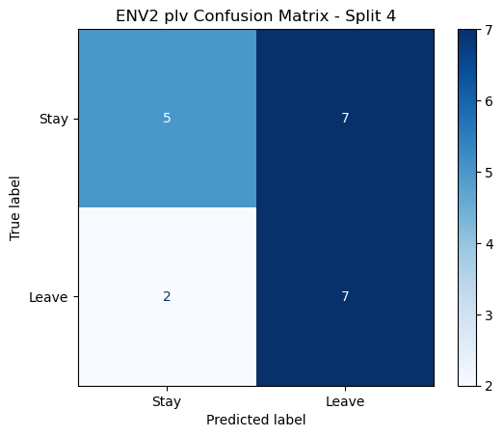

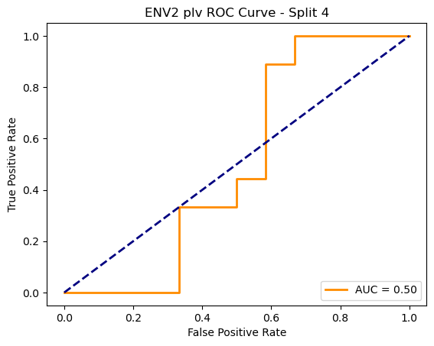

=== ENV2 Split 5/5 ===

After oversampling, class counts: Counter({1: 44, 0: 44})

C:\Users\sansk\miniconda3\Lib\site-packages\torch_geometric\deprecation.py:26: UserWarning: 'data.DataLoader' is deprecated, use 'loader.DataLoader' instead

warnings.warn(out)

Epoch 1/100 | Loss: 0.8158

Epoch 2/100 | Loss: 0.6713

Epoch 3/100 | Loss: 0.8289

Epoch 4/100 | Loss: 0.7880

Epoch 5/100 | Loss: 0.7783

Epoch 6/100 | Loss: 0.7526

Epoch 7/100 | Loss: 0.7645

Epoch 8/100 | Loss: 0.7493

Epoch 9/100 | Loss: 0.7121

Epoch 10/100 | Loss: 0.7221

Epoch 11/100 | Loss: 0.7218

Epoch 12/100 | Loss: 0.7282

Epoch 13/100 | Loss: 0.7742

Epoch 14/100 | Loss: 0.7757

Epoch 15/100 | Loss: 0.7880

Epoch 16/100 | Loss: 0.7757

Epoch 17/100 | Loss: 0.7934

Epoch 18/100 | Loss: 0.7251

Epoch 19/100 | Loss: 0.7544

Epoch 20/100 | Loss: 0.6510

Epoch 21/100 | Loss: 0.7848

Epoch 22/100 | Loss: 0.7639

Epoch 23/100 | Loss: 0.7085

Epoch 24/100 | Loss: 0.7551

Epoch 25/100 | Loss: 0.7409

Epoch 26/100 | Loss: 0.7285

Epoch 27/100 | Loss: 0.7487

Epoch 28/100 | Loss: 0.7158

Epoch 29/100 | Loss: 0.7243

Epoch 30/100 | Loss: 0.7330

Epoch 31/100 | Loss: 0.7088

Epoch 32/100 | Loss: 0.7522

Epoch 33/100 | Loss: 0.7320

Epoch 34/100 | Loss: 0.6840

Epoch 35/100 | Loss: 0.7029

Epoch 36/100 | Loss: 0.7207

Epoch 37/100 | Loss: 0.6646

Epoch 38/100 | Loss: 0.7271

Epoch 39/100 | Loss: 0.6824

Epoch 40/100 | Loss: 0.7529

Epoch 41/100 | Loss: 0.6732

Epoch 42/100 | Loss: 0.6947

Epoch 43/100 | Loss: 0.7325

Epoch 44/100 | Loss: 0.7101

Epoch 45/100 | Loss: 0.7238

Epoch 46/100 | Loss: 0.7149

Epoch 47/100 | Loss: 0.6839

Epoch 48/100 | Loss: 0.7700

Epoch 49/100 | Loss: 0.7192

Epoch 50/100 | Loss: 0.7383

Epoch 51/100 | Loss: 0.7091

Epoch 52/100 | Loss: 0.7023

Epoch 53/100 | Loss: 0.7330

Epoch 54/100 | Loss: 0.6976

Epoch 55/100 | Loss: 0.7786

Epoch 56/100 | Loss: 0.6780

Epoch 57/100 | Loss: 0.7242

Epoch 58/100 | Loss: 0.6914

Epoch 59/100 | Loss: 0.6778

Epoch 60/100 | Loss: 0.7395

Epoch 61/100 | Loss: 0.6825

Epoch 62/100 | Loss: 0.7154

Epoch 63/100 | Loss: 0.6967

Epoch 64/100 | Loss: 0.6765

Epoch 65/100 | Loss: 0.7802

Epoch 66/100 | Loss: 0.7485

Epoch 67/100 | Loss: 0.7013

Epoch 68/100 | Loss: 0.7500

Epoch 69/100 | Loss: 0.7025

Epoch 70/100 | Loss: 0.7362

Epoch 71/100 | Loss: 0.6789

Epoch 72/100 | Loss: 0.6447

Epoch 73/100 | Loss: 0.6785

Epoch 74/100 | Loss: 0.7612

Epoch 75/100 | Loss: 0.6947

Epoch 76/100 | Loss: 0.6837

Epoch 77/100 | Loss: 0.7309

Epoch 78/100 | Loss: 0.7575

Epoch 79/100 | Loss: 0.7361

Epoch 80/100 | Loss: 0.7101

Epoch 81/100 | Loss: 0.7225

Epoch 82/100 | Loss: 0.6998

Epoch 83/100 | Loss: 0.6623

Epoch 84/100 | Loss: 0.7236

Epoch 85/100 | Loss: 0.7951

Epoch 86/100 | Loss: 0.7030

Epoch 87/100 | Loss: 0.7421

Epoch 88/100 | Loss: 0.6695

Epoch 89/100 | Loss: 0.7017

Epoch 90/100 | Loss: 0.7137

Epoch 91/100 | Loss: 0.7016

Epoch 92/100 | Loss: 0.7128

Epoch 93/100 | Loss: 0.7007

Epoch 94/100 | Loss: 0.6814

Epoch 95/100 | Loss: 0.6438

Epoch 96/100 | Loss: 0.7210

Epoch 97/100 | Loss: 0.6832

Epoch 98/100 | Loss: 0.6765

Epoch 99/100 | Loss: 0.6805

Epoch 100/100 | Loss: 0.6874

Split 3 Accuracy: 0.5238

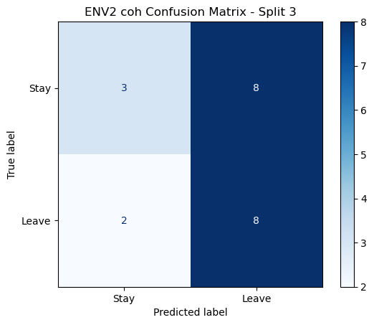

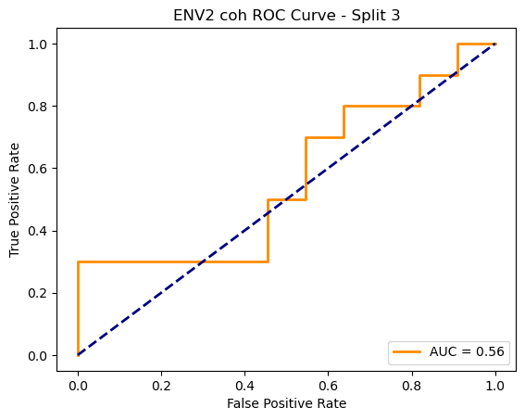

=== ENV2 Split 4/5 ===

C:\Users\sansk\miniconda3\Lib\site-packages\scipy\signal\_spectral_py.py:1668: RuntimeWarning: invalid value encountered in divide

Cxy = np.abs(Pxy)**2 / Pxx / Pyy

After oversampling, class counts: Counter({1: 44, 0: 44})

C:\Users\sansk\miniconda3\Lib\site-packages\torch_geometric\deprecation.py:26: UserWarning: 'data.DataLoader' is deprecated, use 'loader.DataLoader' instead

warnings.warn(out)

Epoch 1/100 | Loss: 0.7986

Epoch 2/100 | Loss: 0.7315

Epoch 3/100 | Loss: 0.7347

Epoch 4/100 | Loss: 0.6925

Epoch 5/100 | Loss: 0.7106

Epoch 6/100 | Loss: 0.7494

Epoch 7/100 | Loss: 0.6424

Epoch 8/100 | Loss: 0.7182

Epoch 9/100 | Loss: 0.7277

Epoch 10/100 | Loss: 0.7098

Epoch 11/100 | Loss: 0.7551

Epoch 12/100 | Loss: 0.7590

Epoch 13/100 | Loss: 0.7097

Epoch 14/100 | Loss: 0.6853

Epoch 15/100 | Loss: 0.7207

Epoch 16/100 | Loss: 0.7483

Epoch 17/100 | Loss: 0.7360

Epoch 18/100 | Loss: 0.7164

Epoch 19/100 | Loss: 0.7025

Epoch 20/100 | Loss: 0.7110

Epoch 21/100 | Loss: 0.6703

Epoch 22/100 | Loss: 0.6782

Epoch 23/100 | Loss: 0.6819

Epoch 24/100 | Loss: 0.6623

Epoch 25/100 | Loss: 0.8092

Epoch 26/100 | Loss: 0.7552

Epoch 27/100 | Loss: 0.7547

Epoch 28/100 | Loss: 0.7527

Epoch 29/100 | Loss: 0.7305

Epoch 30/100 | Loss: 0.7219

Epoch 31/100 | Loss: 0.7186

Epoch 32/100 | Loss: 0.6886

Epoch 33/100 | Loss: 0.6521

Epoch 34/100 | Loss: 0.6740

Epoch 35/100 | Loss: 0.7384

Epoch 36/100 | Loss: 0.6723

Epoch 37/100 | Loss: 0.7020

Epoch 38/100 | Loss: 0.7137

Epoch 39/100 | Loss: 0.6727

Epoch 40/100 | Loss: 0.7301

Epoch 41/100 | Loss: 0.6795

Epoch 42/100 | Loss: 0.6553

Epoch 43/100 | Loss: 0.7004

Epoch 44/100 | Loss: 0.7129

Epoch 45/100 | Loss: 0.6791

Epoch 46/100 | Loss: 0.6705

Epoch 47/100 | Loss: 0.7263

Epoch 48/100 | Loss: 0.6963

Epoch 49/100 | Loss: 0.7490

Epoch 50/100 | Loss: 0.7342

Epoch 51/100 | Loss: 0.7048

Epoch 52/100 | Loss: 0.7637

Epoch 53/100 | Loss: 0.7182

Epoch 54/100 | Loss: 0.7386

Epoch 55/100 | Loss: 0.6843

Epoch 56/100 | Loss: 0.6638

Epoch 57/100 | Loss: 0.7125

Epoch 58/100 | Loss: 0.6500

Epoch 59/100 | Loss: 0.6833

Epoch 60/100 | Loss: 0.6842

Epoch 61/100 | Loss: 0.7617

Epoch 62/100 | Loss: 0.6972

Epoch 63/100 | Loss: 0.6709

Epoch 64/100 | Loss: 0.6858

Epoch 65/100 | Loss: 0.7151

Epoch 66/100 | Loss: 0.7134

Epoch 67/100 | Loss: 0.6967

Epoch 68/100 | Loss: 0.6552

Epoch 69/100 | Loss: 0.7087

Epoch 70/100 | Loss: 0.6038

Epoch 71/100 | Loss: 0.6978

Epoch 72/100 | Loss: 0.7133

Epoch 73/100 | Loss: 0.6752

Epoch 74/100 | Loss: 0.6359

Epoch 75/100 | Loss: 0.6790

Epoch 76/100 | Loss: 0.6898

Epoch 77/100 | Loss: 0.6969

Epoch 78/100 | Loss: 0.7142

Epoch 79/100 | Loss: 0.6976

Epoch 80/100 | Loss: 0.6941

Epoch 81/100 | Loss: 0.6881

Epoch 82/100 | Loss: 0.6837

Epoch 83/100 | Loss: 0.6815

Epoch 84/100 | Loss: 0.6816

Epoch 85/100 | Loss: 0.6136

Epoch 86/100 | Loss: 0.7174

Epoch 87/100 | Loss: 0.7039

Epoch 88/100 | Loss: 0.7000

Epoch 89/100 | Loss: 0.7332

Epoch 90/100 | Loss: 0.7241

Epoch 91/100 | Loss: 0.6976

Epoch 92/100 | Loss: 0.6458

Epoch 93/100 | Loss: 0.6446

Epoch 94/100 | Loss: 0.7304

Epoch 95/100 | Loss: 0.6632

Epoch 96/100 | Loss: 0.7329

Epoch 97/100 | Loss: 0.7002

Epoch 98/100 | Loss: 0.6846

Epoch 99/100 | Loss: 0.6528

Epoch 100/100 | Loss: 0.7120

Split 4 Accuracy: 0.4762

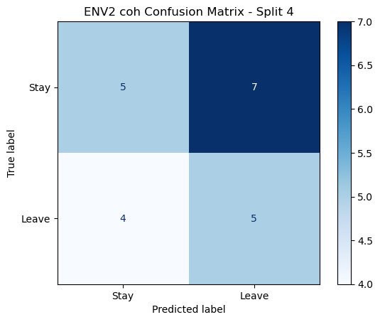

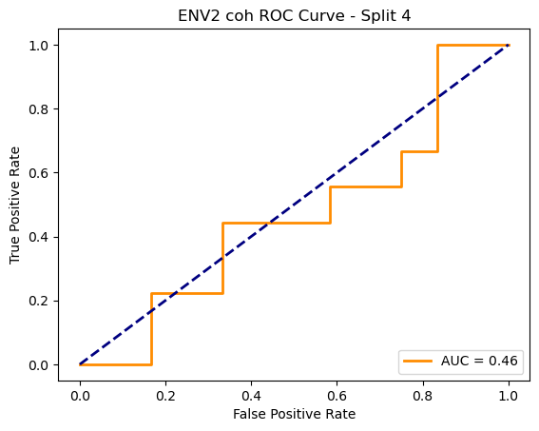

=== ENV2 Split 5/5 ===

C:\Users\sansk\miniconda3\Lib\site-packages\scipy\signal\_spectral_py.py:1668: RuntimeWarning: invalid value encountered in divide

Cxy = np.abs(Pxy)**2 / Pxx / Pyy

After oversampling, class counts: Counter({1: 44, 0: 44})

C:\Users\sansk\miniconda3\Lib\site-packages\torch_geometric\deprecation.py:26: UserWarning: 'data.DataLoader' is deprecated, use 'loader.DataLoader' instead

warnings.warn(out)

Epoch 1/100 | Loss: 0.8386

Epoch 2/100 | Loss: 0.8179

Epoch 3/100 | Loss: 0.7128

Epoch 4/100 | Loss: 0.7597

Epoch 5/100 | Loss: 0.7457

Epoch 6/100 | Loss: 0.7085

Epoch 7/100 | Loss: 0.6746

Epoch 8/100 | Loss: 0.7736

Epoch 9/100 | Loss: 0.7054

Epoch 10/100 | Loss: 0.6486

Epoch 11/100 | Loss: 0.6998

Epoch 12/100 | Loss: 0.7770

Epoch 13/100 | Loss: 0.7083

Epoch 14/100 | Loss: 0.7364

Epoch 15/100 | Loss: 0.7232

Epoch 16/100 | Loss: 0.7170

Epoch 17/100 | Loss: 0.7098

Epoch 18/100 | Loss: 0.7531

Epoch 19/100 | Loss: 0.7285

Epoch 20/100 | Loss: 0.7166

Epoch 21/100 | Loss: 0.7103

Epoch 22/100 | Loss: 0.7148

Epoch 23/100 | Loss: 0.7600

Epoch 24/100 | Loss: 0.7707

Epoch 25/100 | Loss: 0.7189

Epoch 26/100 | Loss: 0.7261

Epoch 27/100 | Loss: 0.7174

Epoch 28/100 | Loss: 0.7244

Epoch 29/100 | Loss: 0.7109

Epoch 30/100 | Loss: 0.7278

Epoch 31/100 | Loss: 0.7273

Epoch 32/100 | Loss: 0.7473

Epoch 33/100 | Loss: 0.7194

Epoch 34/100 | Loss: 0.6182

Epoch 35/100 | Loss: 0.7080

Epoch 36/100 | Loss: 0.6893

Epoch 37/100 | Loss: 0.7167

Epoch 38/100 | Loss: 0.6683

Epoch 39/100 | Loss: 0.6673

Epoch 40/100 | Loss: 0.6907

Epoch 41/100 | Loss: 0.6585

Epoch 42/100 | Loss: 0.7023

Epoch 43/100 | Loss: 0.7284

Epoch 44/100 | Loss: 0.7277

Epoch 45/100 | Loss: 0.6497

Epoch 46/100 | Loss: 0.7257

Epoch 47/100 | Loss: 0.7541

Epoch 48/100 | Loss: 0.7650

Epoch 49/100 | Loss: 0.6988

Epoch 50/100 | Loss: 0.6869

Epoch 51/100 | Loss: 0.7214

Epoch 52/100 | Loss: 0.7309

Epoch 53/100 | Loss: 0.6637

Epoch 54/100 | Loss: 0.7316

Epoch 55/100 | Loss: 0.6844

Epoch 56/100 | Loss: 0.7214

Epoch 57/100 | Loss: 0.6775

Epoch 58/100 | Loss: 0.6960

Epoch 59/100 | Loss: 0.6593

Epoch 60/100 | Loss: 0.6949

Epoch 61/100 | Loss: 0.7476

Epoch 62/100 | Loss: 0.6790

Epoch 63/100 | Loss: 0.7260

Epoch 64/100 | Loss: 0.6620

Epoch 65/100 | Loss: 0.7175

Epoch 66/100 | Loss: 0.6837

Epoch 67/100 | Loss: 0.6820

Epoch 68/100 | Loss: 0.7217

Epoch 69/100 | Loss: 0.7451

Epoch 70/100 | Loss: 0.6910

Epoch 71/100 | Loss: 0.6610

Epoch 72/100 | Loss: 0.7009

Epoch 73/100 | Loss: 0.7028

Epoch 74/100 | Loss: 0.7021

Epoch 75/100 | Loss: 0.7513

Epoch 76/100 | Loss: 0.6696

Epoch 77/100 | Loss: 0.6833

Epoch 78/100 | Loss: 0.7883

Epoch 79/100 | Loss: 0.7166

Epoch 80/100 | Loss: 0.7324

Epoch 81/100 | Loss: 0.6667

Epoch 82/100 | Loss: 0.7122

Epoch 83/100 | Loss: 0.7189

Epoch 84/100 | Loss: 0.6554

Epoch 85/100 | Loss: 0.6620

Epoch 86/100 | Loss: 0.6809

Epoch 87/100 | Loss: 0.7051

Epoch 88/100 | Loss: 0.7245

Epoch 89/100 | Loss: 0.6973

Epoch 90/100 | Loss: 0.6227

Epoch 91/100 | Loss: 0.6508

Epoch 92/100 | Loss: 0.7001

Epoch 93/100 | Loss: 0.7527

Epoch 94/100 | Loss: 0.7169

Epoch 95/100 | Loss: 0.7371

Epoch 96/100 | Loss: 0.7358

Epoch 97/100 | Loss: 0.6461

Epoch 98/100 | Loss: 0.6461

Epoch 99/100 | Loss: 0.6616

Epoch 100/100 | Loss: 0.6621

Split 5 Accuracy: 0.3333

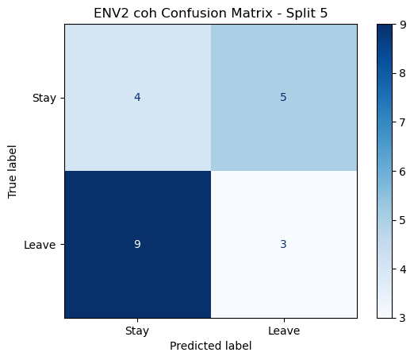

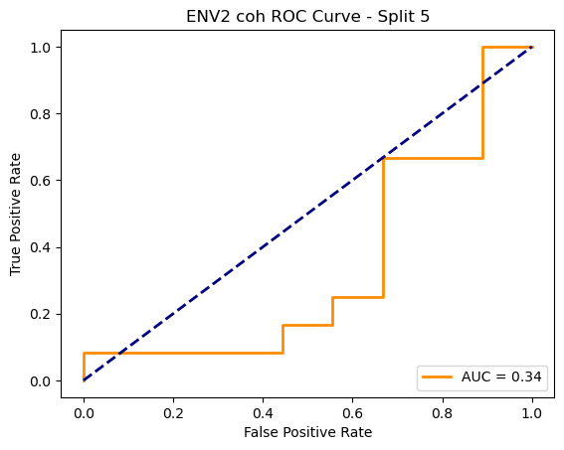

ENV2 coh Average Accuracy: 0.4610 ± 0.0936

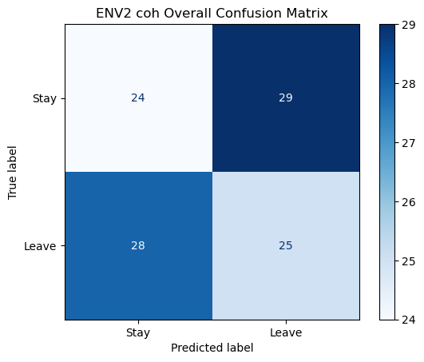

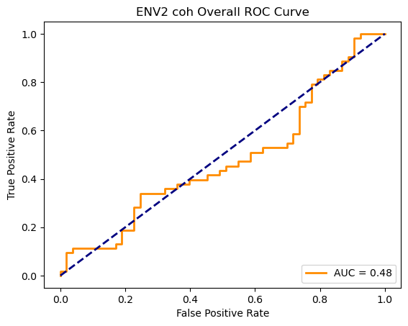

Running GNN with plv connectivity for ENV2...

==================================================

Training GNN for ENV2 with plv connectivity

==================================================

=== ENV2 Split 1/5 ===

After oversampling, class counts: Counter({0: 43, 1: 43})

C:\Users\sansk\miniconda3\Lib\site-packages\torch_geometric\deprecation.py:26: UserWarning: 'data.DataLoader' is deprecated, use 'loader.DataLoader' instead

warnings.warn(out)

Epoch 1/100 | Loss: 0.7304

Epoch 2/100 | Loss: 0.7651

Epoch 3/100 | Loss: 0.7425

Epoch 4/100 | Loss: 0.8042

Epoch 5/100 | Loss: 0.7630

Epoch 6/100 | Loss: 0.7256

Epoch 7/100 | Loss: 0.7339

Epoch 8/100 | Loss: 0.6974

Epoch 9/100 | Loss: 0.7243

Epoch 10/100 | Loss: 0.7024

Epoch 11/100 | Loss: 0.7262

Epoch 12/100 | Loss: 0.7643

Epoch 13/100 | Loss: 0.6774

Epoch 14/100 | Loss: 0.7305

Epoch 15/100 | Loss: 0.6826

Epoch 16/100 | Loss: 0.7132

Epoch 17/100 | Loss: 0.6677

Epoch 18/100 | Loss: 0.6451

Epoch 19/100 | Loss: 0.7270

Epoch 20/100 | Loss: 0.6755

Epoch 21/100 | Loss: 0.5992

Epoch 22/100 | Loss: 0.6790

Epoch 23/100 | Loss: 0.6822

Epoch 24/100 | Loss: 0.6920

Epoch 25/100 | Loss: 0.5897

Epoch 26/100 | Loss: 0.6632

Epoch 27/100 | Loss: 0.6813

Epoch 28/100 | Loss: 0.7209

Epoch 29/100 | Loss: 0.7275

Epoch 30/100 | Loss: 0.7397

Epoch 31/100 | Loss: 0.6920

Epoch 32/100 | Loss: 0.6795

Epoch 33/100 | Loss: 0.6706

Epoch 34/100 | Loss: 0.6974

Epoch 35/100 | Loss: 0.7042

Epoch 36/100 | Loss: 0.6818

Epoch 37/100 | Loss: 0.6618

Epoch 38/100 | Loss: 0.6721

Epoch 39/100 | Loss: 0.6626

Epoch 40/100 | Loss: 0.6632

Epoch 41/100 | Loss: 0.6609

Epoch 42/100 | Loss: 0.6793

Epoch 43/100 | Loss: 0.6831

Epoch 44/100 | Loss: 0.7207

Epoch 45/100 | Loss: 0.7102

Epoch 46/100 | Loss: 0.6477

Epoch 47/100 | Loss: 0.6779

Epoch 48/100 | Loss: 0.6795

Epoch 49/100 | Loss: 0.7122

Epoch 50/100 | Loss: 0.6443

Epoch 51/100 | Loss: 0.6546

Epoch 52/100 | Loss: 0.6559

Epoch 53/100 | Loss: 0.6359

Epoch 54/100 | Loss: 0.6908

Epoch 55/100 | Loss: 0.6622

Epoch 56/100 | Loss: 0.6538

Epoch 57/100 | Loss: 0.6781

Epoch 58/100 | Loss: 0.6348

Epoch 59/100 | Loss: 0.6020

Epoch 60/100 | Loss: 0.6517

Epoch 61/100 | Loss: 0.6509

Epoch 62/100 | Loss: 0.6551

Epoch 63/100 | Loss: 0.6304

Epoch 64/100 | Loss: 0.5843

Epoch 65/100 | Loss: 0.6107

Epoch 66/100 | Loss: 0.5430

Epoch 67/100 | Loss: 0.6336

Epoch 68/100 | Loss: 0.5725

Epoch 69/100 | Loss: 0.5852

Epoch 70/100 | Loss: 0.6301

Epoch 71/100 | Loss: 0.6582

Epoch 72/100 | Loss: 0.5616

Epoch 73/100 | Loss: 0.6501

Epoch 74/100 | Loss: 0.6262

Epoch 75/100 | Loss: 0.5877

Epoch 76/100 | Loss: 0.6385

Epoch 77/100 | Loss: 0.6303

Epoch 78/100 | Loss: 0.6145

Epoch 79/100 | Loss: 0.5744

Epoch 80/100 | Loss: 0.6202

Epoch 81/100 | Loss: 0.5909

Epoch 82/100 | Loss: 0.6301

Epoch 83/100 | Loss: 0.5362

Epoch 84/100 | Loss: 0.6188

Epoch 85/100 | Loss: 0.6085

Epoch 86/100 | Loss: 0.6550

Epoch 87/100 | Loss: 0.5993

Epoch 88/100 | Loss: 0.5571

Epoch 89/100 | Loss: 0.6764

Epoch 90/100 | Loss: 0.5590

Epoch 91/100 | Loss: 0.6814

Epoch 92/100 | Loss: 0.5954

Epoch 93/100 | Loss: 0.5918

Epoch 94/100 | Loss: 0.6514

Epoch 95/100 | Loss: 0.6622

Epoch 96/100 | Loss: 0.5748

Epoch 97/100 | Loss: 0.6164

Epoch 98/100 | Loss: 0.6452

Epoch 99/100 | Loss: 0.6069

Epoch 100/100 | Loss: 0.6301

Split 1 Accuracy: 0.5000

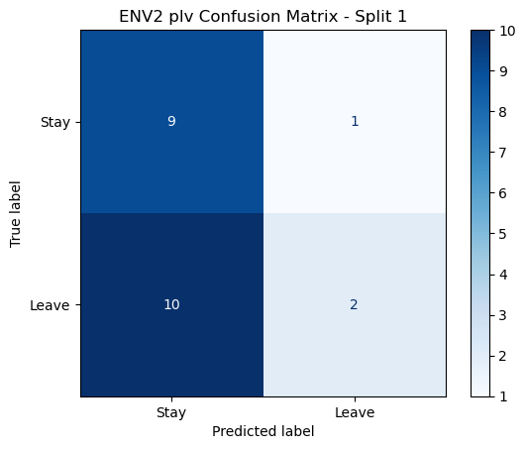

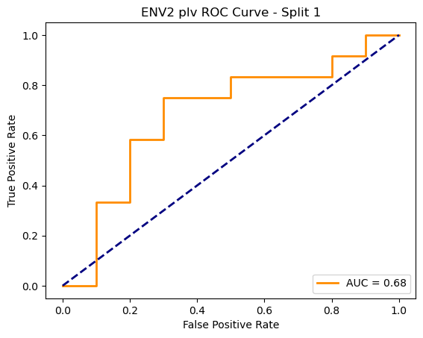

=== ENV2 Split 2/5 ===

After oversampling, class counts: Counter({1: 43, 0: 43})

C:\Users\sansk\miniconda3\Lib\site-packages\torch_geometric\deprecation.py:26: UserWarning: 'data.DataLoader' is deprecated, use 'loader.DataLoader' instead

warnings.warn(out)

Epoch 1/100 | Loss: 0.7575

Epoch 2/100 | Loss: 0.8282

Epoch 3/100 | Loss: 0.7311

Epoch 4/100 | Loss: 0.7300

Epoch 5/100 | Loss: 0.7088

Epoch 6/100 | Loss: 0.7793

Epoch 7/100 | Loss: 0.7223

Epoch 8/100 | Loss: 0.7500

Epoch 9/100 | Loss: 0.7435

Epoch 10/100 | Loss: 0.6676

Epoch 11/100 | Loss: 0.6763

Epoch 12/100 | Loss: 0.7509

Epoch 13/100 | Loss: 0.7381

Epoch 14/100 | Loss: 0.6532

Epoch 15/100 | Loss: 0.7160

Epoch 16/100 | Loss: 0.7018

Epoch 17/100 | Loss: 0.6902

Epoch 18/100 | Loss: 0.7705

Epoch 19/100 | Loss: 0.6801

Epoch 20/100 | Loss: 0.6775

Epoch 21/100 | Loss: 0.7431

Epoch 22/100 | Loss: 0.7414

Epoch 23/100 | Loss: 0.7149

Epoch 24/100 | Loss: 0.7029

Epoch 25/100 | Loss: 0.7115

Epoch 26/100 | Loss: 0.6749

Epoch 27/100 | Loss: 0.6764

Epoch 28/100 | Loss: 0.6180

Epoch 29/100 | Loss: 0.6862

Epoch 30/100 | Loss: 0.6398

Epoch 31/100 | Loss: 0.6538

Epoch 32/100 | Loss: 0.6121

Epoch 33/100 | Loss: 0.6575

Epoch 34/100 | Loss: 0.6984

Epoch 35/100 | Loss: 0.6039

Epoch 36/100 | Loss: 0.6700

Epoch 37/100 | Loss: 0.7081

Epoch 38/100 | Loss: 0.6806

Epoch 39/100 | Loss: 0.6457

Epoch 40/100 | Loss: 0.6922

Epoch 41/100 | Loss: 0.6389

Epoch 42/100 | Loss: 0.7025

Epoch 43/100 | Loss: 0.6210

Epoch 44/100 | Loss: 0.6539

Epoch 45/100 | Loss: 0.6562

Epoch 46/100 | Loss: 0.6350

Epoch 47/100 | Loss: 0.6859

Epoch 48/100 | Loss: 0.6750

Epoch 49/100 | Loss: 0.6063

Epoch 50/100 | Loss: 0.7056

Epoch 51/100 | Loss: 0.6802

Epoch 52/100 | Loss: 0.6647

Epoch 53/100 | Loss: 0.6443

Epoch 54/100 | Loss: 0.6807

Epoch 55/100 | Loss: 0.6549

Epoch 56/100 | Loss: 0.6760

Epoch 57/100 | Loss: 0.6807

Epoch 58/100 | Loss: 0.6102

Epoch 59/100 | Loss: 0.6385

Epoch 60/100 | Loss: 0.6576

Epoch 61/100 | Loss: 0.6137

Epoch 62/100 | Loss: 0.6720

Epoch 63/100 | Loss: 0.6827

Epoch 64/100 | Loss: 0.6748

Epoch 65/100 | Loss: 0.6171

Epoch 66/100 | Loss: 0.6347

Epoch 67/100 | Loss: 0.6562

Epoch 68/100 | Loss: 0.6047

Epoch 69/100 | Loss: 0.6419

Epoch 70/100 | Loss: 0.6077

Epoch 71/100 | Loss: 0.6473

Epoch 72/100 | Loss: 0.6750

Epoch 73/100 | Loss: 0.6203

Epoch 74/100 | Loss: 0.7023

Epoch 75/100 | Loss: 0.6576

Epoch 76/100 | Loss: 0.6658

Epoch 77/100 | Loss: 0.6149

Epoch 78/100 | Loss: 0.5562

Epoch 79/100 | Loss: 0.6634

Epoch 80/100 | Loss: 0.5789

Epoch 81/100 | Loss: 0.6216

Epoch 82/100 | Loss: 0.5876

Epoch 83/100 | Loss: 0.5652

Epoch 84/100 | Loss: 0.6930

Epoch 85/100 | Loss: 0.5776

Epoch 86/100 | Loss: 0.5523

Epoch 87/100 | Loss: 0.6517

Epoch 88/100 | Loss: 0.6137

Epoch 89/100 | Loss: 0.5716

Epoch 90/100 | Loss: 0.6010

Epoch 91/100 | Loss: 0.6420

Epoch 92/100 | Loss: 0.6158

Epoch 93/100 | Loss: 0.5831

Epoch 94/100 | Loss: 0.6125

Epoch 95/100 | Loss: 0.6034

Epoch 96/100 | Loss: 0.6569

Epoch 97/100 | Loss: 0.6470

Epoch 98/100 | Loss: 0.6641

Epoch 99/100 | Loss: 0.5268

Epoch 100/100 | Loss: 0.6508

Split 2 Accuracy: 0.5238



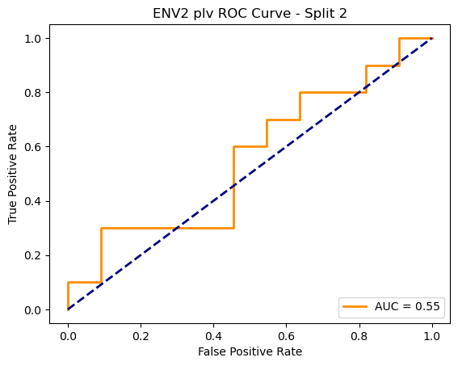

=== ENV2 Split 3/5 ===

After oversampling, class counts: Counter({1: 43, 0: 43})

C:\Users\sansk\miniconda3\Lib\site-packages\torch_geometric\deprecation.py:26: UserWarning: 'data.DataLoader' is deprecated, use 'loader.DataLoader' instead

warnings.warn(out)

Epoch 1/100 | Loss: 0.8257

Epoch 2/100 | Loss: 0.7505

Epoch 3/100 | Loss: 0.7576

Epoch 4/100 | Loss: 0.7306

Epoch 5/100 | Loss: 0.6913

Epoch 6/100 | Loss: 0.7439

Epoch 7/100 | Loss: 0.6669

Epoch 8/100 | Loss: 0.7201

Epoch 9/100 | Loss: 0.6949

Epoch 10/100 | Loss: 0.7434

Epoch 11/100 | Loss: 0.7161

Epoch 12/100 | Loss: 0.7147

Epoch 13/100 | Loss: 0.7336

Epoch 14/100 | Loss: 0.7150

Epoch 15/100 | Loss: 0.6675

Epoch 16/100 | Loss: 0.7251

Epoch 17/100 | Loss: 0.6423

Epoch 18/100 | Loss: 0.7430

Epoch 19/100 | Loss: 0.6948

Epoch 20/100 | Loss: 0.7105

Epoch 21/100 | Loss: 0.7175

Epoch 22/100 | Loss: 0.7191

Epoch 23/100 | Loss: 0.7204

Epoch 24/100 | Loss: 0.6790

Epoch 25/100 | Loss: 0.6873

Epoch 26/100 | Loss: 0.6972

Epoch 27/100 | Loss: 0.6718

Epoch 28/100 | Loss: 0.6514

Epoch 29/100 | Loss: 0.7089

Epoch 30/100 | Loss: 0.7246

Epoch 31/100 | Loss: 0.6812

Epoch 32/100 | Loss: 0.6705

Epoch 33/100 | Loss: 0.6918

Epoch 34/100 | Loss: 0.7202

Epoch 35/100 | Loss: 0.6446

Epoch 36/100 | Loss: 0.6666

Epoch 37/100 | Loss: 0.6325

Epoch 38/100 | Loss: 0.7315

Epoch 39/100 | Loss: 0.6419

Epoch 40/100 | Loss: 0.6643

Epoch 41/100 | Loss: 0.6506

Epoch 42/100 | Loss: 0.6667

Epoch 43/100 | Loss: 0.6141

Epoch 44/100 | Loss: 0.6062

Epoch 45/100 | Loss: 0.6870

Epoch 46/100 | Loss: 0.7216

Epoch 47/100 | Loss: 0.6801

Epoch 48/100 | Loss: 0.6714

Epoch 49/100 | Loss: 0.6843

Epoch 50/100 | Loss: 0.7142

Epoch 51/100 | Loss: 0.6451

Epoch 52/100 | Loss: 0.7083

Epoch 53/100 | Loss: 0.6731

Epoch 54/100 | Loss: 0.6641

Epoch 55/100 | Loss: 0.6709

Epoch 56/100 | Loss: 0.6480

Epoch 57/100 | Loss: 0.6416

Epoch 58/100 | Loss: 0.6697

Epoch 59/100 | Loss: 0.6784

Epoch 60/100 | Loss: 0.6778

Epoch 61/100 | Loss: 0.6424

Epoch 62/100 | Loss: 0.6935

Epoch 63/100 | Loss: 0.7018

Epoch 64/100 | Loss: 0.6057

Epoch 65/100 | Loss: 0.7457

Epoch 66/100 | Loss: 0.6532

Epoch 67/100 | Loss: 0.6414

Epoch 68/100 | Loss: 0.6681

Epoch 69/100 | Loss: 0.6409

Epoch 70/100 | Loss: 0.7099

Epoch 71/100 | Loss: 0.5601

Epoch 72/100 | Loss: 0.6236

Epoch 73/100 | Loss: 0.6623

Epoch 74/100 | Loss: 0.6792

Epoch 75/100 | Loss: 0.6342

Epoch 76/100 | Loss: 0.6779

Epoch 77/100 | Loss: 0.7134

Epoch 78/100 | Loss: 0.6158

Epoch 79/100 | Loss: 0.7119

Epoch 80/100 | Loss: 0.6352

Epoch 81/100 | Loss: 0.6463

Epoch 82/100 | Loss: 0.6512

Epoch 83/100 | Loss: 0.6315

Epoch 84/100 | Loss: 0.6696

Epoch 85/100 | Loss: 0.6357

Epoch 86/100 | Loss: 0.6734

Epoch 87/100 | Loss: 0.6107

Epoch 88/100 | Loss: 0.6007

Epoch 89/100 | Loss: 0.6117

Epoch 90/100 | Loss: 0.6413

Epoch 91/100 | Loss: 0.6676

Epoch 92/100 | Loss: 0.6224

Epoch 93/100 | Loss: 0.6365

Epoch 94/100 | Loss: 0.5323

Epoch 95/100 | Loss: 0.6429

Epoch 96/100 | Loss: 0.5638

Epoch 97/100 | Loss: 0.6434

Epoch 98/100 | Loss: 0.5923

Epoch 99/100 | Loss: 0.6212

Epoch 100/100 | Loss: 0.5914

Split 3 Accuracy: 0.5238

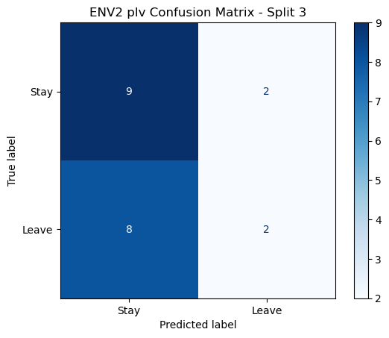

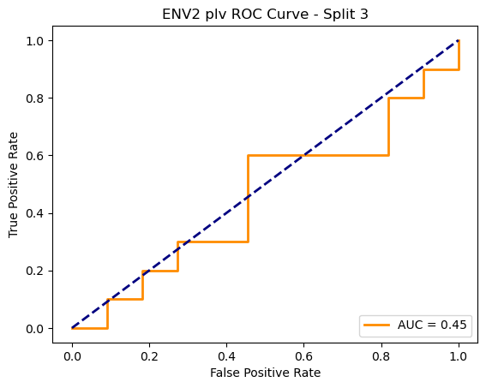

=== ENV2 Split 4/5 ===

After oversampling, class counts: Counter({1: 44, 0: 44})

C:\Users\sansk\miniconda3\Lib\site-packages\torch_geometric\deprecation.py:26: UserWarning: 'data.DataLoader' is deprecated, use 'loader.DataLoader' instead

warnings.warn(out)

Epoch 1/100 | Loss: 0.7273

Epoch 2/100 | Loss: 0.8157

Epoch 3/100 | Loss: 0.7607

Epoch 4/100 | Loss: 0.7910

Epoch 5/100 | Loss: 0.8346

Epoch 6/100 | Loss: 0.6628

Epoch 7/100 | Loss: 0.7815

Epoch 8/100 | Loss: 0.6797

Epoch 9/100 | Loss: 0.7327

Epoch 10/100 | Loss: 0.7141

Epoch 11/100 | Loss: 0.7210

Epoch 12/100 | Loss: 0.7251

Epoch 13/100 | Loss: 0.6710

Epoch 14/100 | Loss: 0.6891

Epoch 15/100 | Loss: 0.7173

Epoch 16/100 | Loss: 0.7073

Epoch 17/100 | Loss: 0.6709

Epoch 18/100 | Loss: 0.7288

Epoch 19/100 | Loss: 0.7310

Epoch 20/100 | Loss: 0.6304

Epoch 21/100 | Loss: 0.6908

Epoch 22/100 | Loss: 0.8119

Epoch 23/100 | Loss: 0.7194

Epoch 24/100 | Loss: 0.7364

Epoch 25/100 | Loss: 0.7191

Epoch 26/100 | Loss: 0.6481

Epoch 27/100 | Loss: 0.6661

Epoch 28/100 | Loss: 0.6481

Epoch 29/100 | Loss: 0.6647

Epoch 30/100 | Loss: 0.6497

Epoch 31/100 | Loss: 0.6199

Epoch 32/100 | Loss: 0.6917

Epoch 33/100 | Loss: 0.6939

Epoch 34/100 | Loss: 0.6311

Epoch 35/100 | Loss: 0.7252

Epoch 36/100 | Loss: 0.6800

Epoch 37/100 | Loss: 0.5805

Epoch 38/100 | Loss: 0.6971

Epoch 39/100 | Loss: 0.6602

Epoch 40/100 | Loss: 0.7289

Epoch 41/100 | Loss: 0.6595

Epoch 42/100 | Loss: 0.7038

Epoch 43/100 | Loss: 0.5918

Epoch 44/100 | Loss: 0.6441

Epoch 45/100 | Loss: 0.6837

Epoch 46/100 | Loss: 0.6335

Epoch 47/100 | Loss: 0.6533

Epoch 48/100 | Loss: 0.6249

Epoch 49/100 | Loss: 0.6453

Epoch 50/100 | Loss: 0.6502

Epoch 51/100 | Loss: 0.7101

Epoch 52/100 | Loss: 0.6480

Epoch 53/100 | Loss: 0.6070

Epoch 54/100 | Loss: 0.6722

Epoch 55/100 | Loss: 0.6395

Epoch 56/100 | Loss: 0.6285

Epoch 57/100 | Loss: 0.6562

Epoch 58/100 | Loss: 0.5681

Epoch 59/100 | Loss: 0.6555

Epoch 60/100 | Loss: 0.6434

Epoch 61/100 | Loss: 0.7272

Epoch 62/100 | Loss: 0.5921

Epoch 63/100 | Loss: 0.6172

Epoch 64/100 | Loss: 0.6461

Epoch 65/100 | Loss: 0.6623

Epoch 66/100 | Loss: 0.7118

Epoch 67/100 | Loss: 0.6905

Epoch 68/100 | Loss: 0.6863

Epoch 69/100 | Loss: 0.6018

Epoch 70/100 | Loss: 0.6545

Epoch 71/100 | Loss: 0.6565

Epoch 72/100 | Loss: 0.6801

Epoch 73/100 | Loss: 0.5869

Epoch 74/100 | Loss: 0.6733

Epoch 75/100 | Loss: 0.6772

Epoch 76/100 | Loss: 0.6444

Epoch 77/100 | Loss: 0.5635

Epoch 78/100 | Loss: 0.6565

Epoch 79/100 | Loss: 0.6431

Epoch 80/100 | Loss: 0.6219

Epoch 81/100 | Loss: 0.5711

Epoch 82/100 | Loss: 0.5597

Epoch 83/100 | Loss: 0.6722

Epoch 84/100 | Loss: 0.5873

Epoch 85/100 | Loss: 0.6766

Epoch 86/100 | Loss: 0.6940

Epoch 87/100 | Loss: 0.5721

Epoch 88/100 | Loss: 0.6628

Epoch 89/100 | Loss: 0.6515

Epoch 90/100 | Loss: 0.5857

Epoch 91/100 | Loss: 0.5597

Epoch 92/100 | Loss: 0.6010

Epoch 93/100 | Loss: 0.6486

Epoch 94/100 | Loss: 0.6387

Epoch 95/100 | Loss: 0.5755

Epoch 96/100 | Loss: 0.5948

Epoch 97/100 | Loss: 0.5239

Epoch 98/100 | Loss: 0.5977

Epoch 99/100 | Loss: 0.5781

Epoch 100/100 | Loss: 0.5748

Split 4 Accuracy: 0.4762

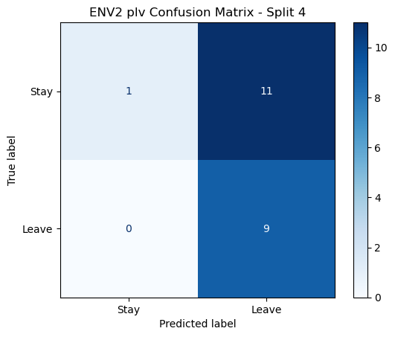

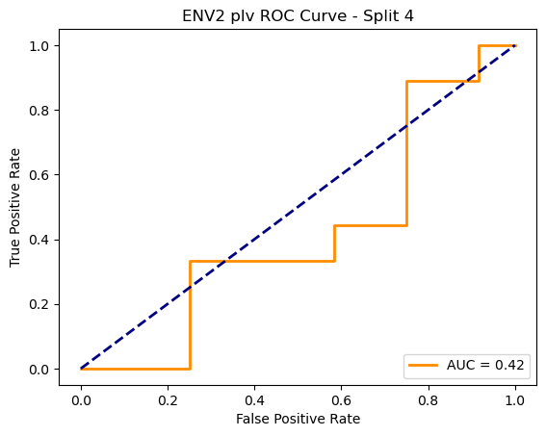

=== ENV2 Split 5/5 ===

After oversampling, class counts: Counter({1: 44, 0: 44})

C:\Users\sansk\miniconda3\Lib\site-packages\torch_geometric\deprecation.py:26: UserWarning: 'data.DataLoader' is deprecated, use 'loader.DataLoader' instead

warnings.warn(out)

Epoch 1/100 | Loss: 0.6794

Epoch 2/100 | Loss: 0.7713

Epoch 3/100 | Loss: 0.7232

Epoch 4/100 | Loss: 0.7291

Epoch 5/100 | Loss: 0.7080

Epoch 6/100 | Loss: 0.6897

Epoch 7/100 | Loss: 0.7634

Epoch 8/100 | Loss: 0.7241

Epoch 9/100 | Loss: 0.6929

Epoch 10/100 | Loss: 0.7365

Epoch 11/100 | Loss: 0.7232

Epoch 12/100 | Loss: 0.7618

Epoch 13/100 | Loss: 0.7398

Epoch 14/100 | Loss: 0.7451

Epoch 15/100 | Loss: 0.7866

Epoch 16/100 | Loss: 0.7121

Epoch 17/100 | Loss: 0.7223

Epoch 18/100 | Loss: 0.7199

Epoch 19/100 | Loss: 0.7426

Epoch 20/100 | Loss: 0.7214

Epoch 21/100 | Loss: 0.7353

Epoch 22/100 | Loss: 0.6588

Epoch 23/100 | Loss: 0.7196

Epoch 24/100 | Loss: 0.6937

Epoch 25/100 | Loss: 0.7211

Epoch 26/100 | Loss: 0.6723

Epoch 27/100 | Loss: 0.7123

Epoch 28/100 | Loss: 0.7457

Epoch 29/100 | Loss: 0.7282

Epoch 30/100 | Loss: 0.7585

Epoch 31/100 | Loss: 0.6777

Epoch 32/100 | Loss: 0.7605

Epoch 33/100 | Loss: 0.6774

Epoch 34/100 | Loss: 0.6928

Epoch 35/100 | Loss: 0.6988

Epoch 36/100 | Loss: 0.6805

Epoch 37/100 | Loss: 0.6612

Epoch 38/100 | Loss: 0.6912

Epoch 39/100 | Loss: 0.6469

Epoch 40/100 | Loss: 0.6904

Epoch 41/100 | Loss: 0.6768

Epoch 42/100 | Loss: 0.6676

Epoch 43/100 | Loss: 0.7011

Epoch 44/100 | Loss: 0.6915

Epoch 45/100 | Loss: 0.6553

Epoch 46/100 | Loss: 0.6273

Epoch 47/100 | Loss: 0.7250

Epoch 48/100 | Loss: 0.7126

Epoch 49/100 | Loss: 0.6517

Epoch 50/100 | Loss: 0.6398

Epoch 51/100 | Loss: 0.6822

Epoch 52/100 | Loss: 0.6561

Epoch 53/100 | Loss: 0.6815

Epoch 54/100 | Loss: 0.6837

Epoch 55/100 | Loss: 0.6543

Epoch 56/100 | Loss: 0.6024

Epoch 57/100 | Loss: 0.6947

Epoch 58/100 | Loss: 0.6860

Epoch 59/100 | Loss: 0.6750

Epoch 60/100 | Loss: 0.6724

Epoch 61/100 | Loss: 0.7308

Epoch 62/100 | Loss: 0.6542

Epoch 63/100 | Loss: 0.6587

Epoch 64/100 | Loss: 0.7146

Epoch 65/100 | Loss: 0.6859

Epoch 66/100 | Loss: 0.6561

Epoch 67/100 | Loss: 0.6120

Epoch 68/100 | Loss: 0.7191

Epoch 69/100 | Loss: 0.6998

Epoch 70/100 | Loss: 0.6089

Epoch 71/100 | Loss: 0.6064

Epoch 72/100 | Loss: 0.5832

Epoch 73/100 | Loss: 0.6260

Epoch 74/100 | Loss: 0.6311

Epoch 75/100 | Loss: 0.5981

Epoch 76/100 | Loss: 0.6173

Epoch 77/100 | Loss: 0.6422

Epoch 78/100 | Loss: 0.6087

Epoch 79/100 | Loss: 0.5581

Epoch 80/100 | Loss: 0.5915

Epoch 81/100 | Loss: 0.6431

Epoch 82/100 | Loss: 0.5874

Epoch 83/100 | Loss: 0.6822

Epoch 84/100 | Loss: 0.6625

Epoch 85/100 | Loss: 0.5912

Epoch 86/100 | Loss: 0.5695

Epoch 87/100 | Loss: 0.6307

Epoch 88/100 | Loss: 0.6674

Epoch 89/100 | Loss: 0.5788

Epoch 90/100 | Loss: 0.6541

Epoch 91/100 | Loss: 0.6701

Epoch 92/100 | Loss: 0.6309

Epoch 93/100 | Loss: 0.5628

Epoch 94/100 | Loss: 0.6486

Epoch 95/100 | Loss: 0.6081

Epoch 96/100 | Loss: 0.6094

Epoch 97/100 | Loss: 0.6448

Epoch 98/100 | Loss: 0.6089

Epoch 99/100 | Loss: 0.6114

Epoch 100/100 | Loss: 0.5534

Split 5 Accuracy: 0.4762

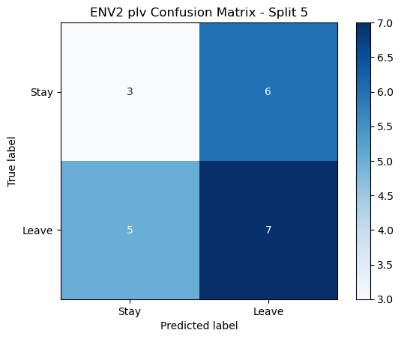

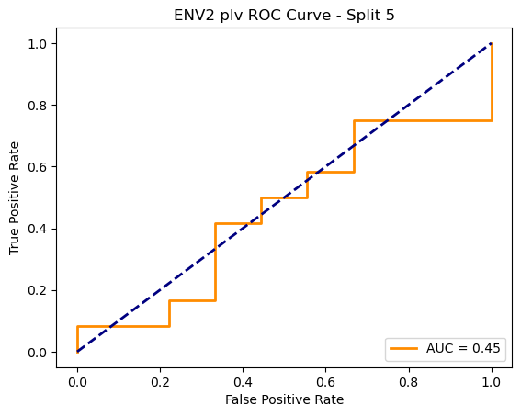

ENV2 plv Average Accuracy: 0.5000 ± 0.0213

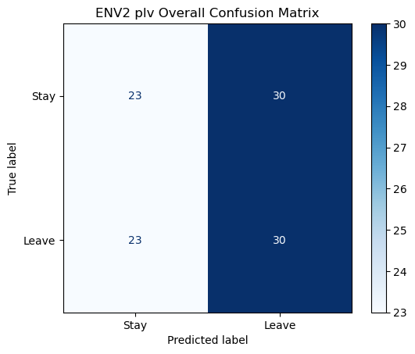

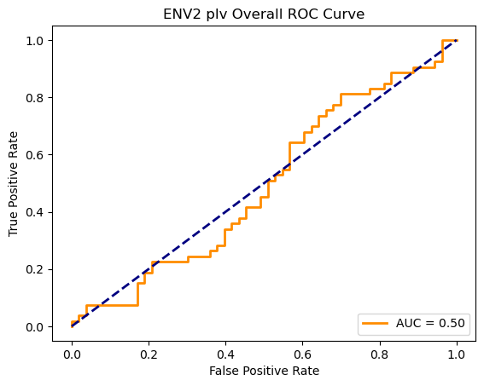

Epoch 1/200 | Loss: 0.8349

Epoch 2/200 | Loss: 0.7790

Epoch 3/200 | Loss: 0.8604

Epoch 4/200 | Loss: 0.8659

Epoch 5/200 | Loss: 0.8371

Epoch 6/200 | Loss: 0.8180

Epoch 7/200 | Loss: 0.8452

Epoch 8/200 | Loss: 0.8437

Epoch 9/200 | Loss: 0.8649

Epoch 10/200 | Loss: 0.8129

Epoch 11/200 | Loss: 0.8261

Epoch 12/200 | Loss: 0.8257

Epoch 13/200 | Loss: 0.7717

Epoch 14/200 | Loss: 0.7591

Epoch 15/200 | Loss: 0.8335

Epoch 16/200 | Loss: 0.7757

Epoch 17/200 | Loss: 0.8158

Epoch 18/200 | Loss: 0.8337

Epoch 19/200 | Loss: 0.7932

Epoch 20/200 | Loss: 0.7135

Epoch 21/200 | Loss: 0.7958

Epoch 22/200 | Loss: 0.7960

Epoch 23/200 | Loss: 0.7736

Epoch 24/200 | Loss: 0.7956

Epoch 25/200 | Loss: 0.8256

Epoch 26/200 | Loss: 0.7138

Epoch 27/200 | Loss: 0.7724

Epoch 28/200 | Loss: 0.7777

Epoch 29/200 | Loss: 0.7445

Epoch 30/200 | Loss: 0.7291

Epoch 31/200 | Loss: 0.8002

Epoch 32/200 | Loss: 0.7913

Epoch 33/200 | Loss: 0.7962

Epoch 34/200 | Loss: 0.7696

Epoch 35/200 | Loss: 0.7511

Epoch 36/200 | Loss: 0.7490

Epoch 37/200 | Loss: 0.7388

Epoch 38/200 | Loss: 0.7474

Epoch 39/200 | Loss: 0.7841

Epoch 40/200 | Loss: 0.7357

Epoch 41/200 | Loss: 0.7817

Epoch 42/200 | Loss: 0.7087

Epoch 43/200 | Loss: 0.7555

Epoch 44/200 | Loss: 0.6786

Epoch 45/200 | Loss: 0.7569

Epoch 46/200 | Loss: 0.7404

Epoch 47/200 | Loss: 0.7390

Epoch 48/200 | Loss: 0.7367

Epoch 49/200 | Loss: 0.7624

Epoch 50/200 | Loss: 0.7327

Epoch 51/200 | Loss: 0.7628

Epoch 52/200 | Loss: 0.7561

Epoch 53/200 | Loss: 0.8112

Epoch 54/200 | Loss: 0.6737

Epoch 55/200 | Loss: 0.7457

Epoch 56/200 | Loss: 0.6606

Epoch 57/200 | Loss: 0.7569

Epoch 58/200 | Loss: 0.7064

Epoch 59/200 | Loss: 0.7564

Epoch 60/200 | Loss: 0.7570

Epoch 61/200 | Loss: 0.7136

Epoch 62/200 | Loss: 0.7879

Epoch 63/200 | Loss: 0.7117

Epoch 64/200 | Loss: 0.7193

Epoch 65/200 | Loss: 0.7305

Epoch 66/200 | Loss: 0.7742

Epoch 67/200 | Loss: 0.7399

Epoch 68/200 | Loss: 0.7219

Epoch 69/200 | Loss: 0.7262

Epoch 70/200 | Loss: 0.6680

Epoch 71/200 | Loss: 0.7094

Epoch 72/200 | Loss: 0.7187

Epoch 73/200 | Loss: 0.7783

Epoch 74/200 | Loss: 0.7362

Epoch 75/200 | Loss: 0.7318

Epoch 76/200 | Loss: 0.7197

Epoch 77/200 | Loss: 0.7295

Epoch 78/200 | Loss: 0.6562

Epoch 79/200 | Loss: 0.6835

Epoch 80/200 | Loss: 0.7413

Epoch 81/200 | Loss: 0.7527

Epoch 82/200 | Loss: 0.6675

Epoch 83/200 | Loss: 0.7372

Epoch 84/200 | Loss: 0.7024

Epoch 85/200 | Loss: 0.7223

Epoch 86/200 | Loss: 0.7001

Epoch 87/200 | Loss: 0.7405

Epoch 88/200 | Loss: 0.7336

Epoch 89/200 | Loss: 0.6793

Epoch 90/200 | Loss: 0.6702

Epoch 91/200 | Loss: 0.7967

Epoch 92/200 | Loss: 0.7871

Epoch 93/200 | Loss: 0.6822

Epoch 94/200 | Loss: 0.7187

Epoch 95/200 | Loss: 0.7104

Epoch 96/200 | Loss: 0.6799

Epoch 97/200 | Loss: 0.7034

Epoch 98/200 | Loss: 0.6780

Epoch 99/200 | Loss: 0.7267

Epoch 100/200 | Loss: 0.6717

Epoch 101/200 | Loss: 0.6664

Epoch 102/200 | Loss: 0.7158

Epoch 103/200 | Loss: 0.6787

Epoch 104/200 | Loss: 0.6860

Epoch 105/200 | Loss: 0.7002

Epoch 106/200 | Loss: 0.6940

Epoch 107/200 | Loss: 0.6549

Epoch 108/200 | Loss: 0.7331

Epoch 109/200 | Loss: 0.6979

Epoch 110/200 | Loss: 0.7427

Epoch 111/200 | Loss: 0.7115

Epoch 112/200 | Loss: 0.7216

Epoch 113/200 | Loss: 0.7068

Epoch 114/200 | Loss: 0.6123

Epoch 115/200 | Loss: 0.7035

Epoch 116/200 | Loss: 0.6610

Epoch 117/200 | Loss: 0.6971

Epoch 118/200 | Loss: 0.6845

Epoch 119/200 | Loss: 0.6891

Epoch 120/200 | Loss: 0.6921

Epoch 121/200 | Loss: 0.7049

Epoch 122/200 | Loss: 0.6604

Epoch 123/200 | Loss: 0.7318

Epoch 124/200 | Loss: 0.7068

Epoch 125/200 | Loss: 0.7084

Epoch 126/200 | Loss: 0.6963

Epoch 127/200 | Loss: 0.7401

Epoch 128/200 | Loss: 0.7529

Epoch 129/200 | Loss: 0.6163

Epoch 130/200 | Loss: 0.7518

Epoch 131/200 | Loss: 0.6311

Epoch 132/200 | Loss: 0.6526

Epoch 133/200 | Loss: 0.6807

Epoch 134/200 | Loss: 0.6810

Epoch 135/200 | Loss: 0.6798

Epoch 136/200 | Loss: 0.5980

Epoch 137/200 | Loss: 0.6894

Epoch 138/200 | Loss: 0.6059

Epoch 139/200 | Loss: 0.6712

Epoch 140/200 | Loss: 0.6759

Epoch 141/200 | Loss: 0.6097

Epoch 142/200 | Loss: 0.6688

Epoch 143/200 | Loss: 0.6506

Epoch 144/200 | Loss: 0.7060

Epoch 145/200 | Loss: 0.7028

Epoch 146/200 | Loss: 0.6925

Epoch 147/200 | Loss: 0.7265

Epoch 148/200 | Loss: 0.7024

Epoch 149/200 | Loss: 0.6387

Epoch 150/200 | Loss: 0.7099

Epoch 151/200 | Loss: 0.6690

Epoch 152/200 | Loss: 0.6867

Epoch 153/200 | Loss: 0.6928

Epoch 154/200 | Loss: 0.6477

Epoch 155/200 | Loss: 0.6434

Epoch 156/200 | Loss: 0.6035

Epoch 157/200 | Loss: 0.6405

Epoch 158/200 | Loss: 0.6751

Epoch 159/200 | Loss: 0.5877

Epoch 160/200 | Loss: 0.6887

Epoch 161/200 | Loss: 0.7476

Epoch 162/200 | Loss: 0.6878

Epoch 163/200 | Loss: 0.6248

Epoch 164/200 | Loss: 0.7108

Epoch 165/200 | Loss: 0.6484

Epoch 166/200 | Loss: 0.6758

Epoch 167/200 | Loss: 0.6471

Epoch 168/200 | Loss: 0.6847

Epoch 169/200 | Loss: 0.6994

Epoch 170/200 | Loss: 0.6477

Epoch 171/200 | Loss: 0.6308

Epoch 172/200 | Loss: 0.6299

Epoch 173/200 | Loss: 0.6921

Epoch 174/200 | Loss: 0.6789

Epoch 175/200 | Loss: 0.6682

Epoch 176/200 | Loss: 0.6534

Epoch 177/200 | Loss: 0.7326

Epoch 178/200 | Loss: 0.6512

Epoch 179/200 | Loss: 0.6204

Epoch 180/200 | Loss: 0.6305

Epoch 181/200 | Loss: 0.6843

Epoch 182/200 | Loss: 0.6789

Epoch 183/200 | Loss: 0.7184

Epoch 184/200 | Loss: 0.5777

Epoch 185/200 | Loss: 0.6642

Epoch 186/200 | Loss: 0.6015

Epoch 187/200 | Loss: 0.6313

Epoch 188/200 | Loss: 0.7098

Epoch 189/200 | Loss: 0.7395

Epoch 190/200 | Loss: 0.6392

Epoch 191/200 | Loss: 0.6111

Epoch 192/200 | Loss: 0.6415

Epoch 193/200 | Loss: 0.6445

Epoch 194/200 | Loss: 0.6489

Epoch 195/200 | Loss: 0.5932

Epoch 196/200 | Loss: 0.6504

Epoch 197/200 | Loss: 0.6351

Epoch 198/200 | Loss: 0.7304

Epoch 199/200 | Loss: 0.6229

Epoch 200/200 | Loss: 0.6160

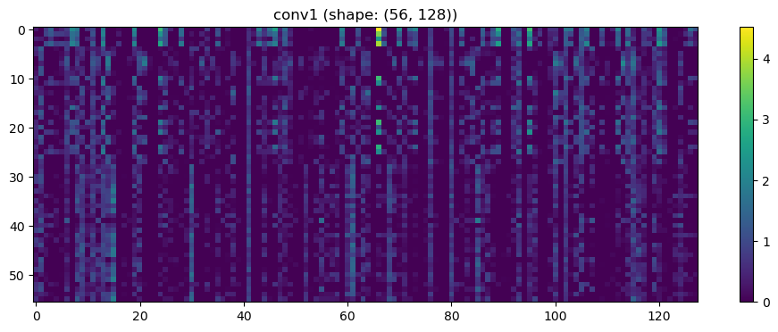

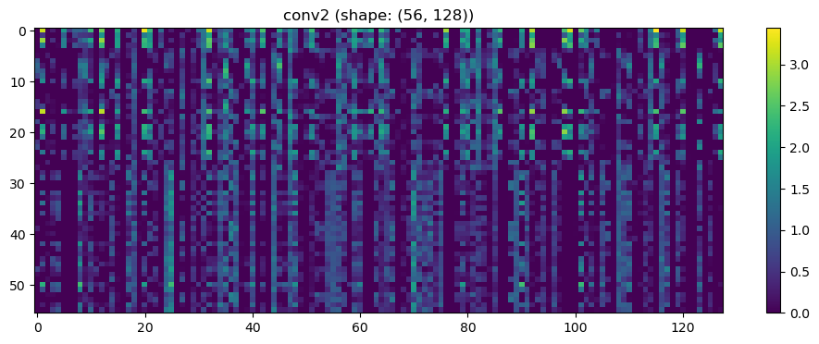

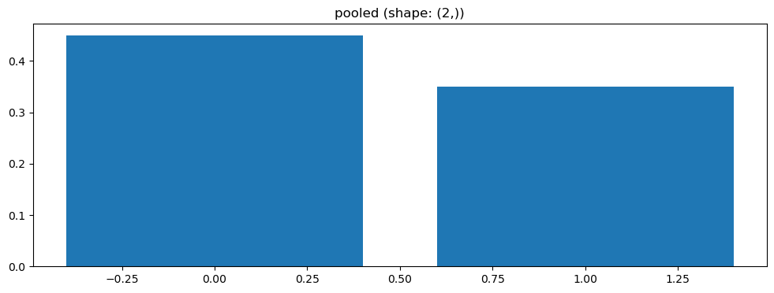

Split 5 Accuracy: 0.4762

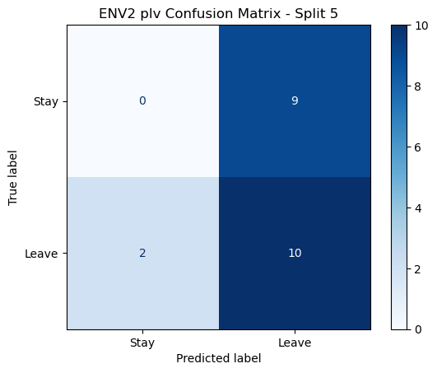

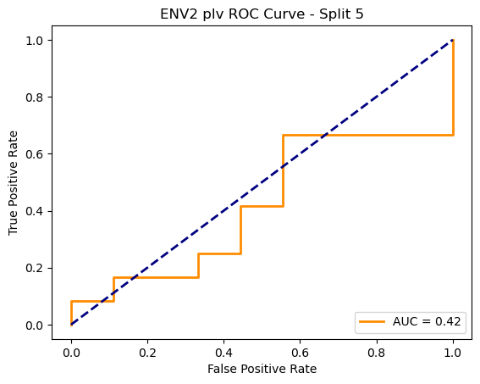

ENV2 plv Average Accuracy: 0.5299 ± 0.1151

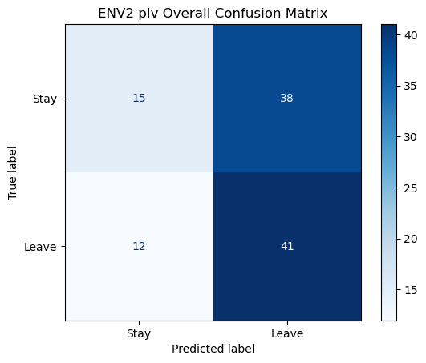

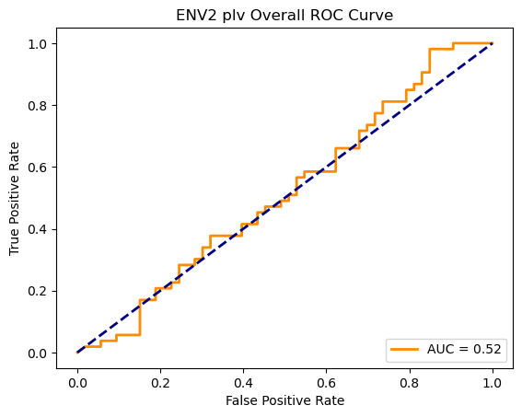

Click to add a cell.